**R Programming:**

|  |  |  |
| --- | --- | --- |
| **S.No** | **Bookname** | **Author** |
| 1 | Learning R : a step-by-step function guide to data analysis | Cotton, Richard |
| 2 | R cookbook | Teetor, Paul |
| 3 | R for Everyone : Advanced Analytics and Graphics | Lander, Jared P |
| 4 | “R Reference Card” – type this in google, you will find a pdf from CRAN site | CRAN site |
| 5 | R Graph Essentials | David Alexander Lillis |
| 6 | Text Mining with R | Julia Silge & David Robinson |
| 7 | Efficient R programming - <https://csgillespie.github.io/efficientR/> | Colin Gillespie, Robin Lovelace |
| 8 | R programming for Dummies | Andrie de Vries, Joris Meys |
| 9 | R for Data Science - <http://r4ds.had.co.nz/> |  |
| 10 | http://r-statistics.co/R-Tutorial.html |  |
| 11 | http://r-pkgs.had.co.nz/ |  |

|  |  |
| --- | --- |
| Regression | Simple, Multiple, Polynomial, SVR, DT, Random Forests, Survival Analysis, Non-Linear Least Square, CART(Regression Trees) |
| Classification | Logistic, KNN, SVM, Naive Bayes, Decision Trees, Random Forest, CART(Classification Trees) |
| Clustering | K Means, Hierarchical |
| Time Series Analysis | AR, MA, ARMA, ARIMA |
| Text Mining in R | Sentiment Analysis |
| Dimensionality Reduction | PCA, KPCA, LDA |
| Association | Apriori, Eclat |
| Deep Learning | ANN |
| Reinforcement | UCB, Thompson sampling |
| Model Selection/Evaluation | Feature Extraction: Cross validation ((K fold), grid selection |
| Feature Selection: Backward Elimination |
| Boosting Algorithms | Gradient Boosting(GBM), XGBoost |

**Blogs:**

<https://www.datasciencecentral.com/page/search?q=time/series>

<http://www.gastonsanchez.com/>

<https://www.machinelearningplus.com/>

http://statisticsbyjim.com/

IBM Knowledge center

<https://www.superdatascience.com/machine-learning/> 🡺 all codes available.

Git and Github:

<http://r-pkgs.had.co.nz/>

<https://help.github.com/>

Good resource for R and Rstudio:

<https://support.rstudio.com/hc/en-us/articles/200552336>

<https://resources.rstudio.com/>

Time series :

<https://onlinecourses.science.psu.edu/stat510/node/74/>

<https://nwfsc-timeseries.github.io/atsa-labs/>

<http://www.minitab.com/en-us/Published-Articles/ARIMA--How-to-Avoid-the-Herd-When-Analyzing-Time-Series-Data/>

Good link: <https://robjhyndman.com/papers/foresight.pdf>

Multiple algorithms tried on a dataset :

<https://machinelearningmastery.com/evaluate-machine-learning-algorithms-with-r/>

R Devtools cheatsheet:

<https://rawgit.com/rstudio/cheatsheets/master/package-development.pdf>

R Markdown tutorials:

<https://rmarkdown.rstudio.com/lesson-1.html>

xgboost:

<https://rviews.rstudio.com/2018/11/07/in-database-xgboost-predictions-with-r/>

DS resources:

<https://github.com/Shujian2015/FreeML/blob/master/README.md>

NLP:

<https://allennlp.org/tutorials>

**SQL tutorials:**

<https://www.youtube.com/watch?v=ZNObiptSMSI&list=PL08903FB7ACA1C2FB>

**R Programming MQ’s:**

<https://www.sanfoundry.com/r-programming-questions-answers-connections-interfaces/>

**Topics to read:**

[Stochastic Gradient Descent](https://www.quora.com/Whats-the-difference-between-gradient-descent-and-stochastic-gradient-descent)., undersampling, oversampling or SMOTE,  [probability caliberation](https://www.analyticsvidhya.com/blog/2016/07/platt-scaling-isotonic-regression-minimize-logloss-error/),  [Imbalanced Classification](https://www.analyticsvidhya.com/blog/2016/03/practical-guide-deal-imbalanced-classification-problems/)

Reliability models, Markov Models, Stochastic models, Bayesian Modeling, Classification Models, Cluster Analysis, Neural Network, Non-parametric Methods, Multivariate Statistics

|  |  |
| --- | --- |
| **Topics to read/New concepts** |  |
| First principle models |  |
| P10, P50, P90 |  |
| PLS |  |
| Dynamic Time Warping (DTW) |  |
| Processing image, audio and video files in R |  |
| Comparative analysis or comparison analysis |  |
| Minimum number of observation required for regression analysis |  |
| Pdp – Partial dependency plots |  |
| Can timestamp be part of regression variable?  [r - Does it make sense to use a date variable in a regression ...](https://stats.stackexchange.com/questions/65900/does-it-make-sense-to-use-a-date-variable-in-a-regression) |  |
| Interpretting Circle of coefficients in pls |  |
| Fault tree analysis |  |
| FMEA analysis |  |
| Beta regression |  |
| R markdown |  |

R is case sensitive. R is a vectorized language -> meaning operations can be applied to each element of vector without the need to loop through the vector.

**IDE:**

1. Emacs+ESS
2. Eclipse/Architect
3. RStudio
4. Revolution-R
5. Live-R

**To get help:**

? followed by exact name of the function ->details about the function (**help** can also be used)

?? followed by keyword related to the problem or search ->details the function (**help.search** can also be used)

With help also we need to enclose the arguments in quotes

Eg: help(“mean”), help(“plotting”), help(“regression model”)

**Apropos function:**

Finds variable names including function names which matches the argument.

Eg: abc_2 <-c(1,2,3)

apropos(“2$”) -> finds list of variables , function which ends with 2

o/p: abc_2

CTRL +l to clear the console window

**To comment the code and to undo the comment:**

**CTRL+SHIFT+c**

**Vignettes :**

* Short document that details how to use the package.
* browseVignettes() -> details about the packages that are installed.
* RSiteSearch(“Bayesian regression”) -> details about any packages as it fetches from R website.

**Installing packages:**

install.packages(“name of the package”) - >installs the package

library(name of the package) -> loads the mentioned package

detach(“package:matlab”) -> this unloads the package matlab.

library() 🡺 displays all the packages installed in the system.

.libPaths() 🡺 displays the paths where the packages are located.

search() 🡺 displays the packages that are currently loaded in the R environment.

identical(2^3,2**3) -> returns TRUE if the values are same. If not FALSE.

all.equal(2,3)-> returns report on the differences. If we need Logical output, include isTRUE(). In all.equal(), there is a tolerance level of 1.5e-8, so rounding errors less than the tolerance level are ignored.

eg: isTRUE(all.equal(2,3)) ->returns FALSE.

Both identical and all.equal accepts numbers and character strings as input.

%/% -> this operator returns quotient of the division.

Eg: 5%/%2 -> returns 2

%% -> this operator returns reminder of the division

Eg: 5%%2 -> returns 1

**Assignment operator:**

<- , = , assign()

Eg: a <- 3 , If space is left between < and – then it will considered as less than operator.

a=3

assign(“a”,3)

**<<-** indicates global assignment.

In case of global assignment, additional parameter required in assign()

Eg: assign(“a”, 3, globalenv())

assign function doesn’t check its first argument to see if the variable name is valid. It just always creates it.

Eg: assign(“.2a”,4) ->this will not leave any error message, but normal assignment will return an error.

If you want to assign a variable and return the value all in one line ; should be used.

Eg: a=3;a

Or

(a=3) this will make the assignment and also return the value of a.

**Special Numbers:**

4 special numeric values:

1. Inf(positive infinity)
2. –Inf (negative infinity)
3. NAN(Not A Number) -> when calculation makes no mathematical sense or could not be performed properly.
4. NA (Not Available) -> represents a missing value.

(Inf – Inf) results in NaN

When arithmetic involves NA and NaN, the value is either of them.

**Numeric datatype => covers both integers(whole digit numbers like 3,5) + floating point number (like 6.5)**

to calculate the product of all elements in the vector, use prod(vector_name) function.

V1 = c(1,2,3)

prod(V1) 🡺 o/p 6

**Logical Vectors:**

R accepts 3 values – TRUE, FALSE, NA – Hence called as troolean logic

TRUE and FALSE are Keywords but not True and False

True = 3 (this is correct)

all(“logical vector name”) 🡪 all values should be true

any(“logical vector name”) 🡪 atleast one value should be true.

**Lazy evaluation:**

f <- function(a, b=c) {c = log(a); a*b}

Now the default argument is a variable that doesn’t exist until the body of the function executes! If f is called with one argument, the R interpreter chugs along until it gets to the last line of the function and says “Hmm. What is b? Let me go back and see. Oh, the default value of b is c, and now I know what c is.”

This behavior is called lazy evaluation. Expressions are not evaluated unless and until they are needed. It’s a common feature of functional programming languages.

**Classes:**

1. Logical class - TRUE, FALSE, NA
2. Numbers class:
   1. Numeric – includes floating point numbers eg: class(1.5:10.5)
   2. Integer – includes number with ‘L’ eg: class(1:10),class(4L)
   3. Complex – i creates imaginary component of complex number eg: class(3+4i)
3. Vector class:
   1. character – stores text
   2. factors – stores categorical data
   3. raw – stores binay data

object.size returns the memory allocation for each object.

as.raw on a complex object discards imaginary part.

Eg. as.raw(3+4i) results as 03 leaving the imaginary part.

is.numeric() function returns true for both floating point numbers and integers. To test only for floating point, use is.double() function.

is.* functions used to check if the variables are of a specific class. as.* function used for type casting (to convert one object type to another type.)

In general, when some calculation or name of the variable is mentioned in the console, implicit print method is called.

Eg: 1+1 will show the result 2 same as print(1+1)

But inside loops or functions, print should be called explicitly.

Eg:

a=1:5

for (i in a) i (will not return any result)

for(i in a) print(i) (returns result)

for print, digits parameter can control the number of printed digits.

For cat, format() which also has digits parameter used to alter the formatting of numbers.

>cat(format(pi, digits =4))

3.142

>print(pi, digits=4)

[1] 3.142

cat, can redirect the output to a file. Print cannot.

|  |
| --- |
| >a=c(1:5)  >cat(a, file="a.out", append = TRUE) 🡺 o/p gets redirected to a.out file |

>b=5:10

>con = file("a.out","w") 🡺 create con object so that we can reuse...

>cat(b,file=con) 🡺 append is implicit with con object

**print drawback:**

it can print only one object at a time. but cat can do.

**cat drawback:**

it cannot print compound data structures like matrix, list etc.

> print("hi,", "hello")

Error in print.default("hi,", "hello") : invalid 'digits' argument

In addition: Warning message:

In print.default("hi,", "hello") : NAs introduced by coercion

> cat("hi,", "hello")

hi, hello

>

> print(list('a','b'))

[[1]]

[1] "a"

[[2]]

[1] "b"

> cat(list('a','b'))

Error in cat(list("a", "b")) :

argument 1 (type 'list') cannot be handled by 'cat'

Print function shows special characters in string. Cat does not.

>word = "abc \r saranya \r"

>print(word)

[1] "abc \r saranya \r"

>cat(word)

saranya

sample function randomly samples from the input vector of mentioned size with replace=TRUE. If replace=FALSE, then sampling size should be less than the vector elements count.

Eg: sample(c(1,2,3), 5, replace=TRUE)

o/p : 3,2,1,3,1

If replace=FALSE in above statement, we get error saying size can’t be more than the vector elements.

attributes(“objectname”) -> returns the list of all attributes of an object such as $names, $row.names, , $class

unclass(factor variable) -> returns integer vector with attribute called levels.

For visualizing matrix and data frames, 3 functions available.

1. View() -> provides read only spreadsheet. Eg: View(dfr) – no changes allowed
2. edit() -> allows to manually change the data values and can be stored on a separate variable. Eg: c=edit(dfr) ->changes gets updated in c
3. fix() -> allows to manually change the data values in the same variable name. Eg: fix(dfr) -> changes gets updated in dfr

ls() used to view the list of variable names in the current workspace.

rm() used to remove the variables.

**Vectors**

vector(mode = “type”,length = size) creates empty vector, mode – numeric, integer, character,logical.

eg: vector(“numeric”,5) amd numeric(5) results same output.

Vectors cannot contain mix of data types.

**Precision:**

> x <- 3.66342

> y <- 3.34354

> ceiling(x)

[1] 4

> ceiling(y)

[1] 4

> floor(x)

[1] 3

> floor(y)

[1] 3

> round(x,2)

[1] 3.66

> round(y,4)

[1] 3.3435

> trunc(x)

[1] 3

> trunc(y)

[1] 3

**Sequences:**seq (from, to, interval)

Eg: seq(1,5,2)

o/p: 1 3 5

seq.int(3,7)

o/p: 3 4 5 6 7

seq_len starts the sequence from 1 up to its input.

Eg:seq_len(5)

o/p: 1 2 3 4 5

seq_along creates a sequence from 1 up to the length of its input

for (i in seq_along(a)) print(a[i])

length() used to identify the number of elements in the input vector.

Length behaves different for vectors, lists, matrices, and data frame.

Eg:

> length(1:5) 🡺 for vector, number of entries

[1] 5

> my_df2

age sal

1 20 1000

2 21 1001

3 22 1002

> length(my_df2) 🡺 for dataframe, number of columns or variables.

[1] 2

> m= matrix(1:16,nrow=2)

> m

[,1] [,2] [,3] [,4] [,5] [,6] [,7] [,8]

[1,] 1 3 5 7 9 11 13 15

[2,] 2 4 6 8 10 12 14 16

> length(m) 🡺 for matrix, nrow*ncol

[1] 16

> l=list(a=matrix(1:6,nrow=2),b=1:10,c="saranya")

> l

$a

[,1] [,2] [,3]

[1,] 1 3 5

[2,] 2 4 6

$b

[1] 1 2 3 4 5 6 7 8 9 10

$c

[1] "saranya"

> length(l) 🡺 for list, number of items.

[1] 3

names(vector_input) used to label the elements of the vector.

rep() used for repeating the values, for the given number of times.

Eg: rep(1:5,2)

o/p: 1 2 3 4 5 1 2 3 4 5

rep(1:4,each=2)

o/p: 1 1 2 2 3 3 4 4

rep(1:4, times=1:4)

o/p: 1 2 2 3 3 3 4 4 4 4

rep(1:5, length.out=7)

o/p: 1 2 3 4 5 1 2

**Lists:**

Lists can be nested within list. Hence they are like recursive variables. Lists are recursive. Vectors, matrices and arrays are atomic

is.recursive(list()) -> returns TRUE

is.atomic(numeric()) -> returns TRUE

length(list_name) -> provides the top level elements that it contains.

List1=list(‘a’,1:5,”sara”)

Length(List1) =3

NROW(List1) -> returns 3

NCOL(List1) -> returns 1

nrow(List1) and ncol(List1) returns NULL same as vectors.

**Indexing Lists:**

Indexes can be positive , negative or logical operators (TRUE, FALSE)

Positive index -> selects those elements from the list.

Negative index -> ignores that index and selects other elements from the list.

Logical -> returns the elements corresponding to TRUE indexes.

Vectors can be converted to list using as.list()

Similarly list with scalar elements, can be converted to vector using as.numeric, as.character and so on.

Lists can be combined using c()

cbind and rbind possible with lists but not recommended. Use only for matrix, dataframe

NA is a scalar value. NULL takes up no space.

Length(NA) -> returns 1

Length(NULL) ->returns 0

is.null() is used to check if the value of the variable is null or not.

is.na() used to check if the value is missing or not.

is.na(NULL) ->will result in error because it cannot check the value is missing or not as null has length 0 and there is nothing to check against the function is.na()

if we want to remove a item from the list or vector, by assigning NULL, we can remove

eg: b=list(“one”=1,”two”=2,”three”=3)

b[“two”]=NULL

b -> result will show only one and three

but, if we want to retain that entry and just make the value as null, we need to use below

b[“two”] = list(NULL)

o/p

b[“one”]

1

b[“two”]

NULL

b[“three”]

3

**Data Frames:**

If any of the input vector has names, then the row names for the data frame would be taken from the first vector names provided the number of elements in the dataframe matches the vector length otherwise names will not appear.

Eg:

a=c(‘a’,’b’,’c)

names(a)=c(‘apple’,’bag’,’cat’)

b=data.frame(1:3,a)

**o/p**

> b

X1.3 a

apple 1 a

bag 2 b

cat 3 c

Here vector ‘a’ has 6 elements but in dataframe, the first element is of

Length 3, hence row names didn’t appear.

> a=c('a','b','c',1:3)

> names(a)=c('apple','bag','cat')

> a

apple bag cat <NA> <NA> <NA>

"a" "b" "c" "1" "2" "3"

> b=data.frame(1:3,a)

> b

X1.3 a

1 1 a

2 2 b

3 3 c

4 1 1

5 2 2

6 3 3

If we don’t want the row names from the vector, we need to give as below

b=data.frame(1:3,a,row.names=NULL)

> b

X1.3 a

1 1 a

2 2 b

3 3 c

We can pass customized rownames through row.names vector within data frame.

rownames, colnames, dimnames gives the values of the row, column and dimension(both row and column) names.

>dput(colnames(df)) 🡺 displays the column names in vector which can be used in our code directly.

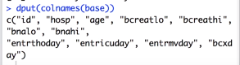

nrow, ncol,dim gives the count of row, col, and dim (both row and column) count.

In data frame, length() returns number of columns and names() return names of the columns. We need to use ncol() and colnames() instead.

In data frame, different length vectors allowed, but the lowest should be multiple of largest vector.

Eg

A=data.frame(x=1, y=2:3, z= 4:7)

> A

x y z

1 1 2 4

2 1 3 5

3 1 2 6

4 1 3 7

If, length not compatible, error will be thrown.

Names of the column will be checked for its validity in data frame during creation.

> d=data.frame(".2df"=1:3,"@#$%"=”4:6")

Error: unexpected string constant in "d=data.frame(".2df"=1:3,"@#$%"=4"6""

If we don’t want, we can add check.names=FALSE during data frame creation

> d=data.frame(".2df"=1:3,"@#$%"=4:6, check.names = FALSE)

> d

.2df @#$%

1 1 4

2 2 5

3 3 6

**Class:**

> my_df = data.frame("name" = c("aa","bb"), age=c(21,22))

> my_df

name age

1 aa 21

2 bb 22

> my_df[,"name"]

[1] aa bb

Levels: aa bb

> class(my_df[,"name"])

[1] "factor"

> my_df["name"]

name

1 aa

2 bb

> class(my_df["name"])

[1] "data.frame"

> my_df[["name"]]

[1] aa bb

Levels: aa bb

> class(my_df[["name"]])

[1] "factor"

> class(my_df[,"name",drop=FALSE])

[1] "data.frame"

**Viewing default packages in R:**

|  |
| --- |
| > getOption("defaultPackages")  [1] "datasets" "utils" "grDevices" "graphics" "stats" "methods" |
|  |
| |  | | --- | |  | |

**Subset**:

subset() used to select portion of a data frame when a particular condition is met. It takes 3 parameters.

1. name of the data frame
2. logical vector condition for selecting the rows.
3. Vector of columns to keep/display.

|  |
| --- |
| > A  x y z  one 1 2 4  two 1 3 5  three 1 2 6  four 1 3 7  > subset(A, x == 1 ,z)  z  one 4  two 5  three 6  four 7  while merging data frames, if we are using rbind, it is smart enough to match the column names even though  they are shuffled whereas cbind will not check for column duplicates.  > A  x y z  one 1 2 4  two 1 3 5  three 1 2 6  four 1 3 7  > B=data.frame("y"=4,"x"=2,"z"=8)  > rbind(A,B)  x y z  one 1 2 4  two 1 3 5  three 1 2 6  four 1 3 7  1 2 4 8 |
| > cbind(A,B)  x y z y x z  one 1 2 4 4 2 8  two 1 3 5 4 2 8  three 1 2 6 4 2 8  four 1 3 7 4 2 8 |
|  |

**Merge()**

Merge function used to merge two data frames.

merge(df1_name,df2_name, by=c(common_key(in both df)),all=TRUE)

all=TRUE -> returns all the values mentioned in ‘by’ field from both data frames,

all.x= TRUE -> x refers to first data frame. So all rows of 1st df and the matching rows from 2nd df

all.y=TRUE -> y refers to 2nd data frame. Returns all rows from 2nd and matching from 1st.

|  |
| --- |
| > A  x y z  one 1 2 4  two 1 3 5  three 1 2 6  four 1 3 7  > B  x w o  1 1 c e  2 b d f  > merge(A,B,by="x",all=TRUE)  x y z w o  1 1 2 4 c e  2 1 3 5 c e  3 1 2 6 c e  4 1 3 7 c e  5 b NA NA d f |
|  |
| colSums() function is used to calculate sum column wise. But column  should be minimum 2. Otherwise it results in below error. |

> colSums(A[, 1])

Error in colSums(A[, 1]) :

'x' must be an array of at least two dimensions

> colSums(A[, 1:2])

x y

4 10

ColMeans used to calculate the mean column wise.

> colMeans(A[ , 1:2])

x y

1.0 2.5

Similarly rowSums() and rowMeans(), but they accept one row.

> rowMeans(A[1,])

one

2.333333

> rowSums(A[1,])

one

7

**Coding standards:**

To adher to R coding standards, there are 2 ways.

1. Static code analyzer from R, lintr package, just invoke lint(“filename”) this will list out all syntax and sematic issues.
2. In R studio, tools -> global options -> code -> diagnostics , all options in this should be checked so, R studio while writing code, notifies syntactical issues.

**Weighted mean:**

A weighted mean is a kind of average. Instead of each data point contributing equally to the final mean, some data points contribute more “weight” than others. If all the weights are equal, then the weighted mean equals the arithmetic mean (the regular “average” you're used to).

x= c(1:10)

weighted.mean(x) 🡺returns weighted mean value.

Using [] single square bracket for indexing dataframe, will result in another dataframe with the specified index. Whereas [[]] double square bracket is used to specify the indexes , we will get vector.

Eg:

> df

name age

1 a 1

2 b 2

3 c 3

> df[2] - > this is another dataframe

age

1 1

2 2

3 3

> df[[2]] -> this is a vector

[1] 1 2 3

Similarly for list, if [] single square bracket used, the result will be another list. If [[]] is used, result is a vector.

**Sorting :**

In order to sort a column, sort() can be used. This will not rearrange the rows in df. Just returns sorted column values as vector. If we want to rearrange the table, then we need to use order(). We need to specify based on which column as 1st parameter and decreasing = TRUE will arrange in desending order. By default ascending. order() returns indexes which can be passed to df to fetch the values as below.

|  |
| --- |
| > df3  name age  1 a 1  2 b 2  3 c 3  4 z 50  5 d 35  6 w 45  > sort(df3$age)  [1] 1 2 3 35 45 50  > df3[order(df3$age),]  name age  1 a 1  2 b 2  3 c 3  5 d 35  6 w 45  4 z 50  > df3[order(df3$age,decreasing = TRUE),]  name age  4 z 50  6 w 45  5 d 35  3 c 3  2 b 2  1 a 1  identical(sort(x), x[order(x)]) -> result is TRUE  **3 sorting algorithms**:  **Shell**  > sort(vec,method = "shell")  **Quick**  > sort(vec,method = "quick”)  **Radix: (optimal for most situations)**  vec <- c(25, 478, 34, 9021, 6, 9947, 504, 22)  > sort(vec,method = "radix")  In summary, Radix sort does the following:  Sort based on unit positions: 9021, 22, 34, 504 ,25, 6, 9947, 478  Sort based on ten positions: 504, 6, 9021, 22, 25, 34 ,9947, 478  Sort based on hundred positions: 6, 9021, 22, 25, 34, 478, 504, 9947  Sort based on thousand positions: 6, 22, 25, 34, 478 ,504, 9021, 9947 |

**Environments:**

Environment is where all the created variables are stored. Environment by itself is a type of variable. We can assign values, manipulate them and pass as argument to function. Closely related to list. Most of the syntax of list is applicable to environments.

All environments have a parent environment exception empty environment at the top.

**2 types:**

1. Global environment – whenever you create and assign variables in command prompt. Also called as user workspace.
2. Base environment – This contains functions and other variables from R base package.

To create new environment:

> ev = new.env()

To add variables to the environment – 3 ways:

1. ev$a = 1:5
2. ev[["b"]]=c("aa","bb",'cc')
3. assign("name",6:10,ev)

To retrieve variables from the environment – 3 ways:

1. > ev[['a']]

[1] 1 2 3 4 5

2. > ev$b

[1] "aa" "bb" "cc"

3. > get("b",ev)

[1] "aa" "bb" "cc"

To view the list of variables in an environment:

1. Just to view the column names.

> ls(ev)

[1] "a" "b" "name"

2. To view the structure.

> ls.str(ev)

a : int [1:5] 1 2 3 4 5

b : chr [1:3] "aa" "bb" "cc"

name : int [1:5] 6 7 8 9 10

To check if a variable exists in an environment:

> exists("b",ev)

[1] TRUE

To convert an environment to list and viceversa..

> listA = as.list(ev)

> listA

$a

[1] 1 2 3 4 5

$b

[1] "aa" "bb" "cc"

$name

[1] 6 7 8 9 10

To convert a list to an environment – 2 ways:

1. > evA = as.environment(listA)

> ls(evA)

[1] "a" "b" "name"

2. > evA = list2env(listA)

> ls(evA)

[1] "a" "b" "name"

**Nested Environment:**

All environments are nested meaning they should have a parent environment. Exception is a special environment called empty environment which sits at the top of the chain. By default, exists and get function look for variable in parent environment if not come to the child. To override this behavior, we can specify inherit = FALSE in exists and get().

Eg:

> nested_env <- new.env(parent = evA )

> exists("a",nested_env)

[1] TRUE

> exists("a",nested_env,inherits = FALSE)

[1] FALSE

> get("b",nested_env)

[1] "aa" "bb" "cc"

> get("b",nested_env,inherits = FALSE)

Error in get("b", nested_env, inherits = FALSE) : object 'b' not found

**Functions:**

Functions are used to perform something on the data.

> hypotenuse <- function(x=1,y=4)

+ {

+ sqrt(x^2+y^2)

+ }

>

> hypotenuse(3,7)

[1] 7.615773

> hypotenuse()

[1] 4.123106

> hypotenuse(y=6,x=2)

[1] 6.324555

**To view the function arguments – 3 ways:**

1. formals(“func_name”) - > to view the arguments in (pair) list format.

> formals(hypotenuse)

$x

[1] 1

$y

[1] 4

2. args(“func_name”) -> to view the function arguments in more human readable format.

> args(hypotenuse)

function (x = 1, y = 4)

NULL

3. formalArgs(“func_name”) -> to view the function arguments as character vectors.

> formalArgs(hypotenuse)

[1] "x" "y"

deparse() - > used to convert unevaluated expression into character strings.

> deparse(hypotenuse)

[1] "function (x = 1, y = 4) " "{" " sqrt(x^2 + y^2)"

[4] "}"

**apply() function:**

apply() function is used to apply a function for either column wise or row wise in a data set.

1st arg - > name of the dataset/data frame

2nd arg -> 1 refers to rowwise, 2 refers to columnwise

3rd arg -> name of the function to be applied.

> df4

age sal

1 1 1000

2 2 1001

3 3 1002

4 50 1003

5 35 1004

6 45 1005

> apply(df4,2,sum)

age sal

136 6015

apply() **is very restrictive**. It must be used on matrix meaning all elements must be of same type. Whether they are character or numeric or logical. If used on some object like data.frame with mixed object types, it will result in error. Or if they are compatible datatypes, tries to convert them into matrix first.

> my_df

name age

1 aa 21

2 bb 22

> apply(my_df,1,sum)

Error in FUN(newX[, i], ...) : invalid 'type' (character) of argument

> my_df2

age sal

1 20 1000

2 21 1001

3 22 1002

> apply(my_df2,2,sum)

age sal

63 3003

Here nchar function is applied, it converted the numbers into string and provided result.

> apply(my_df,2,nchar)

name age

[1,] 2 2

[2,] 2 2

**tapply(): (Split –Apply –Combine) 🡺 somewhat similar to MapReduce paradigm of Hadoop.**

tapply() used to apply a function(3rd arg) to a specific field(1st arg) based on the grouping of 2nd arg.

In below example, based on the crr , average salary is calculated.

> df4

age sal crr

1 1 1000 1

2 2 1001 2

3 3 1002 1

4 50 1003 3

5 35 1004 4

6 45 1005 2

> tapply(df4$sal,df4$crr,mean)

1 2 3 4

1001 1003 1003 1004

**Variables_scope:**

Variables of parent function will be seen inside subfunctions.

> f = function(x)

+ {

+ print(x)

+ y='saranya';

+ print(y);

+ }

> subf= function(x)

+ {

+ print(c(x, y))

+ }

> f(1)

[1] 1

[1] "saranya"

> subf(1)

Error in print(c(x, y)) : object 'y' not found

R will try to find the variable in the current function if not available will go to the parent workspace a.k.a global environment to find that variable.

It’s always recommended to explicitly pass all the variables within the function to avoid going for global variables.

**Week 2:**

do.call() function provides another way for calling a function.

do.call(“function_name”,”args_list”)

**Note**: second argument must be list always.

eg:

> my_fun = function(x)

+ {

+ print(x)

+ }

> my_fun("saranya") 🡪 this is usual way of calling function

[1] "saranya"

>

> do.call(my_fun,list(x = "saranya")) 🡪 this is other way

[1] "saranya"

Functions returning function is rarer. ecdf function returns empirical cumulative distribution function of a vector.

> my = ecdf(rnorm(c(3,5,8,2)))

> is.function(my)

[1] TRUE

> plot(my)

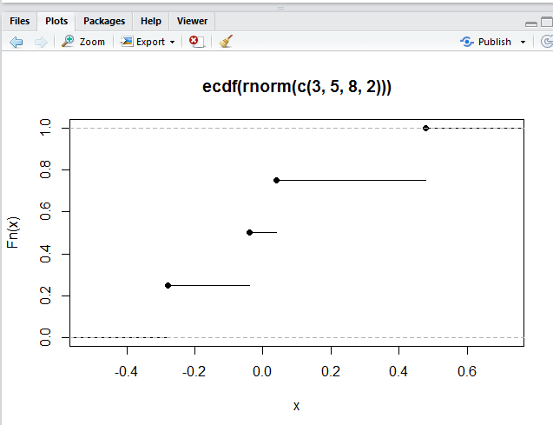

**Factors:**

Factors are used to store categorical data like gender (“Male”,”Female”) where there are limited number of options for a string.

To see factors in data frame form, use model.matrix to create a set of indicator or dummy variables. That is one column for each level and with 1 if a row contains that level or 0 otherwise.

> my_fac = factor(c("a","b","c"))

> model.matrix(~my_fac - 1)

my_faca my_facb my_facc

1 1 0 0

2 0 1 0

3 0 0 1

attr(,"assign")

[1] 1 1 1

attr(,"contrasts")

attr(,"contrasts")$my_fac

[1] "contr.treatment"

**Creating our own binary operator:**

"%mult_add_one%" <- function(left, right){ # Notice the quotation marks!

left * right + 1

}

5 "%mult_add_one% 6 🡺 12

**Paste option:**

**Syntax:**

paste(…, sep=” “, collapse = “ “)

Thumb rule in r is, all the arguments following … operator should have default values.

Paste function is used to combine two string vectors or strings.

sep argument used to specify the separator between 2 strings. paste0 is used to remove spaces while merging.

collapse parameter used to separate the results.

> (my_string = c("my name is saranya","I'm studying"))

[1] "my name is saranya" "I'm studying"

> paste(my_string,"hello")

[1] "my name is saranya hello" "I'm studying hello"

> paste(my_string,"hello",sep=':')

[1] "my name is saranya:hello" "I'm studying:hello"

> paste0(my_string,"hello")

[1] "my name is saranyahello" "I'm studyinghello"

> paste0(my_string,"hello",collapse = '$')

[1] "my name is saranyahello$I'm studyinghello"

toString() used to print as character vector and width parameter controls the number of o/p characters.

> toString(1:5, width=10)

[1] "1, 2, ...."

noquote() used to remove the quotes from character vector

> (strquote= c("I","am",'Saranya'))

[1] "I" "am" "Saranya"

> (newstr = noquote(strquote))

[1] I am Saranya

chartr (“old text”,”newtext”, “object with text data) 🡺 used to perform string substitutions.

> chartr("e","O",txt)

[1] "ROd" "BluO" "GrOOn"

formatC() function accepts numeric type or array and returns character vector or array.

> p = exp(1:3)

> p

[1] 2.718282 7.389056 20.085537

> formatC(p)

[1] "2.718" "7.389" "20.09"

> formatC(p,digits=3)

[1] "2.72" "7.39" "20.1"

> formatC(p,digits=3,width = 10)

[1] " 2.72" " 7.39" " 20.1"

> formatC(p,digits=3, format='e')

[1] "2.718e+00" "7.389e+00" "2.009e+01"

> formatC(p,digits=3,flag='+')

[1] "+2.72" "+7.39" "+20.1"

sprintf() used to specify formatting string with placeholders for other values.

> my_string2 = "hello saranya" 🡪 %s denotes string

> my_num = 10 🡪 %d denotes number

> my_float = 99.99 ->%f denotes floating point, %e refers scientific format

> sprintf("my string = %s, my number = %d, my floating = %f", my_string2, my_num, my_float)

[1] "my string = hello saranya, my number = 10, my floating = 99.990000"

Partial arguments can also be supplied…

> my_fun <- function(first, last)

+ sprintf("first = %s , last = %s", first, last)

> my_fun("saranya","govindaraj")

[1] "first = saranya , last = govindaraj"

> my_fun(f="saran",l="shalya")

[1] "first = saran , last = shalya"

> my_fun(last="pandey", "saranya")

[1] "first = saranya , last = pandey"

Similarly paste can also work with substituting variable values with variable names.

> name = "Saranya"

> age = 27

> paste("hi",name, "your age is ,", age, sep=’-‘)

[1] "hi Saranya your age is , 27"

**prettyNum** is best for pretty formatting of very big or very small numbers. big.mark argument used to specify the separator among digits.

> prettyNum((1e10), big.mark = ",", scientific = FALSE)

[1] "10,000,000,000"

> prettyNum((1e10), big.mark = "$", scientific = FALSE)

[1] "10$000$000$000

> prettyNum((1e10), big.mark = "$", scientific = TRUE)

[1] "1e+10"

**cat statement:**

\n in cat -> newline, \t – tab, \0 – NULL string. This results in error, \a = alarm character. fill=TRUE substitutes NA values for the missing fields.

> cat("a\nb", "saranya", fill=TRUE)

a

b saranya

> cat("a\0b", "saranya")

Error: nul character not allowed (line 1)

> cat("a\tb", "saranya")

a b saranya

> cat("a\"b", "saranya")

a"b saranya

> cat("a'b", "saranya")

a'b saranya

> cat('a"b', "saranya")

a"b saranya

> cat('a\'b', "saranya")

a'b saranya

**Changing case:**

> toupper("hello saranya")

[1] "HELLO SARANYA"

> tolower("HELLO SARANYA")

[1] "hello saranya"

**substring and substr:**

both behaves slightly differently. Substring output will be as long as the longest input. Substr output is as long as the first input.

> substring("hello",2,4)

[1] "ell"

> substring("hello",1:2,4)

[1] "hell" "ell"

> substr("hello",1:2,4)

[1] "hell"

> substr(c("hello","saranya"),1:2,4)

[1] "hell" "ara"

> substring(c("hello","saranya"),1:2,4)

[1] "hell" "ara"

> substring(c("hello","saranya"),1:3,4)

[1] "hell" "ara" "ll"

> substr(c("hello","saranya"),1:3,4)

[1] "hell" "ara"

**strsplit():**

used to split the string.

> h = c("hello, I'm reading R", "It is quite interesting", "Good scope")

> h

[1] "hello, I'm reading R" "It is quite interesting" "Good scope"

> strsplit(h, " ")

[[1]]

[1] "hello," "I'm" "reading" "R"

[[2]]

[1] "It" "is" "quite" "interesting"

[[3]]

[1] "Good" "scope"

**? makes the preceding character optional. Removes trailing ‘,’ from the words.**

> strsplit(h, ",? ")

[[1]]

[1] "hello" "I'm" "reading" "R"

[[2]]

[1] "It" "is" "quite" "interesting"

[[3]]

[1] "Good" "scope"

**If no space is given, it splits characterwise.**

> strsplit(h, "")

[[1]]

[1] "h" "e" "l" "l" "o" "," " " "I" "'" "m" " " "r" "e" "a" "d" "i" "n" "g" " " "R"

[[2]]

[1] "I" "t" " " "i" "s" " " "q" "u" "i" "t" "e" " " "i" "n" "t" "e" "r" "," "e" "s" "t"

[22] "i" "n" "g"

[[3]]

[1] "G" "o" "o" "d" " " "s" "c" "o" "p" "e"

**Replacing substrings:**

sub(old,new,string) 🡺 replaces first occurance of old substring to new in the string.

>st = "saranya is reading R, saranya loves Data analysis"

>sub("saranya","saran",st)

[1] "saran is reading R, saranya loves Data analysis"

gsub(old,new,string) 🡺 replaces all occurance of old substring to new in the string.

>st = "saranya is reading R, saranya loves Data analysis"

>gsub("saranya","saran",st)

[1] "saran is reading R, saran loves Data analysis"

**Generating all pairwise combinations of strings:**

outer and paste functions together generate a matrix of all possible combinations.

>names

[1] "Saran" "Shalya"

>alpha

[1] "a" "b" "c" "d" "e" "f"

>pair = outer(names,alpha,paste,sep="-")

>pair

[,1] [,2] [,3] [,4] [,5] [,6]

[1,] "Saran-a" "Saran-b" "Saran-c" "Saran-d" "Saran-e" "Saran-f"

[2,] "Shalya-a" "Shalya-b" "Shalya-c" "Shalya-d" "Shalya-e" "Shalya-f"

4th arg is passed to paste. 3rd arg is the function to be applied instead of multiplication.

**To retrieve current working directory. This is where all the files will be read from or written to.**

> getwd()

[1] "C:/Users/saranya_govindaraj/Documents"

**setwd() used to change the working directory. Forward slash can be used as generally windows path has back slash. R understands forward slash. Or we can use double backslash**

file.path("C:","Program Files","R","R-devel") 🡪 this function constructs file path from individual directory.

R.home() provides shortcut to the R installation dir.

> R.home()

[1] "C:/PROGRA~1/R/R-3.4.1"

**Paths:**

1. it can be absolute path (starting with drive letter)
2. it can be relative to the current working directory.

‘.’ (dot) refers to current wd

‘..’(double dot) refers to the parent directory

‘~’(tilde) refers to the home directory.

|  |
| --- |
| > path.expand("~")  [1] "C:/Users/saranya_govindaraj/Documents"  > path.expand(".")  [1] "."  > path.expand("..")  [1] ".." |
| basename() returns the name of a file without the preceding directory location. dirname() returns the  name of the directory  > file_name = "C:\\Program Files\\R\\R-3.4.1\\bin\\R.exe"  > basename(file_name)  [1] "R.exe"  > dirname(file_name)  [1] "C:/Program Files/R/R-3.4.1/bin" |
|  |

**Factors:**

> my_df = data.frame("name"=c("sara","shalya","amma","daddy","sis"),"age"=25:29)

> my_df

name age

1 sara 25

2 shalya 26

3 amma 27

4 daddy 28

5 sis 29

> class(my_df$name)

[1] "factor"

> class(my_df$age)

[1] "integer"

> my_df$name[1] = "Sara"

Warning message:

In `[<-.factor`(`*tmp*`, 1, value = c(NA, 4L, 1L, 2L, 5L)) :

invalid factor level, NA generated

> my_df

name age

1 <NA> 25

2 shalya 26

3 amma 27

4 daddy 28

5 sis 29

**levels and nlevels used to view the factor levels and count of levels.**

> levels(my_df$name)

[1] "amma" "daddy" "sara" "shalya" "sis"

> nlevels(my_df$name)

[1] 5

**Factor levels:**

if there are NA fields in the df and after we drop the NA rows from df, levels will still show the factor field entries.

> (my_df = data.frame("name"=c("sara","shalya","amma","daddy","sis","shalya"),"age"=c(30,31,NA,NA,50,35)))

name age

1 sara 30

2 shalya 31

3 amma NA

4 daddy NA

5 sis 50

6 shalya 35

> (my_df = subset(my_df, !is.na(my_df$age)))

name age

1 sara 30

2 shalya 31

5 sis 50

6 shalya 35

> levels(my_df$name)

[1] "amma" "daddy" "sara" "shalya" "sis" *# even after the NA rows are d*

*# deleted, levels are still showing.*

> my_df$name = droplevels(my_df$name) *#drop level at factor field will help*

> levels(my_df$name)

[1] "sara" "shalya" "sis"

> my_df = droplevels(my_df) *#drop level at df will also help*

> levels(my_df$name)

[1] "sara" "shalya" "sis"

**Ordered Levels:**

Levels can be ordered through a function ordered() or by adding an argument ordered = TRUE to factor.

**1st option:**

> happy_choices <- c("depressed","grumpy", 'so-so',"cheery","ecstatic")

> happy_values = sample(happy_choices,10000,replace = TRUE)

> happy_fac = factor(happy_values,happy_choices)

> str(happy_fac)

Factor w/ 5 levels "depressed","grumpy",..: 2 4 4 2 5 2 4 2 4 2 ...

> head(happy_fac)

[1] grumpy cheery cheery grumpy ecstatic grumpy

Levels: depressed grumpy so-so cheery ecstatic

> happy_ord = ordered(happy_values,happy_choices)

> head(happy_ord)

[1] grumpy cheery cheery grumpy ecstatic grumpy

Levels: depressed < grumpy < so-so < cheery < ecstatic

> is.ordered(happy_fac)

[1] FALSE

> is.factor(happy_ord)

[1] TRUE

**2nd option to achieve**:

> happy_ordered2 = factor(happy_values,happy_choices,ordered = TRUE)

> head(happy_ordered2)

[1] ecstatic depressed grumpy ecstatic ecstatic depressed

Levels: depressed < grumpy < so-so < cheery < ecstatic

> is.ordered(happy_fac)

[1] FALSE

> is.factor(happy_ordered2)

[1] TRUE

**Generating Factor Levels:**

For balanced data, where there are equal number of datapoints for each level, gl function can be used to generate a factor.

1st arg – total number of levels

2nd arg – how many times each levels should be repeated.

3rd arg(optional) – names for the levels.

4th arg (optional) = for complex orderings, include length parameter which refers the total length of the factor.

> gl(3,2)

[1] 1 1 2 2 3 3

Levels: 1 2 3

> gl(3,2,labels=c("A","B","C"))

[1] A A B B C C

Levels: A B C

> gl(3,1,6,labels=c("A","B","C"))

[1] A B C A B C

Levels: A B C

> lev = gl(3,2,6,labels=c("A","B","C"))

> class(lev)

[1] "factor"

**Combining factors:**

interaction() combines the two factors and create a resultant factor.

> factorA = gl(3,2,labels=c("A","B","C"))

> factorB = gl(2,1,6,labels=c("F","M"))

> interaction(factorA,factorB)

[1] A.F A.M B.F B.M C.F C.M

Levels: A.F B.F C.F A.M B.M C.M

Real and Imaginary components of complex numbers:

> Im(-1+9i)

[1] 9

> Re(-1+9i)

[1] -1

**Vectorized if:**

In normal if – else statements, we cannot pass vector inputs. Vectorized if helps to achieve that. ifelse(“condition”, “TRUE output”,” FALSE output)

> isEven = function (v)

+ v%%2 == 0

> ifelse(isEven(1:5),"yes","no")

[1] "no" "yes" "no" "yes" "no"

**if syntax:**

> if(5>1) message("5 is greater than 1")

5 is greater than 1

**if else syntax:**

**Note:** else should start in the same line as closing curly brace of if.

> if(5>1) {

+ message("5 is greater than 1")

+ } else {

+ message ("5 is less than 1")

+ }

5 is greater than 1

**If else if else syntax:**

> if(5>1) {

+ message("5 is greater than 1")

+ } else if(3>2) {

+ message ("3 is greate than 2")

+ } else

+ message ("5 is less than 1")

5 is greater than 1

**Loops:**

**repeat loop:**

> repeat

+ {

+ message("my name is saranya")

+ if(5>3) break

+ }

my name is saranya

**break statement**  exits the loop workflow and control comes out of the loop. repeat loop is similar to do…while loop..

**while loop:**

> while (TRUE)

+ {

+ message("hi")

+ break

+

+ }

hi

**for loop:**

> for (i in a) message(i)

a

b

c

> for(month in month.name) message(month)

January

February

March

April

May

June

July

August

September

October

November

December

> sea_shells = c("She","sells","sea","shells","the")

> for(i in min(nchar(sea_shells)):max(nchar(sea_shells))){

+ message("These words have ", i," letters")

+ ifelse((nchar(sea_shells)==i),print(toString(unique(sea_shells[(nchar(sea_shells)==i)])),next)

+

+ }

These words have 3 letters

[1] "She, sea, the"

These words have 4 letters

[1] ""

These words have 5 letters

[1] "sells"

These words have 6 letters

[1] "shells"

**replicate() and rep() function:**

replicate() function is used to generate different numbers each time in uniform random number generation function runif() whereas rep() will repeat same number several times.

> replicate(2,1:5)

[,1] [,2]

[1,] 1 1

[2,] 2 2

[3,] 3 3

[4,] 4 4

[5,] 5 5

> rep(1:5,2)

[1] 1 2 3 4 5 1 2 3 4 5

> rep(runif(1),5)

[1] 0.5922991 0.5922991 0.5922991 0.5922991 0.5922991

> replicate(5,runif(1))

[1] 0.96813134 0.09878489 0.86007688 0.96419536 0.04189943

replicate() is used in Monte Carlo analyses where you repeat an analysis an know number of times and each iteration is independent of other.

**Looping Over lists:**

**lapply()**

lapply returns output as list and it is same as apply() function to apply a particular function but **only column wise and not row wise.**

lapply(dataframe_name, func_name)

in order to access 1 element from the result, we can use [[]] which returns vector o/p. but, if multiple items are to be retrived from o/p, then we need to covert the output as numeric and then we can fetch.

> df4 = birthwt

> s = lapply(df4,mean)

> s[[1:4]]

Error in s[[1:4]] : recursive indexing failed at level 2

> as.numeric(s[1:4]) 🡪 o/p will not carry column names

[1] 0.3121693 23.2380952 129.8148148 1.8465608

> s[1:4] -🡪 output will carry column names.

$low

[1] 0.3121693

$age

[1] 23.2381

$lwt

[1] 129.8148

$race

[1] 1.846561

> class(s[1:4])

[1] "list"

**vapply()**

vapply() is same as lapply() but rather than returning result as list, it simplies the result to be a vector or an array. We need to pass 3rd argument as template for the return values.

vapply() stands for **“list apply that returns a vector”**

> df4 = birthwt

> s = vapply(df4, mean, numeric(1))

> s[[1:4]]

Error in s[[1:4]] :

attempt to select more than one element in vectorIndex

> as.numeric(s[1:4])

[1] 0.3121693 23.2380952 129.8148148 1.8465608

> s[1:4]

low age lwt race

0.3121693 23.2380952 129.8148148 1.8465608

> class(s[1:4])

[1] "numeric"

**sapply() – stands for “simplifying list apply”**

sapply() does not return list otherwise same as lapply(). Applied only column wise. Output will be simplified to appropriate vector or array if it can. If the returned value’s length is 1, then we get vector. Otherwise, matrix. If the lengths vary, then we get list.

> df4 = birthwt

> s = sapply(df4,mean)

> s[[1:4]]

Error in s[[1:4]] :

attempt to select more than one element in vectorIndex

> as.numeric(s[1:4])

[1] 0.3121693 23.2380952 129.8148148 1.8465608

> s[1:4]

low age lwt race

0.3121693 23.2380952 129.8148148 1.8465608

> class(s[1:4])

[1] "numeric"

If the input for sapply is an empty list, then the result will be of list again.

> sapply(list(),summary)

list()

In this case if vapply is most suitable.

> ab=vapply(list(),length,numeric(1))

> ab

numeric(0)

**tapply():**

tapply is used for processing items in groups. In below example, we have calculated sum of prices, for every category of cylinder.

>tapply(Cars93$Price, Cars93$Cylinders, sum)

3 4 5 6 8 rotary

25.4 717.8 46.4 755.8 236.5 32.5

1st arg – vector of data

2nd arg – factor that defines the group

3rd arg – function.

**Applying function to group of rows:**

by(df,fact,func)

>by(Cars93,Cars93$Origin,summary)

**range** argument – returns vector of minimum and maximum within that field.

> df4 = birthwt

> s = sapply(df4,range)

> s

low age lwt race smoke ptl ht ui ftv bwt

[1,] 0 14 80 1 0 0 0 0 0 709

[2,] 1 45 250 3 1 3 1 1 6 4990

**Looping over Arrays:**

magic(n) used to create n x n magic matrix.

Magic matrix have equal number of rows and columns and sum of rows, columns and diagonal will give same result.

o/p of apply() column wise is same as sapply()..

> df1

name age

1 dfd 21

2 ere 22

3 rtrt 23

> as.character(df1$name)

[1] "dfd" "ere" "rtrt"

> df1=data.frame(name=c("dfd","ere","rtrt"),age=c(21:23),stringsAsFactors = FALSE)

> r=apply(df1,1,toString)

> class(r)

[1] "character"

> t=apply(df1,2,toString)

> t

name age

"dfd, ere, rtrt" "21, 22, 23"

> class(t)

[1] "character"

> i=sapply(df1,toString)

> i

name age

"dfd, ere, rtrt" "21, 22, 23"

> ii=sapply(df1,range)

> ii

name age

[1,] "dfd" "21"

[2,] "rtrt" "23"

**mapply: (multiple argument list apply)**

Drawbacks of lapply():

1. it can be applied on a single vector.
2. Function cannot access the names of the elements.

Both are overcome in mapply. We can use a multiple vectors. And the user defined function can access the elements name.

1st arg – func name. This function will be applied to the first element of each argument and to the second and so on.

> prime_factor = list(two=2,three=3,four=c(2,2),five=5,six=c(2,3))

> prime_factor

$two

[1] 2

$three

[1] 3

$four

[1] 2 2

$five

[1] 5

$six

[1] 2 3

>

> names(prime_factor)

[1] "two" "three" "four" "five" "six"

>

> msg = function (names, factors)

+ {

+ ifelse(

+ length(factors)==1,

+ paste(names , " is prime "),

+ paste(names, " has factors ", toString(factors))

+ )

+ }

>

> mapply(msg,names(prime_factor),prime_factor)

two three four

"two is prime " "three is prime " "four has factors 2, 2"

five six

"five is prime " "six has factors 2, 3"

mapply can simply the output if it can same as sapply. In order to turn this behavior, we can add an argument SIMPLIFY = FALSE

**Instant Vectorization:**

Vectorize() function accepts the function which takes only scalar input and returns a new function that accepts vector.

> fruits = c("A","O","Other")

>

> func1 = function(f){

+ switch(

+ f,

+ A = "Apple is available",

+ O = "Orange is available",

+ "Sorry, not available"

+ )

+ }

>

> var1 = func1(fruits)

Error in switch(f, A = "Apple is available", O = "Orange is available", :

EXPR must be a length 1 vector

>

> var1 = Vectorize(func1)

> var1(fruits)

A O Other

"Apple is available" "Orange is available" "Sorry, not available"

**Profiling:**

**Ref: https://rstudio.github.io/profvis/**

Profvis is a tool for visualizing code profiling data in R. It creates a web page which provides a graphical interface for exploring the time taken to execute the code.

Package : profvis

Wrap the code within profvis({code…..})

o/p will be displayed in 2 tabs: Flame Graph and Data

**plyr Packages:**

*apply function family has some drawbacks:

1. names are bit obscure. t in tapply stands for?

2. Arguments aren’t entirely consistent. For mapply function should be first.

3. output isn’t as controllable as it could be.

plyr package named **ply where asterisks denote the form of i/p and o/p

llply -> takes input as list and returns list as o/p

we need to load the library(plyr)

llply(prime_factors,unique)

laply - >takes list as input and returns array (same as sapply) but in case of empty i/p list, it returns empty logical vector instead of returning a list (like sapply).

laply(prime_factors, length)

## [1] 1 1 2 1 2 1 3 2 2

laply(list(),length)

## logical(0)

raply -> replaces replicate(not rapply)

rlply and rdply returns result in list and dataframe.

r_ply ->discards o/p and returns null.

r_ply(5,runif(1))

## NULL

ddply -> takes and retuns data frame as input and output. This is replacement for tapply.

**revalue()**

In plyr package, there is a function revalue(factor or character vector to modify, named character vector)

> x <- c("a", "b", "c")

> revalue(x, c(a = "A", c = "C"))

[1] "A" "b" "C"

> revalue(x, c("a" = "A", "c" = "C"))

[1] "A" "b" "C"

> y <- factor(c("a", "b", "c", "a"))

> revalue(y, c(a = "A", c = "C"))

[1] A b C A

Levels: A b C

**Packages:**

There are thousands of R packages available.

Majority of R packages are available in online repository - CRAN – Comprehensive R Archive Network which is maintained by R core team.

plyr – for advanced looping,

lubridate – for date and time manipulation.

xlsx – for importing excel files. One easy method would be convert excel file into csv and use read.table() or read.csv2/read.delim2( incase the delimiters are used within the cell.

readxl - for importing excel sheets.

excel_sheets(“xxx.xlsx”) 🡺 displays available sheet names

**o/p:** Sheet1

df <- read_excel(“xxx.xlsx”,sheet=”Sheet1”)

xlsx package for writing excel files:

write.xlsx(df,”output.xlsx”)

Reshape2 – manipulating shape of data frames.

ggplot2 – for plotting

Library(“package name”) ->loads the package which was already installed. Require() also does the same but it returns TRUE or FALSE based on the package successfully loaded or not.

> if(library(lattice))print("hi")

Error in if (library(lattice)) print("hi") :

argument is not interpretable as logical

In addition: Warning message:

In if (library(lattice)) print("hi") :

the condition has length > 1 and only the first element will be used

> if(require(lattice))print("hi")

[1] "hi"

search() returns the list of loaded packages. Global environment is the first package followed by most recently loaded package. Last 2 values are always special environment – Autoloads, base package.

> search()

[1] ".GlobalEnv" "package:lattice" "tools:rstudio" "package:stats"

[5] "package:graphics" "package:grDevices" "package:utils" "package:datasets"

[9] "package:methods" "Autoloads" "package:base"

If a variable var is created in global environment. R will find that first before it finds the usual variance function in the stats package because, global environment is come first in the search list.

**Libraries and Installed packages:**

To view the installed packages.

> View(installed.packages()) 🡪 this opens up a read only version of the list of installed packages..

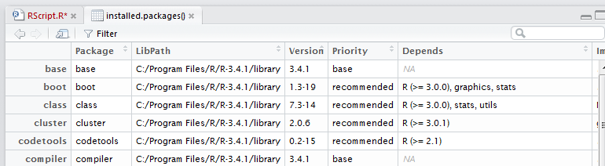

With R install we get 30 more packages including base and stats.All are stored in library subdirectory of wherever you installed R. To retrieve the location of the library (2ways).

> R.home("library")

[1] "C:/PROGRA~1/R/R-3.4.1/library"

> .Library

[1] "C:/PROGRA~1/R/R-3.4.1/library"

Sink - function diverts R output to a connection

<http://www.endmemo.com/program/R/sink.php>

> sink("tp.txt") -> opens tp.txt and writes all output

> for(i in 1:10) print("hello")

> sink() or sink(NULL) -> closed tp.txt and writes output to console.

**Dates and Time:**

3 types of date and time classes.

1. POSIXct – POSIX calendar time ( stores date as number of seconds since start of 1970 in UTC(coordinated universal time) zone. Used best for storing dates and calculating with them.
2. POSIXlt (stores date as a 9 element list, with components of seconds, min, hours, day of the month etc. used for extracting specific parts of date.
3. Date – Stores dates as number of days since 1970. Is used when you are not bothered about time.

**Note:** POSIX standards for Portable Operating System Interface

> (now = Sys.time())

[1] "2017-08-02 15:48:08 IST"

> class(now)

[1] "POSIXct" "POSIXt"

> unclass(now)

[1] 1501669088

>

> (now = as.POSIXlt(now))

[1] "2017-08-02 15:48:08 IST"

> class(now)

[1] "POSIXlt" "POSIXt"

> unclass(now)

$sec

[1] 8.355894

$min

[1] 48

$hour

[1] 15

$mday

[1] 2

$mon

[1] 7

$year

[1] 117

$wday

[1] 3

$yday

[1] 213

$isdst

[1] 0

$zone

[1] "IST"

$gmtoff

[1] 19800

attr(,"tzone")

[1] "" "IST" "+0630"

**Convertion to and from Strings:**

In many text files, dates will not be stored in exact date format. Eg. in csv file, every field will be stored as strings. in order to extract date, we need to assign the date string to a variable of date class. Similarly to write back to csv, date should be converted to strings.

**Parsing Dates:**

Usually dates in text files are stored as character vectors or factors. To convert them to dates, first we need to parse using strptime(). In this function we need to specify which bits of string correspond to which bit of dates. strptime() retuns in POSIXlt format. as.POSIXct and as.POSIXlt() functions can also be used.

tz represents timezone. If it is “ “ then it refers to current locale. UTC – refers to Universal time.

%H – Hour in 24 hours, %I – hours in 12 hour, %M – Minutes, %S – second, %m – month, %d - day of the month, %Y – 4 digit year.

> date_str = c("20:17:40 20/07/1969",

+ "06:54:35 19/11/1971")

> (date_lt = strptime(date_str,"%d:%m:%Y %H:%M:%S", tz="UTC"))

[1] NA NA

If the string doesn’t match the format mentioned, result will be NA.

> (date_lt = strptime(date_str,"%H:%M:%S %d/%m/%Y", tz="UTC"))

[1] "1969-07-20 20:17:40 UTC" "1971-11-19 06:54:35 UTC"

**Formatting Dates:**

To convert date variable to a string(opposite to parse), we need to format it. strftime(string format time). format() function can also be used instead of strftime() which is nearly identical.

> (now = Sys.time())

[1] "2017-08-02 16:41:48 IST"

> strftime(now, "It's %I:%M%p on %A %d %B, %Y")

[1] "It's 04:41PM on Wednesday 02 August, 2017"

> format(now, "It's %I:%M%p on %A %d %B, %Y")

[1] "It's 04:44PM on Wednesday 02 August, 2017"

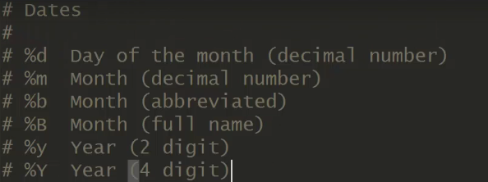

**Timezone:**

Timezone is quite complex from programming perspective. Day light savings adds complexiy. Many abbreviated names of time zone are not unique.

1. The easiest to read and most portable way of specifying time zones is to use Olson form which is “Continent/City”

> strftime(now,tz="America/Los_Angeles")

[1] "2017-08-02 04:19:01"

> strftime(now,tz="Asia/Kolkata")

[1] "2017-08-02 16:49:01"

2.Most reliable method is to give manual offset. UTC + n or –n.

> strftime(now,tz="UTC-5")

[1] "2017-08-02 19:21:34"

Warning message:

In as.POSIXlt.POSIXct(x, tz = tz) : unknown timezone 'UTC-5'

> strftime(now,tz="GMT-5:30")

[1] "2017-08-02 19:51:34"

Warning message:

In as.POSIXlt.POSIXct(x, tz = tz) : unknown timezone 'GMT-5:30'

3.Specifying timzone abbreviations.

**Drawbacks:**

1. Harder to read and prone to errors.
2. Not unique
3. Different OS support different set of abbreviations.
4. > strftime(now,tz="EST")
5. [1] "2017-08-02 09:21:34"
6. > strftime(now,tz="PST8PDT")
7. [1] "2017-08-02 07:21:34"

**Arithmetic with Dates and Time:**

R supports arithmetic with 3 base classes – POSIXct, POSIXlt, Date

With POSIX classes, if you add a number, date shifts by that many seconds.

With Date class, if you add a number, date shifts by that many days.

> (now = Sys.time())

[1] "2017-08-02 20:05:43 IST"

> class(now)

[1] "POSIXct" "POSIXt"

> now+1000

[1] "2017-08-02 20:22:23 IST" ---- # added the date by 1000 seconds.

> now_date= as.Date(now)

> now_date

[1] "2017-08-02"

> now_date+1

[1] "2017-08-03" -----# increased the day by 1

> now_lt=as.POSIXlt(now)

> now_lt

[1] "2017-08-02 20:05:43 IST"

> now_lt+100

[1] "2017-08-02 20:07:23 IST" ------# increased the day by that many seconds

Addition, multiplication and division of 2 dates not supports as it makes no sense. Subtraction supported. This behavior is same for all 3 date classes. Dates will be automatically parsed of the form

%Y-%m-%d or %Y/%m/%d.

> date3 = date2 +date1

Error in `+.Date`(date2, date1) :

binary + is not defined for "Date" objects

> date1 = as.Date("1989-09-18")

> date2= as.Date("2017-08-02")

> date3 = date2 -date1

> date3

Time difference of 10180 days

> class(date3)

[1] "difftime"

> unclass(date3)

[1] 10180

attr(,"units")

[1] "days"

difftime() function can be used to see the date difference in various units such as secs, mins, hours, days, weeks, auto(auto gives in days)

date1 = as.Date("1989-09-18")

date2= as.Date("1990-10-02")

> difftime(date1,date2, units = "auto")

Time difference of -379 days

> date1 = as.Date("1989-09-18")

> date2= as.Date("1989-10-02")

> difftime(date1,date2, units = "weeks")

Time difference of -2 weeks

seq() function is used for creating test datasets with artificial dates.

**Note**: first date should be smaller than the second. The sequence will go in incremented way.

> date1 = as.Date("1989-09-18")

> date2= as.Date("1985-10-02")

> seq(date2, date1, by = "1 year")

[1] "1985-10-02" "1986-10-02" "1987-10-02" "1988-10-02"

**Lubridate:**

Lubridate adds needed lubrication to the process of date manipulation. To replace strptime, lubridate offers many functions with predetermined format. ymd() accepts date in the form year, month and day. It can have any separators like hypen, dot, forward or backward slashes, colons or spaces but it should be in the order year->month->day.

>ymd("2010-09.12")

## [1] “2010-09-12 UTC”

If the date data is in other forms, lubridate offers multiple functions such as ydm,mdy,myd,dmy and dym. If we have time included, ymd_h,ymd_hm, ymd_hms.

All these parsing functions in lubridate return POSIXct dates with UTC timezone by default.

stamp() function used to format the date in human readable format.

date_format = stamp(“my customized date Monday 01 January 1900 at 18:00:00”)

date_format(“18-09-1989, 09:15”)

my customized date Monday 18 September 1989 at 21:15:00

dyears, dseconds, dminutes and so forth functions consider leap year while adding the number of years/seconds/minutes with the input parameters.

years, seconds, minutes, doesn’t count leap year.

Eg:

(duration_1_to_10_years = dyears(1:5))

today() +duration_1_to_10_years

## [1] “2017-08-03” “2018-08-03”…….till 5 years.. we can observe that the date changes based on the leap year

(period_1to5_years = years(1:5)

today()+period_1to5_years

## [ 1] ““2017-08-03” “2018-08-03”……”2021-08-03” date ends in the same date as started as it ignores leap year.

**The Data Analysis Workflow:**

**Built-in Datasets:**

‘dataset’ package carries built-in dataset for practice. To view the list of data sets, use data() function.

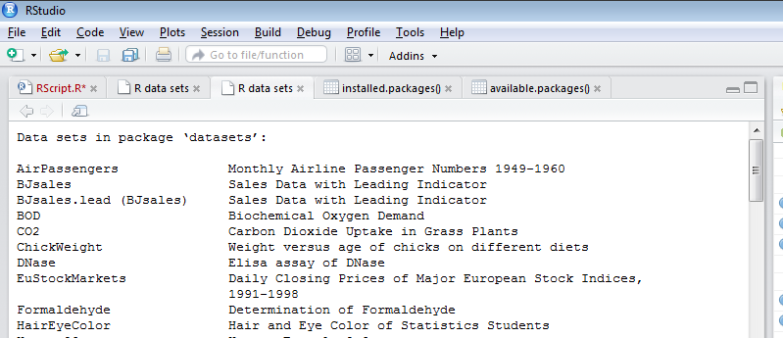

If you want to view the dataset from other packages as well,

data(package= .packages(TRUE))

We get list of datasets from all the packages.

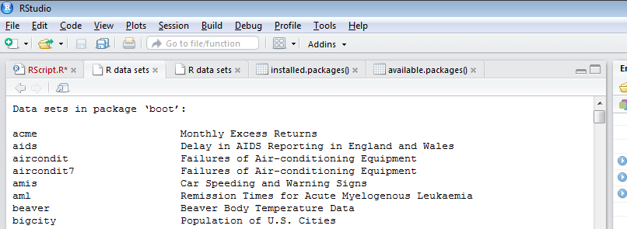

If we want to view specific dataset from a package,

> data("kidney",package="survival")

> head(kidney)

id time status age sex disease frail

1 1 8 1 28 1 Other 2.3

2 1 16 1 28 1 Other 2.3

3 2 23 1 48 2 GN 1.9

4 2 13 0 48 2 GN 1.9

5 3 22 1 32 1 Other 1.2

6 3 28 1 32 1 Other 1.2

kidney is the dataset name and survival is package name.

**Reading Text data:**

Text data can be in one of the below form.

1. Delimiter separated files eg: CSV or tab delimited.
2. XML – eXtensible Markup Language
3. JSON – JavaScript Object Notation
4. YAML – YAML Ain’t Markup Language.

Other sources of text data – book which is not having any formal structure.

List of wrapper functions:

|  |  |  |
| --- | --- | --- |
| **Wrapper function** | **Delimiter** | **Decimal places** |
| read.table, read.csv | Comma (assumption is header=T) | dot |
| read.csv2 | Semicolon | comma |
| read.delim, read.delim2 | Tab | Both dot and comma |

**system.file()** used to locate the file inside package.

deer_file = system.file(“extdata”,”RedDeerEndocranialVolume.dlm”,package=”learning”)

extdata is the folder, RedDeerEndocranialVolume.dlm is the file name, package=”learning

**read.table()** used to fetch the data from the file. There can be below parameters..

1. header
2. fill
3. sep – to specify the separator.
4. nrow – to specify how many lines of data to read
5. skip – how many rows to skip from beginning of the file.
6. na.strings – which value should be treated as missing value should be mentioned. Default is blank space. For SQL, na.strings = “NULL”, for SAS or Stata, na.strings =’.’ , for excel, na.strings=c(“”,”#N/A”,”#DIV/0!”,”#NUM!”)
7. file.choose() – opens windows explorer so that the file can be browsed.

deer_data = read.table(deer_file, header=TRUE, fill = TRUE)

str(deer_data,vec.len=1) #vec.len – returns only couple of results under each column instead of returning more.

**Content of my_csv.csv:**

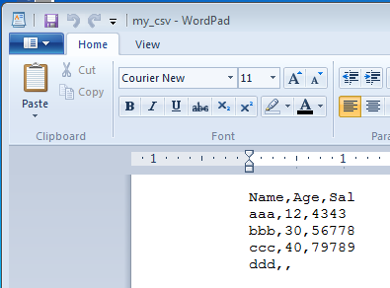

> filedata = (read.table("C:/Users/saranya_govindaraj/Desktop/my_csv.csv",header=TRUE,fill=TRUE,sep="," ))

> str(filedata)

'data.frame': 4 obs. of 3 variables:

$ Name: Factor w/ 4 levels "aaa","bbb","ccc",..: 1 2 3 4

$ Age : int 12 30 40 NA

$ Sal : int 4343 56778 79789 NA

**Write.table/csv/csv2…() :**

Just opposite of read.

1st arg – data frame to write.

2nd arg – location to write

row.name = FALSE (will skip rowname while writing)

fileEncoding = what character encoding of the output file.

> my_csv_write = write.csv(filedata,"C:\\Users\\saranya_govindaraj\\Downloads\\my_csv_Write.csv",row.names=T)

In downloads, we could see below file.

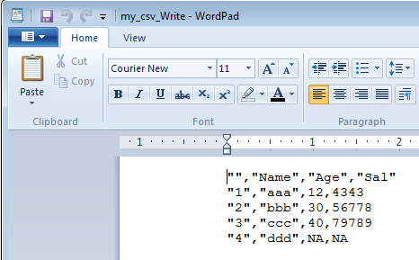

**Unstructured Text file:**

readLines() used to specify the file to import.

writeLines() used to perform reverse operation.

Note: While giving path, use double forward slash // first and then single forward slash /..henceforth if a path is pasted, it will be accepted by R, we don’t have to manually change the forward slashes to backward slashes or double forward slashes everywhere.

Eg: setwd("C://Users/saranya_govindaraj/Downloads")

**XML and HTML files:**

XML,RCurl, XMLX package is required.

**XML import:**

xmlParse(“filename”,useInternalNodes=FALSE) this is equal to xmlTreeParse(“FileName”).

One drawback of using Internal Nodes is that summary function str and head don’t work. To use R level Nodes, set useInternalNodes = FALSE or xmlTreeParse()

xpath is a language for interrogating xml documents, letting you find nodes(tags) corresponding to a some filter.

Eg: xpathSApply(“xmlParse o/p variable”, “//variable[contains(@name,’warn’)]”)

variable – is the node name or tag name,

name = is the attribute

warn is the search string

**o/p:**

<variable name = “warnings” type=”numeric”>

<value> 50 </value>

</variable>

**HTML:**

**Ref**: <https://www.youtube.com/watch?v=LwpnWU8urW8>

1. fetch the html content of the web page using htmlTreeParse(“link”,useInternalNodes = TRUE)
2. use getNodeSet(1st step variable,”//uI//li”) , 2nd arg – start and end tag of our area of interest.
3. sapply(2nd step arg, xmlValue) – ignores all tags and fetches only the xml values
4. select the specific rows based on your interest. From step 3 variable. If you want to ignore last 3 rows, then use x(result of step 3) – 3. If you want to remove first 11 entries, then content=x[12:x]
5. To write the extracted info to excel, then write.xlsx(content,”excelname.xlsx”)
6. View the excel in the current working directory.

**JSON and YAML files:**

Import rjson or RJSONIO package. RJSONIO is more forgiving than rjson when reading incorrect JSON.

If you are importing both the packages, then before invoking the function, use double semicolon to mention the package name from which the function should be called. If only one package is imported, :: can be ignored.

Eg:

Json_file <- rjson::fromJSON(file = ‘ …’)

In RJSONIO, NaN and NA are treated as JSON null values. But Inf and –Inf are treated the same.

In rjson, all 4 special numbers are treated as strings:

Special_numbers <- c(NaN, NA, Inf, -Inf)

RJSONIO::fromJSON(Special_numbers)

o/p: [1] “[null, null, Inf, -Inf]

rjson::fromJSON(Special_numbers)

o/p: [1] “[\”NaN\” ,\ “NA\”, \“Inf\”, \“-Inf\”]”

1.fromJSON() is the function to read JSON file to R

2. use as.data.frame to convert into data frame.

**YAML:**

If you are dealing with more of special numbers, yaml is good to use.

Import yaml package.

yaml.load() -> accepts string of YAML and converts to R object

yaml.load_file() -> treats string input as path of the file containing YAML.

as.yaml() performs the opposite task of converting R object to YAML strings.

**Reading SAS, Stata, SPSS and MATLAB files:**

Package name – foreign

|  |  |  |
| --- | --- | --- |
| **SAS** | **Stata** | **SPSS** |
| File format – SAS7BDAT | DTA | SPSS data files |
| read.ssd | read.dta | read.spss |
| write.foreign | write.foreign | write.foreign |

Package: R.matlab

|  |
| --- |
| **MATLAB** |
| binary data files |
| readMat |
| writeMat |

**Web Data:**

**Sites with API:**

World Bank makes its World Development Indicators(WDI) data publicly available in **WDI** package.

1. install.package(“WDI”)
2. library(WDI)
3. wdi_datasets = WDIsearch() #list of all data sets
4. head(wdi_datasets)

## indicator

## [1] “BG.GSR.NFSV.GD.ZS”

….

1. Wdi_trade_inservices = WDI(indicator=“BG.GSR.NFSV.GD.ZS”)
2. Str(Wdi_trade_inservices)

Similarly, **SmarterPoland** package provides similar wrapper to Polish government data.

**quandmod** provides access to stock tickets(Yahoo’s! by default)

twitteR packages provide access to twitter users and their tweets. More advanced access to web pages can be achieved through RCurl package.

**Scraping Web Pages:**

RCurl package provides access to **libcurl** network client interface library. This is particulary useful if you data is inside a html or xml page.

getURL retrieves the page as a character string.

1. Library(RCurl)
2. time_page = getURL(<http://tycho.usno.navy.mil/cgi-bin/timer.pl>
3. cat(time_page)
4. library(XML)
5. time_doc = htmlParse(time_page)
6. pre - xpathSApply(time_doc,”//pre”)[[1]] # pre is the tag
7. values = strsplit(xmlValue(pre),”\n”)[[1]][[-1]]
8. strsplit(values,”\t+”)

**Accessing Databases:**

|  |  |  |
| --- | --- | --- |
| **Database** | **Package name** | **Backend package** |
| SQLite | DBI | RSQLite |
| MySQL | DBI, RMySQL | RSQLite |
| PostgreSQL | RPostgreSQL |  |
| Oracle | ROracle |  |
| JDBC | RJDBC |  |
| SQL Server or Access database. | RODBC |  |

1. library(DBI)
2. library(RSQLite) # backend package
3. driver = dbDriver(“MySQL”) #depending upon the database this changes.
4. db_file = system.file(“folder_name”,”filename.sqlitte”,”package_name)
5. conn=dbConnect(driver,db_file)
6. Query = “Select * from IdBlock”
7. (id_block = dbGetQuery(conn,query))
8. dbDisconnect(conn)
9. dbUnloadDriver(driver)

For RODBC connections, we need to setup ODBC data source on your machine, then

1. library(RODBC)
2. conn = odbcConnect(“databasename”,uid=” “,pwd=” “)
3. dat = sqlFetch(conn,”Table name”)
4. id_block = sqlQuery(conn, “select * from idBlock”)
5. odbcClose(conn)

**WebScraping using R:**

Extracting information from the html file

Package: rvest (require html and css knowledge)

Or www.import.io , this will download the webpages content into R as data frame. (No knowledge of html and css required)

**Cleaning and Transforming:**

**Regular expressions:**

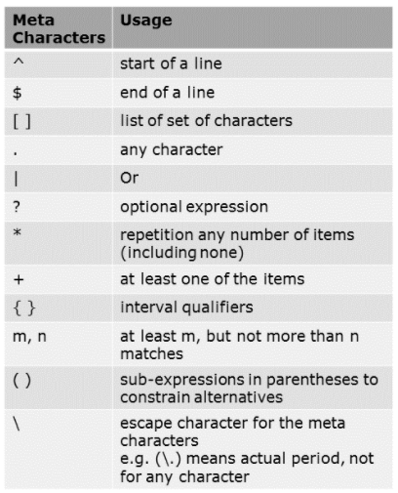

^ inside [], indicates “NOT”, ^ outside [] indicates starting of a line.

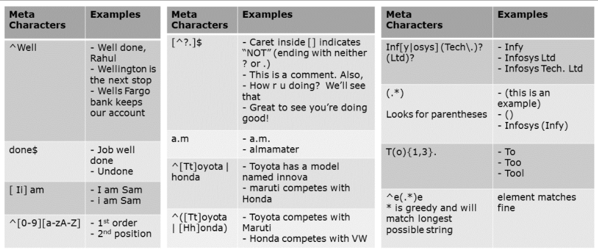

**Most common problems with strings:**

1. logical values have been encoded in a way that R doesn’t understand.

Eg: “Y” or “N” values instead of TRUE or FALSE.

Option 1: by writing a function

ynconversion = function(x)

{

y = rep.int(NA,length(x))

y[x=='y'] = TRUE

y[x=='n'] = FALSE

y

}

Option 2:

grep,grepl, regexp -> finds all the strings that match a pattern.

> v <- c("a","b","c","d")

> grepl("c",v) # grepl returns the output as logical

[1] FALSE FALSE TRUE FALSE

> grep("c",v) # returns the index of the search.

[1] 3

sub and gsub -> replace the matching string.

library(stringr) # used for manipulating strings.

**str_detect()** -> used to detect a pattern. fixed() tells if we are looking for a fixed string rather than a regular expression. pattern=”…” specify the pattern we are looking for.

str_detect() -> o/p is a logical vector which can be used as index.

Eg:

str_detect(column_name,fixed(“,”)) -> this identifies comma in the column value and return the indexes.

Johnindex <- str_detect(column_name, pattern = “John”) 🡺 this returns the index values .

If we are looking for comma or ‘and’ word, then,

str_detect(column_name,fixed(“, | and ”))

1. If we want to split some column value into words, **str_split** can be used. This accepts a vector and returns a list. If wach input must return same number, then **str_split_fixed** can be used, which returns a matrix.

Eg:str_split(columnname, “, | and”)

1. **str_count()** used to count the occurrence of an character in a string.

word = function(x)

{

str_count(x,'a')

}

word("saranya")

1. **str_replace_all()**  used to identify a pattern and replace it with another.

str_replace_all("saranya","[ar]","sh") # This identifies either letter ‘a’ or ‘r’ and replaces it with ‘sh’ in the word.

1. **str_replace()**  identify the pattern and replace the first occurance alone.

str_replace(“Saranya”,”[ar]”,”sh)

1. **str_extract()** extracts the string matching the pattern given and returns the matching string.

str_extract(“Saranya”,pattern = ”nya”) 🡺 returns nya.

Regular expression can also be used under pattern field.

[0-9] 🡺 indicates one digit between 0 – 9

[0-9]{2} 🡺 indicates two digit number

\\d or [0-9] 🡺 are one and the same , \\d{4} => this detects 4 digit number.

. 🡺 indicates anything.

+ 🡺 search for one or more times

? 🡺 not a greedy search

() indicate grouping them, it can be referred sequentially starting \\1

command = c(“<a href =index.html> The link is here </a>”)

Str_replace(string=command, pattern=”<.+?> (.+?) <.+?>”, replacement = \\1)

o/p : “The link is here”

1. **str_sub() ,**  used to extract characters.

str_sub(“columnname”, start = 1, end = 3) 🡺 this extracts first 3 characters from the mentioned column

**Manipulating data frames:**

Common problems with df:

1. **Adding and Replacing columns:**

Option 1:

We can use standard assignment operator.

> head(Orange)

Tree age circumference

1 1 118 30

2 1 484 58

3 1 664 87

4 1 1004 115

5 1 1231 120

6 1 1372 142

In order to create a column sum12,

my_df = head(Orange)

my_df$sum12 = my_df$age+my_df$circumference.

Option 2:

**with() - > takes the dataframe and an expression to evaluate. More suitable for changes in one column only.**

> my_df = with(

+ my_df,

+ {

+ sum12 = age - circumference

+ }

+ )

> my_df

[1] 88 426 577 889 1111 1230 #result will not be a data frame.

Option 3:

**within() -> works in the same way but returns whole data frame. More suitable if we want to modify multiple columns.**

> my_df = head(Orange)

> my_df = within(

+ my_df,

+ {

+ sum12 = age - circumference

+ }

+ )

> my_df

Tree age circumference sum12

1 1 118 30 88

2 1 484 58 426

3 1 664 87 577

4 1 1004 115 889

5 1 1231 120 1111

6 1 1372 142 1230

In plyr package, there is a function called mutate() performs, same as within()

my_df = mutate(

my_df,sum12 = age - circumference

)

**Note:** There is no curly brace as we haveF in within()

1. **Dealing with Missing values:**

complete.cases() -> returns the indexes of the rows where there are no missing values..

> my_df

Tree age circumference nafield

1 1 118 30 NA

2 1 484 58 1

3 1 664 87 2

4 1 1004 115 3

5 1 1231 120 NA

6 1 1372 142 4

> index = complete.cases(my_df)

> index

[1] FALSE TRUE TRUE TRUE FALSE TRUE

> my_df[index,]

Tree age circumference nafield

2 1 484 58 1

3 1 664 87 2

4 1 1004 115 3

6 1 1372 142 4

na.omit() -> returns the list of rows which are not having missing values.

> my_df$nafield = c(NA,1,2,3,NA,4)

> na.omit(my_df)

Tree age circumference nafield

2 1 484 58 1

3 1 664 87 2

4 1 1004 115 3

6 1 1372 142 4

na.fail() -> will throw an error if your data frame contains any missing values.

> my_df

Tree age circumference nafield

1 1 118 30 NA

2 1 484 58 1

3 1 664 87 2

4 1 1004 115 3

5 1 1231 120 NA

6 1 1372 142 4

> na.fail(my_df)

Error in na.fail.default(my_df) : missing values in object

> x= na.omit(my_df)

> na.fail(x)

Tree age circumference nafield

2 1 484 58 1

3 1 664 87 2

4 1 1004 115 3

6 1 1372 142 4

**Converting between Wide and Long form: ->reshape2 package**

Wide form: -> repeated responses for a subject column wise.

In red deer dataset -> volume of deer skulls obtained in 4 different ways.

|  |  |  |  |  |
| --- | --- | --- | --- | --- |
|  | 1st way | 2nd way | 3rd way | 4th way |
| Skull id |  |  |  |  |
| Skull id2 |  |  |  |  |
| …. |  |  |  |  |

Long form: -> replication of items row wise.

|  |  |  |
| --- | --- | --- |
| Skull id | Measurements | Type of measurement |
| Skull id 1 | .. | 1st way |
| Skull id 1 | .. | 2nd way |
| Skull id 1 | .. | 3rd way |
| Skull id 1 | .. | 4th way |
| Skull id 2 | .. | 1st way |
| … |  |  |

**2 functions:**

1. melt() -> converts from wide to long
2. dcast() -> converts from long to wide

Both these functions are merged to latest function recast().

id.vars argument -> refers to rows.

measure.vars -> refers to columns.

Eg:

cast(dfname, rowvariable ~ column variable , values =”columnname”)

melt(dfname, id.var = c(“field name 1, field name 2))

**Using SQL:**

sqldf package used for manipulating data frames using SQL.

>subset(deer_endocranial_volume, VolCT >400 | VolCT2 >400, c(VolCT,VolCT2))

the same can be achieved using..

>query <-“Select VolCT, VolCT2 from deer_endocranial_volume where VolCT >400 or VolCT2 >400”

>sqldf(query)

**Sorting:**

In dplyr package, there is function called tbl_df() to create local data frame which creates a copy of it and mainly during display, limited number of rows with all columns that fits the window will only be shown.

arrange() in dplyr package provides alternative to order().

Eg: arrange(column1, columns2) -> o/p will be sorted with column1 and within that column2.

rank() gives the rank of each element in a dataset, providing a few ways of dealing with ties.

**object_size(): (package pryr)**

gives the size occupied by the object.

> a =1:10000

> object_size(a)

40 kB

> b=1:5

> object_size(b)

56 B

> object_size(a,b)

40.1 kB

**Pipe: (package – magrittr)**

%>% is the pipe operator in R.

airquality %>% filter(Month != 5) %>% group_by(Month) %>% summarise(mean(Temp, na.rm = TRUE))

**Additional pipe operators:** <https://www.datacamp.com/community/tutorials/pipe-r-tutorial>

1. compound assignment operator %<>%

x <- rnorm(5)

x %<>% abs %>% sort # updates and assigns the result to x

assign("x",10)

x # 10

"x" %>% assign(100)

X #10

"x" %>% assign(100, envir = .GlobalEnv)

X #100

That's because the function assigns the new value 100 to a temporary environment used by %>%. So, if you want to use assign() with the pipe, you must be explicit about the environment.

**Building Unary function:**

Unary functions are functions that take one argument. Any pipeline that you might make that consists of a dot ., followed by functions and that is chained together with %>%can be used later if you want to apply it to values.

f <- . %>% cos %>% sin

> f(10)

[1] -0.7440231

1. Tee operator %T>%

The tee operator works exactly like %>%, but it returns the left-hand side value rather than the potential result of the right-hand side operations.

This means that the tee operator can come in handy in situations where you have included functions that are used for their side effect, such as plotting with plot() or printing to a file.

In other words, functions like plot() typically don't return anything. That means that, after calling plot(), for example, your pipeline would end. However, in the following example, the tee operator %T>% allows you to continue your pipeline even after you have used plot():

rnorm(200) %>%

matrix(ncol = 2) %T>%

plot %>%

colSums

1. exposition pipe operator %$%

Exposing Data Variables with the Exposition Operator

When you're working with R, you'll find that many functions take a data argument. Consider, for example, the [lm() function](https://www.rdocumentation.org/packages/stats/versions/3.4.1/topics/lm) or the [with() function](https://www.rdocumentation.org/packages/base/versions/3.4.1/topics/with). These functions are useful in a pipeline where your data is first processed and then passed into the function.

For functions that don't have a data argument, such as the cor() function, it's still handy if you can expose the variables in the data. That's where the %$% operator comes in. Consider the following example:

iris %>%

subset(Sepal.Length > mean(Sepal.Length)) %$%

cor(Sepal.Length, Sepal.Width)

With the help of %$% you make sure that Sepal.Length and Sepal.Width are exposed to cor(). Likewise, you see that the data in the data.frame() function is passed to the ts.plot() to plot several time series on a common plot:

data.frame(z = rnorm(100)) %$%

ts.plot(z)

1. dot arrow pipe %.>%
2. to dot pipe %>.%
3. [Bizarro pipe ->.;](https://www.datacamp.com/community/tutorials/www.win-vector.com/blog/2016/12/magrittrs-doppelganger)

**mutate:**

mutate(“new column name” , expression )

library(dplyr)

head(mutate(mtcars, disp_l = disp / 61.0237), 3)

mpg disp disp_l

1 21.0 160 2.621932

2 21.0 160 2.621932

3 22.8 108 1.769804

In tandem: mutate() and ifelse()

mutate() and ifelse() make for a powerful combination in tandem.

section <- c("MATH111", "MATH111", "ENG111")

grade <- c(78, 93, 56)

student <- c("David", "Kristina", "Mycroft")

gradebook <- data.frame(section, grade, student)

mutate(gradebook, Pass.Fail = ifelse(grade > 60, "Pass", "Fail"))

section grade student Pass.Fail

1 MATH111 78 David Pass

2 MATH111 93 Kristina Pass

3 ENG111 56 Mycroft Fail

There are three ways to quote inputs that dplyr understands:

* With a formula, ~Sepal.Length.
* With quote(), quote(Sepal.Length).
* As a string: “Sepal.Length”.

Eg:

* # Use formula, mutate_(my_data, sepal_by_petal_l = ~Sepal.Length/Petal.Length, sepal_by_petal_w = ~Sepal.Width/Petal.Width )
* # Or use quote, transmute_(my_data, sepal_by_petal_l = quote(Sepal.Length/Petal.Length), sepal_by_petal_w = quote(Sepal.Width/Petal.Width) )
* # or, this transmute_(my_data, sepal_by_petal_l = "Sepa l.Length/Petal.Length", sepal_by_petal_w = "Sepal.Width/Petal.Width" )

**anti_join():**

anti_join() used to select the unmatched rows.

**dplyr package:**

flights is the dataset used...

**filter** -> used to select rows based on condition

head(filter(flights, month == 11,day==3, carrier =="AA")) # selects the rows which matches the specified conditions.

**slice** -> used to select rows based on index

slice(flights, 14:16) # selects rows from index 14 to 16

**arrange()** # used to reorder the elements...

head(arrange(flights,year,month,day, desc(arr_time)))

**select()** # simple way to select subset of table using the column names.

head(select(flights, arr_delay, carrier))

**rename()** # rename is used to rename the column name to a different name. eg. day is renamed to day.of.travel, similarly month.

head(rename(flights, day.of.travel = day,month.of.travel = month))

**distinct()** # selects unique values from the columns listed. Distinct commonly used with select to get unique values of a column.

distinct(select(flights,carrier))

**mutate()** # used to create new columns with the function of existing columns.

mutate(flights, new_col = arr_time-arr_delay) # creates new_col with the diff of arr_time and arr_delay.

**transmute()** # used to display only the newly created column

head(transmute(flights, new_col = arr_time-arr_delay)) # this displays only new_col in the output.

**summarise()/summarize** # used to group by the data and an aggregate function

summarize(flights, avg_dep_delays = mean(dep_delay,na.rm = TRUE))

> summarise(flights, total_air_Time = sum(air_time, na.rm = TRUE))

# A tibble: 1 x 1

total_air_Time

<dbl>

1 49326610

**sample_n() and sample_frac()** # used to select rows randomly.

sample_n(flights, 5) # used to select 5 rows randomly

sample_frac(flights, 0.1) # used to select rows based on the % given. 10% of random rows returned.

#Nesting -> filter, sample_n , arrange functions are nested within each other.

> set.seed(1)

> result <- arrange(sample_n(filter(df, mpg>20),size=5), desc(mpg))

> print(result)

mpg cyl disp hp drat wt qsec vs am gear carb

1 32.4 4 78.7 66 4.08 2.200 19.47 1 1 4 1

2 24.4 4 146.7 62 3.69 3.190 20.00 1 0 4 2

3 22.8 4 108.0 93 3.85 2.320 18.61 1 1 4 1

4 21.5 4 120.1 97 3.70 2.465 20.01 1 0 3 1

5 21.4 6 258.0 110 3.08 3.215 19.44 1 0 3 1

# multiple assignment -> many intermediate variables are used

> set.seed(1)

> a <- filter(df, mpg>20)

> b <- sample_n(a, 5)

> result <- arrange(b,desc(mpg))

> print(result)

mpg cyl disp hp drat wt qsec vs am gear carb

1 32.4 4 78.7 66 4.08 2.200 19.47 1 1 4 1

2 24.4 4 146.7 62 3.69 3.190 20.00 1 0 4 2

3 22.8 4 108.0 93 3.85 2.320 18.61 1 1 4 1

4 21.5 4 120.1 97 3.70 2.465 20.01 1 0 3 1

5 21.4 6 258.0 110 3.08 3.215 19.44 1 0 3 1

# Pipe operator %>% used to overcome both the drawbacks and easy to read.

> set.seed(1)

> result <- df %>% filter(mpg>20) %>% sample_n(size = 5) %>% arrange(desc(mpg))

> print(result)

mpg cyl disp hp drat wt qsec vs am gear carb

1 32.4 4 78.7 66 4.08 2.200 19.47 1 1 4 1

2 24.4 4 146.7 62 3.69 3.190 20.00 1 0 4 2

3 22.8 4 108.0 93 3.85 2.320 18.61 1 1 4 1

4 21.5 4 120.1 97 3.70 2.465 20.01 1 0 3 1

5 21.4 6 258.0 110 3.08 3.215 19.44 1 0 3 1

>

**tidyr package:**

data.table package is required.

data.table syntax is almost same as data.frame.

main diff is, usually speed of operation. data.table will not do internal copying so it will be faster.

**gather()** # collapses multiple columns into key value pairs

> head(df)

comp year Qtr1 Qtr2 Qtr3 Qtr4

1 1 1998 89.838968 76.98414 12.555510 49.35413

2 1 1999 94.467527 49.76992 26.722067 18.62176

3 1 2000 66.079779 71.76185 38.611409 82.73733

4 2 1998 62.911404 99.19061 1.339033 66.84667

5 2 1999 6.178627 38.00352 38.238796 79.42399

6 2 2000 20.597457 77.74452 86.969085 10.79436

> df_gathered <- df %>% gather(Quarter, price, Qtr1:Qtr4)

> head(df_gathered)

comp year Quarter price

1 1 1998 Qtr1 89.838968

2 1 1999 Qtr1 94.467527

3 1 2000 Qtr1 66.079779

4 2 1998 Qtr1 62.911404

5 2 1999 Qtr1 6.178627

6 2 2000 Qtr1 20.597457

**spread()** is reverse of gather()..

> df_gathered %>% spread(Quarter, price)

comp year Qtr1 Qtr2 Qtr3 Qtr4

1 1 1998 89.838968 76.98414 12.555510 49.35413

2 1 1999 94.467527 49.76992 26.722067 18.62176

3 1 2000 66.079779 71.76185 38.611409 82.73733

4 2 1998 62.911404 99.19061 1.339033 66.84667

5 2 1999 6.178627 38.00352 38.238796 79.42399

6 2 2000 20.597457 77.74452 86.969085 10.79436

7 3 1998 17.655675 93.47052 34.034900 72.37109

8 3 1999 68.702285 21.21425 48.208012 41.12744

9 3 2000 38.410372 65.16738 59.956583 82.09463

**separate()** # splits single column into multiple columns based on non alpha numeric character separator by defualt

> df <- data.frame(my_col=c(NA,"1.a","2.b","3.c"))

> df

my_col

1 <NA>

2 1.a

3 2.b

4 3.c

> separate(df, my_col, c("number","alphabet"))

number alphabet

1 <NA> <NA>

2 1 a

3 2 b

4 3 c

In above example even though seperator is not mentioned, it has taken dot(.) as separator because it is non-alpha numeric.

> df <- data.frame(my_col=c(NA,"1-a","2-b","3-c"))

> df

my_col

1 <NA>

2 1-a

3 2-b

4 3-c

> separate(df, my_col, c("number","alphabet"), sep="-")

number alphabet

1 <NA> <NA>

2 1 a

3 2 b

4 3 c

> unite(df.sep, new.joined.col, number,alphabet, sep=";;;")

new.joined.col

1 NA;;;NA

2 1;;;a

3 2;;;b

4 3;;;c

**Functional Programming:**

1. **Negate()** -> accepts a function predicate and returns a function which does opposite to the predicate.

Eg:

> prime_factor = list(two=2,three=3,four=c(2,2),five=5,six=c(2,3),seven=NA)

> prime_factor

$two

[1] 2

$three

[1] 3

$four

[1] 2 2

$five

[1] 5

$six

[1] 2 3

$seven

[1] NA

> isntna = Negate(is.na)

>

> identical(isntna(prime_factor),!is.na(prime_factor))

[1] TRUE

1. **Filter** (function predicate that returns logical vector, input vector)

> prime_factor

two three four five six seven

1 2 3 2 5 2 NA

2 2 3 2 5 3 NA

> Filter(isntna,prime_factor$six)

[1] 2 3

> Filter(isntna,prime_factor$seven)

logical(0)

**which():**

returns the index where the logical vector are TRUE.

> x

[1] 5 3 8 1 6

> which.min(x)

[1] 4

> which.max(x)

[1] 3

> which(x>7)

[1] 3

> which(x>5)

[1] 3 5

1. **Position() -> same as which() by returns only first index.**

Position() returns the first index by applying the predicate on the given vector which returns TRUE.

> Position(isntna,prime_factor$four)

[1] 1

1. **Find()**

Same as Position() but returns first value instead of first index.

> Find(isntna,prime_factor$four)

[1] 2

1. **Map() -> applies a function element-wise to its inputs.**

Map() is a wrapper to mapply with SIMPLIFY = FALSE

> Map(is.na,prime_factor$four)

[[1]]

[1] FALSE

[[2]]

[1] TRUE

1. **Reduce() –**used to convert a binary function into one that accepts multiple inputs.

**Eg:** + operator takes 2 inputs. But sum() takes multiple inputs.

> Reduce("+",c(1:5))

[1] 15

> x

[1] 5 3 8 1 6

> Reduce("+",x)

[1] 23

Basically it does, ((((5+3)+8)+1)+6)..

So for mean it will not work correct because,

(mean(mean(a,b),c)) != mean(a,b,c)

1. **Exploring and Visualizing**

2 main tools – Summary statistics, plots.

Variance(s^2) – average distance of the observations from the mean . square the deviations/n-1

Standard deviation (s) – sqrt(variance)

MAD – Mean absolute deviation – ignore the signs of deviation and take average of them.

Always sd >MAD

pmin,pmax -> parallel equivalents. Calculates smallest and largest values at each point across several vectors of same length.

> prime_factor

two three four five six seven

1 2 3 2 5 2 NA

2 2 3 NA 5 3 NA

> with(prime_factor,pmin(six,two))

[1] 2 2

**range**() -> returns the max and min values of the argurment.

**cummin and cummax, cumsum, cumprod:**

> y

[1] 1 2 3 4 5

> cummax(y)

[1] 1 2 3 4 5

> cummin(y)

[1] 1 1 1 1 1

> cumsum(y)

[1] 1 3 6 10 15

> cumprod(y)

[1] 1 2 6 24 120

**quantile() –** defaults to median, minimum, max, lower and upper quartiles.

> x

[1] -5 -4 -3 -2 -1 0 1 2 3 4 5

> quantile(x)

0% 25% 50% 75% 100%

-5.0 -2.5 0.0 2.5 5.0

**IQR() –** InterQuartile Range(75th percentile – 25th percentile) 🡺 50%of the data is held in the box. The lines extend 1.5 * IQR in both directions. Outlier points are plotted beyond that.

> IQR(x)

[1] 5

**fivenum()** – alternative to quantile.

**cor()** - > calculates correlations between numeri vectors. , value ranges between -1 and 1. Lower number means less relationship. Higher number indicates high correlation.

**Dealing with missing columns:**

1. use = “all.obs”
2. use = “complete.obs”
3. use = “pairwise.complete.obs”
4. use = “everything”
5. use = “na.or.complete”

> cor(themat, use = "everything")

m n o p q

m 1 NA NA NA NA

n NA 1 NA NA NA

o NA NA 1 NA NA

p NA NA NA 1.0000000 0.9244735

q NA NA NA 0.9244735 1.0000000

everything🡺 entirety of all columns must be free of Nas. Otherwise result is Na.

> cor(themat, use = "all.obs")

Error in cor(themat, use = "all.obs") : missing observations in cov/cor

all.obs 🡺 even a single NA in any column will cause an error.

> cor(themat, use = "complete.obs")

m n o p q

m 1 -1 -1 1 1

n -1 1 1 -1 -1

o -1 1 1 -1 -1

p 1 -1 -1 1 1

q 1 -1 -1 1 1

complete.obs and na.or.complete 🡺 work similarly they keep only rows where every entry is not NA and complete correlation for them.

Complete.obs return error is no single complete row can be found. Na.or.compelte will not.

> cor(themat, use = "pairwise.complete.obs")

m n o p q

m 1.00000000 -0.98198051 -0.9449112 0.02195285 -0.1298748

n -0.98198051 1.00000000 0.9449112 0.03802346 0.4107003

o -0.94491118 0.94491118 1.0000000 0.55549206 0.7789241

p 0.02195285 0.03802346 0.5554921 1.00000000 0.9244735

q -0.12987482 0.41070025 0.7789241 0.92447345 1.0000000

pairwise.complete.obs 🡺 compares 2 columns at a tie and keeps rows for those 2 columns where neither entry is NA. k

**cancor()** -> canonical correlation

**cov() ->** covariance

**Difference between covariance, covariate and coefficient of variation:**

"Covariance" is the raw version of correlation. It is a measure of the linear relationship between two variables. For instance, you could measure brain size and body weight (both in grams) across species. Then you could get the covariance but you would usually want to scale it and get the correlation.

"Covariate" is a variable in a regression or similar model. For instance, if you were modeling number of animals in a given area, you might have covariates such as temperature, season, latitude, altitude, time of day and so on.

There's no "coefficient of variance" that I know of. I think you mean "coefficient of variation". It is simply the standard deviation divided by the mean of a variable. IT can be a useful way to compare the "spread" of two variables, as long as both take only positive values. For instance, you might want to see if head size varies more in pygmy chimpanzees than in humans. But you'd have to control for the size of the head. CV is one way to do that.

**Parallel processing , doParallel package:**

**Ref link:** [**http://blog.aicry.com/r-parallel-computing-in-5-minutes/**](http://blog.aicry.com/r-parallel-computing-in-5-minutes/)

**Difference between read.csv and read.csv2:**

In various European locales, as the comma character serves as the decimal point, the function read.csv2 should be used instead

**Graphics:**

|  |  |
| --- | --- |
| **High level graphics** | **Low level graphics** |
| plot (data should be numeric)  boxplot (data can be factors)  hist  qqnorm  curve | points  lines  abline  segments  polygon  text |

First high level graphics should be called before low level graphics are called.

**The Three Plotting System:**

1. base graphics
2. lattice
3. ggplot2

**base graphics:**

plot()

eg:

> my_df

name age sal

1 sara 21 1000

2 shalya? 22 800

3 amma? 23 1500

> with(my_df,plot(age,sal))

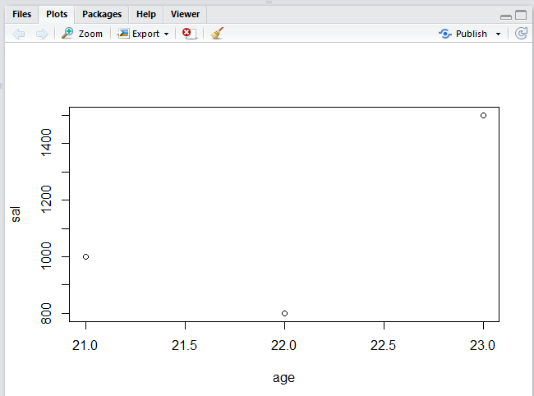

Arguments of plot:

col – colour of the points.

pch – plot character. Round or triangle or square etc.. We can also give the character in double quotes eg: pch= “*”

log – log scales are set by using log argument. log = “x” ->logarithmic x scale , y for y scale and log=”xy” makes both scales logarithmic.

with(my_df,plot(age,sal,col="Blue",pch=20))

**Multiple plots:**

> my_df

name age sal

1 sara 21 1000

2 shalya? 22 800

3 amma? 23 1500

> x=levels(my_df$name)

> plot_number =seq_along(levels(my_df$name))

> ?layout

> layout(matrix(plot_number,ncol=3,byrow=TRUE))

> for(i in x)

+ {

+ r_data=subset(my_df,name==i)

+ with(r_data,plot(age,sal))

+

+ }

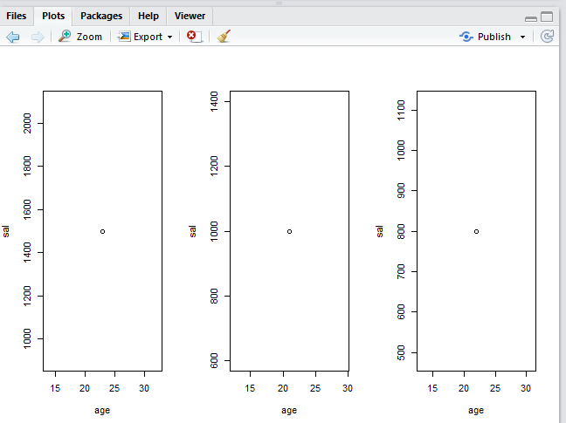

ann=FALSE indicates, we can inhibit the annotations and cover them using title().

>plot(a,b,ann=FALSE)

>title(main="a vs b", xlab = "a", ylab = "b")

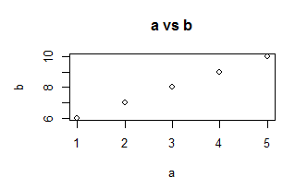

layout() -> accepts the matrix to denote the locations where the plots should come.

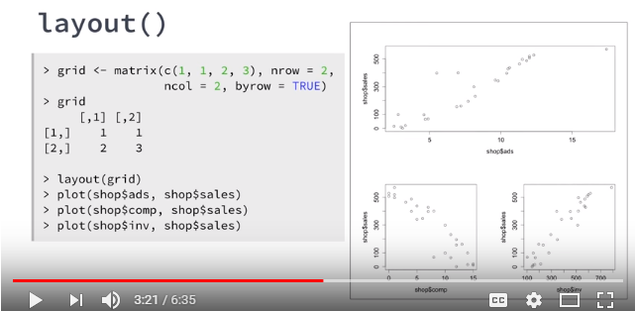

grid() adds grid to the plot,

1. call plot() with type=”n” to initialize the graphics frame without displaying the data.
2. Call grid() to draw the grid.
3. Call low level graphic function such as points or lines to draw the graphics overlaid on the graph.

>plot(a,b, main="a vs b", xlab = "a", ylab = "b", type = "n")

>grid()

>points(a,b)

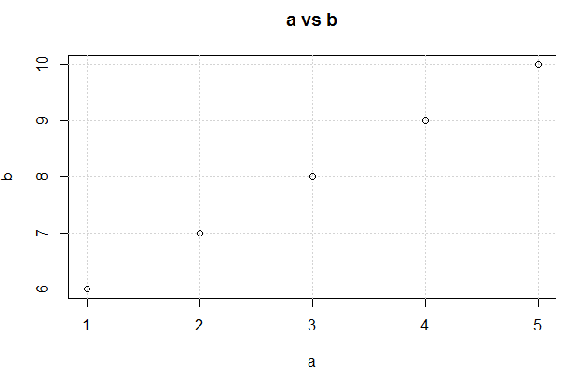

To differentiate the pch(plot characters) include that parameter.

>with(iris,plot(Petal.Length, Petal.Width,pch=(as.integer(Species))))

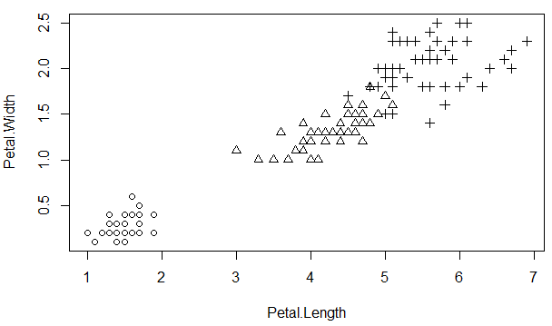

**pairs()** : to view pairwise combinations of continuous variables in scatterplots.

> pairs(iris[1:4], pch = 21)

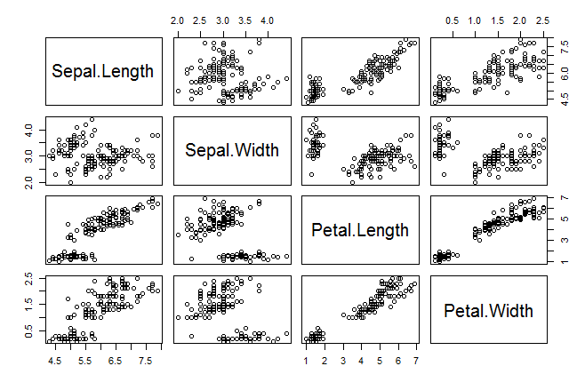

**Dotchart:**

dotchart is a fairly simple command where in the most cases just one data list is passed.

> dotchart(iris$Petal.Length)

**lattice graphics:**

> library(lattice)

> xyplot(sal ~ name,my_df) # yvar ~ xvar # first value indicates col and 2nd indicates row. Which is not the case for both base and ggplot2

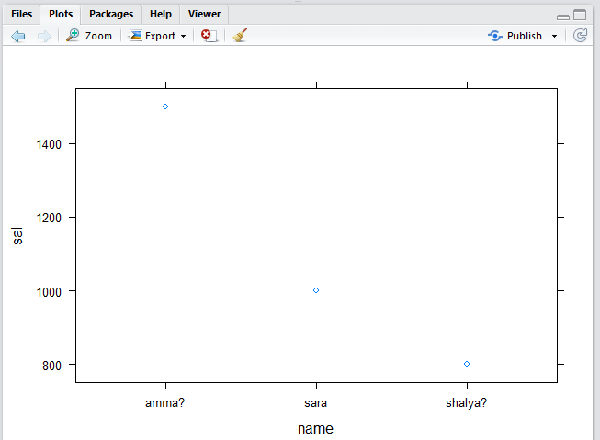

To specify logarithmic scales, we need to use scales=list(log =TRUE) within xyplot -> both axes are log scaled. Scale value should be always list with name =value pairs.

xyplot(sal~age, my_df,scales=list(log=TRUE))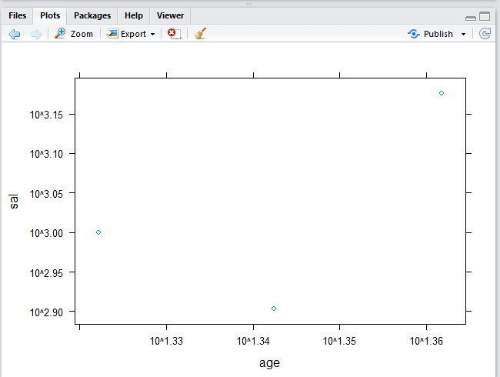

to specify just for y axis…

xyplot(

sal~age,

my_df,

scales=list(y=list(log=TRUE))

)

In case of multiple plots, just append a | character and the variable. relation=”same” means each panel share same axes. alternating=FALSE, axis ticks for each panel are drawn on alternate sides of the plot when alternating=TRUE. If not on same side.

> xyplot(sal~age |name, my_df,scales=list(log=TRUE,relation="same",alternating =FALSE))

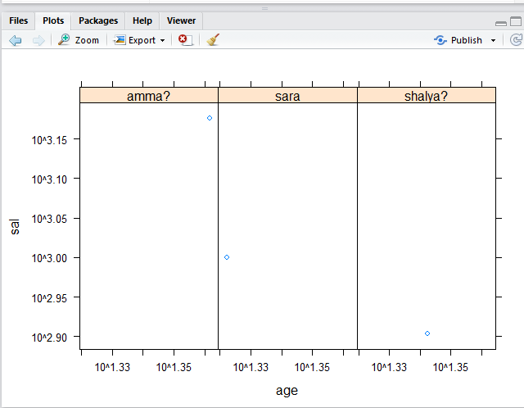

In lattice graphics, we can save the plot and modify them later which is not possible with base.

Eg:

> lat1 = xyplot(sal~age |name, my_df, scales =list(alternating=FALSE))

> lat1

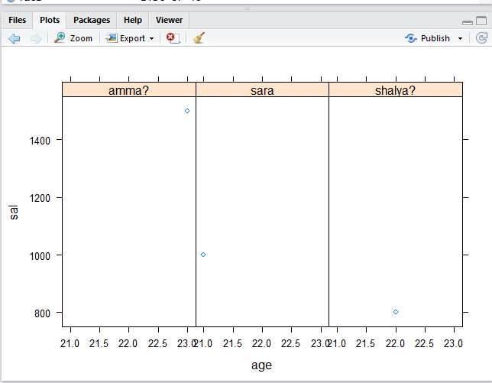

> lat2=update(lat1,col="red",pch=25)

> lat2

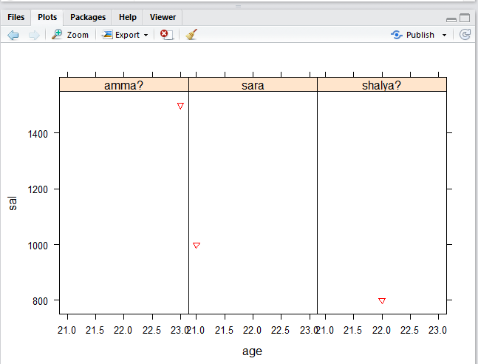

**ggplot2 Graphics:**

**Ref link :** [**http://ggplot2.tidyverse.org/reference/**](http://ggplot2.tidyverse.org/reference/)

**Types of Data:**

1. Temporal Data – Data with time component. Eg: opening and closing values of stocks in a year.
2. Geospatial Data – Data which has physical location. Eg: location of volcanos.
3. Topical Data – Data converned with topics. Eg: feedback from customers.
4. Network Data – Data which is in the form of nodes and links between nodes. Eg: social networking data.
5. Tree Data – Data which is basically network data but contains some hierarchy. Eg: Organizational structure.

Different layers in ggplot.



To plot multiple variables in same graph:

deaths_df <- read_csv("deaths-from-homicides-and-suicid.csv", col_names = c("year", "homicide", "suicide"), skip = 1)

deaths_df <- gather(deaths_df, key = 'type', value = 'deaths', homicide:suicide)

ggplot(deaths_df, aes(x = year, y = deaths, color = type)) + geom_line() + scale_colour_manual(values=c("green","blue")) + ggtitle("Australia: Homicides and suicides")

eg:

library(dplyr)

library(tidyr)

library(ggplot2)

data2 <- data1 %>% gather(key = 'price_quantity', value ='number', Sales_Value:Quantity)

names(data2)[1] <- c("Timestamp")

data2 <- data2[,c(1,3,4)]

data2$Timestamp <- paste(data2$Timestamp,"01", sep="-")

data2$Timestamp <- as.Date(data2$Timestamp)

ggplot(data2, aes(x=Timestamp, y=number,color = price_quantity)) +geom_line() +

scale_colour_manual(values=c("green","red")) + ggtitle("Sales_quantity chart")

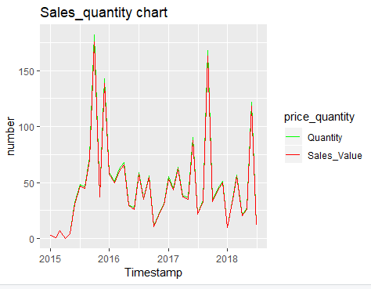

To use wide variety of colors, go to <http://www.color-hex.com/> and select the color and click choose button..copy to R studio and add # at the beginning.

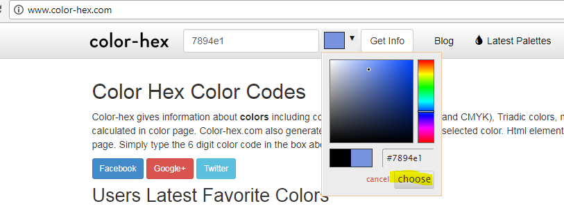

alpha parameter is for transparency of grid lines within the graph. If alpha = 0, then grid lines will be fully visible, if 1, grid lines will not be visible.

|  |  |
| --- | --- |
| **Graph** | **Used when** |
| Histogram | To plot 1 single continuous variable |
| Scatterplot | To plot 2 continuous variable |
| Barplot | To plot 1 discrete x variable and 1 continuous y variable |
| Boxplot | To plot 1 discrete or continuous variable. |
|  |  |

Difference between histogram and barplot:

1. there will be gap between each bars in bar plot. In histograms, continuous bins will be present
2. x axis will be discrete in bar , continuous in histogram.

Resources for Plotly and ggplot2

Section 17, Lecture 83

Resources and Links for Plotly and ggplot2

Here are the links for the resources mentioned in the last lecture:

[Plotly:](https://plot.ly/)

<https://plot.ly>

Package to install:

install.packages('plotly')

[Reference for gglotly() examples:](https://plot.ly/ggplot2/)

<https://plot.ly/ggplot2/>

[Reference for full ggplotly example documentation:](http://ropensci.github.io/plotly-test-table/tables/0e3d5ca144d27d8416318824c1b6ec1421a51045/index.html)

<http://ropensci.github.io/plotly-test-table/tables/0e3d5ca144d27d8416318824c1b6ec1421a51045/index.html>

> ggplot(my_df,aes(age,sal)) + geom_point(colour = “violet”, shape= 20) +

scale_x_log10(breaks = seq (2e1,4e1,1e1)) +

scale_y_log10(breaks = seq(800,1500,200)) +

facet_wrap(~ name, ncol=4) +

theme(axis.text.x = element.text(angle=30,hjust=1))

1st arg –DF

2nd arg – aes() which tells x and y axis.

geom_point() -> tells to plot some points.

ggplot also recognizes pch and color. Instead we can also use shape and colour respectively.

scale should be added for each axis. Breaks argument specifies the locations for the axis ticks and it’s optional.

facet_wrap() used to split the plot into individual plots. To split by multiple variables, the formula will be ~ var1 + var2 + var3

theme() used for making axis ticks easy reading. Eg: to rotate axis ticks by 30 degrees and right justified.

**Line Plot:**

->to view how continuous variable changes over time.

1. In base, line plots are plotted in the same way as scatter plot but with an argument **type = ‘l’**

with(crab_tag$daylog,

plot(Date, -Max.Depth, type = ‘l’, ylim = c(-max(Max.Depth),0))

)

Here, depth is plotted as negative number to make more sense.

2.In lattice, line plots are plotted same as base. Add type=’l’

xyplot( -Min.Depth + -Max.Depth ~ Date,crab_tag$daylog, type= ‘l’)

3.In ggplot2, swapping scatterplot to line plot is as simple as swapping geom_plot to geom_line

> ggplot(crab_tag$daylong, aes(Date, -Min.Depth))+geom_line()

In order to get multiple lines, we need to specify aesthetics in the call to ggplot.

> ggplot(crab_tag$daylong, aes(Date, -Min.Depth)) +

geom_line(aes(y = -Max.Depth)) +

geom_line(aes(y = -Min.Depth))

If there are only two lines to plot, geom_ribbon(colour=”black”, fill=”white”) can be used.

> ggplot(crab_tag$daylong, aes(Date, ymin = -Min.Depth, ymax = -Max.Depth)) +

geom_ribbon(color="black",fill="white")

**Histograms**:

* to explore the distribution of a continuous variable.
* Package RColorBrewer provides more color variants. Eg: col=brewer.pal(8,”green”)

**In base**, hist() is used.

with(Obama_vs_mccain, hist(Obama))

> my_df

name sal age

1 sara 1000 21

2 shalya? 800 22

3 amma? 1500 23

> with(my_df, lines(age,sal,col="blue"))

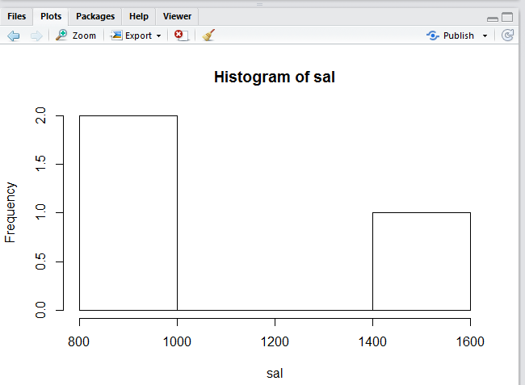

The number of breaks is calculated using Sturges’s algorithm. We can do in below ways.

1. Passing a single number to specify number of bins.
2. Vector of bin edges
3. Name of a different algorithm. Eg: scott, fd
4. User defined function to specify the bin edges

> with(my_df,hist(sal,9,main="salary range")) #width is 9 and main to denote title.

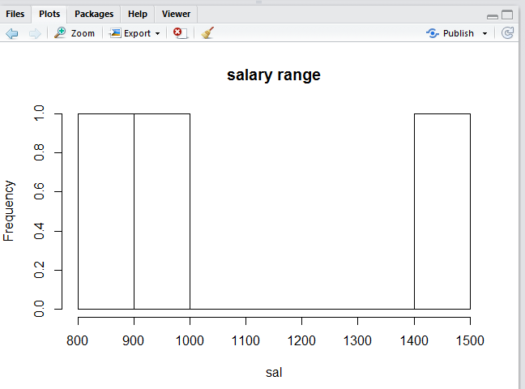

**Lattice Histogram:**

Behaves in the same way as base.

> histogram(~sal,my_df,breaks=10)

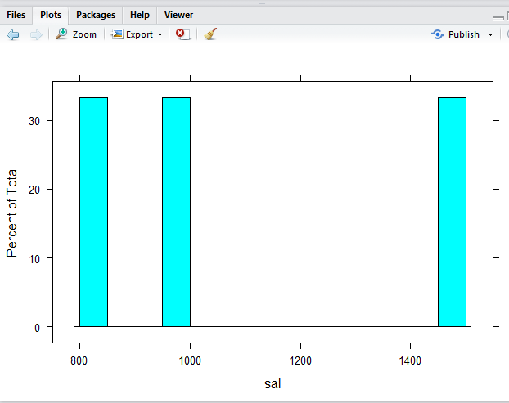

**ggplot histogram:**

> ggplot(my_df, aes(sal, ..density..)) +geom_histogram(binwidth=100)

We can choose between counts and densities by passing special names ..count.. or ..density..to the y-aesthetic.

**Box Plots or whisker plots:**

If we want to compare many distributions at once, box plots are used. used to view the spread of the data or range of the data. If horizontal=T is set, then it makes the boxplot appear horizontal.

In boxplot, title can be added by passing title(“..”) after boxplot() creation. Title arg cannot be given within boxplot()

**Eg:**

>boxplot(trees$Girth)

>title("Girth of trees",ylab="tree diameter in inches")

**Base:** almost same as lattice.

> boxplot(age~sal, data=my_df)

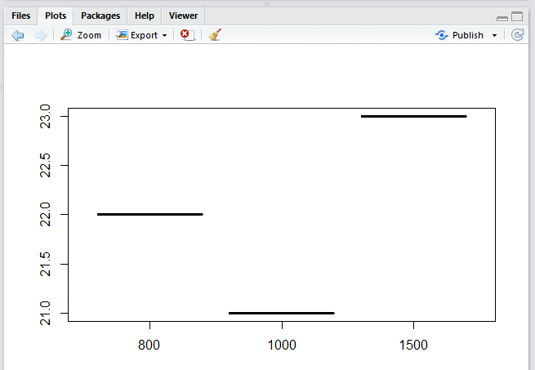

**Lattice boxplot:**

> bwplot(sal~age, data=my_df)

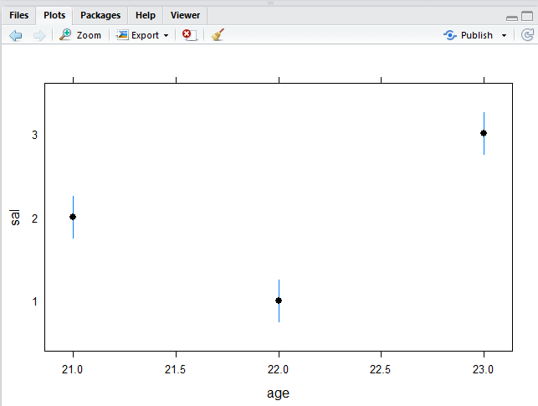

**ggplot boxplot:**

> ggplot(my_df,aes(age,sal))+geom_boxplot()

**Barchart:**

**Base :**

> with(my_df,barplot(age,names.arg = name,horiz = FALSE))

name.arg -> the argument passed will be the labels.

horiz = TRUE -> by default the bars will be vertifical to make the labesl readable, we can make them horizontal.

par() -> used to set plot parameters such as las and mar etc

las -> label axis style, controls whether lables are horizontal, vertical, parallel or perpendicular to the axis. las =1 for horizontal

mar-> numeric vector of length 4, to specify bottom, left, top and right width of plot margins.

> par(las=1,mar=c(3,5,1,1))

> with(my_df,barplot(age,names.arg = name,horiz = FALSE))

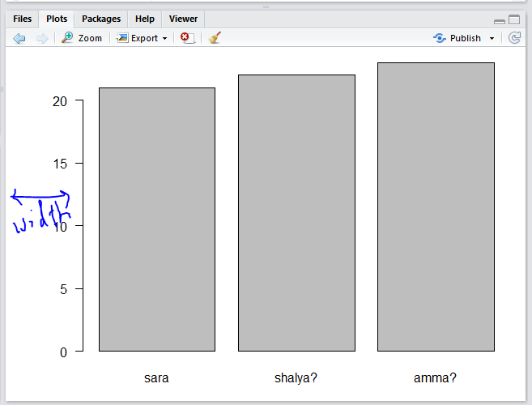

Stacked bar chart is achieved using **beside = FALSE** in barplot.

For plotting multiple variables, place them into a matrix, one in each row using rbind.

Column name of this matrix used as names of the bars.

And then apply barplot for the matrix.

**Lattice:**

> barchart(name ~ age , my_df)

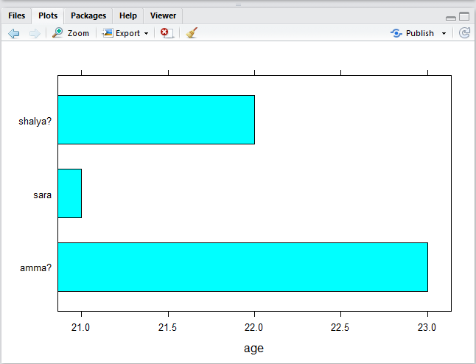

Inorder to extend this to multiple variables, just tweak the formula by adding more variables.

And stack = TRUE.

> barchart(name ~ age +sal , my_df,stack=TRUE)

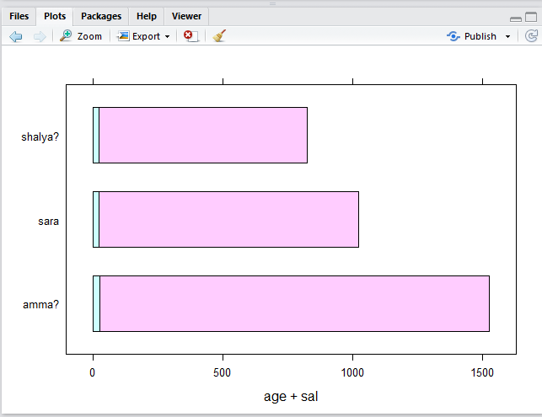

**ggplot:**

1. Change the data to long form using melt.
2. ggplot defaults to vertical bars, to change this add coord_flip.
3. Since we already have length of each bars, we must pass stat = “identity” to geom_bar.
4. To avoid the bars being stacked, use the argurment position=”dodge” to geom_bar.

ggplot(religions_long, aes(Sate,value,fill=variable)) +

geom_bar(stat =”identity”,position=”dodge”) +

coord_flip()

**qplot() or quick plot: package ggplot2**

**Ref link:** [**http://www.sthda.com/english/wiki/qplot-quick-plot-with-ggplot2-r-software-and-data-visualization**](http://www.sthda.com/english/wiki/qplot-quick-plot-with-ggplot2-r-software-and-data-visualization)

The function **qplot()** [in **ggplot2**] is very similar to the basic **plot()** function from the **R** base package. It can be used to create and combine easily different types of plots. However, it remains less flexible than the function **ggplot()**.

**Basic scatter plots**

The plot can be created using data from either numeric vectors or a data frame:

# Use data from numeric vectors

x <- 1:10; y = x*x

# Basic plot

qplot(x,y)

# Add line

qplot(x, y, geom=c("point", "line"))

# Use data from a data frame

qplot(mpg, wt, data=mtcars)

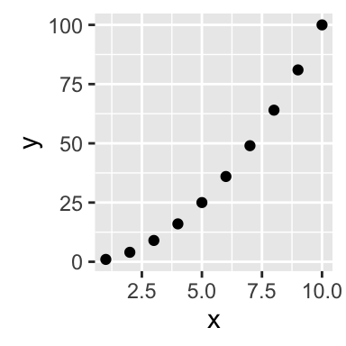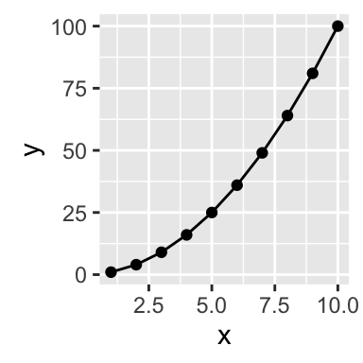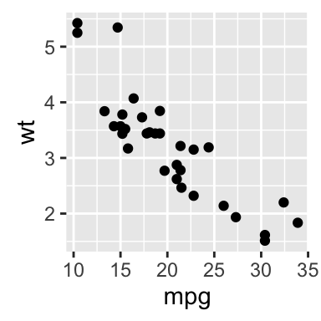

**Scatter plots with smoothed line:**

The option **smooth** is used to add a **smoothed line** with its **standard error**:

# Smoothing

qplot(mpg, wt, data = mtcars, geom = c("point", "smooth"))

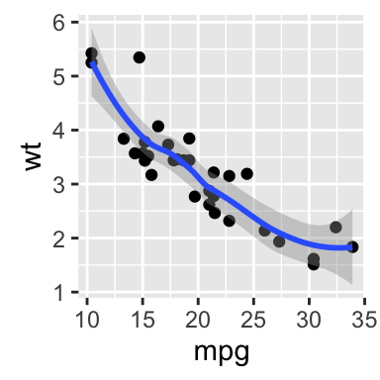

**Distributions and Modelling:**

Drawbacks of summary statistics and plots:

1. Statistics don’t give you the shape of the data
2. Plots aren’t scalable to many variable. with more than 5 or 6, it gets confusing.
3. Both are not good at giving predictions from the data.

Solution is model. Helps in making judgements and make predictions.

**Random numbers:**

sample()

> sample(colours(),10)

[1] "turquoise3" "mediumorchid1" "darkslategray4" "khaki" "lemonchiffon1"

[6] "grey73" "gray77" "mistyrose" "grey41" "seagreen1"

> sample(.leap.seconds,4)

[1] "1978-01-01 05:30:00 IST" "2009-01-01 05:30:00 IST" "2006-01-01 05:30:00 IST"

[4] "1976-01-01 05:30:00 IST"

**Sampling from Distributions:**

r<distn>

eg: rnorm -> normal distributed random numbers.

runif -> uniform random numbers.

1st parameter -> number of random numbers to generate.

Further parameters affect the shape of the distribution

> runif(5) -> uniform random numbers between 0 and 1

[1] 0.1832281 0.1384290 0.1726848 0.1886753 0.3292977

> runif(5,1,10) -> uniform random numbers between 1 and 10

[1] 8.506779 8.533553 5.040067 2.317850 5.889162

> rnorm(5) -> normal random numbers with mean 0 and std dev 1

[1] -1.33751349 -2.22299242 0.54532693 -0.43578066 0.07705276

> rnorm(5,3,7) – normal random numbers with mean 0 and std dev 1

[1] 11.607222 -2.373212 1.632916 -4.831747 -2.756029

Random number generation is through algorithms available in ?RNG page.

To view the algorithms used for uniform and normal random number generation

> RNGkind()

[1] "Mersenne-Twister" "Inversion"

Random number generation require a starting point known as seed. Once you set the seed to a value, same random numbers generated each time.

> runif(5)

[1] 0.19752067 0.08571447 0.06029096 0.93167639 0.71079133

> runif(5) ->different set of values..

[1] 0.39559432 0.04144524 0.22067402 0.58974330 0.44135761

> set.seed(1)

> runif(5)

[1] 0.2655087 0.3721239 0.5728534 0.9082078 0.2016819

> set.seed(1) ->same value as previous.

> runif(5)

[1] 0.2655087 0.3721239 0.5728534 0.9082078 0.2016819

Normal distribution/guassian distribution has below functions:

Probability Density Function(PDF) -> dnorm

Cumulative Distribution function (CDF) -> pnorm

Inverse CDF -> qnorm

Random normal distribution -> rnorm

**Degrees of Freedom:**

[**http://www.statisticshowto.com/degrees-of-freedom/**](http://www.statisticshowto.com/degrees-of-freedom/)

Degrees of freedom of an estimate is **the number of independent pieces of information that went into calculating the estimate**. It’s not quite the same as the number of items in the sample. In order to get the df for the estimate, you have to subtract 1 from the number of items. Let’s say you were finding the mean weight loss for a low-carb diet. You could use 4 people, giving 3 degrees of freedom (4 – 1 = 3), or you could use one hundred people with df = 99.

In math terms (where “n” is the number of items in your set):

Degrees of Freedom = n – 1

**Why do we subtract 1 from the number of items?** Another way to look at degrees of freedom is that they are **the number of values that are free to vary**in a data set. What does “free to vary” mean? Here’s an example using the mean (average):  
**Q**. Pick a set of numbers that have a mean (average) of 10.  
**A**. Some sets of numbers you might pick: 9, 10, 11 or 8, 10, 12 or 5, 10, 15.  
Once you have chosen the first two numbers in the set, the third is fixed. In other words, **you can’t choose the third item in the set**. The only numbers that are free to vary are the first two. You can pick 9 + 10 or 5 + 15, but once you’ve made that decision you **must** choose a particular number that will give you the mean you are looking for. So degrees of freedom for a set of three numbers is TWO.

**Formulae:**

Right side response variable ~ independent variables.

Eg: Rate ~ Year +Age +Ethnicity + Gender.

Here Rate is the response and other 4 are independent variables.

If intercept is included, then

Rate ~ α0 +α1*Year+α2*Age+α3*Ethnicity +α4*Gender +€

Each αi is a constant to be determined by the model. € is the normally distributed error term

If intercept term is zero, then,

Rate ~ 0+Year + Age+ Ethnicity + Gender

Updated equation:

Rate ~ α1*Year+α2*Age+α3*Ethnicity +α4*Gender +€

To specify the interactions, use caret symbol ^

Eg: Rate ~ (year+Ethnicity +Gender) ^2 -> indicates, three two way interaction.

If you want to specify Year squared, then wrap them in I() as caret symbol is reserved for two way interaction.

Eg: Rate ~ I(Year^2) -> this indicates year squared and not an interaction.

Null hypothesis = sample and population data(historic data) are same. Independent variable has no impact on dependent variable.

Alternate hypothesis = sample and population data are not same.

For alpha =0.05, if p<0.05, we can reject null hypothesis.

**Coefficient properties:**

1. Magnitude -> how much times (cooefficient) of the independent variable influence the response.
2. Direction -> directly proportional or inversely proportional.
3. Causal -> cause and effect. Unidirectional or bidirectional. It cannot be measured but gauged using domain knowledge.

When we see the summary of lm() model

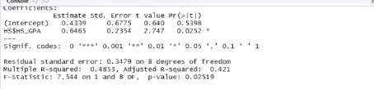

We get below result..

Intercept = 0.4339 -> the base constant.

Cooefficient/slope = 0.6465 -> the dependent variable is 0.6465 times of independent variable.

F-statistic -> 1 or close to 1 means it confirms null hypothesis(no relation between X and Y), if greater than 1 -> rejects null hypothesis..if n(number of observations) are large, then even if f-statistic is near to 1, it means it rejects null hypothesis. For small n, large f-statistic value only means rejection of null hypothesis.

P value = 0.0252 -> means this is the estimated probability of the model. If this value is less than the assumed probability, then we can ignore null hypothesis.

Eg: if we have a model relating college grade ~ highschool grade..if we are 95% confident that both are dependent then the assumed probability will be 0.05 or 5%.since our model p value is 0.02<0.05, we can ignore null hypothesis.

Multiple R-squared: 0.4853 -> meaning our model is 48% accurate. If we add more independent variables, the accuracy will increase. But if Adjusted R-squared value (0.421) is not increasing accordingly then there is no use in adding the independent variable for prediction as it has no impact on the accuracy.

R^2 =1 indicates perfect relationship between the variables.. i.e both the estimated and actual points will coincide exactly.

If it is 0.8, there is slight variation.if it is 0.02, then the relationship is bad. If it is 0, then no relationship.

**Explanation of summary o/p from linear regression:**

> summary(Chickmodel3)

Call:

lm(formula = log(weight) ~ Time + Diet, data = ChickWeight)

Residuals:

Min 1Q Median 3Q Max

-1.12169 -0.11939 0.02129 0.12597 0.65207

Coefficients:

Estimate Std. Error t value Pr(>|t|)

(Intercept) 3.678196 0.021301 172.680 < 2e-16 ***

Time 0.077548 0.001406 55.161 < 2e-16 ***

Diet2 0.119065 0.025897 4.598 5.26e-06 ***

Diet3 0.246586 0.025897 9.522 < 2e-16 ***

Diet4 0.246354 0.026034 9.463 < 2e-16 ***

---

Signif. codes: 0 ‘***’ 0.001 ‘**’ 0.01 ‘*’ 0.05 ‘.’ 0.1 ‘ ’ 1

Residual standard error: 0.2281 on 573 degrees of freedom

Multiple R-squared: 0.8484, Adjusted R-squared: 0.8474

F-statistic: 802 on 4 and 573 DF, p-value: < 2.2e-16

**Call: -** lm definition

**Residuals:**

1. Ideally, there would be perfect normal distribution among regression residuals.
2. OLS algorithm mathematically guarantee to produce mean of zero.
3. Hence, the sign of median defines the skew direction and the magnitude of median defines the extent. In this case, it is positive and very slightly skewed right.
4. If the residuals have a nice bell shaped distribution, then first and 3rd quartile (1Q and 3Q) should have same magnitude. (0.12597 vs 0.11939)
5. Min and max residuals helps to detect extreme outliers in the data.

**Coefficients:**

1. Column estimate contains the estimated regression coefficients as calculated by OLS
2. If a variable’s coefficient is zero then the variable is worthless, it adds nothing to the model.
3. P-value is the probability that the coefficient of variable or the variable is not relevant/significant .so smaller is better. Conventional limit of p should be less than 0.05.
4. Last column indicates how significant the variable is. Same is given under “signif. Codes”
5. Std. Error indicates standard error of the estimated coefficient.
6. t value is t statistic and p-value given in (3)

**Residual Standard error:**

Standard error of the residuals (i.e), sample standard deviation of €

R^2 (Coefficient of determination) is used to determine goodness of fit.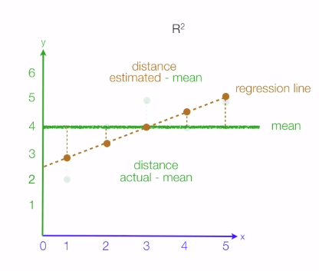

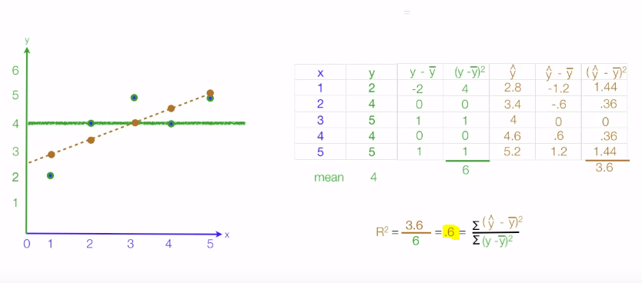

**Relative Absolute error:**

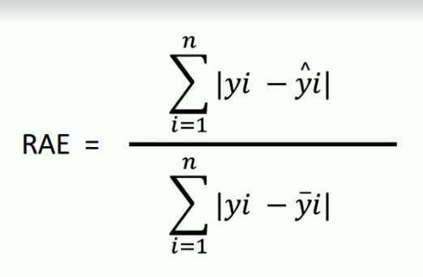

R2:

Good link: <http://blog.minitab.com/blog/adventures-in-statistics-2/regression-analysis-how-do-i-interpret-r-squared-and-assess-the-goodness-of-fit>

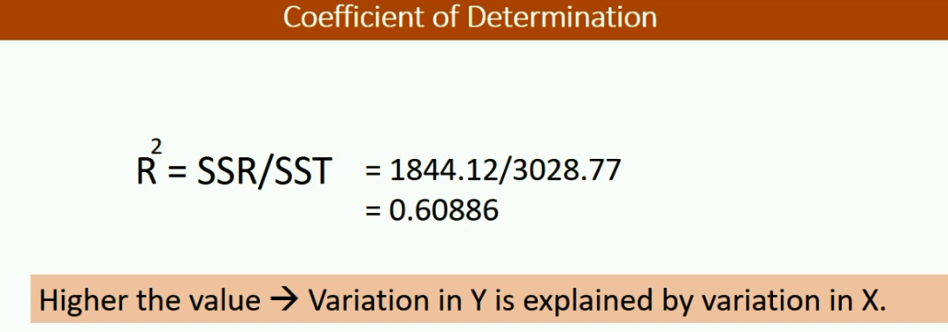

**F statistic:**

Tells whether model is significant or not. If all the coefficients are zero, then the model is insignificant. Atleast one of the coefficient should be non-zero then, the model is significant.

**Regression Techniques:**

**Good link:** <https://www.r-bloggers.com/15-types-of-regression-you-should-know/>

Linear regression example:

> data(airquality)

> names(airquality)

[1] "Ozone" "Solar.R" "Wind" "Temp" "Month" "Day"

> plot(Ozone~Solar.R, data=airquality)

>

> mean.Ozone = mean(airquality$Ozone, na.rm=T)

> mean.Ozone

[1] 42.12931

> abline(h=mean.Ozone)

> model1 = lm(Ozone~Solar.R, data=airquality)

> model1

Call:

lm(formula = Ozone ~ Solar.R, data = airquality)

Coefficients:

(Intercept) Solar.R

18.5987 0.1272

> abline(model1 , col="blue")

> plot(model1)

Hit <Return> to see next plot: summary(model1)

Hit <Return> to see next plot:

Hit <Return> to see next plot:

Hit <Return> to see next plot:

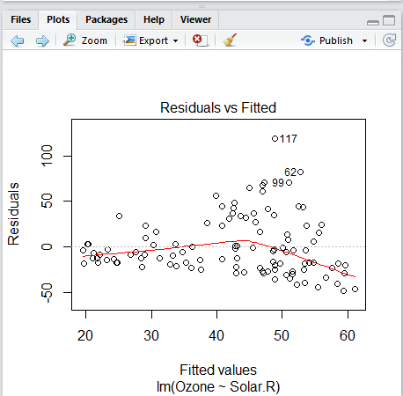

Residuals vs fitted : There shouldn’t be a pattern

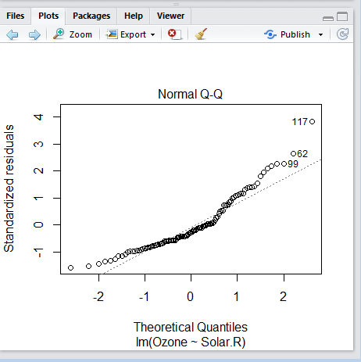

Ideally, this plot should show a straight line. If you find a curved, distorted line, then your residuals have a non-normal distribution (problematic situation).

**Scale Location Plot:**

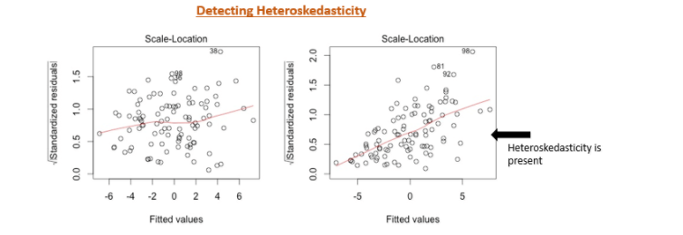

Ideally, this plot shouldn't show any pattern. Presence of a pattern determine heteroskedasticity.

Reference link for - [http://r-statistics.co/Linear-Regression.html#](http://r-statistics.co/Linear-Regression.html)

**Programming:**

Messages, Warnings and Errors:

**message:**

concatenates its inputs without spaces and writes them to the console.

**Advantage over print():**

1. we can turn off the display. When repeatedly running the same code, and not seeing same message over 100 times can have wonderful effect.

suppressMessages(“….”)

> print(letters[1:5])

[1] "a" "b" "c" "d" "e"

> message(letters[1:5])

abcde

**warning:**

|  |
| --- |
| > g=function(x)  + {  + if(any(x<0))  + {warning("x contains negative value",toString(x[x<0]))  + x  + }  + }  > g(c(-3:3))  Warning message:  In g(c(-3:3)) : x contains negative value-3, -2, -1  [1] -3 -2 -1 0 1 2 3 |

Similarly, warnings can also be suppressed using suppressWarnings()

**warn** is a global option which takes value 0 by default to display the warning after program execution.

To view the current level of warn option, if this value is changed to less than zero, all the warning will be ignored.

> getOption("warn")

[1] 0

> Old_ops <-options(warn=-1)

> g(c(-3:3))

[1] -3 -2 -1 0 1 2 3

|  |  |
| --- | --- |
| **Option warn values** | **Results** |
| warn=0 | Displays warnings at the end of program execution |
| 1 | Displays as and when they occur |
| 2 or more | Turns all warnings into error |
| <0 (negative values) | Ignores all warning |

To access last warning:

> last.warning

$`x contains negative value-3, -2, -1`

g(c(-3:3))

when the option is set to 0, warnings will be displayed at the end provided the number of warning are less than 10. Otherwise, we will only get the count of warnings and to view them, use warnings()

|  |
| --- |
| > w = function(n)  + {  + for(i in seq_len(n))  + warning("warning number ",i)  + }  >  > w(3)  Warning messages:  1: In w(3) : warning number 1  2: In w(3) : warning number 2  3: In w(3) : warning number 3  > w(11)  There were 11 warnings (use warnings() to see them)  > warnings()  Warning messages:  1: In w(11) : warning number 1  2: In w(11) : warning number 2  3: In w(11) : warning number 3  4: In w(11) : warning number 4  5: In w(11) : warning number 5  6: In w(11) : warning number 6  7: In w(11) : warning number 7  8: In w(11) : warning number 8  9: In w(11) : warning number 9  10: In w(11) : warning number 10  11: In w(11) : warning number 11 |

**Errors:**

Halts the execution.

> e = function(m, na.rm=FALSE)

+ {

+ if(!na.rm && any(is.na(m)))

+ stop("x has missing values")

+ }

> e(c(4,NA))

Error in e(c(4, NA)) : x has missing values

stopifnot throws error if any of the expressions passed to it evaluate to something that isn’t true.

|  |
| --- |
| > e = function(m, na.rm=FALSE)  + {  + if(!na.rm)  + stopifnot(!any(is.na(m)))  + }  > e(c(4,NA))  Show Traceback    Rerun with Debug    Error: !any(is.na(m)) is not TRUE |
|  |

Package **assertive,** helps with extensive set of human friendly tests.

library(assertive)

h<-function(x,na.rm=FALSE)

{

if (!na.rm)

assert_all_are_not_na(x)

x}

h(c(1,NA))

## Error: x contains NAs.

tryapply() function will retain the results of successful iteration and removes the results of failed iterations.

**tryCatch()**

# do something, or tell me why it failed

my_function <- function(baz){

tryCatch(

## This is what I want to do:

something(mydata, baz)

,

## But if an error occurs, do the following:

error=function(error_message) {

message("Yet another error message.")

message("Here is the actual R error message:")

message(error_message)

return(NA)

}

)

}

Eg:

my_func = function(a){

tryCatch(

add(a,10),

error = function(error_message){

message("Addition - Not possible ")

return(NA)

}

)

}

val = my_func(20)

print(val)

o/p:

[1] 20

val = my_func('sara')

print(val)

o/p:

[1] NA

If you also want to capture a "warning", just add warning= similar to the error= part.

**Types of regression: https://www.analyticsvidhya.com/blog/2015/08/comprehensive-guide-regression/**

* Linear Regression
* Logistic Regression
* Polynomial Regression
* Stepwise Regression
* Ridge Regression
* Lasso Regression
* ElasticNet Regression

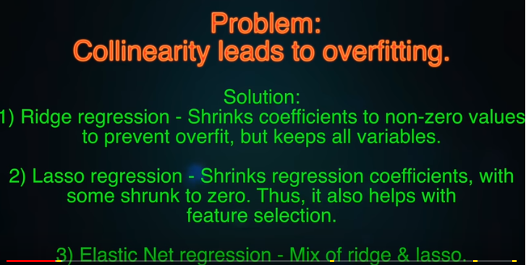

**Object Oriented Programming:**

3 object oriented systems built into R

1. S3 classes – lightweight system for overloading functions (proto)
2. S4 classes – fully featured OOP system. But it’s clunky and tricky to debug. Only use it for legacy code. (R.oo)
3. Reference classes(RC) are the modern replacement for S4 classes. (OOP)

**S3 classes:**

Function overloading 🡺 behaving differently based on the input type.

Eg: print()

> print

function (x, ...)

UseMethod("print")

<bytecode: 0x00000000111a2ba0>

<environment: namespace:base>

(…) ellipsis is necessary. It takes x argument and UseMethod checks the class of x and looks for another function named print.class_of_x. If it can’t find the function, it tries to call print.default.

If class specific method not found, and if no default method, then error will be thrown.

To view the available methods for a function use methods()

> head(methods(print))

[1] "print.acf" "print.anova" "print.aov" "print.aovlist"

[5] "print.ar" "print.Arima"

> methods(mean)

[1] mean.Date mean.default mean.difftime mean.POSIXct mean.POSIXlt

see '?methods' for accessing help and source code

**Reference Classes:**

Similar to OOP system. setRefClass() creates template for a class. also called as class generator.

|  |
| --- |
| > point_generator = setRefClass(  + "point",  + field=list(  + x="numeric",  + y="numeric"  + ),  + methods=list(  + initialize= function(x=NA_real_,y=NA_real_)  + {  + "Assign x and y upon object creation"  + x <<- x  + y <<- y  + }  + )  + )  > (a_point = point_generator$new(5,3)) # object creation  Reference class object of class "point"  Field "x":  [1] 5  Field "y":  [1] 3  > point_generator$help("initialize")  Call:  $initialize(x = , y = )  Assign x and y upon object creation  **Note:**  NA_real_ is used instead of NA to represent missing value, because we have declared the fields as numeric, so we need to explicity state the type.  Every class generator has **new** method for object creation.  Also **help** method to return the help string for the method specified. The first string statement within the method, will be considered as help text.  Within method, <<- global assignment operator used to assign to a field. Local assignment <- just creates local variable inside the method.  fields() and methods() are used to view the variables and methods of the class.  > point_generator$fields()  x y  "numeric" "numeric"  > point_generator$methods()  [1] ".objectPackage" ".objectParent" "callSuper" "copy"  [5] "export" "field" "getClass" "getRefClass"  [9] "import" "initFields" "initialize" "show"  [13] "trace" "untrace" "usingMethods"  contains arugument helps in inheriting fields and methods from another class.  > three_d_point_generator = setRefClass(  + "three_d_poin",  + fields = list(  + z="numeric"  + ),  + contains = "point",  + methods = list(  + initialize=function(x,y,z){  + x <<-x  + y<<-y  + z<<-z  + }  + )  +  + )  > a_three_d_point = three_d_point_generator(3,4,5)  **Hypothesis Testing:** |
| **3 common models:**   1. lm – linear regression, normal errors, constant variance -> used for traditional models 2. glm – generalized linear models, non-normal errors, non-constant variance -> used for poisson account data 3. gls – generalized least square model, (same as glm) + correlated errors, spatial/temporal patterns/trends -> temporal auto correlation |
|  |

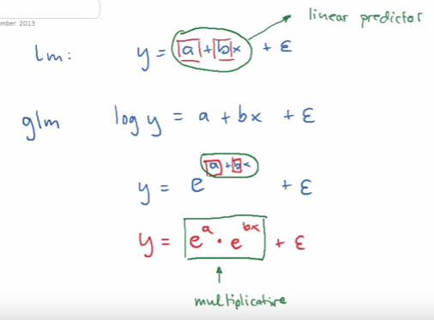

Basically glm is exponential of lm model.

**Autocorrelation or serially correlated errors:**

**Consequence of autocorrelation**  is we cannot meet **BLUE –**Best Linear Unbiased Estimates

**Hackerearth – Machine Learning – Regression topic:**

Regression – It’s a parametric technique to determine continuous variable(dependent) for the given set of independent variable.

Y = βo + β1X + ∈

where, Y - Dependent variable  
X - Independent variable  
βo - Intercept  
β1 - Slope  
∈ - Error/residual value

βo and β1 are known as coefficients.

Error is inevitable but we try to reduce the (∈) error term. To do this, regression uses a technique

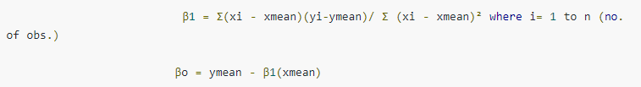

->OLS(Ordinary Least Square) -> tries to reduce sum of squared errors by finding best value for βo and β1

Other regression techniques:

Generalized least square, percentage least square, total least squares, Least absolute deviation and many more.

**Residual Sum of Squares (RSS)** - ∑[Actual(y) - Predicted(y)]²

**Explained Sum of Squares (ESS)** - ∑[Predicted(y) - Mean(ymean)]²

**Total Sum of Squares (TSS)** - ∑[Actual(y) - Mean(ymean)]²

[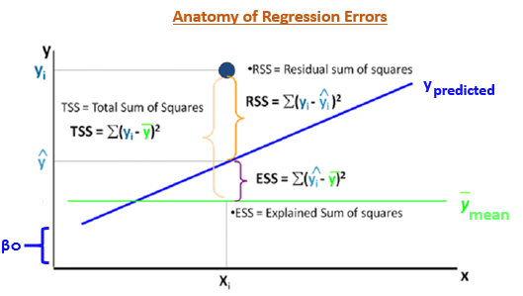](http://blog.hackerearth.com/wp-content/uploads/2016/12/anat.png)

Coefficient of determination => `R² = 1 - (SSE/TSS)`

**Correlation:**

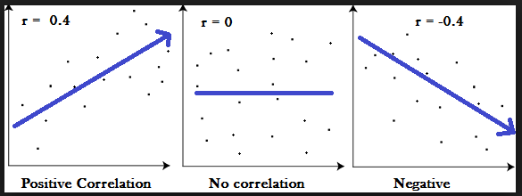

More details of linear regression/least square :

<https://www.hackerearth.com/practice/machine-learning/machine-learning-algorithms/beginners-guide-regression-analysis-plot-interpretations/tutorial/>

If you are a non-graphical person, you can also perform quick tests / methods to check assumption violations:

**Durbin Watson Statistic (DW) -** This test is used to check autocorrelation. Its value lies between 0 and 4. A DW=2 value shows no autocorrelation. However, a value between 0 < DW < 2 implies positive autocorrelation, while 2 < DW < 4 implies negative autocorrelation.

**Variance Inflation Factor (VIF) -** If there are high intercorrelation between the independent variables, then it means multicollinearity condition exists. This metric is used to check multicollinearity. VIF <=4 implies no multicollinearity but VIF >=10 suggests high multicollinearity. Alternatively, you can also look at the tolerance (1/VIF) value to determine correlation in IVs. In addition, you can also create a correlation matrix to determine collinear variables.

Multicollinearity is nothing but Dummy Variable Trap. In below case, State column was part of df, and its values are New York and California. We can create one dummy variable called New York and add values 1 whereever it is newyork else 0. If we are creating two dummy variables, we will end up in multicollinearity as there is dependency between Newyork and California independent variables. So always omit 1 dummy variable from the set. i.e , if we have 9 unique values in a column, we should create 8 dummy variables.

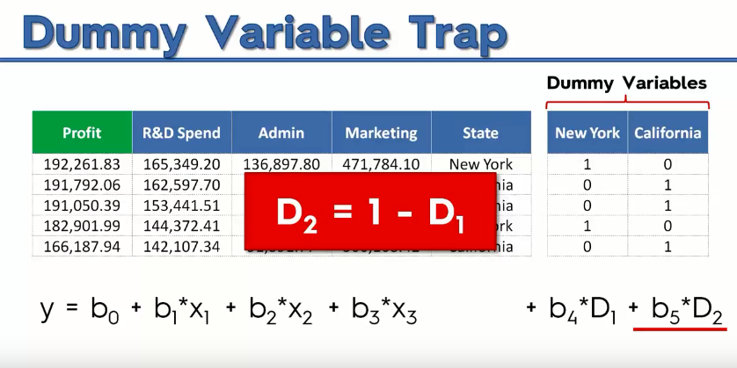

**Breusch-Pagan / Cook Weisberg Test** - This test is used to determine presence of heteroskedasticity. If you find p < 0.05, you reject the null hypothesis and infer that heteroskedasticity is present.

Ref link: <https://www.r-bloggers.com/how-to-detect-heteroscedasticity-and-rectify-it/>

**Homoskedasticity:** In statistics, a sequence or a vector of random variables is homoscedastic /ˌhoʊmoʊskəˈdæstɪk/ if all random variables in the sequence or vector have the same finite variance. This is also known as homogeneity of variance. The complementary notion is called heteroscedasticity.

**Performing linear regression without intercept:**

>lm(y~x+0)

This means we are forcefully setting y value as 0 when x is 0. Before doing this, check confidence interval

>confint(lm(y~x))

If the intercept range covers zero, then it makes reasonable to make zero intercept.

**Performing linear regression with interaction terms:**

>lm(y~u*v) => separating by * indicates, along with 2 predictor variables, their product is also a predictor for the model.

(u+v+…+w)^2=> indicates all their first order interaction.

(u+v+…+w)^3 => indicates all their first order and second order interactions.

And so on.

Semicolon is used to specify a single product. Eg: u:v:w denotes product term u*v*w

**Selecting best regression variables** without all possible interactions.**:**

**Code:** <https://searchcode.com/file/115174822/RegressionTests/Code/glmStepAIC.R>

step() function performs stepwise regression both forward or backward.

Backward: starts with all variables and removes the underperformers.

> C5 = lm(log(weight)~.,data=ChickWeight)

> reduced.model <- step(C5,direction="backward")

Start: AIC=-1990.12

log(weight) ~ Time + Chick + Diet

Step: AIC=-1990.12

log(weight) ~ Time + Chick

Df Sum of Sq RSS AIC

<none> 15.487 -1990.1

- Chick 49 21.284 36.771 -1588.3

- Time 1 152.769 168.256 -613.3

Forward: starts with few variables and adds new ones to improve the model until it cannot be improved further.

> fwd.model <- step(min.model, direction ="forward", scope = (~ Time + Chick +Diet),trace=0)

> summary(fwd.model)

Call:

lm(formula = log(weight) ~ Time + Chick, data = ChickWeight)

Residuals:

Min 1Q Median 3Q Max

-0.65135 -0.09082 0.02479 0.10764 0.50193

Coefficients:

Estimate Std. Error t value Pr(>|t|)

(Intercept) 3.801891 0.013430 283.094 < 2e-16 ***

Time 0.076885 0.001066 72.101 < 2e-16 ***

Chick.L 1.039363 0.057839 17.970 < 2e-16 ***

---

Signif. codes: 0 ‘***’ 0.001 ‘**’ 0.01 ‘*’ 0.05 ‘.’ 0.1 ‘ ’ 1

Residual standard error: 0.1714 on 527 degrees of freedom

Multiple R-squared: 0.9213, Adjusted R-squared: 0.9138

F-statistic: 123.4 on 50 and 527 DF, p-value: < 2.2e-16

**Regressing on a subset of your data:**

>lm( y ~ x , subset = 1:500) => selects only first 500 rows for regression.

**Using an expression inside a Regression formula:**

If we want to regress on the sum of x and y, then use the expression within I(…)

**>**lm(y~I(x + y))

If we want to regress on sum u +u^2, then

>lm(y ~ u + I(u^2))

**Finding best Power Transformation(Box – Cox Procedure)**

Boxcox can be applied to the observations greater than 0.

y^λ = x+e ,where lambda is the power of y, which improves the fit of the model. boxcox() is used to determine λ

boxcox is part of library(MASS)

1. library(MASS)
2. m=lm( y ~ x) => normal linear regression using OLS
3. bc <- boxcox(x) => this plots a graph for λ(x axis) against log- likelihood (y axis)
4. lambda <- bc$x[which.max(bc$y)] => we need to find value of lambda corresponding max log likelihood.
5. Lets say lamba value is -1.515
6. z <- y^lambda

m2 <- lm( z ~ x)

summary(m2) => R^2 value would have improved compared to summary(m)

**Plotting Regression Residuals**

If we want to visualize just the regression residuals then, add **which = 1** parameter in lm()

Eg:

m <- lm(y ~ x)

plot(m , which =1)

**Diagnosing a Linear Regression:**

1. Find the outliers by either looking at the plot(points which are far away from center) or by using **outlier.test()** from **car** package.
2. plot() provides lot of diagnostic plots such as Residuals vs Fitted, Normal Q-Q plot and Scale – Location plot and Residuals vs Leverage plots.
   1. Residuals vs Fitted -> they should be randomly scattered without any pattern
   2. Normal Q-Q plot -> should be more or less on the line, indicating that residuals follow normal distribution
   3. Scale-location and Residuals vs Leverage plot -> the points are in a group with none too far from the center. => the outlier points can be determined using outlier.test() in car package.
3. m <- lm(y ~ x)
4. outlier.test(m) => output will be some observation number which is far war from center and warns that there is something odd with that observation.

**Identifying Influential Observation:**

Influential Observation => removing that observation will significantly change the fitted regression model. It can be outliers which distort our model. need to carefully decide what should be done with that.

influence.measures(m) 🡺 m refers to the regression model.

this results in lot of statistics such as DFBETAS, DFFITS, covariance ratio, Cook’s distance and hat matrix values. (*) asterisk will be added near the most influential observation.

**Testing Residuals for Autocorrelation:**

* Durbin – Watson test is used dwtest() from lmtest() package. This returns p value which ideally should be less than 0.05 🡺 residuals are significantly correlated. p>0.05 🡺 no correlation.
* Durbin – Watson used often in time –series analysis.
* Autocorrelation in residuals distorts regression statistics such as F statistics and t statistics.
* Presence of autocorrelation indicates we are missing a useful predictor variable or there should be time series component included such as trend or seasonal indicator.
* Eg: if a test returns p value of 0.07755 🡺 indicates there is no significant autocorrelation.
* Eg2: If a test returns p value of 0.01298 🡺 indicates there is autocorrelation.
* By default, dwtest performs one sided test. If our model could exhibit negative autocorrelation, then we can use altenative option
  + dwtest(m, alternative = “two.sided”)

1. library(lmtest)
2. m <- lm(y ~ x)
3. dwtest(m)

**Predicting New Values:**

Used to predict response variable using the model for new data set.

predict(model_name, newdata = “df_name of new data set”)

**Forming Prediction intervals:**

predict(model_name, newdata = “df_name of new data set”, interval = “prediction”)

this returns, 3 columns 🡺 fits, lwr, upr

lwr and upr are the lower and upper limits of the prediction. Generally, predict uses confidence level of 0.95, it can be changed using level parameter.

Note: If the response variable is not normally distributed, consider nonparametric technique such as bootstrap for prediction intervals.

**ANOVA is used to find the variation among more than 2 groups. T-test is used to find variation among 2 groups.**

**Performing one-way ANOVA:**

* **Assumption:** data is divided into groups and groups are **normally distributed.**
* **Purpose** : To check if the groups have significantly different means.
* **How to do:**

use factor to define the groups, then apply **oneway.test()**

oneway.test(x ~ f)

x is the vector of numeric values, f is the factor that identifies group.

* **Result:**

p < 0.05 🡺 two or more groups have significantly different means.

p>0.05 🡺 not the case.

aov() also performs one way anova but it assumes equal variance. oneway.test() doesn’t assume equal variance.

> oneway.test(ChickWeight$Time ~ ChickWeight$Diet)

One-way analysis of means (not assuming equal variances)

data: ChickWeight$Time and ChickWeight$Diet

F = 0.15823, num df = 3.00, denom df = 281.96, p-value = 0.9243

As per this, there is no significant different between means of different groups.

F value = variance between the groups/variance within the group. If the variance between the group is more, then there is significant effect. If the variance is within the group, then probably no significant effect.

**Creating an Interaction Plot:**

interaction.plot(pred1, pred2, resp)

pred1 , pred2 are the two categorical predictors.

resp – is the response variable

**Use**: To check the interaction between the predictors.

Interaction between predictors indicate , as one predictor changes the value, other predictor changes its relationship with the response variable.

The resultant plot should have the lines parallel indicating there is no interaction. If not, there is an interaction.

**Finding differences between means of groups:**

oneway.test(x~ f) is one way of determining if there is significant difference in the means. But to determine how much is the difference,

1. Perform m <- aov(x ~ f) , where x is the data set and f is the grouping factor
2. TukeyHSD(m) 🡺 this function calculates the differences and confidence interval (lwr and upr limits) and helps to identify the largest difference.
3. plot(TukeyHSD(m)) 🡺 this provides graphical view of the mean differences.
4. Output of plot will show horizontal lines plot the confidence interval for each pair. The lines which are crossing zero indicate not much differences in mean. If the confidence interval line is far away from center, it indicates largest difference.

TukeyHSD() -> can be applied only on aov() object.

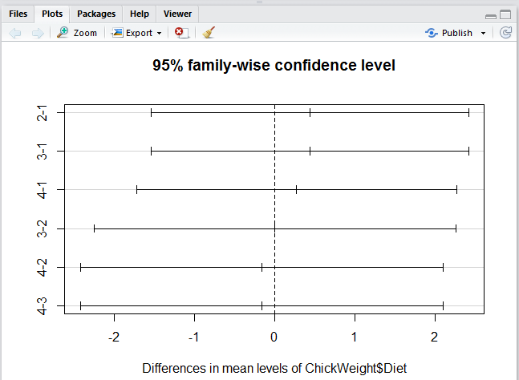

**Performing Robost ANOVA( Kruskal – Wallis Test)**

* **Assumption:** data is divided into groups and groups are **not** **normally distributed or the data is unknown.**
* **Purpose** : To check if the groups have significantly different medians.
* **How to do:**

use factor to define the groups, then apply **kruskal.test()**

kruskal.test(x ~ f)

x is the vector of numeric values, f is the factor that identifies group.

* **Result:**

p < 0.05 🡺 two or more groups have significantly different medians.

p>0.05 🡺 not the case.

**Comparing models using anova:**

**Use:** to compare two models and report if they are significantly different.

anova(m1, m2) , m1 and m2 are the models.

Note: all terms / predictors of smaller model must appear in the larger model for comparison otherwise not possible.

* **Result:**

p < 0.05 🡺 two groups have significantly difference.

p>0.05 🡺 not the case.

**Correlation diagrams:**

There are two packages for correlation diagrams – corrplot and corrgram

**corrplot:**

blue dark shades indicate high correlation between the variables. Along diagonal, each variable is related with the same hence high correlation. In order to apply corrplot, we need cor() function applied on numeric fields

> num.cols <- sapply(df,is.numeric) # filtering numeric columns

> cor.data <- cor(df[,num.cols]) # applying correlation

> print(corrplot(cor.data,method="color")) # applying corrplot to view the correlation diagram.

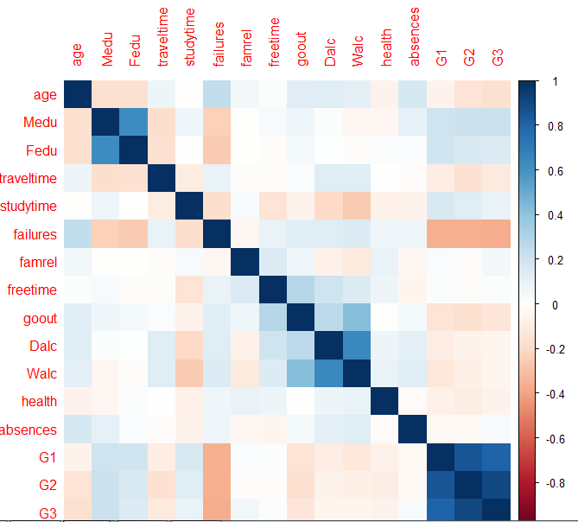

**corrgram:**

corrgram doesn’t require cor() object and can be applied on all fields(not just numeric like we have in corrplot). Here again, along diagonal, its highly correlated so it is given as a text box with the field names. And dark blue shades indicate high correlation between the variables.

> corrgram(df)

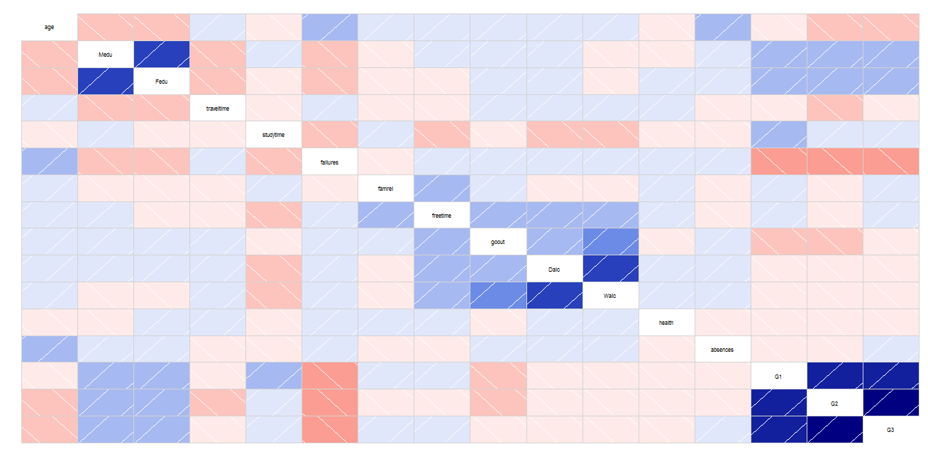

> corrgram(df, order=TRUE, lower.panel = panel.shade, upper.panel = panel.pie, text.panel = panel.txt)

Full pie indicates 1, which is fully correlated. Redpies indicate negative correlation.

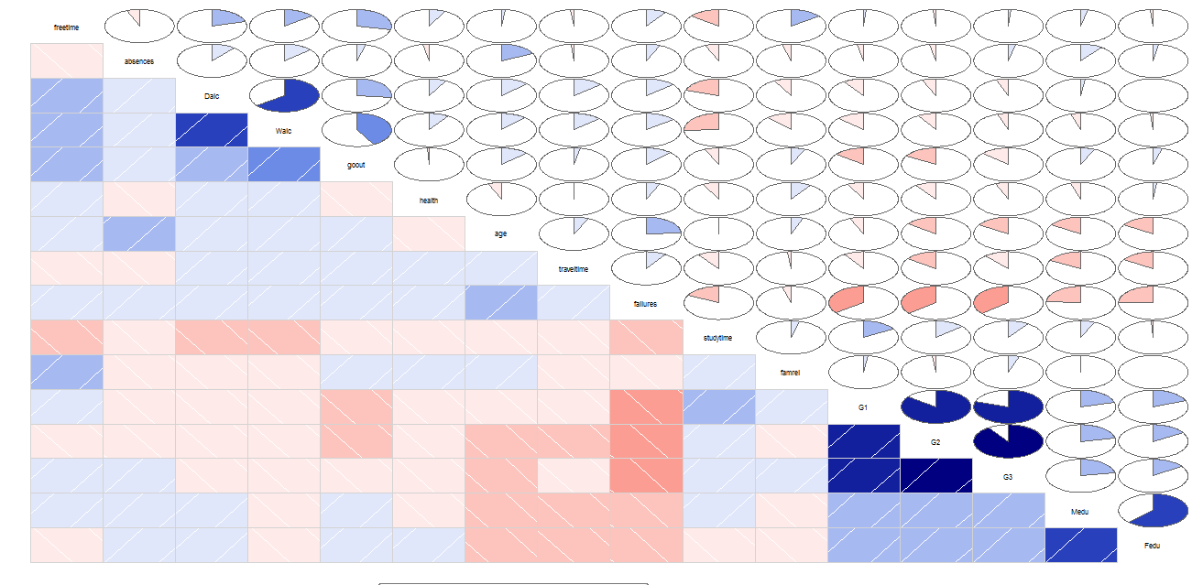

**Splitting Training and Testing datasets:**

>library(caTools)

> set.seed(101)

> sample <- sample.split(df$G3,SplitRatio = 0.7) # any column can be given, just as standard response variable is given.

> train <- subset(df,sample==TRUE)

> test <- subset(df,sample==FALSE)

**Amelia package: To view missingness map**

Used to view the missingness map showing where missingness occurs in the dataset passed to amelia.

>missmap(df.train,main="missing map",col=c("yellow","black"),legend = FALSE)

Below graph indicates, there are lot of missing values in Age column..

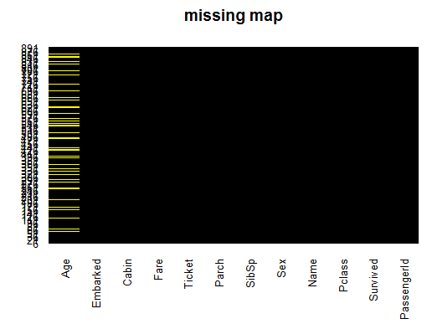

After doing imputation to remove NA values, we can again try missmap to view if any missing values.

**Central tendency:**

Is nothing but center value which represents the whole data. Nothing but average.

In average, 2 types:

1. Positional average -> median(M), mode(Z)
2. Arithmetic average -> arithmetic mean, geometric mean, harmonic mean

**Useful tricks:**

**Finding the position of a particular value:**

> vec = c(100,20, 40,80,5)

> match(40, vec)

[1] 3

**Generating all combinations of several factors:**

To generate all combinations of factors levels, also known as Cartesian product. Use expand.grid(fac1,fac2,..)

> vec1 = c(100,20, 40,80,5)

> vec2 = c('a','b','c','d')

> vec3 = c("one","two")

> expand.grid(vec1,vec2,vec3)

Var1 Var2 Var3

1 100 a one

2 20 a one

3 40 a one

4 80 a one

5 5 a one

6 100 b one

7 20 b one

8 40 b one

9 80 b one

10 5 b one

….

…

35 5 c two

36 100 d two

37 20 d two

38 40 d two

39 80 d two

40 5 d two

**Flatten a data frame:**

If you want to process all the elements of a numeric data frame and not as separate columns, eg: to find mean of all values, first convert the dataframe to matrix and then find mean.

> flatten = data.frame(a = c(1:5), b= c(6:10))

> mean(as.matrix(flatten))

[1] 5.5

**Revealing structure of an object:**

To dig inside the object, use class(), mode() and str.

Class 🡺 defines the abstract type of an object.

Two data element can coexist only if they are of same mode. Otherwise, R will convert them to one single mode.   
Mode indicates how an object is stored in memory. It can be numeric, character, list, function.

> Chickmodel3 = lm(log(weight)~ Time+Chick,data=ChickWeight)

> class(Chickmodel3)

[1] "lm"

> mode(Chickmodel3)

[1] "list"

> str(Chickmodel3)

List of 13

$ coefficients : Named num [1:51] 3.8019 0.0769 1.0394 -0.3153 0.0696 ...

..- attr(*, "names")= chr [1:51] "(Intercept)" "Time" "Chick.L" "Chick.Q" ...

$ residuals : Named num [1:578] -0.00824 0.03214 0.02408 -0.04834 -0.03026 ...

..- attr(*, "names")= chr [1:578] "1" "2" "3" "4" ...

….

.. .. ..- attr(*, "predvars")= language list(log(weight), Time, Chick)

.. .. ..- attr(*, "dataClasses")= Named chr [1:3] "numeric" "numeric" "ordered"

.. .. .. ..- attr(*, "names")= chr [1:3] "log(weight)" "Time" "Chick"

- attr(*, "class")= chr "lm"

**Timing your code:**

> system.time(sum(rnorm(1000000)))

user system elapsed

0.07 0.00 0.14

o/p having 3 numbers:

1. User CPU time – no. of CPU seconds spent running R
2. System CPU time – no. of CPU seconds spent running the OS, typically for input/output.
3. Elapsed time – no. of seconds on clock.

**Suppressing messages or warnings:**

suppressWarnings(function name()) 🡺 this will hide the warnings from the function passed.

To view, the warnings, we can use warnings().

**JSON:**

New package: jsonlite. A smart(er) JSON encoder/decoder.

fromJSON(jsonobject) 🡺 converts the passed json object to R object

toJSON(Robject) 🡺 converts the passed R object to json

**Set operations:**

|  |
| --- |
| > s1 <- c('a','b','c')  > s2 <- c('d','c')  > union(s1,s2)  [1] "a" "b" "c" "d"  > intersect(s1,s2)  [1] "c"  > setdiff(s1,s2)  [1] "a" "b"  > setdiff(s2,s1)  [1] "d" |
|  |
| && checks on the first result of the comparison vectors and provides output.  Eg:  > s1 <- c('a','b','c')  > s2 <- c('d','c')  > s1 == 'a' && s2 == 'd' 🡺 double sign compares only first parameter.  [1] TRUE  > s1 == 'a' & s2 == 'd' 🡺 single sign returns for each parameter  [1] TRUE FALSE FALSE  **Note**: && and || should not be used on vectors, since it will give incorrect answer.  **Eigen Values and Eigen vector:** |

Av = λv ,A is the matrix, v is the non-zero vector or eigen vector, λ is the eigen value

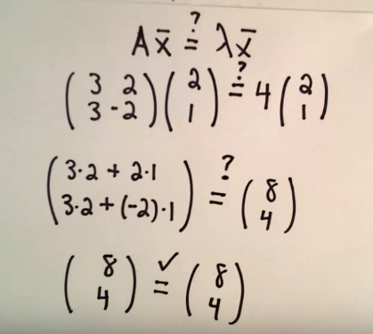

4 is the eigen value and matrix (2,1) (columnwise) is the eigen vector.

> mat = matrix (c(3,2,3,-2),nrow=2)

> mat

[,1] [,2]

[1,] 3 3

[2,] 2 -2

> eigen(mat)

eigen() decomposition

$values

[1] 4 -3

$vectors

[,1] [,2]

[1,] 0.9486833 -0.4472136

[2,] 0.3162278 0.8944272

**Fibonacci series:**

0,1,1,2,3,5,8,13,21,34,55….

Sum of previous two numbers.

**To calculate greatest common divisor:**

> gcd <- function(a,b){

+ if(b==0) return (a)

+ else

+ return (gcd(b, a%%b))

+ }

> gcd(10,15)

[1] 5

> gcd (20,25)

[1] 5

> gcd(3,9)

[1] 3

> gcd(1,7)

[1] 1

> gcd(0,6)

[1] 6

**Support websites:**

1. Use help() /RSiteSearch()
2. <http://rseek.org> 🡺 to search function by name or keyword and click on functions tab.
3. <http://stackoverflow.com/> 🡺 Q&A website, prefix the search with “ [r]”
4. <http://stats.stackexchange.com/> 🡺 Q&A website
5. <http://cranstastic.org> 🡺 search for packages by keyword
6. <http://crab,r-project.org/web/views/> 🡺 provides list of task views.
7. <http://cran.r-project.org/web/packages/> 🡺 complete alphabetical list of packages is available
8. <http://www.r-project.org/mail.html> 🡺 contains instructions for using R-help mailing list.
9. [r-help@r-project.org](mailto:r-help@r-project.org) is the mail id 🡺 should be last resort.

**To save your workspace without exiting from R:**

> save.image()

**Viewing your command history:**

1. Use upward key or Ctrl + P
2. history() , history(100) 🡺 show 100 most recent lines of history.

**Saving the result of previous command:**

If we missed to save the value of the most recently evaluated expression, then **.Last.value** variable holds it,

> sum(sample(100,10))

[1] 475

> y = .Last.value

> y

[1] 475

**Running a script:**

> source("C://Users/saranya_govindaraj/Desktop/my_txt.R")

[1] "hi saranya"

> (a= c(1:5))

[1] 1 2 3 4 5

**Customizing R:**

Changing prompt.

> options(prompt ="R>")

R>a=c(1:5)

R>a

[1] 1 2 3 4 5

**To set the number of digits.**

>options(digits = 10)

>pi

[1] 3.141592654

**Listing files:**

>list.files() 🡺 to view the names of the data files in working directory.

[1] "a.out" "airfoil_self_noise.csv" "Custom Office Templates"

[4] "desktop.ini" "My Music" "My Pictures"

[7] "My Videos" "R"

>list.files(recursive=T) 🡺 to see all the files in subdirectories

[1] "a.out" "airfoil_self_noise.csv" "desktop.ini"

>list.files(all.files = T) 🡺 to view all the files including hidden files.

[1] "." ".." ".RData"

[4] ".Rhistory" "a.out" "airfoil_self_noise.csv"

[7] "Custom Office Templates" "desktop.ini" "My Music"

[10] "My Pictures" "My Videos" "R"

**Reading fixed width file:**

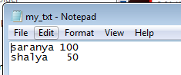

>fwf = read.fwf("C://Users/saranya_govindaraj/Desktop/my_txt.txt",

width = c(7,-1,3),col.names = c("name","score"))

>fwf

name score

1 saranya 100

2 shalya 50

width argurment carries a vector of length of each field. -1 indicates, ignore 1 character.

**Reading HTML table:**

Tbl = readHTMLTable(“url”, which=3)

which parameter indicates the nth number of table to read.

**Difference between [] and [[]]:**

**lst[[n]]** used to access nth element from the list lst.

lst[c(2,3)] used to access second and third element from list lst.

class(lst[[1]] 🡺numeric

class(lst[1]) 🡺 list

cat(lst[[1]]) 🡺 print the first element.

cat(lst[1]) 🡺 results in error

Scalar 🡺 vector with one element.

[[]] 🡺 returns result as vector

[] -> returns the result as data frame.

>pi

[1] 3.141592654

>pi[1]

[1] 3.141592654

>pi[2]

[1] NA

**Converting vector to matrix through dim():**

>r = c(1:6)

>dim(r)

NULL

>dim(r) = c(2,3)

>r

[,1] [,2] [,3]

[1,] 1 3 5

[2,] 2 4 6

**List to matrix:**

>lst = list(1,2,3,4,5,6)

>dim(lst)

NULL

>dim(lst) = c(2,3)

>lst

[,1] [,2] [,3]

[1,] 1 3 5

[2,] 2 4 6

**Append: using c()**

>r

[1] 1 2 3 4 5 6

>b

[1] 5 6 7 8 9 10

>r = c(r,b)

>r

[1] 1 2 3 4 5 6 5 6 7 8 9 10

**R automatically extends the vector to accommodate the new index value.**

>r[15]=15

>r

[1] 1 2 3 4 5 6 5 6 7 8 9 10 NA NA 15

**To insert one ore more data items into a vector:**

append(vec,newvalues,after=n)

>append(r,18,after=12)

[1] 1 2 3 4 5 6 5 6 7 8 9 10 18 NA NA 15

**Combining multiple vectors into one vector and a factor:**

Create a list containing the vectors, stack() combines the list into 2 column data frame. values(contains the data) and ind(contains the factor)

>a

[1] 1 2 3 4 5

>b

[1] 5 6 7 8 9 10

>new_vec = stack(list(a=a,b=b))

>new_vec

values ind

1 1 a

2 2 a

3 3 a

4 4 a

5 5 a

6 5 b

7 6 b

8 7 b

9 8 b

10 9 b

11 10 b

To remove NULL elements from list:

>lst = list(a=1:5,b="saran",c=NULL, d="shalya")

>lst

$a

[1] 1 2 3 4 5

$b

[1] "saran"

$c

NULL

$d

[1] "shalya"

>lst[sapply(lst,is.null)] = NULL

>lst

$a

[1] 1 2 3 4 5

$b

[1] "saran"

$d

[1] "shalya"

**Matrix:**

>m =matrix(0,2,3)

>m

[,1] [,2] [,3]

[1,] 0 0 0

[2,] 0 0 0

>t(m) 🡺 transposition of A

[,1] [,2]

[1,] 0 0

[2,] 0 0

[3,] 0 0

>m =matrix(c(1,2,3,4),2,2)

>solve(m) 🡺 matrix inverse.

[,1] [,2]

[1,] -2 1.5

[2,] 1 -0.5

How to calculate matrix inverse?

For a 2X2 matrix, inverse is: swap the position of a and d, put negatives in front of b and c, and divide everything by the determinant (ad-bc).

>n=matrix(c(1,2,3,4),2,2,byrow=T)

>m =matrix(c(4,7,2,6),2,2,byrow=T)

>m%*%n 🡺 matrix multiplication

[,1] [,2]

[1,] 25 36

[2,] 20 28

>diag(3) 🡺 diagonal identity matrix

[,1] [,2] [,3]

[1,] 1 0 0

[2,] 0 1 0

[3,] 0 0 1

While selecting rows or columns, using drop= FALSE parameter will retain the dimension.

>n[,2]

[1] 2 4

>n[,2,drop=F] 🡺 returns column vector by retaining the dimension

[,1]

[1,] 2

[2,] 4

>m[2,]

[1] 2 6

>m[2, , drop=F] 🡺returns row vector by retaining the dimension

[,1] [,2]

[1,] 2 6

While selecting columns from dataframe, if one column is selected using [[]], result will be a vector. If one column is selected using [], then result will be a dataframe.

>new_vec

values ind

1 1 a

2 2 a

3 3 a

4 4 a

5 5 a

>new_vec[[1]]

[1] 1 2 3 4 5 5 6 7 8 9 10

>new_vec[1]

values

1 1

2 2

3 3

4 4

5 5

To avoid this, we can use drop=false, which will retain the structure same as matrix.

>new_vec[,2]

[1] a a a a a

Levels: a b

>new_vec[,2,drop=FALSE]

ind

1 a

2 a

3 a

4 a

5 a

We can do the same with the dataframe names.

**2 types of matrix multiplication:**

1. scalar product -> each element of 1 matrix will be multiplied exactly with the same position element in second matrix and returns result. A * B where A and B are matrices
2. Dot product -> entire row will be multiplied and added with first column of second matrix.

A %*% B, A and B are matrices.

**attach() , detach()**

if a particular df is frequently used, we can attach the df to the search list, so that the fields can be referred as variables. And we can detach once it is used.

>new_vec

values ind

1 1 a

2 2 a

3 3 a

4 4 a

5 5 a

>attach(new_vec)

>search()

[1] ".GlobalEnv" "new_vec" "tools:rstudio" "package:stats"

[5] "package:graphics" "package:grDevices" "package:utils" "package:datasets"

[9] "package:methods" "Autoloads" "package:base"

>values

[1] 1 2 3 4 5

>ind

[1] a a a a a

Levels: a b

>detach(new_vec)

>search()

[1] ".GlobalEnv" "tools:rstudio" "package:stats" "package:graphics"

[5] "package:grDevices" "package:utils" "package:datasets" "package:methods"

[9] "Autoloads" "package:base"

>values

Error: object 'values' not found

**Splitting a vector into groups:**

split() or unstack() function is used to group the elements based on grouping factor.

Groups <- split(x,f) , x is the vector, f is the grouping factor.

Groups <- unstack(data.frame(x,f))

Both the functions return list of vectors where each vector contain elements for one group.

In unstack, if the count of elements of each group are same, then it returns data frame.

>b=split(Cars93$MPG.city,Cars93$Origin)

>b

$USA

[1] 22 19 16 19 16 16 25 25 19 21 18 15 17 17 20 23 20 29 23 22 17 21 18 29 20 31 23 22

[29] 22 24 15 21 18 17 18 23 19 24 23 18 19 23 31 23 19 19 19 28

$`non-USA`

[1] 25 18 20 19 22 46 30 24 42 24 29 22 26 20 17 18 18 29 28 26 18 17 20 19 29 18 29 24

[29] 17 21 20 33 25 23 39 32 25 22 18 25 17 21 18 21 20

>median(b[[1]])

[1] 20

>median(b[[2]])

[1] 22

>b=unstack(data.frame(Cars93$MPG.city,Cars93$Origin))

>b

$USA

[1] 22 19 16 19 16 16 25 25 19 21 18 15 17 17 20 23 20 29 23 22 17 21 18 29 20 31 23 22

[29] 22 24 15 21 18 17 18 23 19 24 23 18 19 23 31 23 19 19 19 28

$`non-USA`

[1] 25 18 20 19 22 46 30 24 42 24 29 22 26 20 17 18 18 29 28 26 18 17 20 19 29 18 29 24

[29] 17 21 20 33 25 23 39 32 25 22 18 25 17 21 18 21 20

>median(b[[1]])

[1] 20

>median(b[[2]])

[1] 22

**Formula formation :**

measurevar <- "y"

groupvars <- c("x1","x2","x3")

# This creates the appropriate string:

paste(measurevar, paste(groupvars, collapse=" + "), sep=" ~ ")

#> [1] "y ~ x1 + x2 + x3"

# This returns the formula:

as.formula(paste(measurevar, paste(groupvars, collapse=" + "), sep=" ~ "))

#> y ~ x1 + x2 + x3

#> <environment: 0x3361710>

**Probability:**

Binomial coefficient:

choose(n,k) , n is the total number of items, k is the number of items taken at a time.

how many ways can we select k items from n items

eg:

>choose(3,2) 🡺 (1,2),(1,3),(2,3) totally 3 combinations.

[1] 3

Generating combinations:

To view the combinations, use combn(n,k) , n is the total number of items, k is the number of items at a time.

>combn(5,3)

[,1] [,2] [,3] [,4] [,5] [,6] [,7] [,8] [,9] [,10]

[1,] 1 1 1 1 1 1 2 2 2 3

[2,] 2 2 2 3 3 4 3 3 4 4

[3,] 3 4 5 4 5 5 4 5 5 5

>combn(1:5,3)

[,1] [,2] [,3] [,4] [,5] [,6] [,7] [,8] [,9] [,10]

[1,] 1 1 1 1 1 1 2 2 2 3

[2,] 2 2 2 3 3 4 3 3 4 4

[3,] 3 4 5 4 5 5 4 5 5 5

>combn(c("S","A","R","A","N"),3)

[,1] [,2] [,3] [,4] [,5] [,6] [,7] [,8] [,9] [,10]

[1,] "S" "S" "S" "S" "S" "S" "A" "A" "A" "R"

[2,] "A" "A" "A" "R" "R" "A" "R" "R" "A" "A"

[3,] "R" "A" "N" "A" "N" "N" "A" "N" "N" "N"

**Calculating probabilities for Discrete Distributions:**

|  |  |
| --- | --- |
| **Simple probability associated with discrete random variable** | **Cumulative probability associated with discrete random variable** |
| P(X=x) | P(X<=x) |
| Density function prefixed with “d” | Distribution function prefixed with “p” |
| dbinom for binominal distribution | pbinom for binominal distribution |
| Probability of finding x=7, in a binominal randam variable X over 10 trails with each trail has a probability of ½ is  >dbinom(7,10,0.5)  [1] 0.1171875 | Cumulative probability of X<=7,  >pbinom(7,10,0.5)  [1] 0.9453125 |
| Also called as probability mass function or probability function. | Also called as cumulative probability function. |

Complement of cumulative probability is survival function, P(X>x). All distribution function let you find this right tail probability by simply specifying lower.tail = FALSE.

>pbinom(7,10,0.5,lower.tail = FALSE)

[1] 0.0546875

**Interval Probability: P(x1 < X <=x2)**

Probability of observing X between x1 and x2. It is calculated by differene between two cumulative probabilities: P(X <=x2) – P(X<=x1). Here is P(3<X<=7) for our binominal variable:

>pbinom(7,10,0.5) - pbinom(3,size=10,prob=0.5)

[1] 0.7734375

R allows to calculate for vector of variables and returns the result as vector.

>pbinom(c(3,7),size=10,prob=0.5)

[1] 0.1718750 0.9453125

>diff(pbinom(c(3,7),size=10,prob=0.5)) 🡺 interval probability can also calculated this way.

[1] 0.7734375

Here are the density functions and distribution functions for some common discrete distributions:

|  |  |  |
| --- | --- | --- |
| **Distribution** | **Density function P(X=x)** | **Distribution function P(X<=x)** |
| Binominal | dbinom(x,size,prob) | pbinom(x,size,prob) |
| Geometric | dgeom(x,prob) | pgeom(x,prob) |
| Poisson | dpois(x,lambda) | ppois(x,lambda) |

**Calculating probabilities for Continuous Distributions:**

Distribution function, P(X<=x)

|  |  |
| --- | --- |
| **Distribution** | **Distribution function P(X<=x)** |
| Normal | pnorm(x,mean,sd) |
| Student’s t | pt(x,df) |
| Exponential | pexp(x,rate) |
| Gamma | pgamma(x,shape,rate) |
| Chi-squared(X^2) | pchisq(x,df) |

Eg: probability that a man shorter than 66 inches, assuming men’s heights are normally distributed with mean 70 inches and a sd of 3 inches, mathematically we want to find P(X<-66)

>pnorm(66,mean=70,sd=3)

[1] 0.09121121973

**Converting probabilities to quantiles:**

Every distribution function has quantile function to convert the probabilities to quantiles.

qnorm is the quantile function for normal distribution.

>qnorm(0.05,mean=100,sd =15)

[1] 75.3271956

>qnorm(c(0.025,0.975))

[1] -1.959963985 1.959963985

Here are the quantile function for discrete distributions:

|  |  |
| --- | --- |
| **Distribution** | **Quantile function** |
| Binominal | qbinom(p,size,prob) |
| Geometric | qgeom(p,prob) |
| Poisson | ppois(p,lambda) |

Here are the quantile function for continuous distributions:

|  |  |
| --- | --- |
| **Distribution** | **quantile function** |
| Normal | qnorm(p,mean,sd) |
| Student’s t | qt(p,df) |
| Exponential | qexp(p,rate) |
| Gamma | qgamma(p,shape,rate) or qgamma(p,shape,scale=scale) |
| Chi-squared(X^2) | qchisq(p,df) |

**General Statistics:**

**summary():**

1. for numeric vector or data, summary() returns, min, 1st Qu, median, mean, 3rd qu, max.
2. for matrix, summary() returns columwise summary statistics.
3. For factor, summary() gives count of each levels.
4. For data frame, summary() gives mix of all features. It provides column wise statistics, for numeric columns, statistical summary, for factors => count, character strings are not summarized, instead we get length, class and mode.

**Calculating relative frequency:**

mean(x>0) 🡺 to calculate the relative frequency of positive values in the vector x.

>x

[1] -3 -2 -1 0 1 2 3

>x>0 🡺 returns logical vector.

[1] FALSE FALSE FALSE FALSE TRUE TRUE TRUE

>mean(x>0) 🡺 mean treats true as 1 and calculates relative frequency

[1] 0.4285714286

**Testing Categorical variables for Independece:**

Either chisq.test() or below method can be used to find relation between two categorical variable or factors.

>summary(table(ToothGrowth$len,ToothGrowth$supp))

Number of cases in table: 60

Number of factors: 2

Test for independence of all factors:

Chisq = 39.66667, df = 42, p-value = 0.573895

Chi-squared approximation may be incorrect

>summary(table(ToothGrowth$len,ToothGrowth$dose))

Number of cases in table: 60

Number of factors: 2

Test for independence of all factors:

Chisq = 92.5, df = 84, p-value = 0.2463775

Chi-squared approximation may be incorrect

Ref: <http://www.statisticshowto.com/probability-and-statistics/chi-square/>

What is a Chi Square Test?

There are **two types of chi-square tests**. Both use the chi-square statistic and distribution for different purposes:

* A**chi-square goodness of fit test** determines if a sample data matches a population. For more details on this type, see: [*Goodness of Fit Test*](http://www.statisticshowto.com/goodness-of-fit-test/).
* A **chi-square test for independence** compares two variables in a contingency table to see if they are related. In a more general sense, it tests to see whether distributions of [categorical variables](http://www.statisticshowto.com/what-is-a-categorical-variable/) differ from each another.
  + A **very small chi square test statistic** means that your observed data fits your expected data extremely well. In other words, there is a relationship.
  + A **very large chi square test statistic**means that the data does not fit very well. In other words, there isn’t a relationship.

**Tip**: The Chi-square statistic can only be used on numbers. They can’t be used for percentages, proportions, means or similar statistical value. For example, if you have 10 percent of 200 people, you would need to convert that to a number (20) before you can run a test statistic.

**Calculating Quantiles/Quartiles of a dataset:**

quantile(v,f) , v is the data and f is the fraction.

>a

[1] 1 2 3 4 5

>quantile(a)

0% 25% 50% 75% 100%

1 2 3 4 5

>quantile(a,0.5)

50%

3

>quantile(a,0.05)

5%

1.2

>quantile(a,c(0.05,0.95))

5% 95%

1.2 4.8

**Calculating Z-score:**

A **z-score** (aka, a **standard score**) indicates how many [standard deviations](http://stattrek.com/Help/Glossary.aspx?Target=standard%20deviation) an element is from the mean. A z-score can be calculated from the following formula.

z = (X - μ) / σ

where z is the z-score, X is the value of the element, μ is the population mean, and σ is the standard deviation.

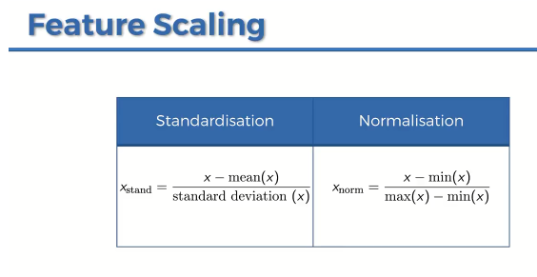

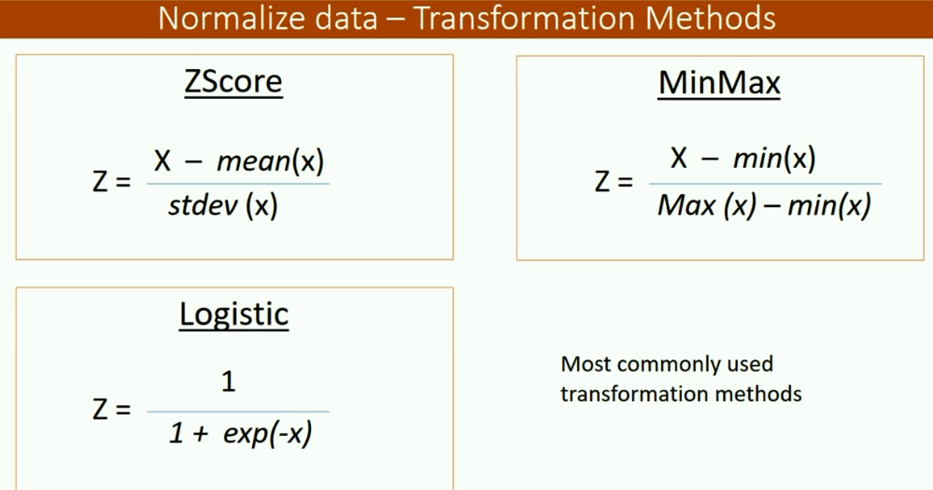

scale(x)

>a

[1] 1 2 3 4 5

>scale(a)

[,1]

[1,] -1.264911064

[2,] -0.632455532

[3,] 0.000000000

[4,] 0.632455532

[5,] 1.264911064

attr(,"scaled:center")

[1] 3

attr(,"scaled:scale")

[1] 1.58113883

**Testing the Mean of a sample(t test): t = variance between groups/variance within groups**

big t value = different groups, small t value = similar groups, every t value is associated with p value. If p= 0.05%, only 5% change there is no real difference.

t.test(x,mu =m), x is the sample and m is the assumed mean.

>a

[1] 1 2 3 4 5

>t.test(a,mu=3)

One Sample t-test

data: a

t = 0, df = 4, p-value = 1

alternative hypothesis: true mean is not equal to 3

95 percent confidence interval:

1.036756839 4.963243161

sample estimates:

mean of x

3

If p-value is <0.05, then population mean is unlikely m, if not yes.

**Forming confidence interval for a mean:**

t.test() output includes confidence interval for mean with 95% confidence level. We can change it by using conf.level argument.

>t.test(a,mu=2, conf.level = 0.99)

One Sample t-test

data: a

t = 1.4142136, df = 4, p-value = 0.2301996

alternative hypothesis: true mean is not equal to 2

99 percent confidence interval:

-0.2555867048 6.2555867048

sample estimates:

mean of x

3

**Forming confidence interval for a median:**

wilcox.text(x,conf.int=TRUE) 🡺 o/p will contain confidence interval for the median.

>wilcox.test(a,conf.int = T)

Wilcoxon signed rank test

data: a

V = 15, p-value = 0.0625

alternative hypothesis: true location is not equal to 0

95 percent confidence interval:

1 5

sample estimates:

(pseudo)median

3

**Testing for Normality:**

To test the data sample is from a normally distributed population

>shapiro.test(a)

Shapiro-Wilk normality test

data: a

W = 0.98676216, p-value = 0.9671739

If p<0.05, population is likely not normally distributed. P>0.05 otherwise.

**Testing for Runs:**

To test the randomness of a sequence of binary values: 0-1, TRUE-FALSE, yes-no…

library(tseries)

runs.test(as.factor(s)) , where s is the sample.

If p<0.05, there is no randomness. P>0.5, randomness

s<- c(0,0,0,1,1,1,0,0,0)

library(tseries)

runs.test(as.factor(s))

o/p : p = 0.02147 🡺 indicating no randomness

**Testing a correlation for significance:**

To identify if the correlation is statistically significant between 2 variables.

P<0.05, correlation is likely significant, p>0.05, it is not.

>a

[1] 1 2 3 4 5

>b

[1] 6 7 8 9 10

>cor.test(a,b)

Pearson's product-moment correlation

data: a and b

t = 82191237, df = 3, p-value < 2.2204e-16

alternative hypothesis: true correlation is not equal to 0

95 percent confidence interval:

1 1

sample estimates:

cor

1

>cor.test(ChickWeight$weight,ChickWeight$Time)

Pearson's product-moment correlation

data: ChickWeight$weight and ChickWeight$Time

t = 36.725235, df = 576, p-value < 2.2204e-16

alternative hypothesis: true correlation is not equal to 0

95 percent confidence interval:

0.8109073287 0.8599480824

sample estimates:

cor

0.8371016995

**Time Series Analysis:**

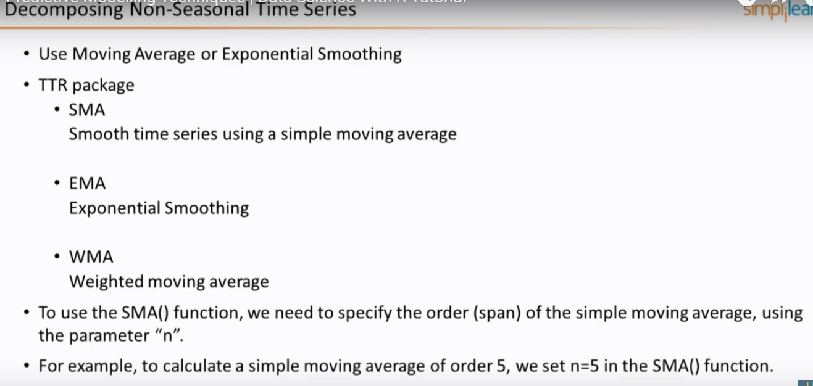

|  |  |  |
| --- | --- | --- |
| **Algorithm** | **What it is** | **When to use** |
| **SMA(n)** | Estimates current levels of series as average of last n observations. Cannot pick up effects of trend and seasonality. Similar to simple exponential smoothing, except that model has no parameters to be fitted to the data. | When historical data is too short and so noisy. |
| **Exponential smoothing** |  |  |
| **WMA – Weighted moving average** | Is similar to SMA. Weights are assigned to previous data. Different weights are assigned to different positions of moving average window.  Generally the weights decrease in arithmetic progression. |  |
|  |  |  |

**Ref link:** [**https://www.datasciencecentral.com/page/search?q=time/series**](https://www.datasciencecentral.com/page/search?q=time/series)

[**https://www.statmethods.net/advstats/timeseries.html**](https://www.statmethods.net/advstats/timeseries.html)

**Limitations**

As you might have surprised, having more training data in a time series need not necessarily lead to more accurate models. Anomalous values or rapidly changing trends could upend(set upside down) any prediction efforts. Worse still, sudden shocks that permanently affect a time series could also render all past data as irrelevant.

Therefore, time series analysis works best for trends that are steady and systematic, for which we can assess with visualizations.

**zoo and xts package**

library(zoo)

ts <- zoo(x,dt) where x is the vector or data frame and should be numeric and dt is the vector corresponding dates or datetime and it is called index.

>coredata(ts) 🡺 returns x values

>index(ts) 🡺 returns dt values

as.xts(ts) 🡺 converts ts into xts object.

as.zoo(ts) 🡺 converts ts into zoo object

**plotting a time series:**

**plot(v, type=’l’) or plot.ts(v) 🡺** v is the vector of time series observations.

**Extracting oldest or newest observation:**

head(ts) 🡺 returns first 6 oldest observation

tail(ts) 🡺 returns last 6 newest observation

in xts package, we have first() and last() functions to select the required number of observations using calendar periods like days, weeks, months or even years.

Eg:

first(as.xts(ts),”3 weeks”)

last(as.xts(ts),”month”)

**Subsetting a timeseries:**

ts[as.date(“yyyy-mm-dd”)]

dates = seq(from=startdate, to=enddate, by=increment)

ts[dates]

window() 🡺 used to select range by start and end date and returns a time series.

window(ts,start=startdate, end=enddate)

**Lag time series:**

**https://math.stackexchange.com/questions/2548314/what-is-lag-in-a-time-series/2548350**

**Lag timeseries:**

laggedTS <- **lag**(tsData, 3) *# shifted 3 periods earlier. Use `-3` to shift by 3 periods forward.*

**Details of timeseries:**

> class(AirPassengers)

[1] "ts"

> start(AirPassengers)

[1] 1949 1

> end(AirPassengers)

[1] 1960 12

> frequency(AirPassengers)

[1] 12

> summary(AirPassengers)

Min. 1st Qu. Median Mean 3rd Qu. Max.

104.0 180.0 265.5 280.3 360.5 622.0

> boxplot(AirPassengers~cycle(AirPassengers))

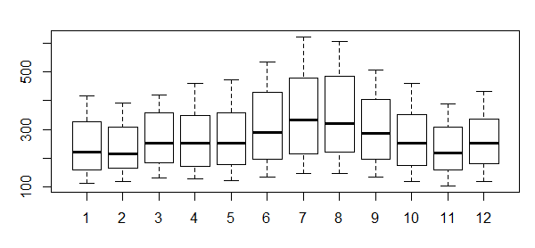

**Merging timeseries:**

merge(ts1,ts2)

lets say ibm and cpi are two timeseries and ibm has entries monthwise and cpi has daily data.

Merge function, merges the both the time series and adds NA for the not available fields.

To remove NA and add the most recent observation, use na.locf() on merge function. Locf stands for last observation carried forward.

Eg:

>merge(ibm,cpi)

|  |  |  |
| --- | --- | --- |
|  | Ibm | Cpi |
| 1970-01-01 | NA | 37.8 |
| 1970-01-02 | 364.75 | NA |
| 1970-01-05 | 368.25 | NA |
| …. |  |  |

>na.locf(merge(ibm,cpi))

|  |  |  |
| --- | --- | --- |
|  | Ibm | Cpi |
| 1970-01-01 | 364.75 | 37.8 |
| 1970-01-02 | 364.75 | 37.8 |
| 1970-01-05 | 368.25 | 37.8 |
| …. |  |  |

**Computing difference:**

diff() used to calculate differences between successive items.

**Applying function by calendar period:**

In xts package, we have below functions for processing time series by day, week, month, quarterly/year.

apply.daily(ts,f) 🡺 f is the function

apply.weekly(ts,f)

apply.monthly(ts,f)

apply.quarterly(ts,f)

apply.yearly(ts,f)

eg:

apply.monthly(as.xts(ibm), mean)

mean will be calculated monthly on ibm object.

> grep('united', c("united states", "united kingdom", "united arab"),value=FALSE)

[1] 1 2 3

> grep('united', "united states, united kingdom, united arab",value=TRUE)

[1] "united states, united kingdom, united arab"

**R for everyone – Advanced Analytics and Graphics:**

RStudio -> tools -> global options -> Sweave

Sweave or knitr -> used for generation of pdf documents

knitr – also enables creation of html documents.

**R Binay files - .rdata**

If we want to transfer R objects among R programmer, we can use R binary files with extension .rdata.

It can carry single R object or multiple objects.

To create a r binary file,

> save(iris,file = "C:\\Users\\saranya_govindaraj\\Desktop\\iris.rdata" )

This will save the iris dataset into desktop as .rdata file.

We can pass this to any R programmer and they can load this .rdata using load command.

> load("C:\\Users\\saranya_govindaraj\\Desktop\\iris.rdata")

> head(iris)

Sepal.Length Sepal.Width Petal.Length Petal.Width Species

1 5.1 3.5 1.4 0.2 setosa

2 4.9 3.0 1.4 0.2 setosa

3 4.7 3.2 1.3 0.2 setosa

4 4.6 3.1 1.5 0.2 setosa

5 5.0 3.6 1.4 0.2 setosa

6 5.4 3.9 1.7 0.4 setosa

**Storing multiple R objects and retrieving:**

> m = 7

> n = 1:10

> o = data.frame(m,n)

> m

[1] 7

> n

[1] 1 2 3 4 5 6 7 8 9 10

> o

m n

1 7 1

2 7 2

3 7 3

4 7 4

5 7 5

6 7 6

7 7 7

8 7 8

9 7 9

10 7 10

> save(m,n,o,file="C:\\Users\\saranya_govindaraj\\Desktop\\multiple.rdata")

> rm(m,n,o)

> m

Error: object 'm' not found

> n

Error: object 'n' not found

> o

Error: object 'o' not found

> load("C:\\Users\\saranya_govindaraj\\Desktop\\multiple.rdata")

> m

[1] 7

> n

[1] 1 2 3 4 5 6 7 8 9 10

> o

m n

1 7 1

2 7 2

3 7 3

4 7 4

5 7 5

6 7 6

7 7 7

8 7 8

9 7 9

10 7 10

If the rdata file is in web, we need to establish connection, load the data and close the connection.

con <- url(<http://.......>)

load(con)

close(con)

**Extra Arguments:**

extra arugument will be specified as ellipses in func definition and can be passed as argument through extra keyword in func call.

> my_fun <- function(first, last,...)

+ sprintf("first = %s , last = %s, extra = %s", first, last , ...)

> my_fun("saranya","govindaraj",extra ="Pandey")

[1] "first = saranya , last = govindaraj, extra = Pandey"

**aggregate function:**

used to apply a function on a variable based on the grouping of another variable.

> aggregate(weight ~ Diet, ChickWeight, mean)

Diet weight

1 1 102.6455

2 2 122.6167

3 3 142.9500

4 4 135.2627

Lefthand side, need to mention the variable on which function should be applied. There can be many variable, which should be given in cbind.

Rightside, need to mention the grouping variable. There can be multiple variables, which should be separated by +

> aggregate(cbind(weight,Time) ~ Diet + Chick, ChickWeight, mean)

In order to apply multiple function, each() can be used.

> aggregate(cbind(weight,Time) ~ Diet + Chick, ChickWeight, each(mean,median))

“by= “ can also be used to achieve aggregate function.

diamondsDT[ , mean(price), by = cut]

(or)

aggregate(price ~ cut, diamondsDT, mean)

we can add multiple columns to group, in by argument as a list. Similarly to apply multiple functions, we can use list.

diamondsDT[ , list(price = mean(price),carat = mean(carat)), by = list(cut,color)]

**Difference between data frame and data table.**

|  |  |
| --- | --- |
| **data.frame** | **data.table** |
|  | for speed junkies, data.table extends and enhances data.frame features. Secret of speed is because it have index like databases. |
| Syntax is data.frame | data.table |
| Comes as part of base package. | require(data.table) |
| Converts character vectors to factors | Doesn’t convert |
|  | We can create data.table table from data frame.  Eg: diamondsDT <- data.table(diamonds) |
| Printing data frame will print all rows.  Eg: diamonds | Printing data table prints only first 5 and last 5 rows.  Eg: diamondsDT |
| To access different columns, we need to specify column names as character vector.  diamonds[,c(A,C)] | To access different columns, we need to specify column names as part of list.  Eg: diamondsDT[,list(A,C)]  Just one column can be given as  diamondsDR[, B]  If we want to specify column names as character vectors, we need to pass with = FALSE argurment  Eg: diamondsDT[,c(“A”,”C”), with = FALSE] |
|  | To see list of data.tables and their information, type **tables()**  o/p :  Name NROW NCOL MB, COLS, KEY  Name of data table, no.of rows, columns,mega bytes,col names, if any keys assigned to the table, key is used to index the data.table and will provide the extra speed. |
|  | setkey(diamondsDT,D) 🡪 this creates index on D column for the data table. |
| If a column name starts with number, it prefix ‘X’ in front of the name.  > my_df <- data.frame("1a"=1:3, "b" = 4:6)  > my_df  X1a b  1 1 4  2 2 5  3 3 6 | It will use same column name.  > my_dt <- data.table("1a"=1:3,"b"=4:6)  > my_dt  1a b  1: 1 4  2: 2 5  3: 3 6 |

Package data.table uses the := syntax for assignment of values within a j statement. In the data.table context, this is to avoid creating copies of the entire object (as would happen with <- or =), which can be very slow for large objects.

eg:

>dt <- data.table(hflights)

>dt[, date := ISOdate(Year, Month, DayofMonth)] # This would create a new variable called 'date' by wrapping the year, month and dayofmonth columns.

>setorder(Dataframe, columnname1 , -columnname2) ==> this function is fastest in sorting the data.table or data.frame based on columns. if - symbol is in front, then it sorts in decending order, else, in ascending order.

Ref link: <https://stackoverflow.com/questions/1296646/how-to-sort-a-dataframe-by-columns/29331287#29331287>

**Data Science:**

**Types of digital data:**

1. Structured.. eg: excel, RDBMS
2. Semi structured eg: xml, html, email
3. Unstructured eg: satellite images, social media data, scientific data.

**Components of data science:**

1. Probability and statistics,
2. Linear Algebra
3. Machine learning
4. Computer science

**Types of Learning:**

1. Supervised learning
2. Unsupervised learning / clustering
3. Semi supervised learning
4. Reinforcement learning

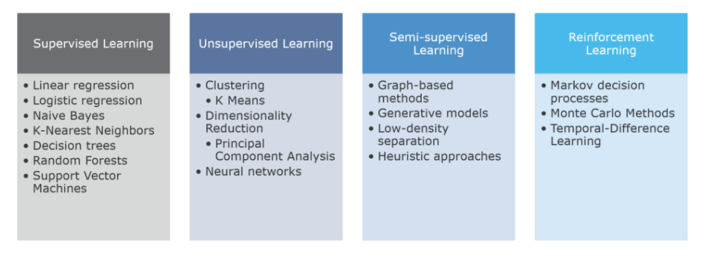

**Reinforcement Learning:**

**Click-through rate (CTR)** is the ratio of users who click on a specific link to the number of total users who view a page, email, or advertisement. It is commonly used to measure the success of an [online advertising](https://en.wikipedia.org/wiki/Online_advertising) campaign for a particular website as well as the effectiveness of [email campaigns](https://en.wikipedia.org/wiki/Email_marketing).

Top 10 use cases of Data science:

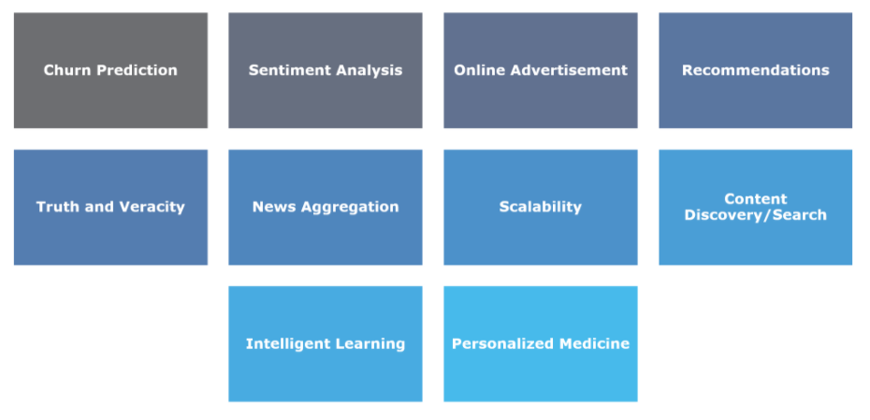

**Logistic regression:**

[**https://www.analyticsvidhya.com/blog/2015/11/beginners-guide-on-logistic-regression-in-r/**](https://www.analyticsvidhya.com/blog/2015/11/beginners-guide-on-logistic-regression-in-r/)

If the predictor variables are categorical or continuous or both, we can use logistic regression.

If the response variable provides binary output like true or false, then it is called binominal logistic regression.

Eg: checking if a mail is spam or not based on other variables

If the response variable takes more than 2values, then it is multinominal logistic regression.

Eg: categorizing films based on jonoure

Logistic regression is based on odds ratio.

Odds is nothing but the probability of occurance of an event/probability of not occuarance of the event.

Odds ration is nothing but ration between two odds.

If the response variable is binary output, we cannot create a best fit model through simple linear regression.

You can also think of logistic regression as a special case of linear regression when the outcome variable is categorical, where we are using log of odds as dependent variable. The left handside of below equation is called log-odds or logit.

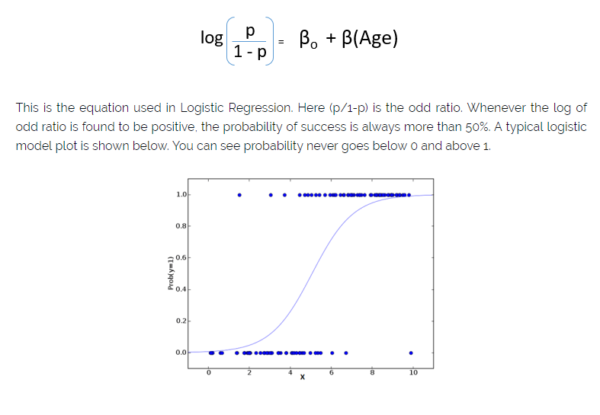

Fundamental equation is g(E(y)) = α + βx1 + γx2

Here, g() is the link function, E(y) is the expectation of target variable and α + βx1 + γx2 is the linear predictor ( α,β,γ to be predicted). The role of link function is to ‘link’ the expectation of y to linear predictor.

Important Points

1. GLM does not assume a linear relationship between dependent and independent variables. However, it assumes a linear relationship between link function and independent variables in logit model.
2. The dependent variable need not to be normally distributed.
3. It does not uses OLS (Ordinary Least Square) for parameter estimation. Instead, it uses maximum likelihood estimation (MLE).
4. Errors need to be independent but not normally distributed.

Model1 = glm(responsevariable ~ predictors, data = “datasetname”,family=binominal(link=”logit”))

**How to verify the performance of the model:**

1. AIC (Akaike Information Criteria) – The analogous metric of adjusted R² in logistic regression is AIC. AIC is the measure of fit which penalizes model for the number of model coefficients. Therefore, we always prefer model with minimum AIC value.

 2. Null Deviance and Residual Deviance – Null Deviance indicates the response predicted by a model with nothing but an intercept. Lower the value, better the model. Residual deviance indicates the response predicted by a model on adding independent variables. Lower the value, better the model.

3. Confusion Matrix: It is nothing but a tabular representation of Actual vs Predicted values. This helps us to find the accuracy of the model and avoid overfitting. This is how it looks like:

[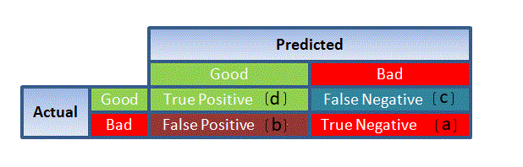](https://www.analyticsvidhya.com/wp-content/uploads/2015/11/1111.png)

FP(False positive) is type 1 error. ( predicting a man is pregnant but in real he is not) kindof warning. This is not that serious.

FN(False Negative is type 2 error. (predicting a woman as not pregnant when she is pregnant) kind of critical error. This is very serious

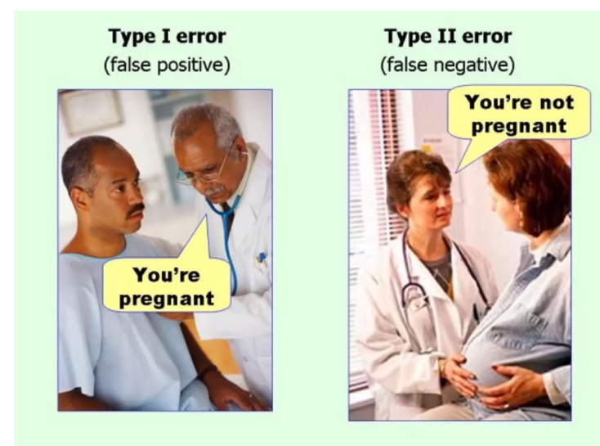

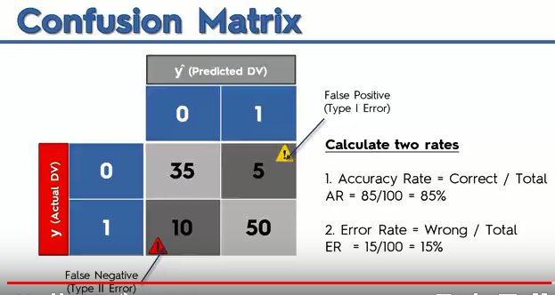

Accuracy Paradox:

Making all predictions as 0, is increasing the accuracy from making predictions as per the model, is increasing the accuracy. Hence, just viewing accuracy to decide the model is not the right approach.

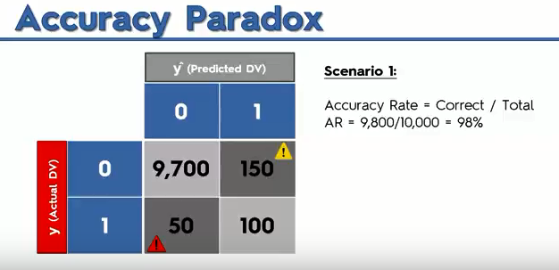

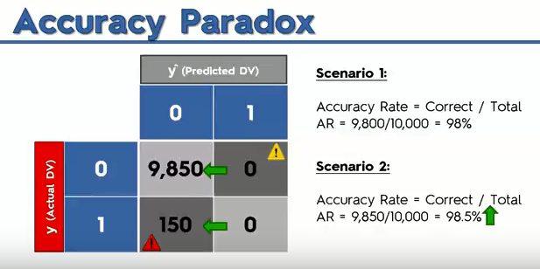

**Cumulative Accuracy Profile (CAP) curve:**

As per below figure, 10% of the users are responding.

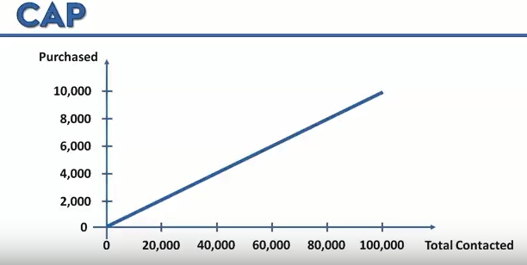

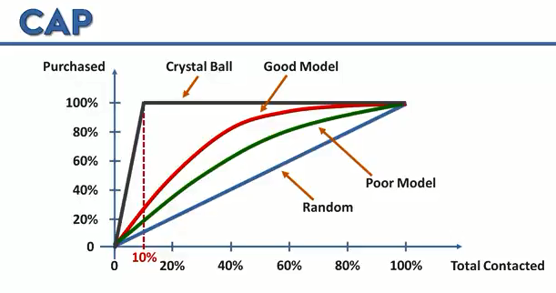

at 10% there is a spline, which is the ideal situation. As we know 10% of the people contacted are responding positive for the ad, so in ideal situation, 10% of the people are contacted and all have purchased the product. Hence spline at 10%.

CAP is not equal to ROC. It looks similar but not same. <https://www.youtube.com/watch?v=pyxTe7MOLbY&list=PL2yCeGM10HrUlu8pN0QMTiaBTAs-h_xye&index=4>

**Interpreting CAP curve:**

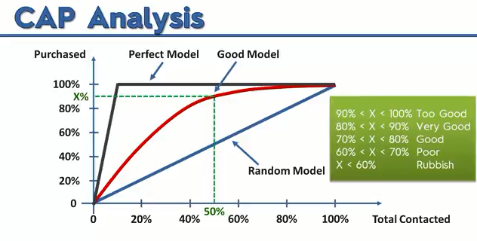

You can calculate the accuracy of your model with:

[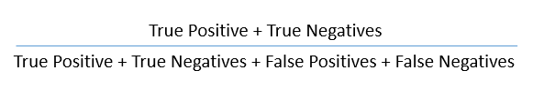](https://www.analyticsvidhya.com/wp-content/uploads/2015/11/7.png)

From confusion matrix, Specificity and Sensitivity can be derived as illustrated below:

[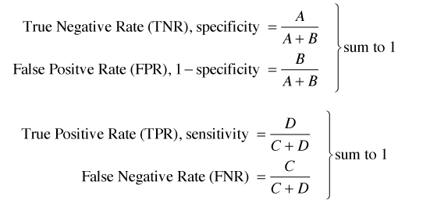](https://www.analyticsvidhya.com/wp-content/uploads/2015/11/9.png)

Specificity and Sensitivity plays a crucial role in deriving ROC curve.

**Precision:** It indicates how many values, out of all the predicted positive values, are actually positive. It is formulated as:(TP / TP + FP). **F Score:** F score is the harmonic mean of precision and recall. It lies between 0 and 1. Higher the value, better the model. It is formulated as 2((precision*recall) / (precision+recall)).

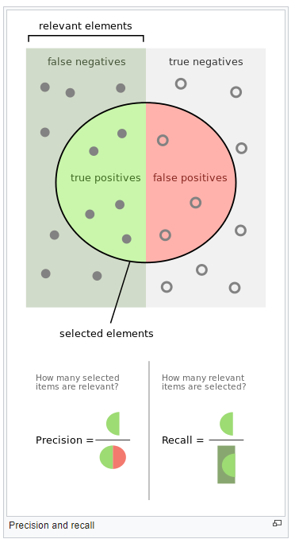

 4. **ROC Curve:** Receiver Operating Characteristic(ROC) summarizes the model’s performance by evaluating the trade offs between true positive rate (sensitivity) and false positive rate(1- specificity). For plotting ROC, it is advisable to assume p > 0.5 since we are more concerned about success rate. ROC summarizes the predictive power for all possible values of p > 0.5.  The area under curve (AUC), referred to as index of accuracy(A) or concordance index, is a perfect performance metric for ROC curve. Higher the area under curve, better the prediction power of the model. Below is a sample ROC curve. The ROC of a perfect predictive model has TP equals 1 and FP equals 0. This curve will touch the top left corner of the graph.

[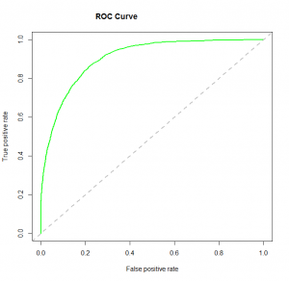](https://www.analyticsvidhya.com/wp-content/uploads/2015/11/logit_roc.png)

Note: For model performance, you can also consider likelihood function. It is called so, because it selects the coefficient values which maximizes the likelihood of explaining the observed data. It indicates goodness of fit as its value approaches one, and a poor fit of the data as its value approaches zero.

<https://www.youtube.com/watch?v=AJN2yl004-4>

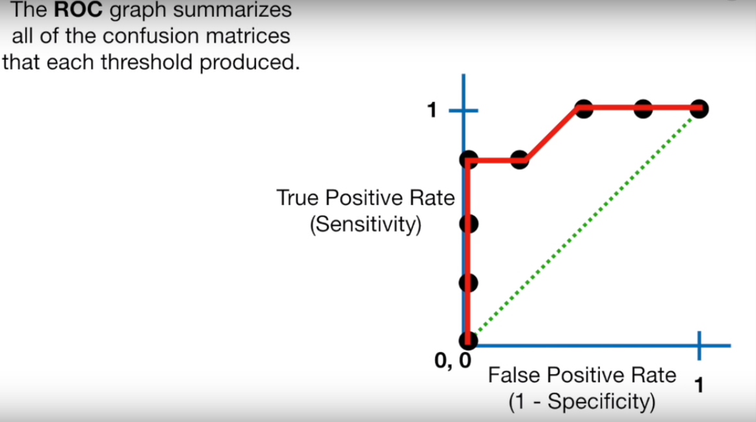

**Probability vs likelihood:**

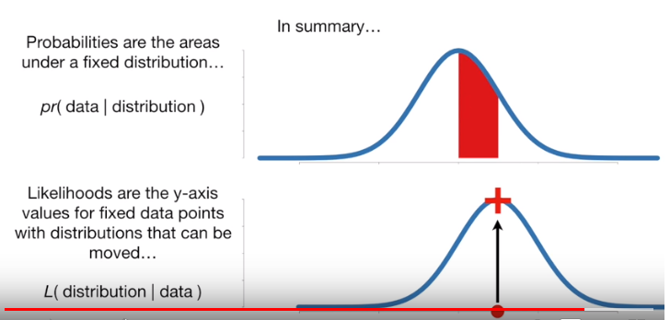

**Explanation for performance analysis of logistic regression model:**

**Ref link :** [**https://www.youtube.com/watch?v=ypO1DPEKYFo**](https://www.youtube.com/watch?v=ypO1DPEKYFo)

nnet package used for multinominal logistic regression.

multinom() is the function name.

>library(nnet)

> mymodel <- multinom(admit~ ., data=binary) #Binary is the data set

# admit, gre, gpa and rank are the varirables, predicting admit for gre,gpa and rank.

**Misclassification Rate**: (Error rate)

Overall how often is it wrong?

(FP+FN)/total

Applying predict on the actual dataset and then comparing the actual data with the model predicted data through confusion matrix as below.

> p <- predict(mymodel, binary)

> tab <- table(p, binary$admit)



20 is misclassification because model says they are admitted, but actually they are not. Similarly 98, is misclassification, as model says they are not admitted but they are admitted.

Correct classification rate is calculated as below:

> sum(diag(tab/sum(tab)))

[1] 0.705

Misclassification :

> 1-sum(diag(tab/sum(tab)))

[1] 0.295

To calculate how many students were admitted and how many not:

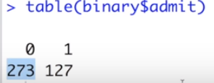

> 273/400

[1] 0.6825

Even if we predict all students are not admitted, we are right by 68%. The model which we have created is giving 70.5% so its better than the benchmark number.

> libarary(ROCR)

> pred <- predict(mymodel,binary,type="prob")

Comparing predicted and actual values:

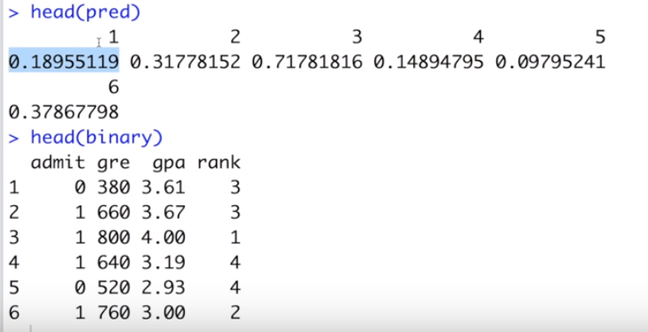

#if probability is less than 0.5, it is considered as not admitted otherwise admitted.

> hist(pred)

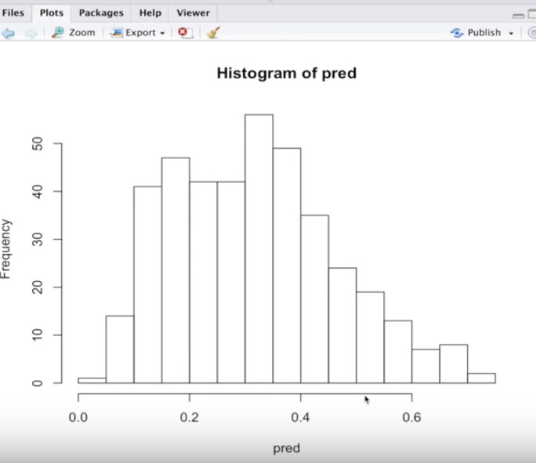

# most of the probability is from 0 to 0.8 and most are less tha 0.4.

> pred <- prediction(pred,binary$admit)

> eval <- performance(pred,"acc")

> plot(eval)

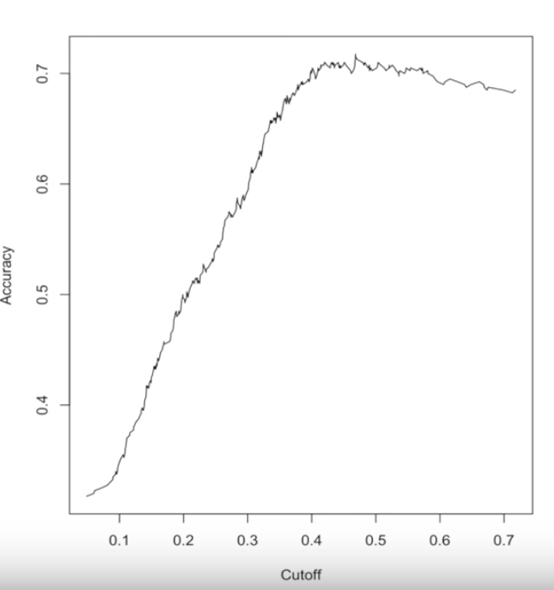

> abline(h=0.71,v=0.45)

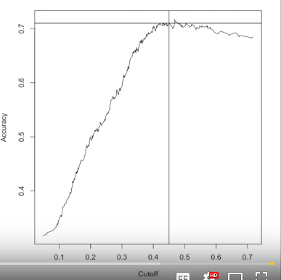

#Identify Best values

> max <- which.max(slot(eval,"y.values")[[1]])

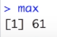

> acc <- slot(eval,"y.values")[[1]][max]

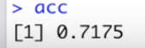

> cut <- slot(eval,"x.values")[[1]][max]

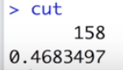

> print(c(Accuracy = acc, Cutoff = cut))

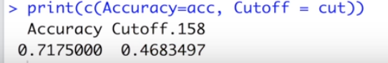

**ROC curve:**

This is used if the prediction focus is primarily on one group instead of both.

Eg: If we have bank corruption details and the aim is to identify how many banks will go bankrupt. Here the focus is only on one case.

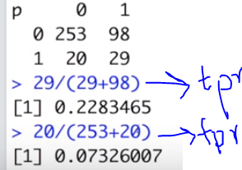

> roc <- performance(pred,"tpr","fpr")

> plot(roc,colourize = T, main = “ROC curve”, xlab = “1-specificity”, ylab=”sensitivity”)

> abline(a=0,b=1)

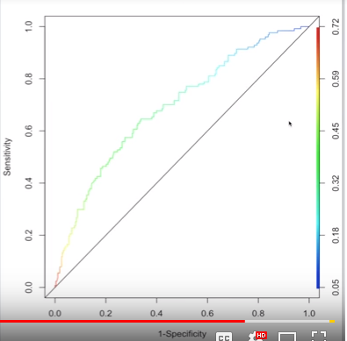

If curve is above line, model is doing good. If not, no

AUC – Area under curve.

If there are many models, to dertermine which is good, we need to calculate the area under curve to decide. 50% of area is below the curve.

> auc <- performance(pred,"auc")

> auc <- unlist(slot(auc,"y.values"))

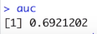

> legend(.6,.2, auc,title ="AUC",cex = 1.2) #cex indicates character size

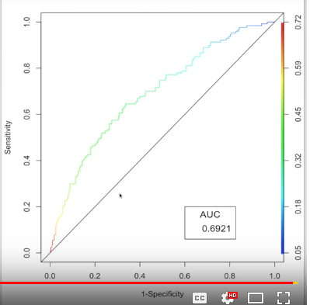

**Two way contingency tables: (logistic regression)**

Used if the response and predictor are categorical. Make sure there are no 0 cells

**Multiclass classification using Logistic regression:**

split the training data in a way that one class is considered as positive class and rest all as negative.

Similarly for other individual classes and create different models by considering each class as positive class.

Finally run all the classifiers and pick the classifier which is most confident in classifying the test observation.

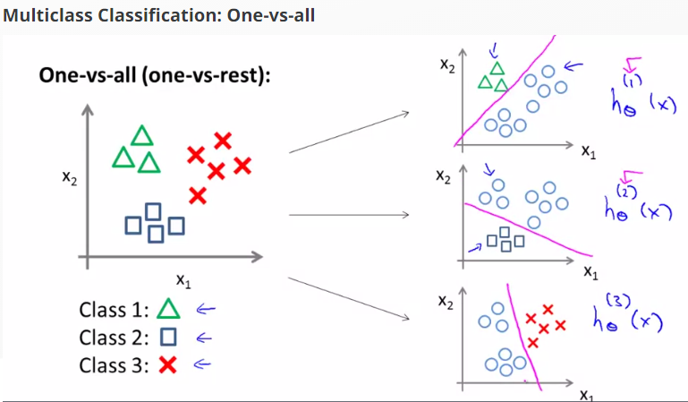

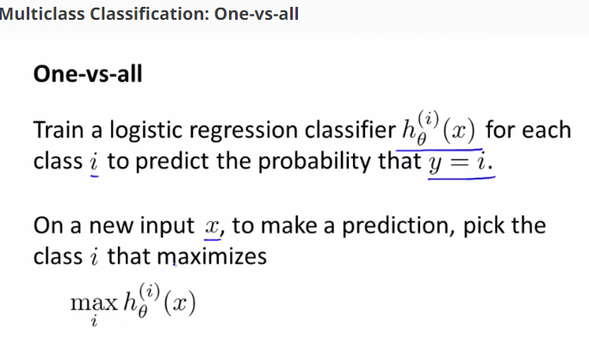

The biggest issue with one-vs-all classification is Class Imbalance.

Consider a binary classification problem with two classes - A and B. Suppose we have a situation where class A makes up 95% of the data and samples of class B occur only in the remaining 5% of the cases. Now think of a classifier trained on this data. This classifier could predict 100% of the data to be from class A and still get away with a 95% prediction accuracy.  To put it in a different perspective, there are not enough samples of class B to conclusively understand when to classify a new sample as class B.

This is a classic case of what's known as a class imbalance or a skewed distribution. Classifiers struggle to handle class imbalances.

Now to answer your question, consider a classification problem where we have 5 classes. The most balanced scenario is if there are equal number of samples of each class i.e. each class makes up 20% of the data. When you do a one-vs-all classification, you convert the problem into 5 binary classification problems. What happens now? In each of the 5 cases you end up with a 20-80 distribution (A class imbalance arises). Although your initial data was balanced, converting it into a one-vs-all problem resulted in an imbalance. This situation is not as bad as the earlier discussed 95-5 example but  nevertheless, still is a problem. Things become more difficult when you have more number of classes or worse, if their distributions are very skewed.

**WOE(Weight of evidence):**

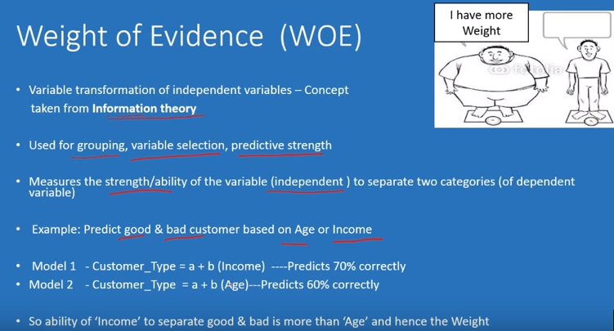

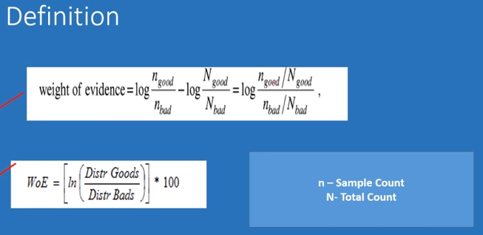

**Information value:**

Used to identify the variables which have high predictive power.

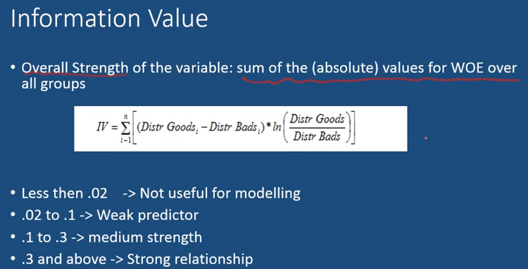

**Eg:** [**http://r-statistics.co/Logistic-Regression-With-R.html**](http://r-statistics.co/Logistic-Regression-With-R.html)

inputData <- read.csv("http://rstatistics.net/wp-content/uploads/2015/09/adult.csv")

str(inputData)

table(inputData$ABOVE50K)

# train test split

input_ones = inputData[which(inputData$ABOVE50K==1),]

input_zeros = inputData[which(inputData$ABOVE50K==0),]

input_ones_training_rows = sample(1:nrow(input_ones), 0.7*nrow(input_ones))

input_zeros_training_rows = sample(1:nrow(input_zeros), 0.7*nrow(input_zeros))

training_ones <- input_ones[input_ones_training_rows,]

training_zeros <- input_zeros[input_zeros_training_rows,]

training_data <- rbind(training_ones, training_zeros)

table(training_data$ABOVE50K)

testing_ones <- input_ones[-input_ones_training_rows,]

testing_zeros <- input_zeros[-input_zeros_training_rows,]

testing_data <- rbind(testing_ones, testing_zeros)

table(testing_data$ABOVE50K)

logit_model <- glm(ABOVE50K ~ AGE+EDUCATIONNUM + OCCUPATION + CAPITALGAIN +RELATIONSHIP, data = training_data, family = binomial(link="logit"))

y_pred <- predict(logit_model, newdata = testing_data, type='response')

predicted <- plogis(predict(logit_model, testing_data))

library(InformationValue)

optCutoff <- optimalCutoff(testing_data$ABOVE50K, predicted) [1]

summary(logit_model)

vif(logit_model)

misClassError(testing_data$ABOVE50K, predicted, threshold = optCutoff)

plotROC(testing_data$ABOVE50K , predicted)

Concordance(testing_data$ABOVE50K, predicted)

confusionMatrix(testing_data$ABOVE50K, predicted, threshold = optCutoff)

**Poisson Regression:**

If the response variable is in form of counts and not in form of fractional numbers.

Eg: count of number of births, number of foodball wins.

General mathematical equation is

log(y) = a + b1x1 + b2x2 + bnxn.....

glm(formula,data,family)

Model1 = glm(responsevariable ~ predictors, data = “datasetname”,family=poisson(link=”log”))

**Survival Analysis:**

Survival analysis deals with predicting the time when a specific event is going to occur. It is also known as failure time analysis or analysis of time to death. For example predicting the number of days a person with cancer will survive or predicting the time when a mechanical system is going to fail.

require(survival)

head(bladder)

bladder[100:105,]

survobject <- with(bladder[100:105,],Surv(stop,event))

survobject

survobject[,1:2]

cox1 = coxph(Surv(stop,event)~rx+number+size+enum,data=bladder)

summary(cox1)

plot(survfit(cox1),xlab = "Days",ylab = "Survival Rate",conf.int = TRUE)

cox2 = coxph(Surv(stop,event)~strata(rx)+number+size+enum,data=bladder)

summary(cox2)

plot(survfit(cox2),xlab="Days",ylab="survival rate",conf.int=TRUE,col=1:2)

cox.zph(cox1)

cox.zph(cox2)

head(bladder2)

ag1 <-coxph(Surv(start,stop,event)~rx+number+size+enum+cluster(id),data=bladder2)

ag2 <-coxph(Surv(start,stop,event)~ strata(rx)+number+size+enum+cluster(id),data=bladder2)

plot(survfit(ag1),conf.int=TRUE)

plot(survfit(ag2),conf.int=TRUE,col=1:2)

legend("topright",legend=c(1,2),lty=1,col=1:2,text.col = 1:2,title="rx")

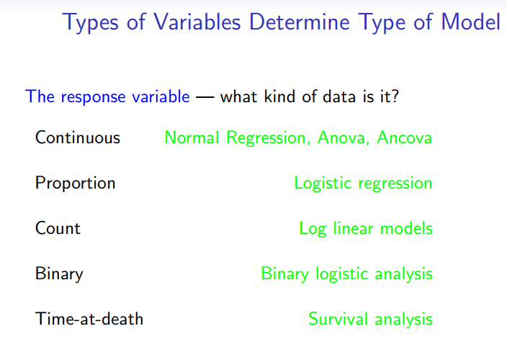

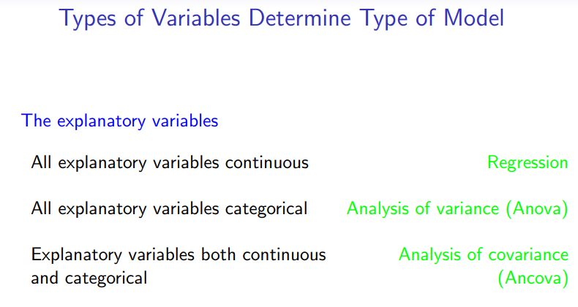

**Model diagnosis:**

1. Verify Residuals vs Fitted, Q-Q plot and histogram of the residuals.
2. AIC – Akaike’s Information Criterion

BIC – Bayesian Information Criterion

Both should be lower for best model.

1. Anova – used to compare the models. Less p value indicates models are different.
2. Cross validation or k fold cross validation:
   1. boot package has cv.glm for performing cross-validation on. It works only on **generalized linear models.** 
      1. > require(boot)
      2. > houseG1 = glm(ValuePerSqFt ~Units +SqFt +Boro,data=housing,family = gaussian(link = "identity"))
      3. > houseCV1 = cv.glm(housing, houseG1, K=5)
      4. > houseCV1$delta
      5. [1] 1898.202 1895.222

o/p includes 2 values. 1. Raw cross validation error and 2. Adjusted cross validation error. Which ever model having least adjusted cross validation error will be the best model.

**Data Mining Problems**

Data Mining gives valuable information from the dataset. Clustering, classification, prediction and association rule mining concepts/techniques are used to solve data mining problems. To divide the dataset into a set of segments (groups) clustering techniques are used. To classify the new input into any one of predefined classes classification techniques are used. To predict/forecast the output value for the set of input variables prediction technique like regression is used. In prediction the output variable will be in the numeric format and in classification the output will be in the categorical format. To identify the sequence of events/items association rule mining is used.

Arules package – apriori algorithm used in data mining.

**Association Rule Learning(ARL) – Apriori Algorithm:**

Apriori algorithm is..



**Eg:**

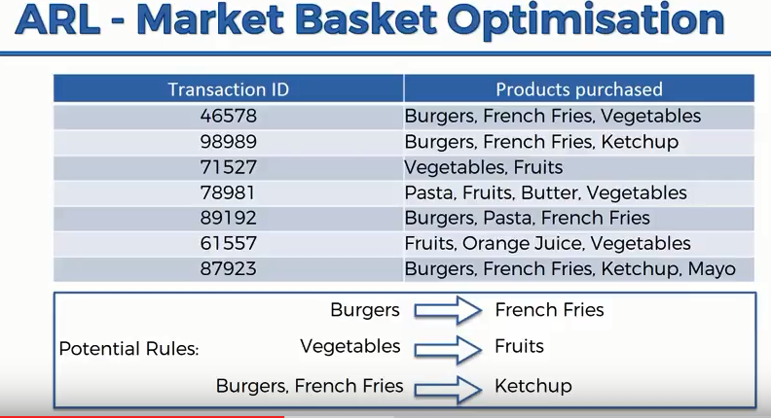

**Apriori algorithm as 3 parts:**

1. **Support – lets say 10 transactions out of 100 contains the product French fries..hence,**

**Support = 10/100**



1. **Confidence – Lets say 7 people have got both burger and French fries, out of 10 people who got French fries , then condience is 7/10**

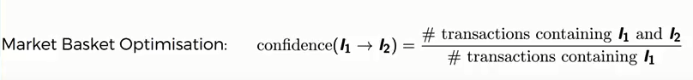

1. **Lift – confidence/support**

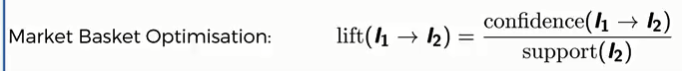

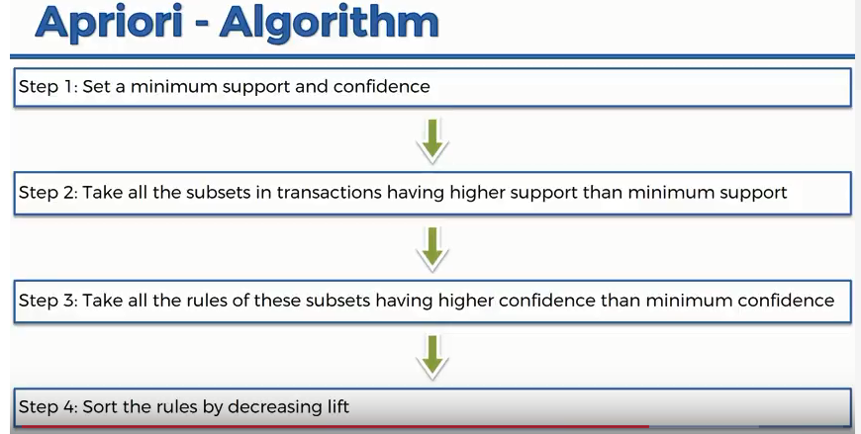

Apriori is slow because it has to consider lot of combinations. Hence, we need to have threshold on selecting support and confidence.

arules package takes sparse matrix as input and not dataframe.

# Apriori

# Data Preprocessing

# install.packages('arules')

>library(arules)

>dataset = read.csv('Market_Basket_Optimisation.csv', header = FALSE)

>dataset = read.transactions('Market_Basket_Optimisation.csv', sep=',',rm.duplicates = TRUE) # to convert into sparse matrix

>summary(dataset)

#frequency plot

>itemFrequencyPlot(dataset , topN = 10)

#training apriori on dataset

>rules<- apriori(dataset, parameter = list(support = 0.004, confidence=0.2))

# support = products that are bought atleast 3 times in a day..so if we convert it for the week 3*7..divide it by 7500 as support is number of transactions containing an item/total number of transactions.

# min support = 3*7/7500 = 0.0028 which is rounded to 0.003

#visualization

>inspect(sort(rules,by='lift')[1:10])

**Cross validation or k fold cross validation:**

Cross validation is done by splitting the training data set into k non overlapping partitions and running the model each time by considering one of the fold as test data and rest(k-1) as training data.

Totally k times the model runs, finally average of the accuracy metric is taken to find the best fit model.

caret package is needed -> for performing cross validation and to apply multiple models like random forest etc.

To view the list of models applied through caret package,

names(getModelInfo()) 🡺 this will return all list of models covered under caret package.

train() function used to apply the model to dataset under caret package.

In **stratified k-fold cross-validation**, the folds are selected so that the mean response value is approximately equal in all the folds. In the case of a dichotomous classification, this means that each fold contains roughly the same proportions of the two types of class labels.

Stratification is the process of rearranging the data as to ensure each fold is a good representative of the whole. For example in a binary classification problem where each class comprises 50% of the data, it is best to arrange the data such that in every fold, each class comprises around half the instances.

stratification is generally a better scheme, both in terms of bias and variance, when compared to regular cross-validation.

**K fold cross validation implementation:**

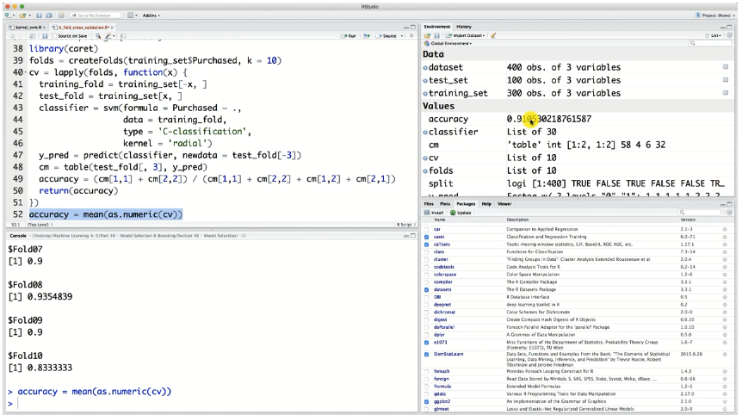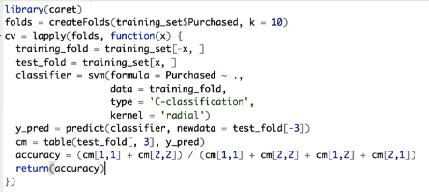

cv contains the list of all accuracies.

**returnResamp parameter in cross validation :**

This returns the information on the resamples

cctrl1 <- trainControl(method = "cv", number = 5, returnResamp = "all")

test_class_cv_form <- train(SZI_1027.PV ~ ., data = train_step,

method = "glmStepAIC",

trControl = cctrl1,

#preProc = c("center", "scale"),

trace = 0)

Ref : <https://stackoverflow.com/questions/28964502/caret-package-for-r-which-samples-are-held-out>

**Caret package: train parameters for each model:**

<http://topepo.github.io/caret/train-models-by-tag.html>

**Difference between OLS(Ordinary least square or linear regression) and GLM (Generalized Linear Model):**

|  |  |
| --- | --- |
| **OLS(Ordinary least square or linear regression)** | **GLM (Generalized Linear Model)** |
| Assumes errors are normally distributed or gaussian. | GLM generalize the errors terms distribution to a family of distributions, called exponential family. It includes poisson, binomial, negative binomial or gamma etc. |
| Indentity link function | Link function such as logit, log |
|  |  |

**Difference between Regression and Classification:**

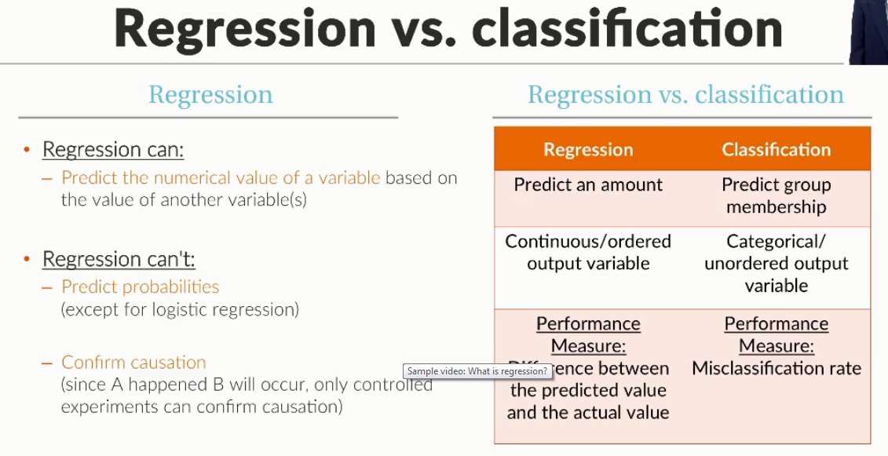

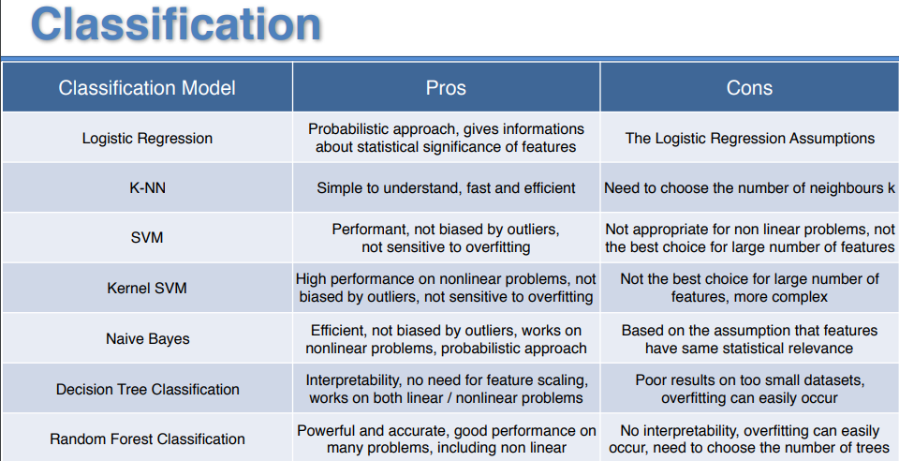

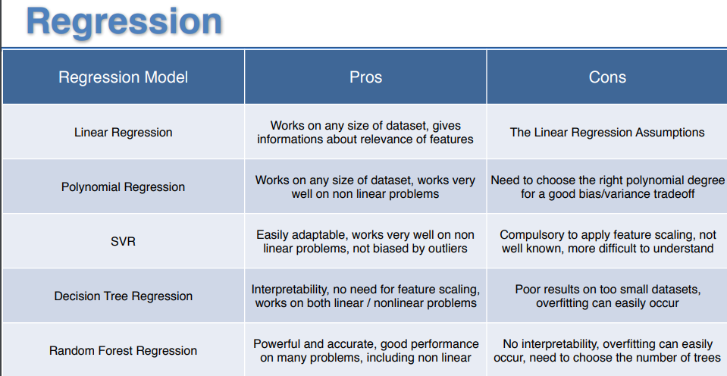

**Non-Linear Models:**

In statistics, nonlinear regression is a form of regression analysis in which observational data are modeled by a function which is a nonlinear combination of the model parameters and depends on one or more independent variables.

1. **Non-Linear least square:**

Eg: using location of wifi connected devices to determine the location of wifi hotspot.

> head(wifi)

Distance x y

1 21.87559 28.60461 68.429628

2 67.68198 90.29680 29.155945

3 79.25427 83.48934 0.371902

4 44.73767 61.39133 80.258138

5 39.71233 19.55080 83.805855

6 56.65595 71.93928 65.551340

> wifimod1 = nls(Distance ~ sqrt((betaX - x)^2+(betaY - y)^2),data=wifi, start = list(betaX = 50, betaY =50))

> summary(wifimod1)

Formula: Distance ~ sqrt((betaX - x)^2 + (betaY - y)^2)

Parameters:

Estimate Std. Error t value Pr(>|t|)

betaX 17.851 1.289 13.85 <2e-16 ***

betaY 52.906 1.476 35.85 <2e-16 ***

---

Signif. codes: 0 ‘***’ 0.001 ‘**’ 0.01 ‘*’ 0.05 ‘.’ 0.1 ‘ ’ 1

Residual standard error: 13.73 on 198 degrees of freedom

Number of iterations to convergence: 6

Achieved convergence tolerance: 3.846e-06

1. Splines:
2. Decision Trees:

Works for both classification and regression

> creditnames = c("Checking","Duration","CreditHistory","Purpose","CreditAmount","Savings","Employment","InstallmentRate","GenderMarital","Otherdebtors","YearsAtResidence","RealEstate","Age","OtherInstallment","Housing","ExistingCredits","Job","NumLiable","Phone","Foreign","Credit")

> names(credit) = creditnames

> creditTree =rpart(Credit ~ CreditAmount +Age+CreditHistory+Employment,data=credit)

> creditTree

n= 1000

node), split, n, deviance, yval

* denotes terminal node

1) root 1000 210.00000 1.300000

2) CreditHistory=A32,A33,A34 911 180.03070 1.271131

4) CreditAmount< 7760.5 846 158.37470 1.249409

8) CreditHistory=A34 278 35.65468 1.151079 *

9) CreditHistory=A32,A33 568 118.71650 1.297535

18) Age>=25.5 432 83.44213 1.261574 *

19) Age< 25.5 136 32.94118 1.411765 *

5) CreditAmount>=7760.5 65 16.06154 1.553846 *

3) CreditHistory=A30,A31 89 21.43820 1.595506 *

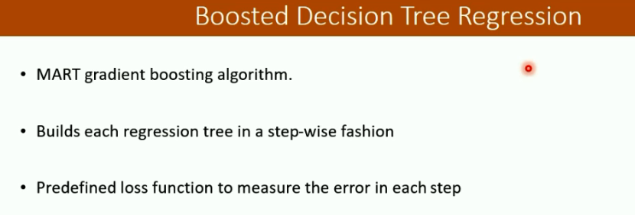

MART – Multiple Additive Regression Trees.

MART is the "trademark" name for Gradient Boosted Decision Trees.  The best R library to use is the "gbm" library.

As their name implies, Regression Trees are best for Regression, not Classification, but if you are planning on binary classification or classes with some strong ordering they'll work fine.

1. Random forest:

require(randomforest)

**Time series and Autocorrelation:**

**Ref link :** [**https://www.youtube.com/watch?v=Y2khrpVo6qI**](https://www.youtube.com/watch?v=Y2khrpVo6qI)

Good article :[**https://www.datascience.com/blog/introduction-to-forecasting-with-arima-in-r-learn-data-science-tutorials**](https://www.datascience.com/blog/introduction-to-forecasting-with-arima-in-r-learn-data-science-tutorials)

Little book on time series:**file:///C:/Users/saranya_govindaraj/Downloads/a-little-book-of-r-for-time-series.pdf**

Rules for ARIMA: **http://people.duke.edu/~rnau/arimrule.htm**

**Creating a time series**

The **ts()** function will convert a numeric vector into an R time series object. The format is **ts(***vector*,**start=, end=, frequency=)** where start and end are the times of the first and last observation and frequency is the number of observations per unit time (1=annual, 4=quartly, 12=monthly, etc.).

**Autoregressive (AR) model:** The AR part involves regressing the variable on its own lagged (i.e., past) values.

y value depends only on the values of that variable took in previous periods plus an error term or white noise(mean is 0 and sd of 1).

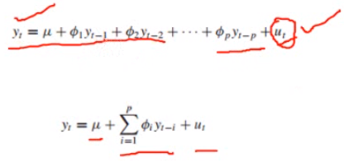

u(t) is the error or white noise.

Y(t-p) 🡺 p lag 🡺 p is some time..The model is called Autoregressive p lag. AR(p)

Eg: predicting stock value based on old period values.

Stock price for last 30 days..it depends on yesterday, day before yesterday….. dependency will reduce as we increase the lags. That’s were we need stationarity property.

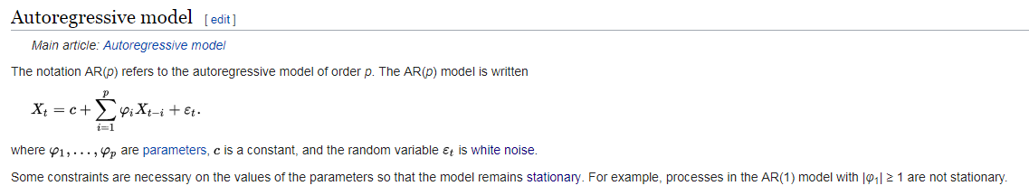

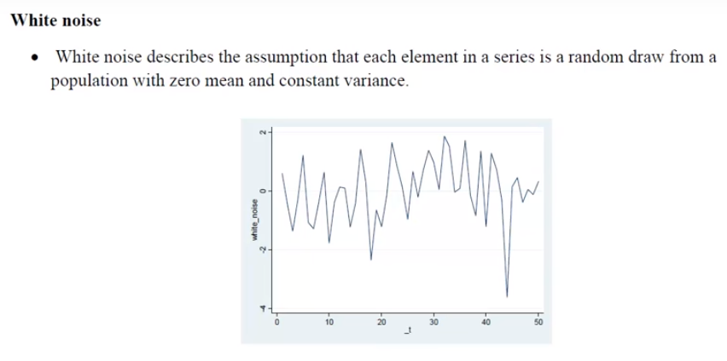

**Stationarity:**

* Desirable property of AR models. Dependency of time series prediction at time t ie.y(t) depends more on y(t-1) and less on y(t-2) and so on.. below is the dependency graph . This is the property of stationary series. For AR model, AIC should be stationary. If not, we need to convert to stationary and then apply AR model.

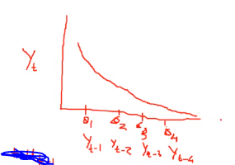

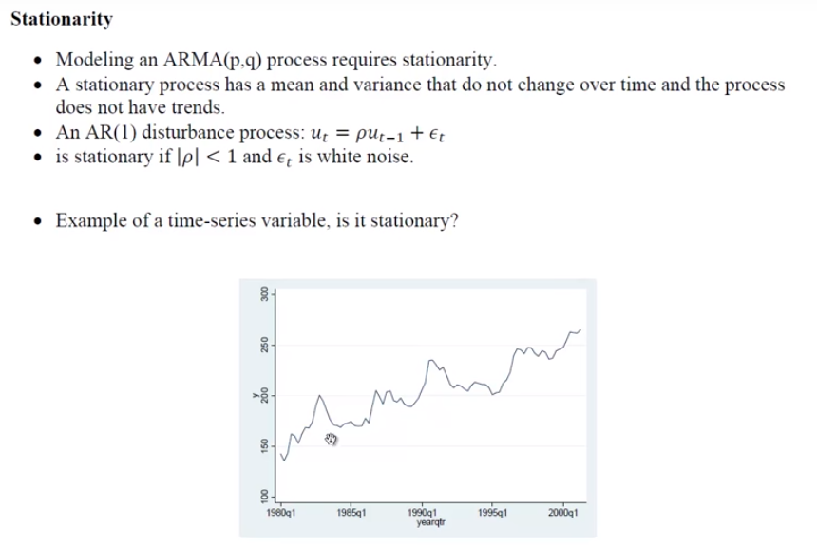

No..

Some cases can be confusing — a time series with cyclic behaviour (but not trend or seasonality) is stationary. That is because the cycles are not of fixed length, so before we observe the series we cannot be sure where the peaks and troughs of the cycles will be.

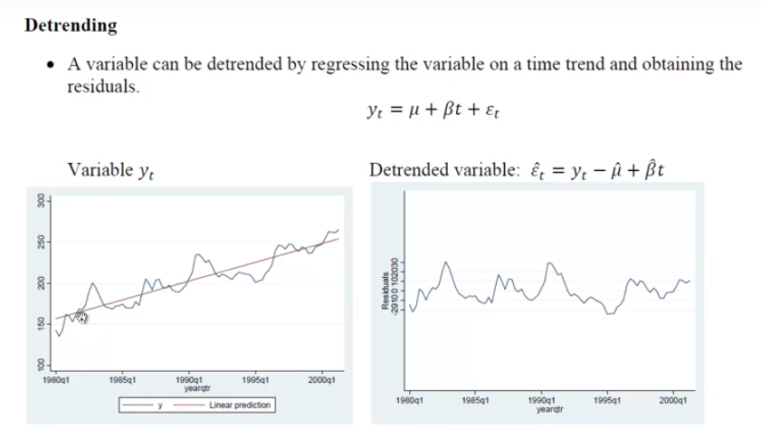

**Detrending:**

Use linear regression to model the Time Series data with linear indices (Ex: 1, 2, .. n). The resulting model’s residuals is a representation of the time series devoid of the trend. In case, if some trend is left over to be seen in the residuals (like what it seems to be with ‘JohnsonJohnson’ data below), then you might wish to add few predictors to the lm() call (like a forecast::seasonaldummy, forecast::fourier or may be a lag of the series itself), until the trend is filtered.

>trModel <- lm(JohnsonJohnson ~ c(1:length(JohnsonJohnson)))

>plot(resid(trModel), type="l") # resid(trModel) contains the de-trended series.

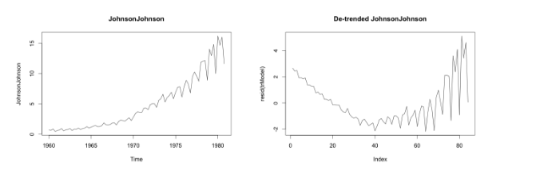

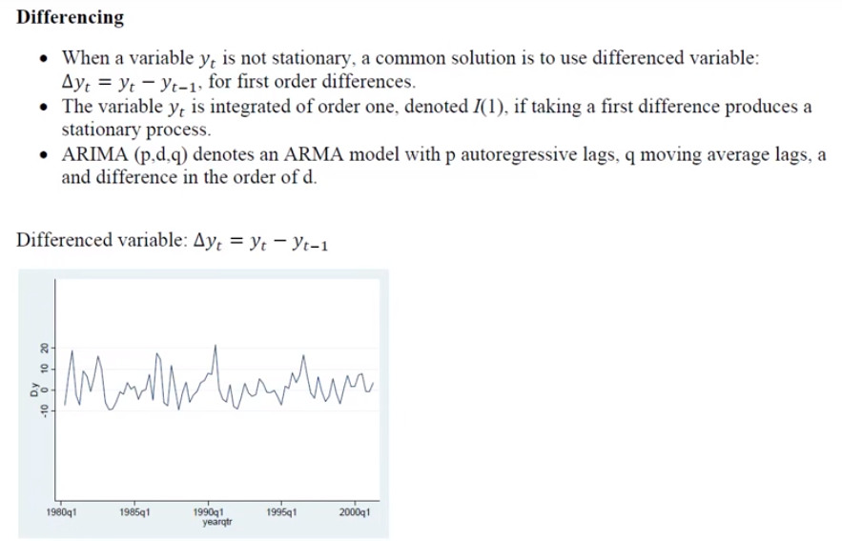

**Differencing – to make the series stationary:**

Differencing a time series means, to subtract each data point in the series from its successor. It is commonly used to make a time series stationary. For most time series patterns, 1 or 2 differencing is necessary to make it a stationary series.

But if the time series appears to be seasonal, a better approach is to difference with respective season’s data points to remove seasonal effect. After that, if needed, difference it again with successive data points. But, How to know how many differencing is needed? the nsdiffs and ndiffs from forecast package can help find out how many seasonal differencing and regular differencing respectively is needed to make the series stationary.

>plot(AirPassengers)

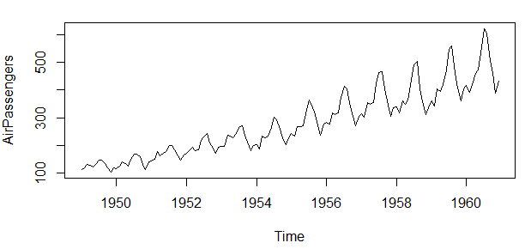

**# Seasonal Differencing**

A seasonal difference is the difference between an observation and the corresponding observation from the previous year.

y′(t)=y(t)−y(t−m) where m= number of seasons.

These are also called “**lag-m differences**” as we subtract the observation after a lag of m periods.

Sometimes it is necessary to do both a seasonal difference and a first difference to obtain stationary data.

Forecasts from this model are equal to the last observation from the relevant season. That is, this model gives seasonal naïve forecasts.

It is important that if differencing is used, the differences are interpretable. First differences are the change between **one observation and the next**. Seasonal differences are the change between **one year to the next**. Other lags are unlikely to make much interpretable sense and should be avoided.

nsdiffs() which uses seasonal unit root tests to determine the appropriate number of seasonal differences required.

>nsdiffs(AirPassengers) # number for seasonal differencing needed

#> 1

AirPassengers_seasdiff <- diff(AirPassengers, lag=frequency(AirPassengers), differences=1) # seasonal differencing

plot(ap_seasdiff, type="l", main="Seasonally Differenced") # still not stationary!

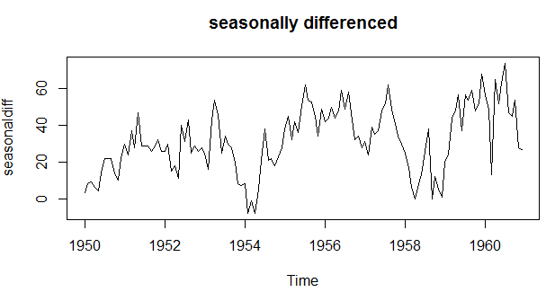

# Make it stationary

ndiffs(AirPassengers_seasdiff) # number of differences need to make it stationary

#> 1

stationaryTS <- diff(AirPassengers_seasdiff, differences= 1)

plot(stationaryTS, type="l", main="Differenced and Stationary") # appears to be stationary

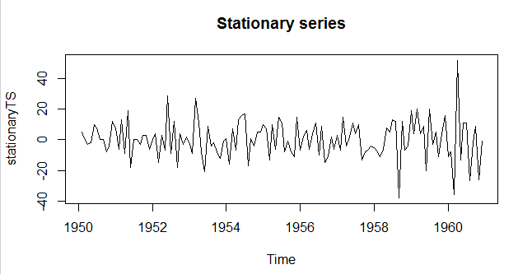

**(or)**

ns <- nsdiffs(x)  
**if**(ns > 0) {  
  xstar <- **diff**(x,**lag**=**frequency**(x),differences=ns)  
} **else** {  
  xstar <- x  
}  
nd <- ndiffs(xstar)  
**if**(nd > 0) {  
  xstar <- **diff**(xstar,differences=nd)  
}

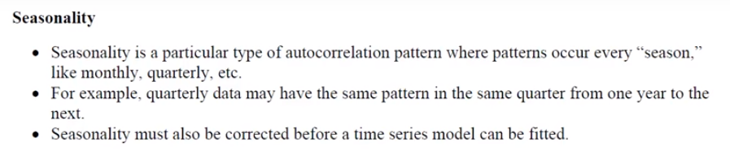

**Difference between Seasonality and cyclic behavior of series:**

If the fluctuations are not of fixed period then they are cyclic; if the period is unchanging and associated with some aspect of the calendar, then the pattern is seasonal.

 In general, the average length of cycles is longer than the length of a seasonal pattern, and the magnitude of cycles tends to be more variable than the magnitude of seasonal patterns.

**De-seasonalize a time series:**

De-seasonalizing throws insight about the seasonal pattern in the time series and helps to model the data without the seasonal effects. So how to de-seasonalize? Step 1: De-compose the Time series using forecast::stl() Step 2: use seasadj() from ‘forecast’ package

>library(forecast)

>ts.stl <- stl(TS,"periodic") # decompose the TS

>ts.sa <- seasadj(ts.stl) # de-seasonalize

>plot(AirPassengers, type="l") # original series

>plot(ts.sa, type="l") # seasonal adjusted

>seasonplot(ts.sa, 12, col=rainbow(12), year.labels=TRUE, main="Seasonal plot: Airpassengers") # seasonal frequency set as 12 for monthly data.

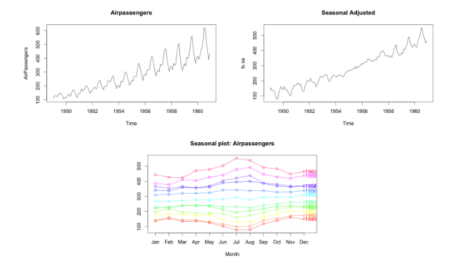

>tsdisplay(AirPassengers) # plots the timeseries along with its acf and pacf.

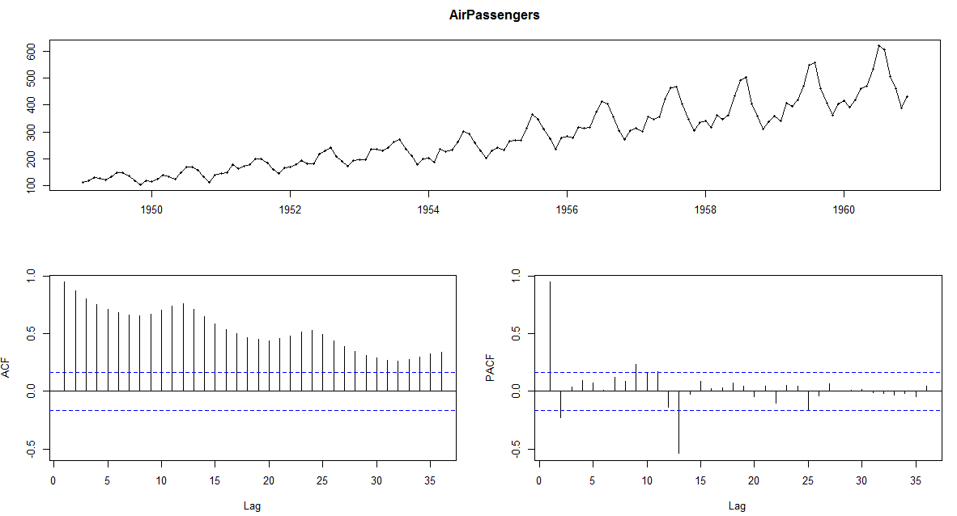

**ACF and PACF: (Correlograms)**

ACF gives number of MA terms in the model

PACF gives number of AR terms in the model. **Partial Autocorrelation** is the correlation of the time series with a lag of itself, with the linear dependence of all the lags between them removed.

 A partial autocorrelation is a summary of the relationship between an observation in a time series with observations at prior time steps with the relationships of intervening observations removed.

**CCF – cross correlation function:**

  cross-correlation is a [measure of similarity](https://en.wikipedia.org/wiki/Similarity_measure) of two series as a function of the displacement of one relative to the other. Cross-correlations are useful for determining the time delay between two signals. First you want to make sure that the series is stationary. The stationarity is essential so that the variances and covariances can be reduced to only the 1st and (1+k)th variables. At lag 0, this just tells you the correlation between the two series. At kth lag, the cross correlation tells you the correlation between between X and Y at lag k. Since X and Y have large correlation at lag 0, you can expect them to have large crosscorrelation upto larger lags.

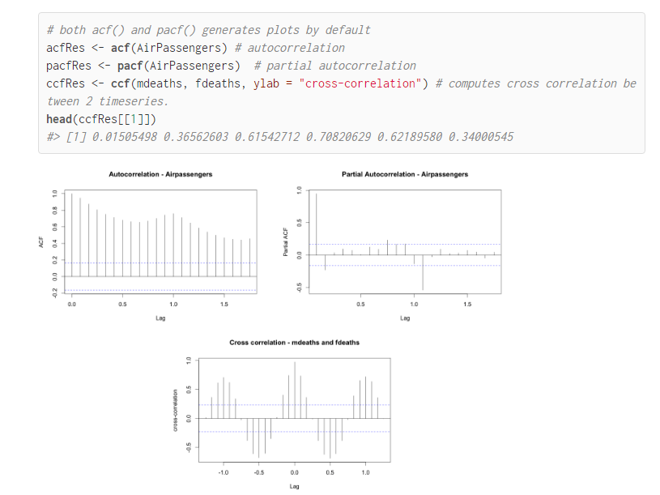

If the data are from an ARIMA(p,d,0) or ARIMA(0,d,q) model, then the ACF and PACF plots can be helpful in determining the value of p or q. If both p and q are positive, then the plots do not help in finding suitable values of p and q.

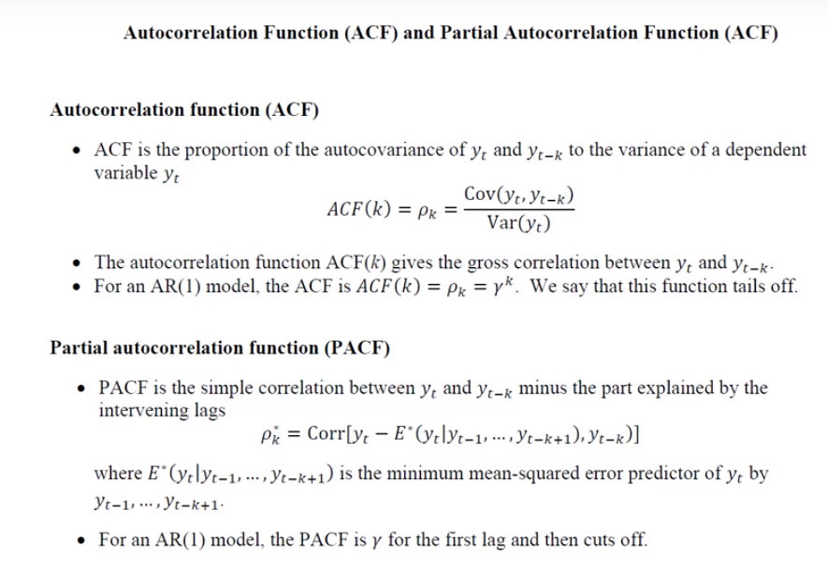

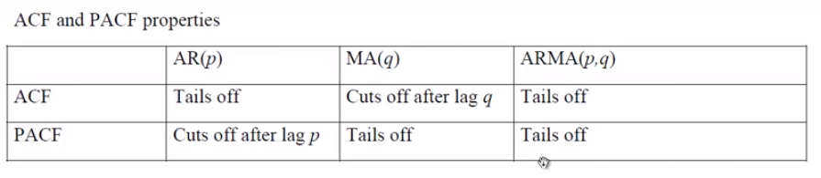

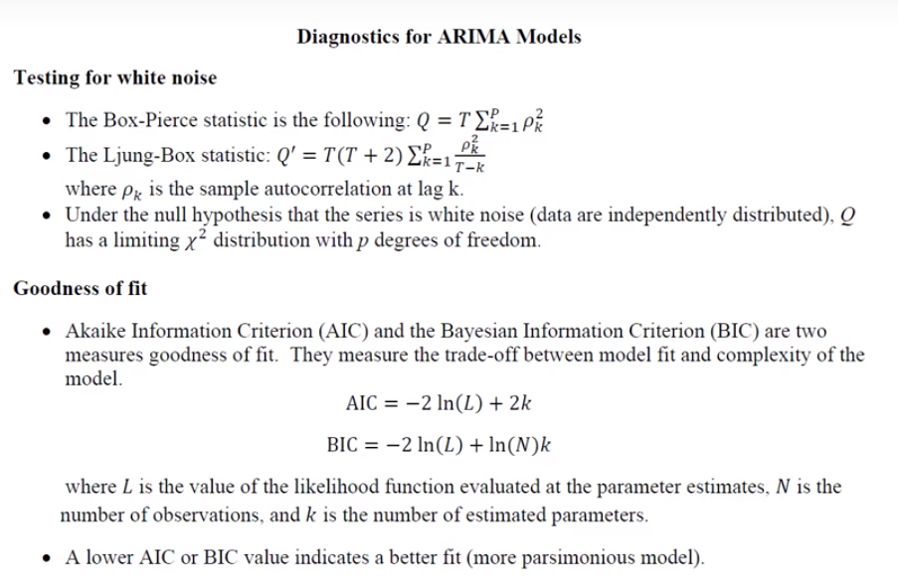

**Moving Average Timeseries model: (MA)**

In time series analysis, the moving-average (MA)model is a common approach for modeling univariate time series. The moving-average model specifies that the output variable depends linearly on the current and various past values of a stochastic (imperfectly predictable) term.

The MA part involves modeling the [error term](https://en.wikipedia.org/wiki/Errors_and_residuals_in_statistics) as a [linear combination](https://en.wikipedia.org/wiki/Linear_combination) of error terms occurring contemporaneously and at various times in the past.

Rather than use past values of the forecast variable in a regression(as in autoregressive models), a moving average model uses past forecast errors in a regression-like model.

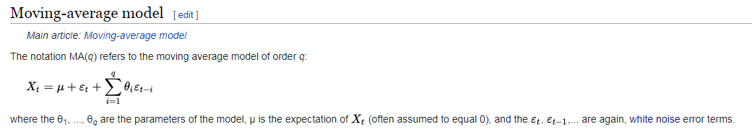

**Autocorrelation:**

Relating y(t) with its previous time lags. Y(t) compared with y(t-1) , y(t-2)… as we go further, there will not be any correlation. We can ignore those values where there is no correlation for prediction.

**ARMA(Auto Regressive Moving Average Model) = AR +MA**

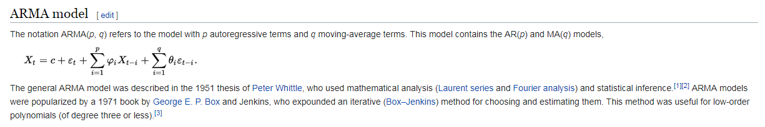

**Dickey Fuller test:** for testing stationarity.

**Stationarity :** A stationary time series is one whose statistical properties such as mean, variance, autocorrelation etc are all constant over time.

**Augmented Dickey fuller test: (package tseries)**

**Null hypothesis: Data is non-stationary**

>library(tseries)

>adf.test(dependent_variable, alternative = “stationary”, k=”number of additional lags” )

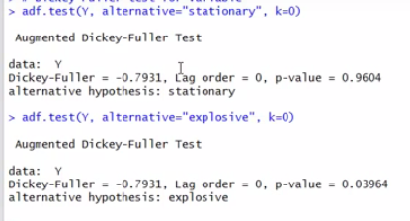

If p value is greater than 0.05, we can reject alternate hypothesis.

In second example, p <0.05, we need to accept explosive hypothesis.

**kpss.test:**

**Null hypothesis: Data is stationary**

KPSS: Another popular unit root test is the Kwiatkowski-Phillips-Schmidt-Shin (KPSS) test. This reverses the hypotheses, so the null-hypothesis is that the data are stationary. In this case, small p-values (e.g., less than 0.05) suggest that differencing is required.

kpss = kpss.test(ts[,1])

Warning message:

In kpss.test(ts[, 1]) : p-value greater than printed p-value

kpss

        KPSS Test for Level Stationarity

data:  ts[, 1]

KPSS Level = 0.1399, Truncation lag parameter = 1, p-value = 0.1

**ARIMA model: (**good for predicting short term future and not long term.)

Ref link : <https://www.youtube.com/watch?v=a5A0dTg5T4k>

|  |  |
| --- | --- |
| White noise | ARIMA(0,0,0) |
| Random walk | ARIMA(0,1,0) with no constant |
| Random walk with drift | ARIMA(0,1,0) with a constant |
| Autoregression | ARIMA(*p*,0,0) |
| Moving average | ARIMA(0,0,*q*) |

The value of d also has an effect on the prediction intervals — the higher the value of d, the more rapidly the prediction intervals increase in size. For d=0, the long-term forecast standard deviation will go to the standard deviation of the historical data, so the prediction intervals will all be essentially the same.

This behaviour is seen in below figure where d=0 and c≠0. In this figure, the prediction intervals are the same for the last few forecast horizons, and the point forecasts are equal to the mean of the data.

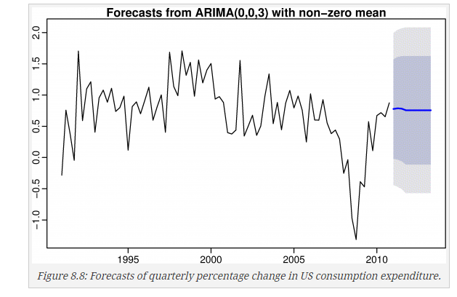

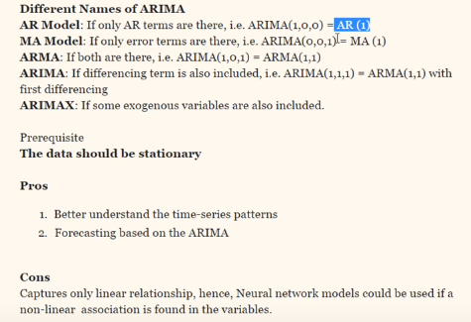

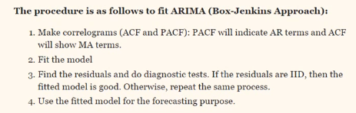

**O/P of arima(“variablename”,order=c(1,0,0))**

Coefficient of ar term should not be close to 1. If it is close to 1, it indicates some sort of random model which is non-stationary.

Compare the AIC value of different arima models to determine, which is good.

AIC - AIC estimates the relative information lost by a given model: the less information a model loses, the higher the quality of that model.

AICc - When the [sample](https://en.wikipedia.org/wiki/Sample_(statistics)) size is small, there is a substantial probability that AIC will select models that have too many parameters, i.e. that AIC will overfit. To address such potential overfitting, AICc was developed: AICc is AIC with a correction for small sample sizes. Thus, AICc is essentially AIC with an extra penalty term for the number of parameters.

To confirm if the chosen model is statistically significant:

Check the autocorrelation of residuals:

tsdiag(arima.final.model_name) 🡺 errors should be white noise with zero mean and 1 sd with no patterns.

**scan(): used to read a file and can skip lines while reading. Below skips 3 lines at top.**

> kings <- scan("http://robjhyndman.com/tsdldata/misc/kings.dat",skip=3)

**Additive model:**

Converting multiplicative model to additive as first step by taking log on the dependent variable

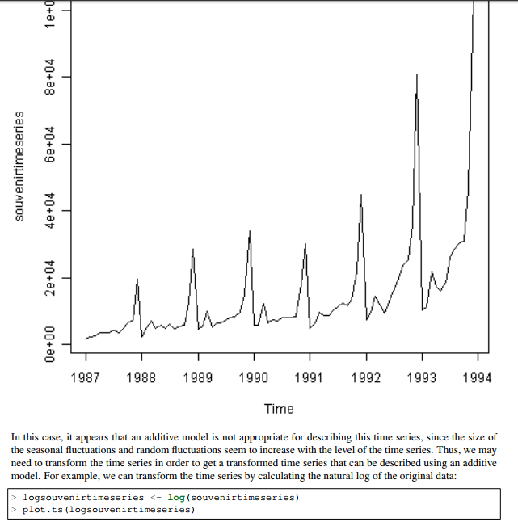

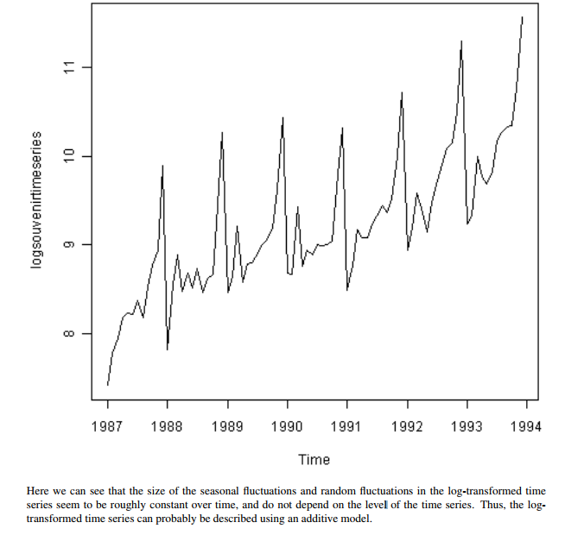

**SMA():**

SMA() in TTR package, is used to smooth the time series data using simple moving average.

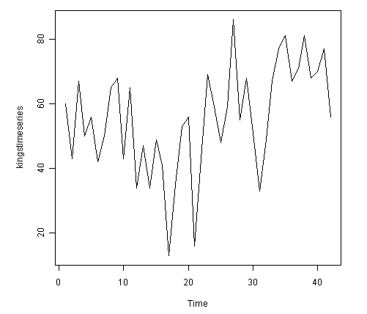

> kingstimeseriesSMA8 <- ma(kingstimeseries,n=8)

> plot.ts(kingstimeseriesSMA8)

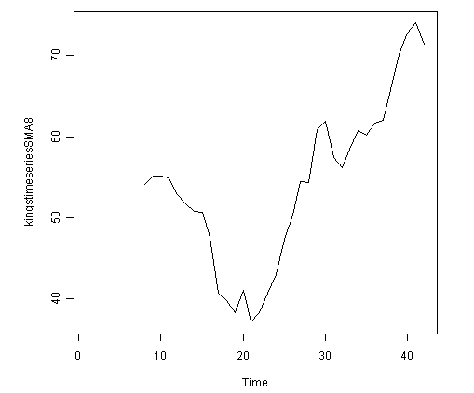

The data smoothed with a simple moving average of order 8 gives a clearer picture of the trend component, and we can see that the age of death of the English kings seems to have decreased from about 55 years old to about 38 years old during the reign of the first 20 kings, and then increased after that to about 73 years old by the end of the reign of the 40th king in the time series.

**Decomposing Seasonal Data**

This function estimates the trend, seasonal, and irregular components of a time series that can be described using an additive model.

> birthstimeseriescomponents <- decompose(birthstimeseries)

> plot(birthstimeseriescomponents)

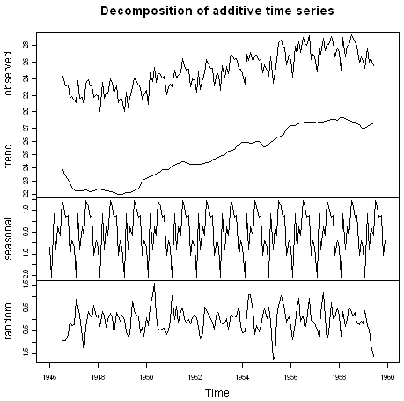

**Classical decompose is not recommended because of following reasons:**

**Ref link:** **https://www.otexts.org/fpp/6/5**

* The estimate of the trend is unavailable for the first few and last few observations. For example, if m=12, there is no trend estimate for the first six and last six observations. Consequently, there is also no estimate of the remainder component for the same time periods.
* Classical decomposition methods assume that the seasonal component repeats from year to year. For many series, this is a reasonable assumption, but for some longer series it is not.
* Occasionally, the value of the time series in a small number of periods may be particularly unusual. For example, monthly air passenger traffic may be affected by an industrial dispute making the traffic during the dispute very different from usual. The classical method is not robust to these kinds of unusual values.

**X-12-ARIMA:**

The X-12-ARIMA method is based on classical decomposition, but with many extra steps and features to overcome the drawbacks of classical decomposition that were discussed in the previous section. In particular, the trend estimate is available for all observations including the end points, and the seasonal component is allowed to vary slowly over time. It is also relatively robust to occasional unusual observations. X-12-ARIMA handles both additive and multiplicative decomposition, but only allows for quarterly and monthly data

**STL:**

STL has several advantages over the classical decomposition method and X-12-ARIMA:

Unlike X-12-ARIMA, STL will handle any type of seasonality, not only monthly and quarterly data.

* The seasonal component is allowed to change over time, and the rate of change can be controlled by the user.
* The smoothness of the trend-cycle can also be controlled by the user.
* It can be robust to outliers (i.e., the user can specify a robust decomposition). So occasional unusual observations will not affect the estimates of the trend-cycle and seasonal components. They will, however, affect the remainder component.

On the other hand, STL has some disadvantages. In particular, it does not automatically handle trading day or calendar variation, and it only provides facilities for additive decompositions.

It is possible to obtain a multiplicative decomposition by first taking logs of the data, and then back-transforming the components. Decompositions some way between additive and multiplicative can be obtained using a Box-Cox transformation of the data with 0<λ<1. A value of λ=0 corresponds to the multiplicative decomposition while λ=1 is equivalent to an additive decomposition.

Or stl() function can be used for seasonl decomposing.

> fit <- stl(agets,s.window = "period")

> plot(fit)

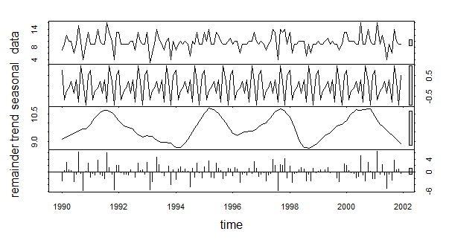

The two main parameters to be chosen when using STL are the trend window (t.window) and seasonal window (s.window). These control how rapidly the trend and seasonal components can change. Small values allow more rapid change. Setting the seasonal window to be infinite is equivalent to forcing the seasonal component to be periodic (i.e., identical across years).

**Seasonally Adjusting**

If you have a seasonal time series that can be described using an additive model, you can seasonally adjust the time series by estimating the seasonal component, and subtracting the estimated seasonal component from the original time series.

> birthstimeseriescomponents <- decompose(birthstimeseries)

> birthstimeseriesseasonallyadjusted <- birthstimeseries - birthstimeseriescomponents$seasonal

We can then plot the seasonally adjusted time series using the “plot()” function, by typing:

> plot(birthstimeseriesseasonallyadjusted)

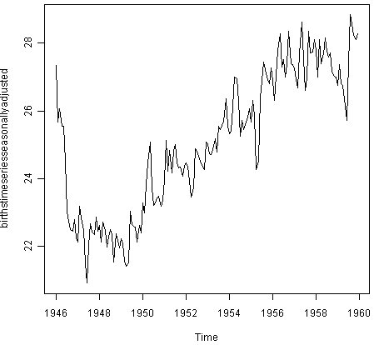

You can see that the seasonal variation has been removed from the seasonally adjusted time series. The seasonally adjusted time series now just contains the trend component and an irregular component.

To forecast a decomposed time series, we separately forecast the seasonal component, S^t, and the seasonally adjusted component A^t. It is usually assumed that the seasonal component is unchanging, or changing extremely slowly, and so it is forecast by simply taking the last year of the estimated component. In other words, a **seasonal naïve method** is used for the seasonal component.

To **forecast the seasonally adjusted component**, any non-seasonal forecasting method may be used. For example**, a random walk with drift model**, or **Holt’s method** , or a **non-seasonal ARIMA model** may be used.

**Random walk: (for non stationary series)**

A random walk model is very widely used for non-stationary data, particularly finance and economic data. Random walks typically have:

* long periods of apparent trends up or down
* sudden and unpredictable changes in direction.

The forecasts from a random walk model are equal to the last observation, as future movements are unpredictable, and are equally likely to be up or down. Thus, the random walk model underpins naïve forecasts.

**Difference between seasonal cycle and non- seasonal cycle:**

A seasonal cycle is a repetitive, predictable pattern in the series values. Seasonal cycles are tied to the interval of your series.

A nonseasonal cycle is a repetitive, possibly unpredictable, pattern in the series values. Some series, such as unemployment rate, clearly display cyclical behavior; however, the periodicity of the cycle varies over time, making it difficult to predict when a high or low will occur.

Many series experience abrupt changes in level. They generally come in two types:

• A sudden, temporary shift, or pulse, in the series level

• A sudden, permanent shift, or step, in the series level

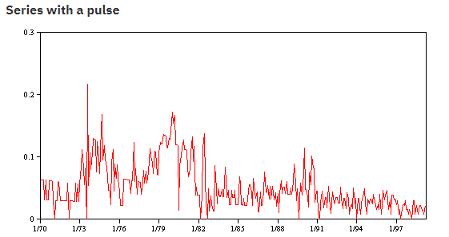

Holt Winter:

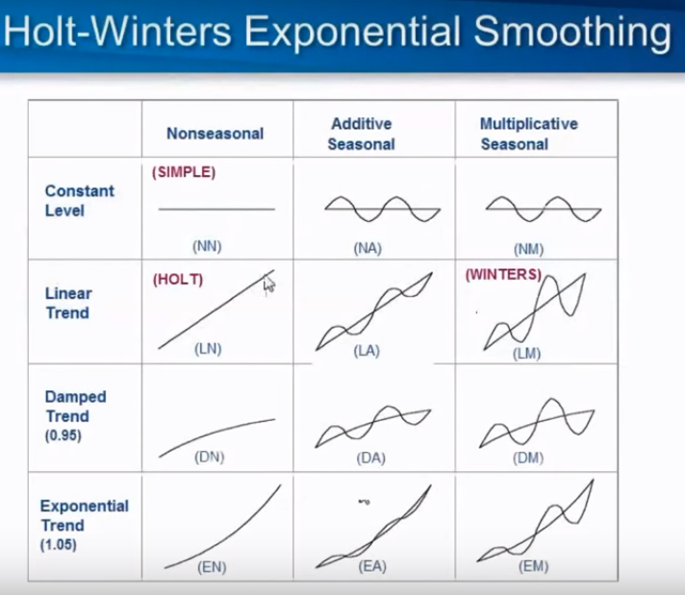

**Holt winter - additive**

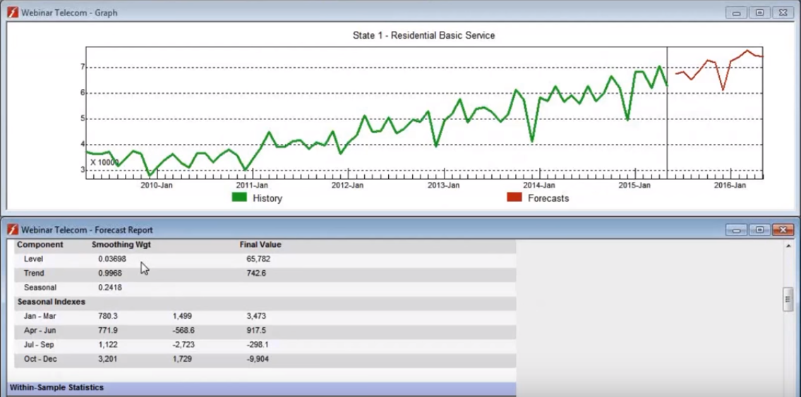

Smoothing Weights: (0 to 1)

Small weights closer towards 0 enforce more smoothing. More data they use to get the underlying component.

Level smoothing weight is 0.03 which is very small so its doing a lot of smoothing

Trend is 0.99 , this is very large value so it concentrates on recent values

Seasonal 0.24 -> moderate smoothing …

Under **Final value,**  we can see for level 65.762 which is the level value of recent observation . This will be the starting point for the forecast.

Similarly 742.6/permonth is the trend value of recent observation.

Seasonal pattern is additive in this case..we can monthly index which is either postve or negative.

In additive model these will be added or subtracted from trend forecast..

**Holt Winter - multiplicative**

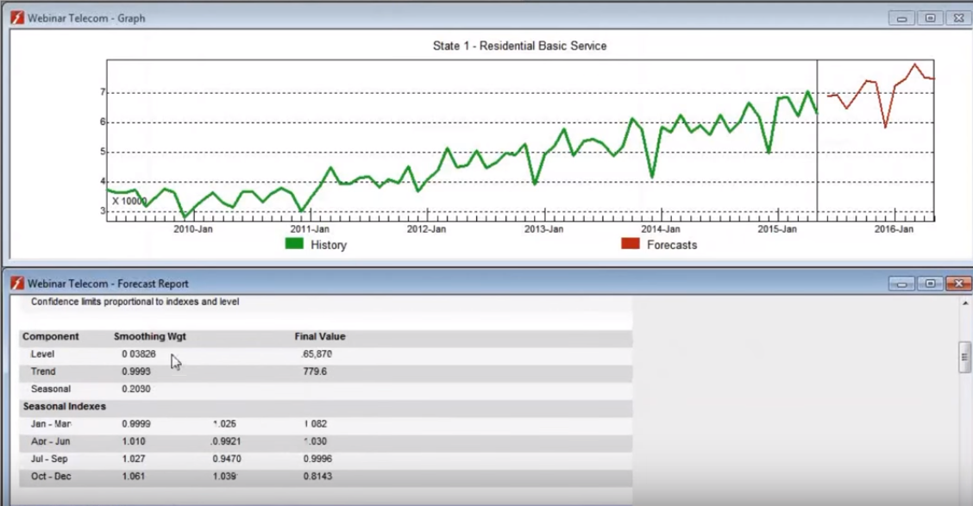

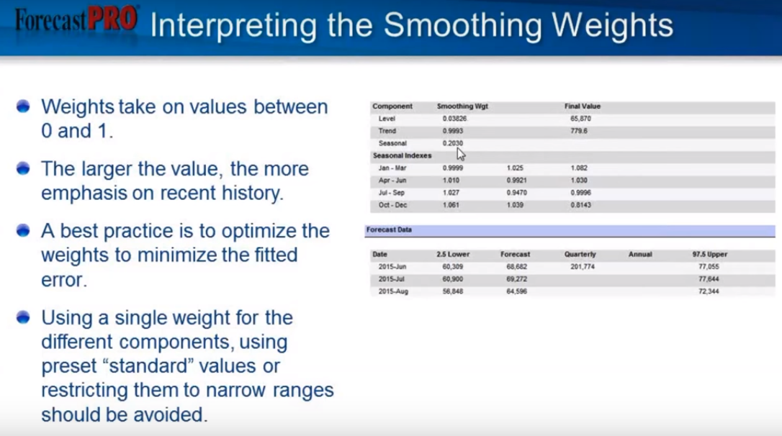

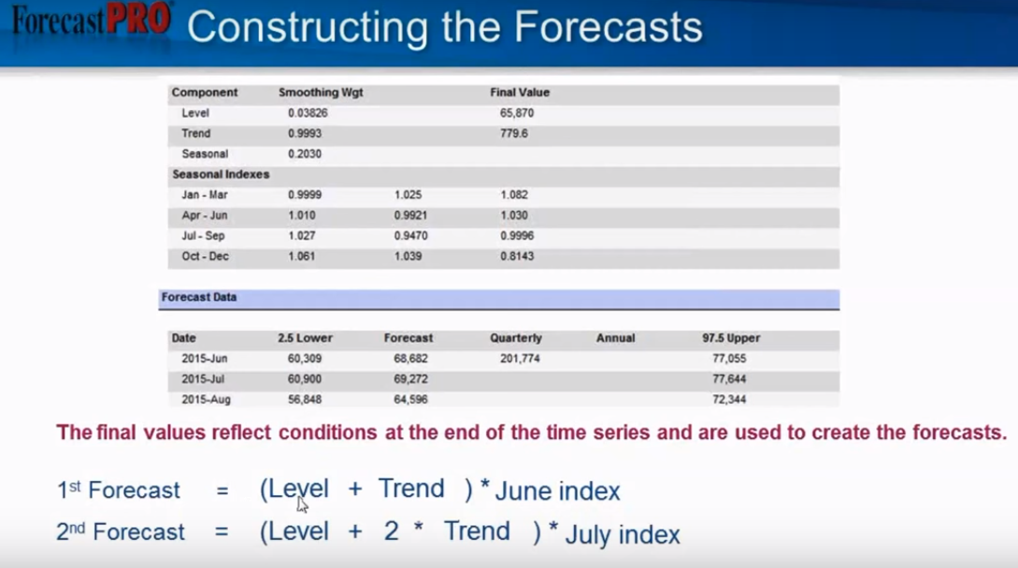

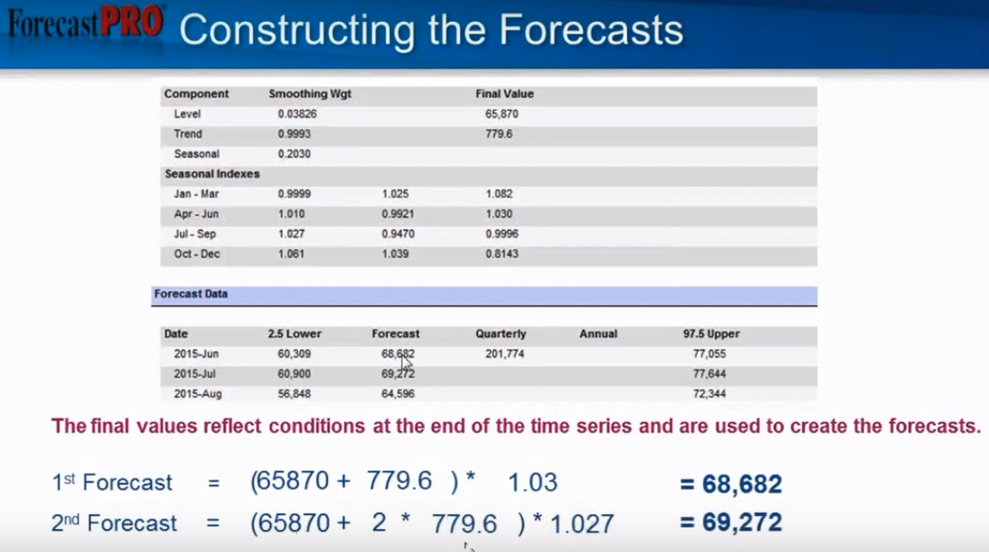

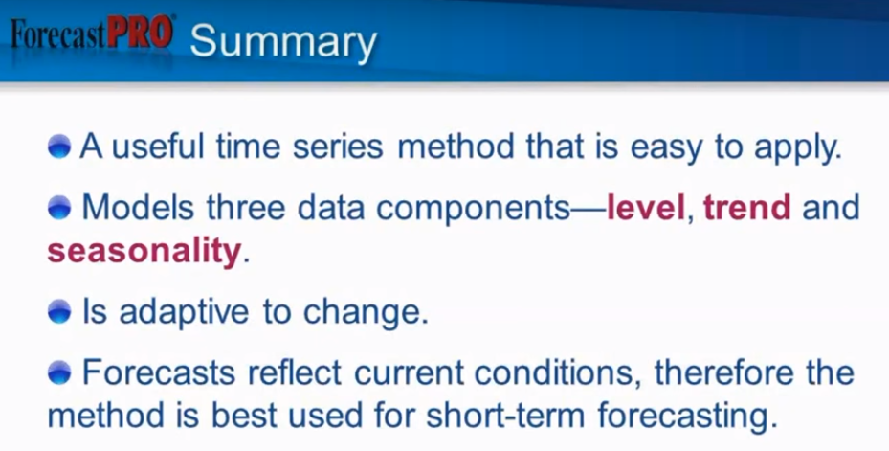

Short term forecasting refers to in monthly forecast , forecasting for 12 to 18 months is short term and 5 years / 10 years forecasting is long term.

Difference between Arima and exponential smoothing:

|  |  |
| --- | --- |
| **Arima** | **Exponential smoothing** |
| Based on correlations with lags. Theoritically, they are all linear model and not based on levels, trend and seasonal component. | Based on level, trend and seasonal component |
| Works better for longer more steady data with less noise | Works best for smoothing rough data. |

445 calendar is production calendar- > (4 weeks or 5 weeks per month)

**Simple Exponential Smoothing: (models only level)**

If you have a time series that can be described using an **additive model** **with constant level** and **no seasonality**, you can use **simple exponential smoothing** to make **short-term forecast**

Smoothing is controlled by the parameter alpha; apha value lies between 0 to 1.

Alpha/ damping factor – is for the estimate of level at the current time point

> rainseriesforecasts <- HoltWinters(rainseries, beta=FALSE, gamma=FALSE)

> rainseriesforecasts

Smoothing parameters: alpha: 0.02412151 🡺 alpha is close to 0, means light weight on most recent observation when making forecast for future values.

beta : FALSE (corresponds to trend)

gamma: FALSE (corresponds to season)

Coefficients: [,1] a 24.67819

Result of HoltWinters() are stored in the list variables.

> rainseriesforecasts$fitted 🡺 returns the fitted levels.

> rainseriesforecasts$SSE 🡺 returns sum of squared errors.

[1] 1828.855

To make 8 predictions for future, import package **forecast**

> rainseriesforecasts2 <- forecast.HoltWinters(rainseriesforecasts, h=8) 🡺 this provides 80% and 95% prediction interval.

> plot.forecast(rainseriesforecasts2) 🡺 to view the result.

Simple Exponential Smoothing result cannot be improved furthur if there is no correlation between the errors of the successive predictions.

> acf(rainseriesforecasts2$residuals, lag.max=20) 🡺 to calculate the autocorrelation with lag 20.

**Autocorrelation** is the correlation of a Time Series with lags of itself. This is a significant metric because,

* It shows if the previous states (lagged observations) of the time series has an influence on the current state. In the autocorrelation chart, if the autocorrelation crosses the dashed blue line, it means that specific lag is significantly correlated with current series. For example, in autocorrelation chart below, there is no significant autocorrelation for all the lags shown on x-axis.
* It is used commonly to determine if the time series is stationary or not. A stationary time series will have the autocorrelation fall to zero fairly quickly but for a non-stationary series it drops gradually.

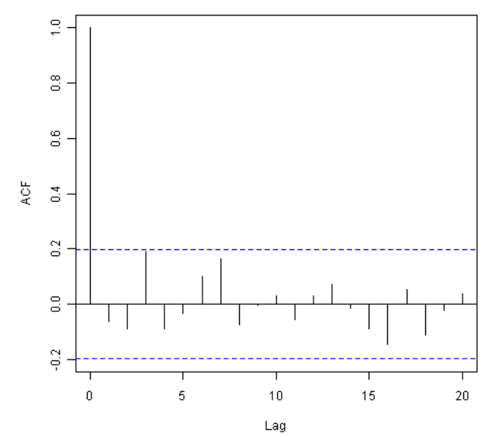

Ljung-box test is to get significant evidence that there is no correlation between residuals.

> Box.test(rainseriesforecasts2$residuals, lag=20, type="Ljung-Box")

Box-Ljung test data:

rainseriesforecasts2$residuals

X-squared = 17.4008, df = 20, p-value = 0.6268 🡺 little evidence that there is non-zero correlation.

To be sure, plot the residuals and check for normal distribution:

> plot.ts(rainseriesforecasts2$residuals)

It is normally distributed. Hence there is no correlation. And simple exponential smoothing technique forecast cannot be improved further.

**Holt’s Exponential Smoothing: or double Exponential Smoothing (models levels and trends)**

If you have a time series that can be described using an **additive model** with **increasing or decreasing trend and no seasonality**, you can use **Holt’s exponential smoothing** to make **short-term forecasts**.

Holt’s exponential smoothing estimates the **level(alpha) and slope of the trend(beta)** at the current time point. Alpha and beta ranges between 0 and 1. If it is towards 0, it means light weight on the most recent observation when making forecast for the future.

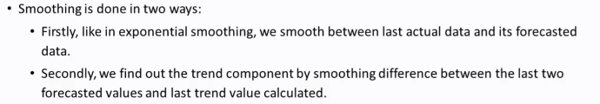

> skirtsseriesforecasts <- HoltWinters(skirtsseries, gamma=FALSE)

> skirtsseriesforecasts Smoothing parameters:

alpha: 0.8383481

beta : 1

gamma: FALSE

Coefficients: [,1] a 529.308585 b 5.690464

> skirtsseriesforecasts$SSE [1] 16954.18

Alpha and beta are almost 1 so the recent observations decides the future predictions more. Rest of the steps are same as Simple Exponential smoothing.

**Holt-Winters Exponential Smoothing: or triple exponential smoothing (models levels, trend, and seasonal components)**

If you have a time series that can be described using an **additive model** with **increasing or decreasing trend and seasonality**, you can use **Holt-Winters exponential smoothing** to make **short-term forecasts.**

Alpha -> level component at current time

Beta -> slope b for the trend component at current time

Gamma -> seasonal componenet at current time.

All ranges between 0 -1. Close to 0 means, light weight on recent observation.

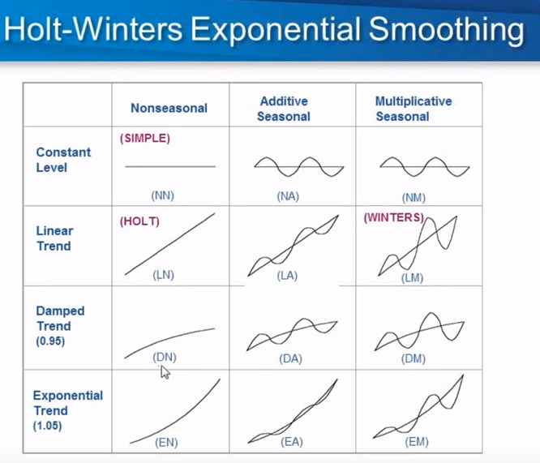

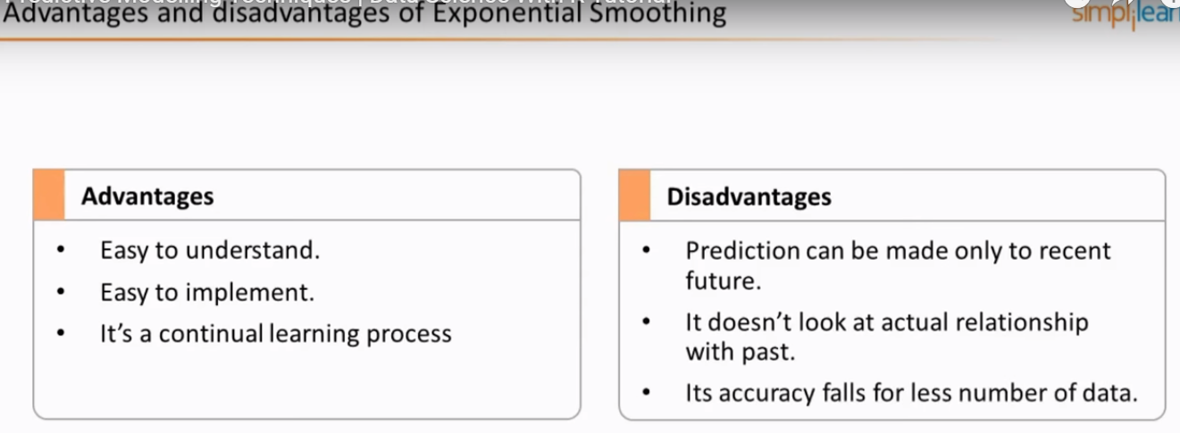

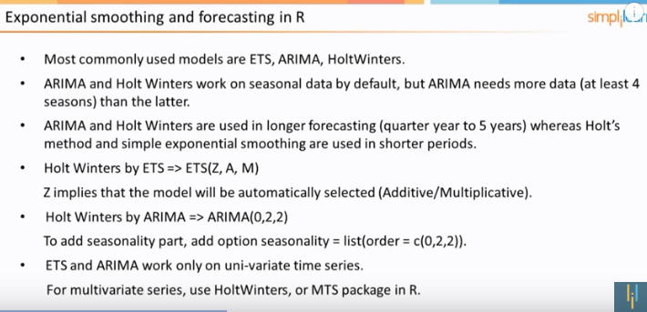

**Automated forecasting:**

forecast package provides ets() function to automatically select exponential models for both additive and multiplicative models.

auto.arima() is automated forecasting for ARIMA model. auto.arima() can handle both seasonal and non-seasonal ARIMA models. Models are chosen to maximize one of several fit criteria. Models are chosen whose AIC and BIC values are low.

auto.arima uses a unit root test to choose the order of differencing, and only uses the AIC to select the orders of the AR and MA components.

Benefits of AIC in

https://robjhyndman.com/hyndsight/aic/

AICc: When the sample size is small, there is a substantial probability that AIC will select models that have too many parameters, i.e. that AIC will overfit.To address such potential overfitting, AICc was developed: AICc is AIC with a correction for small sample sizes.

Fit <- auto.arima(ts_object)

Fit <- ets(ts_object)

**ets():**

**model:** Usually a three-character string identifying method using the framework terminology of Hyndman et al. (2002) and Hyndman et al. (2008). The first letter denotes the error type (“A”, “M” or “Z”); the second letter denotes the trend type (“N”,”A”,”M” or “Z”); and the third letter denotes the season type (“N”,”A”,”M” or “Z”). In all cases, “N”=none, “A”=additive, “M”=multiplicative and “Z”=automatically selected. So, for example, “ANN” is simple exponential smoothing with additive errors, “MAM” is multiplicative Holt-Winters’ method with multiplicative errors, and so on.

ets uses exponential smoothing for all three of error, trend and seasonal; stlm for just error and trend; and thetaf for just error. stlm and thetaf bring in other methods for dealing with the seasonal and trend elements.

**Outlier detection: package – tsoutliers**

**What is an outlier?**

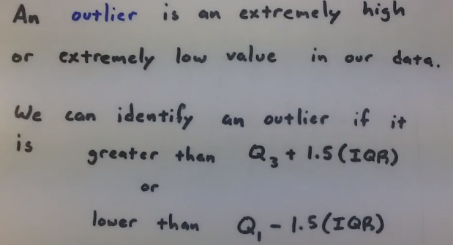

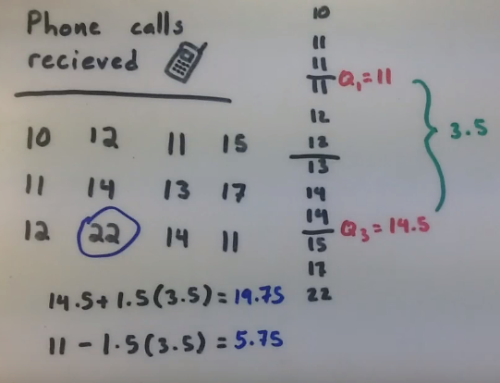

In this case, 22 is outlier since it is larger than 19.75. There is no lower outlier as we don’t have any values less than 5.75.

This package detects 5 types of outliers iteratively in time series data.

1. Additive outlier(AO)
2. Innovation Outlier(IO)
3. Level Shift (LS)
4. Temporary Change(TC)
5. Seasonal Level Shift (SLS)

Outlier types

Outlier types

• Additive Outlier. An additive outlier appears as a surprisingly large or small value occurring for a single observation. Subsequent observations are unaffected by an additive outlier. Consecutive additive outliers are typically referred to additive outlier patches.

• Innovational Outlier. An innovational outlier is characterized by an initial impact with effects lingering over subsequent observations. The influence of the outliers may increase as time proceeds.

• Level Shift Outlier. For a level shift, all observations appearing after the outlier move to a new level. In contrast to additive outliers, a level shift outlier affects many observations and has a permanent effect.

• Transient Change Outlier. Transient change outliers are similar to level shift outliers, but the effect of the outlier diminishes exponentially over the subsequent observations. Eventually, the series returns to its normal level.

• Seasonal Additive Outlier. A seasonal additive outlier appears as a surprisingly large or small value occurring repeatedly at regular intervals.

• Local Trend Outlier. A local trend outlier yields a general drift in the series caused by a pattern in the outliers after the onset of the initial outlier.

**Time series example:**

|  |
| --- |
| > ###  > head(AirPassengers)  Jan Feb Mar Apr May Jun  1949 112 118 132 129 121 135  > start(AirPassengers)  [1] 1949 1  > end(AirPassengers)  [1] 1960 12  > class(AirPassengers)  [1] "ts"  > frequency(AirPassengers)  [1] 12  > summary(AirPassengers)  Min. 1st Qu. Median Mean 3rd Qu. Max.  104.0 180.0 265.5 280.3 360.5 622.0  > boxplot(AirPassengers~cycle(AirPassengers))    > plot(AirPassengers)  > abline(reg = lm(AirPassengers~time(AirPassengers)))    > #converting to additive series  > additive_ts <- log(AirPassengers)  > plot(additive_ts)  >  > #converting to stationary series  > stationary_ts <- diff(additive_ts)  > plot(stationary_ts)  >  > #finding acf and pacf for arima..  > acf(stationary_ts) # ma is 1    > pacf(stationary_ts) # ar is 0    > #differencing is 1 as we differenced the series to make it stationary.  >  > #Applying arima (0,1,1)  > fit <- arima(additive_ts, order= c(0,1,1), seasonal = list(order=c(0,1,1)))  > pred <- predict(fit, n.ahead= 10*12)  > pred1 <- 2.718^pred$pred  > ts.plot(AirPassengers, pred1, log ="y", lty =c(1,3))  >  > #Testing our model  > newdata <- ts(AirPassengers, frequency=12, start = c(1949,1), end = c(1959,12))  > newdata  Jan Feb Mar Apr May Jun Jul Aug Sep Oct Nov Dec  1949 112 118 132 129 121 135 148 148 136 119 104 118  1950 115 126 141 135 125 149 170 170 158 133 114 140  1951 145 150 178 163 172 178 199 199 184 162 146 166  1952 171 180 193 181 183 218 230 242 209 191 172 194  1953 196 196 236 235 229 243 264 272 237 211 180 201  1954 204 188 235 227 234 264 302 293 259 229 203 229  1955 242 233 267 269 270 315 364 347 312 274 237 278  1956 284 277 317 313 318 374 413 405 355 306 271 306  1957 315 301 356 348 355 422 465 467 404 347 305 336  1958 340 318 362 348 363 435 491 505 404 359 310 337  1959 360 342 406 396 420 472 548 559 463 407 362 405  >  > fit <- arima(log(newdata), order = c(0,1,1), seasonal = list(order=c(0,1,1)) )  > pred <-predict(fit, n.ahead = 12)  > pred1 <- 2.718^pred$pred  > pred1 <- round(pred1, digits = 0)  > pred1  Jan Feb Mar Apr May Jun Jul Aug Sep Oct Nov Dec  1960 419 399 466 454 473 547 622 630 526 462 406 452  > Original <- tail(AirPassengers,12)  > Original  Jan Feb Mar Apr May Jun Jul Aug Sep Oct Nov Dec  1960 417 391 419 461 472 535 622 606 508 461 390 432  > ts.plot(AirPassengers, pred1, log ="y", lty = c(1,3))    **Accuracy measuring standards:** |
| <https://pdfs.semanticscholar.org/af71/3d815a7caba8dff7248ecea05a5956b2a487.pdf>  • Always calculate forecast accuracy measures using test data that was not used when computing the forecasts. • Use the MAE or RMSE if all your forecasts are on the same scale.  • Use the MAPE if you need to compare forecast accuracy on several series with different scales, unless the data contain zeros or small values, or are not measuring a quantity.  • Use the MASE if you need to compare forecast accuracy on several series with different scales, especially when the MAPE is inappropriate.  • Use time series cross-validation where possible, rather than a simple training/test set split. |
| |  | | --- | |  | |

**fread():**

In data.table package, we have fread() which is a replacement of read.table or read.csv. Fread helps in fast and easy transmission of file data into data frames.

> library (data.table)

> library (plyr)

> library (stringr)

> train <- fread("train.csv",na.strings = c(""," ",NA,"NA"))

**Commom probability distributions:**

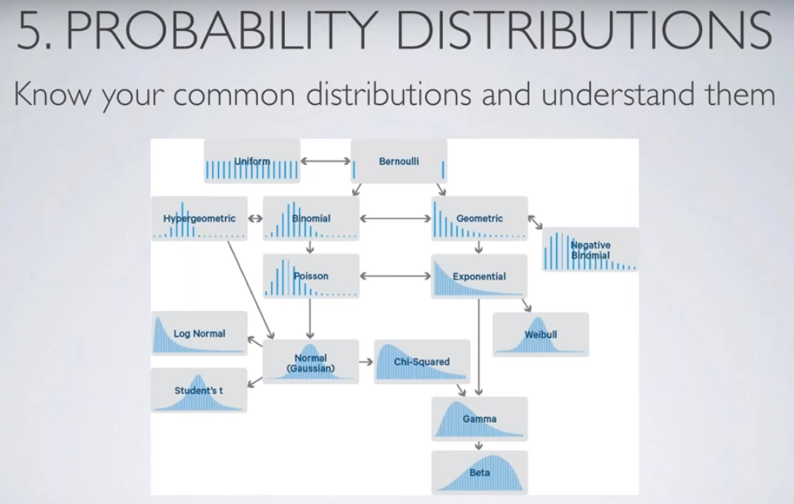

**NLP:**

**Bag of Words:**

A document represented as vector of word counts is called bag of words.

**Term Frequency:**

Importance of term within the document.

TF(d,t) = number of occurances of term in document d. (n/total , n- number of occurances of word in document/total number of words in the doc)

**Inverse Document Frequency:**

Importance of the term within the corpus.

IDF(t) = log(D/t), D – total number of documents, t – number of documents with the term.

Mathematically,

**TF-IDF: (multiplication of tf and idf)**

Finds the word that are important(i.e common) in a text, but not too common.

In tidytext package, there is a function called bind_tf_idf(word, document, n) is used. A Tidy text is passed as input to bind_tf_idf.

Where word – column which is containing the term/token

document – column containing the documents

n – number of occurances of word within document.

Result of bind_tf_idf contains 3 additional columns such as tf, idf, tf-idf.

> book_words %>% bind_tf_idf(word,book,n)

# A tibble: 40,379 x 7

book word n total tf idf tf_idf

<fctr> <chr> <int> <int> <dbl> <dbl> <dbl>

1 Mansfield Park the 6206 160460 0.03867631 0 0

2 Mansfield Park to 5475 160460 0.03412065 0 0

3 Mansfield Park and 5438 160460 0.03389007 0 0

4 Emma to 5239 160996 0.03254118 0 0

5 Emma the 5201 160996 0.03230515 0 0

6 Emma and 4896 160996 0.03041069 0 0

7 Mansfield Park of 4778 160460 0.02977689 0 0

8 Pride & Prejudice the 4331 122204 0.03544074 0 0

9 Emma of 4291 160996 0.02665284 0 0

10 Pride & Prejudice to 4162 122204 0.03405780 0 0

# ... with 40,369 more rows

(Term x within document y) => W(x,y) = tf(x,y) * log(N/df(x))

tf(x,y) -> frequency of x within y

N -> total number of documents

df(x) -> number of documents containing x.

**Zipf’s Law:**

Frequency that a word appears is inversely proportional to its rank. Relationship between rank and frequency will have negative slope.

**Analysing text data:**

**Ref link:** <http://tidytextmining.com/tidytext.html>

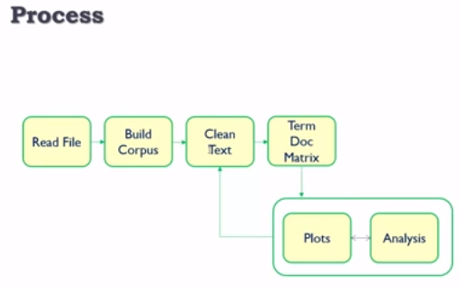

**Corpus** is collection of docs.

**Token** – meaningful unit of text, it can be single word, n-grams, sentence or paragraph.

**Tokenization** – process of splitting text into tokens.

**Tidy text format** 🡺 one token per row.

**Document-term matrix**: This is a sparse matrix describing a collection (i.e., a corpus) of documents with one row for each document and one column for each term. The value in the matrix is typically word count or tf-idf

**Tidy text Analysis steps:**

1. Character vector -> tibble conversion using data_frame() (tibble is modern class of data frame available in **dplyr and tibble packages**)

**Advantages of tibble:**

* + Convenient print method (prints only first 10 rows instead of all rows)
  + Does not convert strings to factors.
  + Does not use row names.
  + Column type is returned below the column name.

1. One token per document per row conversion (Tokenization):

Use unnest_tokens(o/p column name, i/p column name) from **tidytext** package.

o/p: will retain other columns from the data frame, strips punctuation, by default converts tokens to lower case. If we don’t want, to_lower=FALSE arg should be passed.

1. Removing stop words. anti_join(stop_words) , stop_words is from tidytext package
2. count(word, sort=TRUE) from dplyr package used to count the most common words.
3. Use ggplot to plot the frequent words.

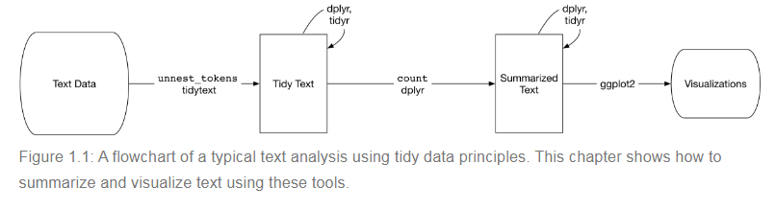

Package ggraph 🡺 extension of ggplot2 to construct network plots

Package widyr 🡺 calculates pairwise correlations and distances within a tidy data frame.

1. **Count:** Package widyr has **pairwise_count(word, section, sort=TRUE)** function 🡺 to determine the pairwise count of words within each section.
2. **Correlation among words:**

How often do words appear together relative to how often they appear separately.

Eg. “Elizabeth” and “Darcy” are most common co-occuring words which we got from pairwise_count(). But they are not particularly meaningful since they are also the most common individual words. we need to determine the correlation among words. Phi coefficient is used. **pairwise_cor(word,section, sort=TRUE)**

Package – tm 🡺 stands for text mining

When dealing with text, below are the default options..

options(header=FALSE, stringAsFactors = FALSE, FileEncoding = “latin1”)

1. readLines(“file location”) 🡺 used to read the text file 🡺 usually we get a warning which can be ignored OR text <- readLines(file.choose())🡺 this will interactively ask u to choose file.
2. Converting into corpus

corpus <- Corpus(VectorSource(text))

inspect(corpus[8]) 🡺 returns the 8th document ( 8th line)

1. Clean – up:
   1. Convert into lowercase

corpus <- tm_map(corpus, content_transformer(tolower))

* 1. Remove punctuations

corpus <- tm_map(corpus, removePunctuation)

* 1. Remove numbers

corpus <-tm_map(corpus,removeNumbers)

* 1. Removing stopwords:

cleanset = tm_map(corpus, removeWords, stopwords(“english”) 🡺 this will leave whitespaces from where the words are removed. Next step will remove those spaces.

* 1. Removing whitespaces:

cleanset <- tm_map(cleanset, stripWhitespace)

1. If the tm package is new 0.6.0

cleanset <- tm_map(cleanset, PlainTextDocument)

1. Building term document matrix

dtm <- TermDocumentMatrix(cleanset, control=list(minWordLength=c(1,Inf)))

1. Inspect frequent words

findFreqTerms(dtm,lowfreq=2)

1. Barplot

termFrequency <- rowSums(as.matrix(dtm))

termFrequency <- subset(termFrequency, termFrequency >=10)

library(ggplot2)

barplot(termFrequency, las=1,col=rainbow(20))

cleanset <- tm_map(cleanset,removeWords, c(“fig”,”per”)) 🡺 remove own stop words.

“syuzhet” uses [NRC Emotion lexicon](http://saifmohammad.com/WebPages/NRC-Emotion-Lexicon.htm). The NRC emotion lexicon is a list of words and their associations with eight emotions (anger, fear, anticipation, trust, surprise, sadness, joy, and disgust) and two sentiments (negative and positive).

**R handling missing values:**

Ref link : <https://stats.idre.ucla.edu/r/faq/how-does-r-handle-missing-values/>

**Opinion mining or sentiment analysis:**

Sentiment content of the whole text = sum of sentiment content of the individual words.

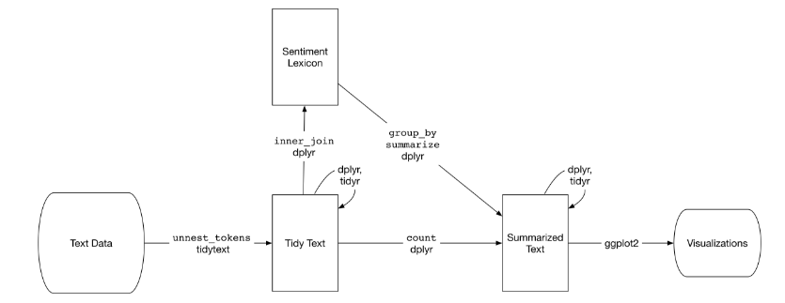

The three general-purpose lexicons are

* AFINN from [Finn Årup Nielsen](http://www2.imm.dtu.dk/pubdb/views/publication_details.php?id=6010), 🡺 score that runs between -5 and 5, with negative scores indicating negative sentiment and positive scores indicating positive sentiment
* bing from [Bing Liu and collaborators](https://www.cs.uic.edu/~liub/FBS/sentiment-analysis.html), and 🡺 binary fashion into positive and negative categories
* NRC from [Saif Mohammad and Peter Turney](http://saifmohammad.com/WebPages/NRC-Emotion-Lexicon.htm). 🡺 (“yes” / “no”) into categories of positive, negative, anger, anticipation, disgust, fear, joy, sadness, surprise, and trust.

Another sentiment lexicon for finantial sentiment terms is Loughran == > has 6 sentiments: positive, negative, litigious, uncertain, constraining, superfluous.

**Tidytext** provides a function **get_sentiments()** to get specific sentiment lexicons without the columns that are not used in that lexicon.

All 3 lexicons are based on unigrams i.e single words. sentiments dataset contains the words, sentiment, lexicon, score.

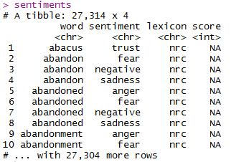

tidyr package : spread() turns a pair of key:value columns into a set of tidy columns.

table2

## Source: local data frame [12 x 4]

##

## country year key value

## 1 Afghanistan 1999 cases 745

## 2 Afghanistan 1999 population 19987071

## 3 Afghanistan 2000 cases 2666

## 4 Afghanistan 2000 population 20595360

library(tidyr)

spread(table2, key, value)

## Source: local data frame [6 x 4]

##

## country year cases population

## 1 Afghanistan 1999 745 19987071

## 2 Afghanistan 2000 2666 20595360

The unique values of the key column become the column names of the field of cells.

gather() is opposite of spread().

**AFINN:**

In afinn we have score column for sentiment analysis, so we are grouping 80 lines together and summarizing sentiment column as sum of scores within the group.

>pride_prejudice %>% inner_join(get_sentiments("afinn")) %>%

group_by(index = linenumber %/% 80) %>%summarise(sentiment = sum(score)) %>% mutate(method ="AFINN")

**Bing and nrc:**

In Bing, sentiment analysis is through binary values positive and negative sentiments.

In NRC, sentiment analysis is through 10 sentiments. Filter only positive and negative sentiments.

Finally counting the sentiments every 80 lines once and spreading the sentiment so that positive and negative sentiments become separate columns and calculate sentiment as positive – negative.

bing_and_nrc <- bind_rows(pride_prejudice %>% inner_join(get_sentiments("bing")) %>% mutate (method="Bing et al."),

pride_prejudice %>% inner_join(get_sentiments("nrc")) %>% filter(sentiment %in% c("positive","negative")) %>% mutate(method="NRC"))

%>% count(method,index=linenumber %/% 80,sentiment) %>% spread(sentiment,n,fill=0) %>%mutate(sentiment = positive - negative)

 R packages included **coreNLP** (T. Arnold and Tilton [2016](http://tidytextmining.com/sentiment.html#ref-R-coreNLP)), **cleanNLP** (T. B. Arnold [2016](http://tidytextmining.com/sentiment.html#ref-R-cleanNLP)), and **sentimentr** (Rinker [2017](http://tidytextmining.com/sentiment.html#ref-R-sentimentr)) are examples of such sentiment analysis algorithms.

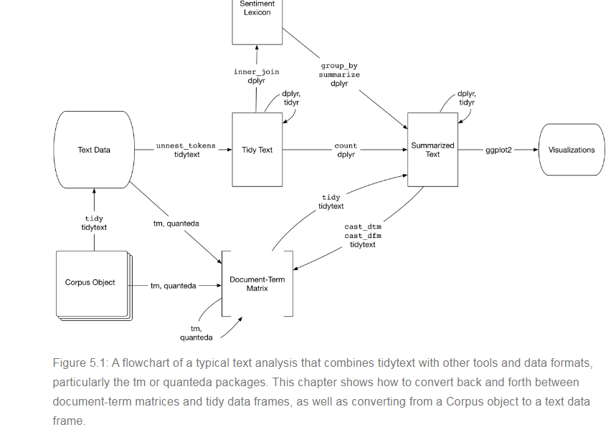

**DTM(Document Term Matrix):**

This is a matrix where:

1. each row represents one document (such as a book or article),
2. each column represents one term, and
3. each value (typically) contains the number of appearances of that term in that document.

DTM objects cannot be used directly with tidy tools. Tidytext package provides 2 functions.

* tidy() turns a document-term matrix into a tidy data frame. This verb comes from the broom package (Robinson [2017](http://tidytextmining.com/dtm.html#ref-R-broom)), which provides similar tidying functions for many statistical models and objects. o/p of tidy() includes only nonzero values in the tidied output.r
* cast() turns a tidy one-term-per-row data frame into a matrix. tidytext provides three variations of this verb, each converting to a different type of matrix: cast_sparse() (converting to a sparse matrix from the Matrix package), cast_dtm() (converting to a DocumentTermMatrix object from tm), and cast_dfm() (converting to a dfm object from quanteda).

Package tm has DocumentTermMatrix() 🡺 widely used implementation for DTM in R.

Terms() 🡺 used to access the terms.

Package tm.plugin.webmining 🡺 connects to online feeds to retrieve news articles based on a keyword.

* tm.plugin.webmining package contains WebCorpus(GoogleFinanceSource(“NASDAQ:XXX”)) 🡺 this will retrieve 20 most recent articles related to XXX. Output of Webcorpus function will be webcorpus object, we need to convert it into data frame using **tidy()** function and unnest it using tidyr’s **unnest()..** like unnest(map(corpus,tidy)) 🡺 corpus carries the WebCorpus output. After that, tokenize text column using unnest_tokens().

Package purr🡺 contains map(symbol, function_name) 🡺 applies the function to each element of symbol and returns the result in list format.

**Topic Modeling: (package - topicmodels)**

Unsupervised classification method for documents similar to clustering on numerical data.

LDA(Latent Dirichlet allocation is a popular method for fitting a topic model.) It treats each document as mixture of topics and each topic as mixture of words.

LDA works on 2 priciples:

1. Every document is a mixture of topics: for eg: In a 2 topic model, Document 1 is 90% topic A and 10% topic B and in Document 2, 30% topic A and 70% topic B.
2. Every topic is a mixture of words: For eg: In a two topic American news, one topic is politics and other is entertainment. Most common words in politics - “government”,”President”,”congress”,

Most common words in entertainment – “ movies”,”television”,”actor”..There could be common words like “budget” which appear equally in both.

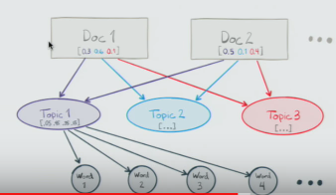

LDA() estimates both of these at the same time. LDA accepts document term matrix as input.

**Word Topic Probabilities:**

**tidytext** package provides **tidy** function which extracts per-topic-per-word probabilities called beta from the model. Beta field contains the probability of the term being generated from the topic.

ap_topics <- tidy(ap_lda,matrix=”beta”) , ap_lda is the LDA() object.

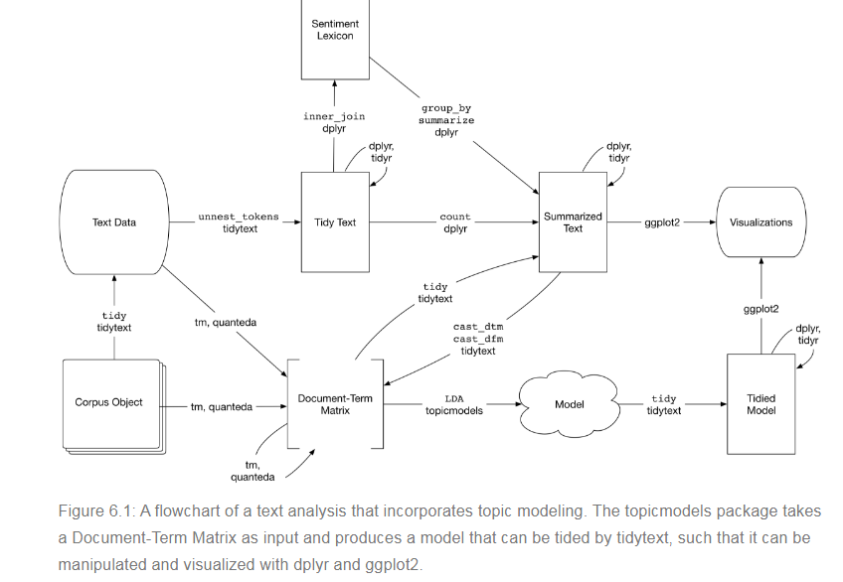

If we want to clearly distinguish the words between 2 topics without any common words, then  consider the terms that had the *greatest difference* in β between topic 1 and topic 2. This can be estimated based on the log ratio of the two: log2(β2/β1), In order to get the common words, consider beta greater than 1/1000 in atleast one topic.

**Document Topic Probabilities:**

Per document per topic probabilities 🡺 gamma with matrix =”gamma” in tidy()

ap_documents <- tidy(ap_lda, matrix= "gamma"), ap_lda is LDA() object.

**By-word assignments : augment()**

Takes document-word pairs and determine to which topic the words should go in that document.

It takes lda object and original dtm (document term matrix) as input.

> chapter_lda

Error: object 'chapter_lda' not found

> chapters_lda

A LDA_VEM topic model with 4 topics.

> chapters_dtm

<<DocumentTermMatrix (documents: 194, terms: 18215)>>

Non-/sparse entries: 104722/3428988

Sparsity : 97%

Maximal term length: 19

Weighting : term frequency (tf)

> assignments <- augment(chapters_lda,data = chapters_dtm)

> assignments

# A tibble: 104,722 x 4

document term count .topic

<chr> <chr> <dbl> <dbl>

1 Great Expectations_57 joe 88 4

2 Great Expectations_7 joe 70 4

3 Great Expectations_17 joe 5 4

4 Great Expectations_27 joe 58 4

o/p contains .topic, with the topic each word was assignment to within each document. Extra dot(.) is added by augment always to prevent overwriting of existing columns.

**1st method in Trees:**

**CART: (Classification and Regression Trees)**

Package: tree

**Steps:**

1. library(tree)
2. apply tree() on the dataset and check the misclassification error rate.
3. For real performance of the model, split the dataset as training and test and apply tree() and predict() on test dataset.
4. Check the misclassification error rate and accuracy.
5. To check if pruning helps with accuracy, apply cv.tree() cross validation method. This determines the best terminal nodes size.
6. Apply prune.misclass() with the best terminal node size
7. Apply the pruned model on the test data and check the misclassification error and accuracy. Improvement will be seen.

###Classification tree### package - tree

# dataset = Carseats

# Creating high variable and categorizing Sales column based on its value. Hi#gh = Y|Sales>8, or No

> Carseats$high <- ifelse(Carseats$Sales>8, "Yes","No")

# Predicting using tree()

> Carseats$high <- factor(Carseats$high)

tree.pred <- tree(high ~ ., Carseats)

summary(tree.pred)

plot(tree.pred)

text(tree.pred,pretty=0)

tree.pred

#Training and test set split -> to perdict the real performance of the classification tree

library(caTools)

set.seed(2)

split <- sample.split(Carseats$high, SplitRatio = 1/2)

test <- Carseats[split==FALSE,]

train <- Carseats[split==TRUE,]

high.test <- Carseats$high[split==FALSE]

high.train<- Carseats$high[split==TRUE]

table(high.test)

table(high.train)

##model implementation and prediction

tree.model <- tree(high ~ .,Carseats,subset=split)

summary(tree.model)

tree.pred <-predict(tree.model, newdata = test,type = "class")

table(tree.pred,high.test) # accuracy = 70.6%

# to determine pruning required or not determined using cross-validation.

set.seed(3)

cv.carseats <- cv.tree(tree.model,FUN = prune.misclass) # FUN=prune.misclass used to indicate we want classification error rate to guide cv and pruning process. By default, deviance is used.

names(cv.carseats)

#o/p is [1] "size" "dev" "k" "method"

#size - no. of terminal nodes of each tree considered.

#dev corresponds to cross validation error rate

#k - value of cost complexity parameter, k folds in cv.

cv.carseats # o/p dev corresponds to cross validation error rate. Tree with 9 terminal nodes results in low cross validation error

#plotting size with cross validation and k with cross validation

par(mfrow=c(1,2))

plot(cv.carseats$size,cv.carseats$dev,type="b")

plot(cv.carseats$k,cv.carseats$dev,type="b")

#pruning the tree to obtain nine node tree as size is 9

prune.carseats <- prune.misclass(tree.model,best = 9)

plot(prune.carseats)

text(prune.carseats,pretty=0)

# applying pruned tree on test data

tree.pred <- predict(prune.carseats,test,type = "class")

table(tree.pred, high.test) # accuracy - 79%

> (91+63)/(91+26+38+63)

**Regression Tree:**

######Regression Tree####

library(MASS)

head(Boston)

str(Boston)

regtree.model <- tree(medv ~ ., data= Boston)

summary(regtree.model)

##Splitting training and test dataset

library(caTools)

set.seed(1)

split <- sample.split(Boston$medv, SplitRatio = 0.5)

train <- Boston[split==TRUE,]

test <- Boston[split==FALSE,]

regtree.model <- tree(medv~., data=train)

summary(regtree.model)

pred <- predict(regtree.model,newdata = test)

plot(pred, test$medv)

abline(0,1)

mean((pred-test$medv)^2) #23.96

#plotting tree

plot(regtree.model)

text(regtree.model,pretty=0)

#to check if pruning necessary use cross validation

cv.model <- cv.tree(regtree.model)

plot(cv.model$size, cv.model$dev, type ="b")

cv.model

#pruning – just for exercise, best value 5 picked but results are not good.

prune.boston <- prune.tree(regtree.model,best=5)

plot(prune.boston)

text(prune.boston)

pred <- predict(prune.boston,newdata = test)

plot(pred, test$medv)

abline(0,1)

mean((pred-test$medv)^2) # 27.26

**Coding Differences in Classification and Regression tree in CART**

|  |  |
| --- | --- |
| **Classification Tree** | **Regression Tree** |
| During cross validation, by default deviation metric is used to determine cross validation and pruning process. We want misclassification error to be used, then explicitly specify cv.tree(model.name, FUN=prune.misclass) | In Regression tree, we don’t specify FUN as deviation is used by default in cross validation method.  cv.tree(model.name) |
| During pruning, prune.misclass(modelname,best=value) is given | During pruning, prune.tree(modelname,best=value) is given. |
| In predict() specify type =”class” to indicate classification. | Here there is no need. |

**Decision Trees: required packages : rpart, rpart.plot**

Ref link : <https://dataaspirant.com/2017/01/30/how-decision-tree-algorithm-works/>

The popular attribute selection measures:

* Information gain
* Gini index

Common way to identify an attribute is entropy. It measures amount of uncertainity or randomness in the data. Eg: politics, before election lots of exit polls. If there is more uncertainity then entropy is high. Otherwise entropy is low eg if BJP was predicted more than congress, its clear that BJP wins,then entropy is low.

If entropy is low, prediction is easy. If entropy is high, prediction is difficult.

Divide the dataset in a way that entropy of subset is low.

Information gain is difference between base entropy and the conditional entropy(after partitioning by a particular attribute). Do this for all columns and pick the column which has high information gain

While using information Gain as a criterion, we assume attributes to be categorical, and for gini index, attributes are assumed to be continuous.

Ref link: <https://courses.cs.washington.edu/courses/cse455/10au/notes/InfoGain.pdf>

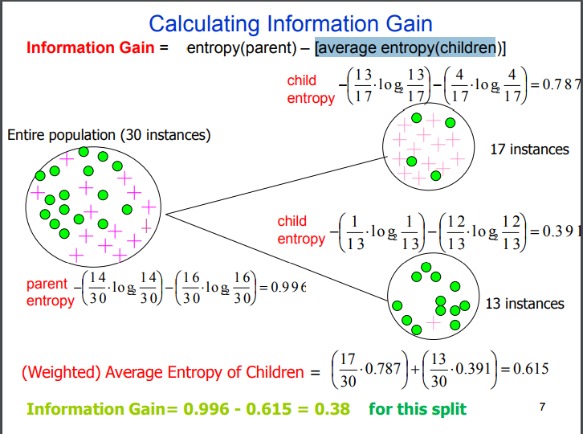

**Gini Index:**

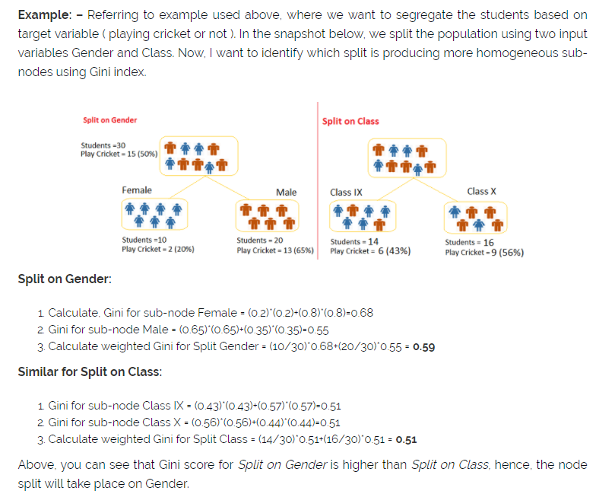

To view the decision tree, call library rpart.plot and then prp(modelname) 🡺 this provides clear tree view.

> str(kyphosis)

'data.frame': 81 obs. of 4 variables:

$ Kyphosis: Factor w/ 2 levels "absent","present": 1 1 2 1 1 1 1 1 1 2 ...

$ Age : int 71 158 128 2 1 1 61 37 113 59 ...

$ Number : int 3 3 4 5 4 2 2 3 2 6 ...

$ Start : int 5 14 5 1 15 16 17 16 16 12 ...

> tree <- rpart(Kyphosis ~ ., method = 'class', data = kyphosis)

> printcp(tree)

Classification tree:

rpart(formula = Kyphosis ~ ., data = kyphosis, method = "class")

Variables actually used in tree construction:

[1] Age Start

Root node error: 17/81 = 0.20988 # This is the error due to the root node chosen to split.

n= 81

CP nsplit rel error xerror xstd

1 0.176471 0 1.00000 1.00000 0.21559

2 0.019608 1 0.82353 0.94118 0.21078

3 0.010000 4 0.76471 1.00000 0.21559

> library(rpart.plot)

> prp(tree) # plot a rpart tree

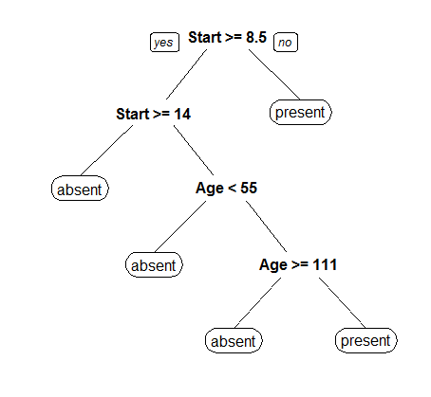

In predict() function, need to specify type =”class” for classification problems and type=”response” for regression problems in order to get right outcome for prediction. Otherwise, will get the probabilities.

**Random forest:**

**Ref link: https://www.youtube.com/watch?v=dJclNIN-TPo**

In a normal decision tree, one decision tree is built and in a random forest algorithm number of decision trees are built during the process. A vote from each of the decision trees is considered in deciding the final class of a case or an object, this is called ensemble process. This is a democratic process. Since , many decision trees are built and used in a process of Random Forest algorithm, it is called a forest.

Key advantages of using Random Forest

* Reduce chances of over-fitting
* Higher model performance or accuracy

Random Forest uses Gini Index based impurity measures for building decision tree. Gini Index is also used for building Classification and Regression Tree (CART).

Random forest is a tree-based algorithm which involves building several trees (decision trees), then combining their output to improve generalization ability of the model. The method of combining trees is known as an ensemble method. Ensembling is nothing but a combination of weak learners (individual trees) to produce a strong learner.

2 parameters:

* ntree , default is 500
* variables randomly sampled as candidates at each split. mtry, default is sqrt(p) for classification, p/3 for regression.

**Random forest Steps:**

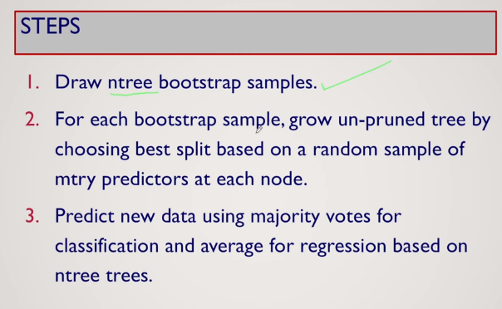

**RMSE:**

Root Mean Square Error (RMSE) is the standard deviation of the [residuals](http://www.statisticshowto.com/residual/) (prediction errors). Residuals are a measure of how far from the regression line data points are; RMSE is a measure of how spread out these residuals are. In other words, it tells you how concentrated the data is around the [line of best fit](http://www.statisticshowto.com/line-of-best-fit/). Root mean square error is commonly used in climatology, forecasting, and [regression analysis](http://www.statisticshowto.com/probability-and-statistics/regression-analysis/) to verify experimental results.

The formula is:  
[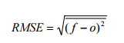](http://www.statisticshowto.com/wp-content/uploads/2016/10/rmse.png)  
**Where**:

* f = forecasts (expected values or unknown results),
* o = observed values (known results).



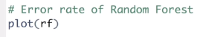

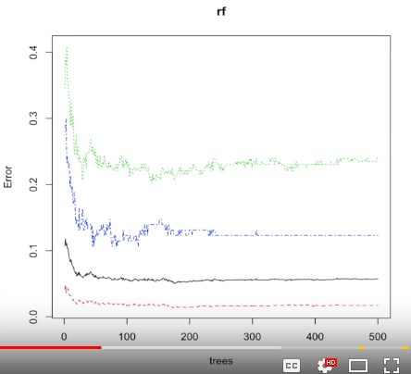

If we plot the rf model, we get error vs trees..we can see that OOB error has reduced till 300 trees and attained saturation. Hence, best suitable ntrees will be 300 rather than default 500.

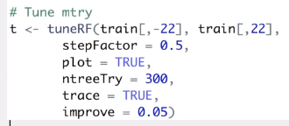

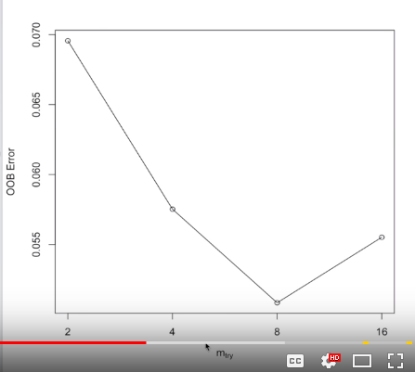

Tuning mtry value using tuneRF function(), we can see that for mtry =8, OOB seems less.

We can remodel using the newly obtained ntree and mtry values.

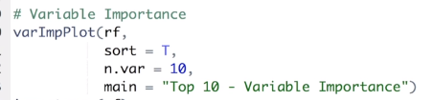

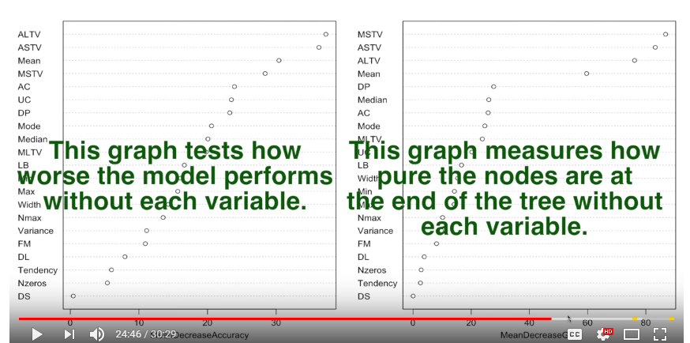

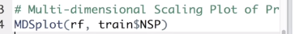

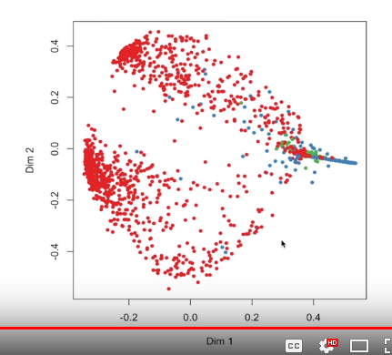

OOB:

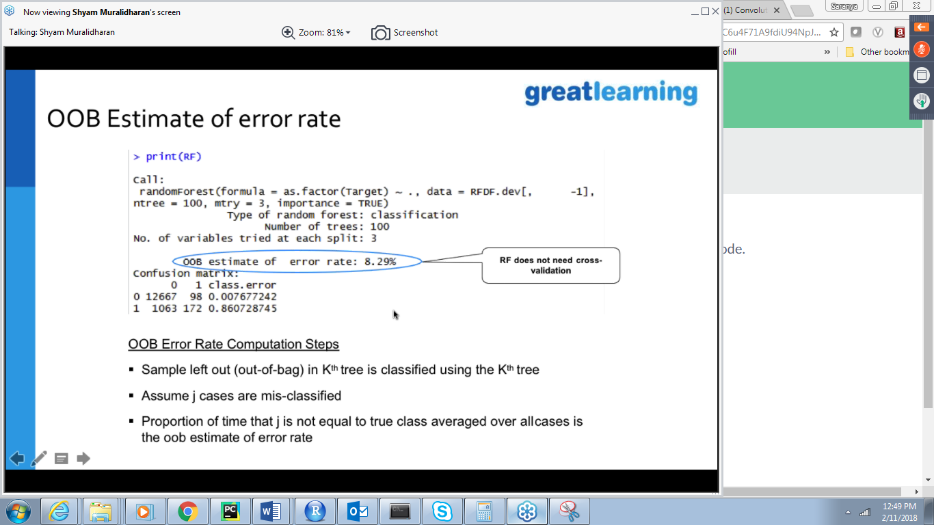

**Model Performance statistics:**

Ref link: <http://dni-institute.in/blogs/predictive-model-performance-statistics/>

**Lift chart:**

Ratio between the result predicted by our model and the result using no model.

**importance()** -> used to determine the variable importance in Random forest algorightm. It provides mean decrease in accuracy(type = 1) and mean decrease in gini (impurity)(type =2)

**varImpPlot(fit, type) 🡺** Dotchart of variable importance as measured by a Random Forest.

**Bootstrap: - >**

**Ref link:** <https://machinelearningmastery.com/bagging-and-random-forest-ensemble-algorithms-for-machine-learning/>

this helps in reducing the variance by judging the data using single model. We create multiple samples and apply same method and take average of the results.

The bootstrap is a powerful statistical method for estimating a quantity from a data sample. This is easiest to understand if the quantity is a descriptive statistic such as a mean or a standard deviation.

Let’s assume we have a sample of 100 values (x) and we’d like to get an estimate of the mean of the sample.

We can calculate the mean directly from the sample as:

mean(x) = 1/100 * sum(x)

We know that our sample is small and that our mean has error in it. We can improve the estimate of our mean using the bootstrap procedure:

* Create many (e.g. 1000) random sub-samples of our dataset with replacement (meaning we can select the same value multiple times).
* Calculate the mean of each sub-sample.
* Calculate the average of all of our collected means and use that as our estimated mean for the data.

For example, let’s say we used 3 resamples and got the mean values 2.3, 4.5 and 3.3. Taking the average of these we could take the estimated mean of the data to be 3.367.

**Bootstrap Aggregation: (Bagging) - package : foreach**

Very powerful Ensemble technique.

Ensemble technique is a technique that combines the predictions from multiple machine learning algorithms together to make more accurate predictions than any individual model.

Bootstrap Aggregation is a general procedure that can be used to reduce the variance for those

algorithm that have high variance. An algorithm that has high variance are decision trees, like classification and regression trees (CART).

Bagging is the application of the Bootstrap procedure to a high-variance machine learning algorithm, typically decision trees.

Let’s assume we have a sample dataset of 1000 instances (x) and we are using the CART algorithm. Bagging of the CART algorithm would work as follows.

* Create many (e.g. 100) random sub-samples of our dataset with replacement.
* Train a CART model on each sample.
* Given a new dataset, calculate the average prediction from each model.

For example, if we had 5 bagged decision trees that made the following class predictions for a in input sample: blue, blue, red, blue and red, we would take the most frequent class and predict blue.

When bagging with decision trees, we are less concerned about individual trees overfitting the training data.

**Random Forest**

Random Forests are an improvement over bagged decision trees.

The number of features/columns that can be searched at each split point (m) must be specified as a parameter to the algorithm. You can try different values and tune it using cross validation.

For classification a good default is: m = sqrt(p)

For regression a good default is: m = p/3

Where m is the number of randomly selected features that can be searched at a split point and p is the number of input variables. For example, if a dataset had 25 input variables for a classification problem, then:

m = sqrt(25)

m = 5

**Estimated Performance**

For each bootstrap sample taken from the training data, there will be samples left behind that were not included. These samples are called Out-Of-Bag samples or OOB.

The performance of each model on its left out samples when averaged can provide an estimated accuracy of the bagged models. This estimated performance is often called the OOB estimate of performance.

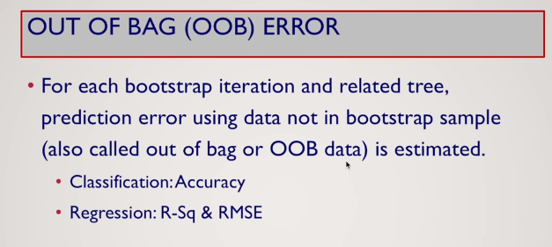

**Decision trees(Regression):**

Recursive binary splitting -> top-down, greedy approach

The approach is top-down because it begins at the top of the tree (at which point all observations belong to a single region) and then successively splits the predictor space; each split is indicated via two new branches further down on the tree. It is greedy because at each step of the tree-building process, the best split is made at that particular step, rather than looking ahead and picking a split that will lead to a better tree in some future step.

In order to perform recursive binary splitting, first select the predictor X(j) and the cutpoint s such that, X(J)<s and X(j)>=s will be the two nodes that leads to greatest possible reduction in RSS(Residual sum of squares).

**Tree Pruning:**

The above technique will build a tree which performs well for training set as it overfit training data but not for test set. One possible alternative to the process described above is to build the tree only so long as the decrease in the RSS due to each split exceeds some (high) threshold.

**Decision trees(Classification):**

Tree is built using same strategy as regression.

|  |  |
| --- | --- |
| **Regression trees** | **Classification trees** |
| Average/Mean response of the training observations | most commonly occurring class of training observations in the region to which it belongs |
| we use recursive binary splitting to grow a regression tree. | we use recursive binary splitting to grow a classification tree. |
| RSS is used as a criterion for making the binary splits. | RSS cannot be used as a criterion for making the binary splits. A natural alternative to RSS is the classification error rate. But Classification error rate is not sensitive for tree-growing. Hence Gini index (measure of node impurity) and entropy(an alternative to the Gini index) is used. |

|  |  |
| --- | --- |
| **Linear model** | **Tree models** |
| If the relationship between featuers and response is linear, then linear model is best | If instead there is a highly non-linear and complex relationship between the features and the response, then decision trees may  outperform classical approaches. |
| cid:image005.jpg@01D33DF9.E47DFF50 | cid:image006.jpg@01D33DF9.E47DFF50 |

**Disadvantage of trees:**

trees can be very non-robust. In other words, a small change in the data can cause a large change in the final estimated tree. (meaning high variance). To overcome this, bagging, random forest and boosting are used.

**Bagging:**

A natural way to reduce the variance and hence increase the prediction accuracy of a statistical learning method is to take many training sets from the population, build a separate prediction model using each training set, and average the resulting predictions. Of course, this is not practical because we generally do not have access to multiple training sets. Instead, we can bootstrap, by taking repeated samples from the (single) training data set.  In this approach we generate B different bootstrapped training data sets. We then train our method on the bth bootstrapped training set in order to get ˆ f∗b(x), and finally average all the predictions. This is called Bagging/Bootstrap aggregation.

|  |  |  |
| --- | --- | --- |
| **Bagging** | **Random Forest/ Decision Forest** | **Boosting** |
| Bootstrapped training samples used and average of the multiple trees are considered as result. i.e multiple subset of training data set is treated as bootstrap samples and trees are constructed on them. | m predictors out of p are chosen randomly where m=sqrt(p) in classification and m=p/3 in regression and predictions are made for each tree. Finally results are averaged. | Boosting works in a similar way as Bagging, except that the trees are grown sequentially: each tree is grown using information from previously grown trees. Boosting does not involve bootstrap sampling; instead each tree is fit on a modified version of the original data set.  Boosting approach learns slowly. |
| **Drawback:** Always the very strong predictor will be used as the top split. All bagged trees will look similar and highly correlated. Averaging them would not reduce variance much. | All other predictors have good chance to become top split and the resultant trees will not be correlated and have high variance. Averaging the results will help in reducing the variance , test error and OOB error. Also, if the number of trees increased then, error rate will reduce. | Very memory intensive, current implementation holds every decision tree in memory to derive further from the previous error. |
| Bagging is nothing but random forest with m=p. randomForest() function itself can be used for both bagging and randomForest. **mtry** value will be equal to the total number of predictors in the dataset. | **randomForest()** is used, **mtry** incidates no. of predictor to be used every time..m=sqrt(p) for classification, m=p/3 for regression. **ntree** indicates no. of trees, importance = TRUE will provide sequence of predictors in the order of mean decrease in accuracy based on OOB samples and total decrease in node impurity | **gbm()** function is used, with option **distribution=”gaussian”** for regression and **distribution =”bernoulli”** for binary classification. **n.trees = 5000** indicates 5000 trees, and **interaction.depth=4** limits the depth of each tree. |

**Gradient Boosting:**

Assume, you are given a previous model M to improve on. Currently you observe that the model has an accuracy of 80% (any metric).

One simple way is to build an entirely different model using new set of input variables and trying better ensemble learners. On the contrary, I have a much simpler way to suggest. It goes like this:

Y = M(x) + error

What if I am able to see that error is not a white noise but have same correlation with outcome(Y) value. What if we can develop a model on this error term? Like,

error = G(x) + error2

Probably, you’ll see error rate will improve to a higher number, say 84%. Let’s take another step and regress against error2.

error2 = H(x) + error3

Now we combine all these together:

Y = M(x) + G(x) + H(x) + error3

This probably will have an accuracy of even more than 84%. What if I can find an optimal weights for each of the three learners,

Y = alpha * M(x) + beta * G(x) + gamma * H(x) + error4

If we found good weights, we probably have made even a better model. This is the underlying principle of a boosting learner.

Boosting is generally done on weak learners, which do not have a capacity to leave behind white noise.  Secondly, boosting can lead to overfitting, so we need to stop at the right point.

**Bagging and Random forest:**

####Bagging#####

library(randomForest)

str(Boston)

library(MASS)

head(Boston)

##Splitting training and test dataset

library(caTools)

set.seed(1)

split <- sample.split(Boston$medv, SplitRatio = 0.5)

train <- Boston[split==TRUE,]

test <- Boston[split==FALSE,]

##bagging model applied

bagging.model <- randomForest(medv~., data = train, mtry=13, importance= TRUE) # mtry =13 indicates all predictors are used expect response variable.

bagging.model # MSE = 13.83

bag.pred <- predict(bagging.model, newdata = test)

plot(bag.pred, test$medv)

abline(0,1)

mean((test$medv-bag.pred)^2) # test MSE 16.90

###Random forest model

rf.model <- randomForest(medv~., data = train, mtry=6, importance= TRUE)

rf.model # MSE 12.09

rf.pred <- predict(rf.model, newdata = test)

plot(rf.pred, test$medv)

abline(0,1)

mean((test$medv-rf.pred)^2) # test MSE 16.69, slight improvement with rf over bagging

importance(rf.model) # 2 variables listed : 1. mean decrease in accuracy in predictions on OOB samples, 2. total decrease in node impurity

varImpPlot(rf.model) #plots importance output

#####Boosting #####

library(gbm)

set.seed(1)

boost.model <- gbm(medv ~ ., data = train, distribution ="gaussian", n.trees = 5000, interaction.depth = 4)

summary(boost.model) # provides relative influence plot and also o/ps the relative influence statistics.

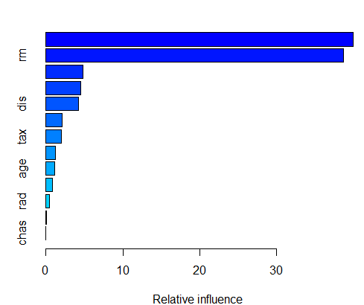

> summary(boost.model)

var rel.inf

lstat lstat 39.9802538

rm rm 38.7515144

ptratio ptratio 4.7813973

crim crim 4.5039893

dis dis 4.2294605

indus indus 2.0548329

tax tax 1.9788610

nox nox 1.2310106

age age 1.0875988

black black 0.8745867

rad rad 0.4860793

zn zn 0.0404153

chas chas 0.0000000

# partial dependency plots

par(mfrow=c(1,2))

plot(boost.model, i="rm") # median housing price is increasing with increase in rm

plot(boost.model, i="lstat") # median housing price is decreasing with lstat

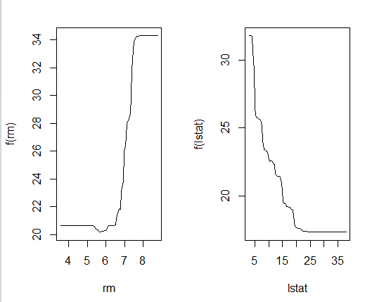

> boost.pred <- predict(boost.model, newdata = test, n.trees = 5000)

> mean((test$medv - boost.pred)^2)

[1] 18.14987 # increase in MSE compared to rf and bagging, which would not be the case usually. Depends on the data.

###modifying shrinkage parameter from default 0.001 to 0.2

> boost.model <- gbm(medv ~ ., data = train, distribution ="gaussian", n.trees = 5000, interaction.depth = 4,shrinkage = 0.2, verbose = F)

> boost.pred <- predict(boost.model, newdata = test, n.trees = 5000)

> mean((test$medv - boost.pred)^2)

[1] 17.01181 # there is improvement in test MSE.

**Multi target Prediction (Multi target regression(MLR)) : package randomForestSRC or** **MultivariateRandomForest**

**Approaches:**

* package randomForestSRC or MultivariateRandomForest

<https://kogalur.github.io/randomForestSRC/theory.html>

* The neural net supports multiple output variables, one such code snippet is below, where 2 output variables [strength and cement] are given based on various features.
* concretemodel = neuralnet (strength +Cement~ Slag+Ash+Water+Superplasticizer+ Coarse+Fineagg+age, data=concretetrain,hidden = c(5,3) )
* PLS with multiple target

**Naive Bayes: package e1071**

**Ref:** [**http://dataaspirant.com/2017/02/06/naive-bayes-classifier-machine-learning/**](http://dataaspirant.com/2017/02/06/naive-bayes-classifier-machine-learning/)

**Bayes Theorem:**

used for calculating conditional probability.

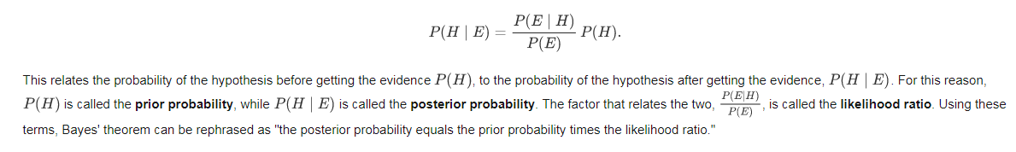

**Assumption:**

All variables in the model are independent of each other. Because of this assumption, it is called as Naïve Bayes as it is making Naïve assumption.

**Laplace Smoothing:**

Adding one to every combination of category and categorical variable. This helps preventing knocking out an entire class just because of one variable.

**Formula:**

naiveBayes(formula,data,laplace=0,subset,na.action=na.pass)

laplace =1, indicates all class will be added with 1.

**Prop.table:**

Used to get the proportions of the table.

**Ref link:** http://www.cyclismo.org/tutorial/R/tables.html

The *plot* command will automatically produce a mosaic plot if its primary argument is a table.

**Kappa:**

Kappa = (observed accuracy - expected accuracy)/(1 - expected accuracy)

Cats Dogs

Cats| 22 | 9 |

Dogs| 7 | 13 |

Ground truth: Cats (29), Dogs (22)   
Machine Learning Classifier: Cats (31), Dogs (20)   
Total: (51)   
Observed Accuracy: ((22 + 13) / 51) = 0.69   
Expected Accuracy: ((29 * 31 / 51) + (22 * 20 / 51)) / 51 = 0.51   
Kappa: (0.69 - 0.51) / (1 - 0.51) = 0.37

**Interpretation**

There is not a standardized interpretation of the kappa statistic. According to Wikipedia (citing their paper), Landis and Koch considers 0-0.20 as slight, 0.21-0.40 as fair, 0.41-0.60 as moderate, 0.61-0.80 as substantial, and 0.81-1 as almost perfect. Fleiss considers kappas > 0.75 as excellent, 0.40-0.75 as fair to good, and < 0.40 as poor. It is important to note that both scales are somewhat arbitrary.

**Model performance measure: Naïve Bayes**

confusionMatrix(table(model_predicted_outcome, actual))

check the accuracy and kappa. Sensitivity and specificity should not have much variance for better model. p value should be less than 0.05.

**Confusion Matrix:**

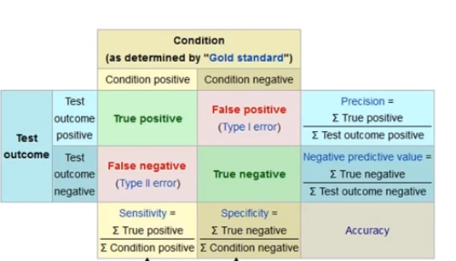

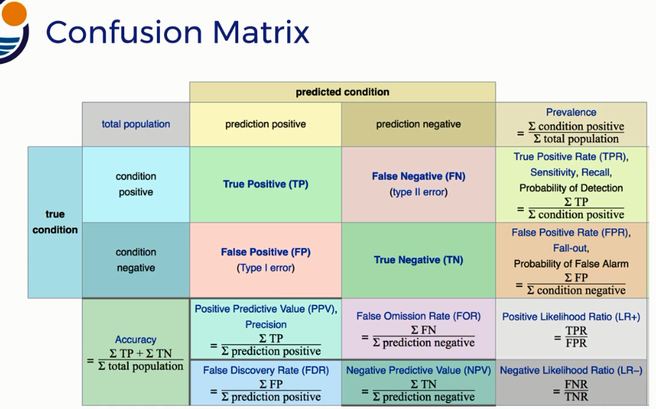

Sensitivity is also called as recall.

The confusion matrix, which is a breakdown of predictions into a table showing correct predictions and the types of incorrect predictions made. Ideally, you will only see numbers in the diagonal, which means that all your predictions were correct!

Precision is a measure of a classifier’s exactness. The higher the precision, the more accurate the classifier.

Recall is a measure of a classifier’s completeness. The higher the recall, the more cases the classifier covers.

The F1 Score or F-score is a weighted average of precision and recall.

The Kappa or Cohen’s kappa is the classification accuracy normalized by the imbalance of the classes in the data.

> str(iris)

'data.frame': 150 obs. of 5 variables:

$ Sepal.Length: num 5.1 4.9 4.7 4.6 5 5.4 4.6 5 4.4 4.9 ...

$ Sepal.Width : num 3.5 3 3.2 3.1 3.6 3.9 3.4 3.4 2.9 3.1 ...

$ Petal.Length: num 1.4 1.4 1.3 1.5 1.4 1.7 1.4 1.5 1.4 1.5 ...

$ Petal.Width : num 0.2 0.2 0.2 0.2 0.2 0.4 0.3 0.2 0.2 0.1 ...

$ Species : Factor w/ 3 levels "setosa","versicolor",..: 1 1 1 1 1 1 1 1 1 1 ...

> id <- sample(2,nrow(iris),prob = c(0.7,0.3),replace = TRUE)

> iris_train <- iris[id==1,]

> iris_test <- iris[id==2,]

> model_NB <- naiveBayes(Species ~ .,iris )

> model_NB

Naive Bayes Classifier for Discrete Predictors

Call:

naiveBayes.default(x = X, y = Y, laplace = laplace)

A-priori probabilities:

Y

setosa versicolor virginica

0.3333333 0.3333333 0.3333333

Conditional probabilities:

Sepal.Length

Y [,1] [,2]

setosa 5.006 0.3524897

versicolor 5.936 0.5161711

virginica 6.588 0.6358796

Sepal.Width

Y [,1] [,2]

setosa 3.428 0.3790644

versicolor 2.770 0.3137983

virginica 2.974 0.3224966

Petal.Length

Y [,1] [,2]

setosa 1.462 0.1736640

versicolor 4.260 0.4699110

virginica 5.552 0.5518947

Petal.Width

Y [,1] [,2]

setosa 0.246 0.1053856

versicolor 1.326 0.1977527

virginica 2.026 0.2746501

> summary(model_NB)

Length Class Mode

apriori 3 table numeric

tables 4 -none- list

levels 3 -none- character

call 4 -none- call

> pred_iris <- predict(model_NB,newdata = iris_test)

> confusionMatrix(table(pred_iris,iris_test$Species))

and Statistics

pred_iris setosa versicolor virginica

setosa 15 0 0

versicolor 0 17 2

virginica 0 1 11

Overall Statistics

Accuracy : 0.9348

95% CI : (0.821, 0.9863)

No Information Rate : 0.3913

P-Value [Acc > NIR] : 1.076e-14

Kappa : 0.9009

Mcnemar's Test P-Value : NA

Statistics by Class:

Class: setosa Class: versicolor Class: virginica

Sensitivity 1.0000 0.9444 0.8462

Specificity 1.0000 0.9286 0.9697

Pos Pred Value 1.0000 0.8947 0.9167

Neg Pred Value 1.0000 0.9630 0.9412

Prevalence 0.3261 0.3913 0.2826

Detection Rate 0.3261 0.3696 0.2391

Detection Prevalence 0.3261 0.4130 0.2609

Balanced Accuracy 1.0000 0.9365 0.9079

Values of sensitivitiy and specificity should be close for better model. Kappa and accuracy should be high.

**K means clustering algorithm: (unsupervised learning)**

Clustering is the process of grouping data objects into clusters.

Dataobjects within cluster should have

1. High intracluster similarity -> betweenss is the parameter of kmeans algorithm which records intra cluster similarity and it should be high.
2. Low intercluster similarity -> withinss is the parameter of kmeans algorithem which records intercluster similarity and it should be low

Used in:

Data analysis, image processing, market research or pattern recognition.

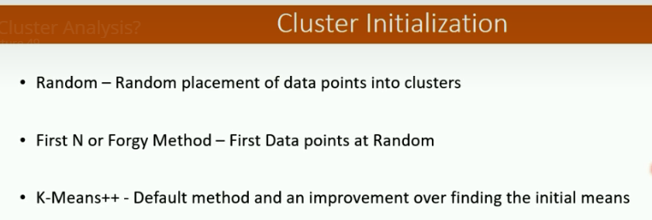

First N or Forgy method – selecting first few data points at Random

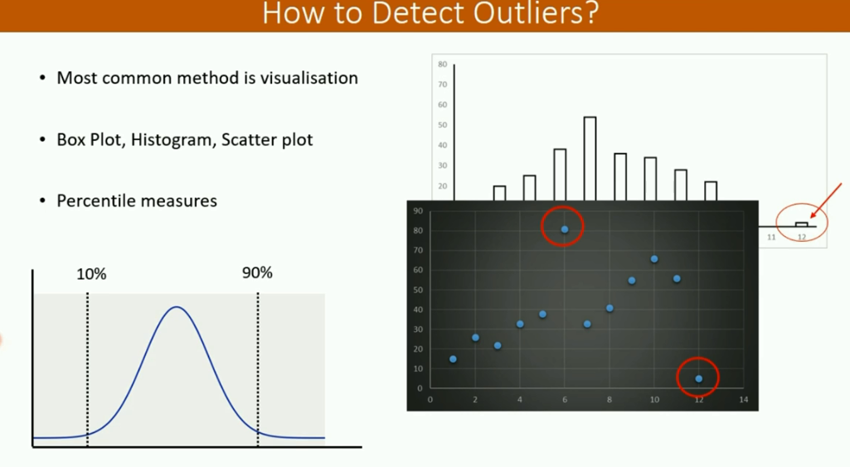

**Types of data and measurement scales:**

1. Nominal
   * + Used for labelling variables.
     + Data is mutually exclusive(no overlap)
     + None of them have numerical significance.
     + “nominal” sounds a lot like “name” and nominal scales are kind of like “names” or labels.
     + a sub-type of nominal scale with only two categories (e.g. male/female) is called “**dichotomous**.”
     + Eg: gender : male/femal , where do u live? – north India/south India/central India
2. Ordinal
   * + Order of the values is what’s important and significant, but the differences between each one is not really known
     + Ordinal scales are typically measures of non-numeric concepts like satisfaction, happiness, discomfort, etc.
     + Ordinal sounds like order.
     + Eg: how do u feel today?
       - 1 – very unhappy
       - 2 – Unhappy
       - 3 – Ok
       - 4 – Happy
       - 5 – Very Happy
3. Interval:
   * + Interval scales are numeric scales in which we know not only the order, but also the exact differences between the values.
     + “Interval” itself means “space in between,”
     + Eg: of an interval scale is Celsius temperature because the difference between each value is the same
     + Here’s the problem with interval scales: they don’t have a “true zero.”  For example, there is no such thing as “no temperature.”
4. Ratio:
   * + they tell us about the order, they tell us the exact value between units, AND they also have an absolute zero.
     + Good examples of ratio variables include height and weight.
     + These variables can be meaningfully added, subtracted, multiplied, divided (ratios).

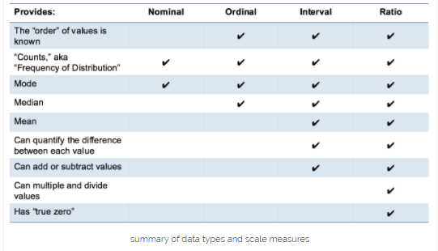

Requirements of Cluster Analysis:

1. Dealing with different attributes: they can be nomial/binary, ordinal/ interval or ration etc..
2. Dealing with noisy data – outliers, missing , unknown or errorneous data.
3. Constraints on clustering - to find a person in a city, we use cluster households with constraints as streets, area or house number.
4. Dealing with arbitrary shape - many algorithms determine clusters using manhattan or Euclidean distance measure. They find spherical cluster with similar size and density. But shape of cluster may not be same always. Need more algorithms to deal arbitrary shapes
5. High dimentioanality – attributes are nothing but dimentions. Need algorithms for high dimenstional data.
6. Ordering of input data – order of input data decides how algorithm performs in some cases. Same i/p data in diff order can result in erroneous data.
7. Interpretability and Usability - results of clusterin algorithm should be interpretabile and usable.
8. Determining i/p parameter – algos are sensitive to i/p parameter. Parameters are hard to determine for high dimentional objects.
9. Scalability - need algos for high data sets with millions of objects. Many clustering algos works well for small data objects. Less than 250.

Types of data in clustering:

1. Data matrix - relational table of nxp matrix, n – objects, p-variables. Dataset of automobiles with variables such as model number, name, weight, dimension or colour..here automobile is object, and variables are model number , etc.
2. Dissimilarity matrix – relational table of nxn matrix where n – objects. d(i,j) represents difference between i and j..value of d(i,j) will be always positive if i and j are same ie. 0

**Interval Scaled variable:**

Calculate the measurements using Euclidean or Manhattan or minkowski distance.

Euclidean – distance between multidimentional spaces.

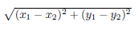

Manhattan – average difference of the various dimention objects.

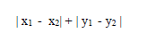

Minkowski – generalization of both Euclidean and manhattan.

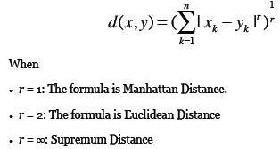

**Binary variable:**

1 or 0 ..

2 types:

1. Symmetric variable- variables have same state values and weights
2. Asymmetric variable – have not same state values.

Dissimilarity matrix for binary data computed using contingency tables.

|  |  |  |  |  |
| --- | --- | --- | --- | --- |
|  | Object 2 | | |  |
|  |  | 1 | 0 | Sum |
| Object 1 | 1 | a | b | a+b |
| 0 | c | d | c+d |
| Sum | a+c | b+d | t |

Total no. of variable t= a+b+c+d

Dissimilarity calculated using

1. Simple matching coefficient – for symmetric variable

d(i,j) = (b+c)/(a+b+c+d)

1. Jaccard coefficient - for asymmetric variable

d(i,j)= (b+c)/(a+b+c)

**Partitioning Method:**

* Arranges all objects into various partitions where total number of partition is less than the number of objects
* Each partition represents a cluster.
* Partitioning depends on a similarity function which can be distance between objects.
* 2 types of partitioning algo:
  + K-means
  + K-medoids

**K –means:**

1. Select k objects randomly as cluster mean or center of gravity of cluster
2. Assign an object to the cluster for which cluster mean is most similar.
3. Update cluster mean for each cluster if necessary.
4. Repeat this process until criterion function converges for all the clusters.

**Example:**

**K-means algorithm:**

> head(iris)

Sepal.Length Sepal.Width Petal.Length Petal.Width Species

1 5.1 3.5 1.4 0.2 setosa

2 4.9 3.0 1.4 0.2 setosa

3 4.7 3.2 1.3 0.2 setosa

4 4.6 3.1 1.5 0.2 setosa

5 5.0 3.6 1.4 0.2 setosa

6 5.4 3.9 1.7 0.4 setosa

> iriskmeans <- iris

> head(iriskmeans)

Sepal.Length Sepal.Width Petal.Length Petal.Width Species

1 5.1 3.5 1.4 0.2 setosa

2 4.9 3.0 1.4 0.2 setosa

3 4.7 3.2 1.3 0.2 setosa

4 4.6 3.1 1.5 0.2 setosa

5 5.0 3.6 1.4 0.2 setosa

6 5.4 3.9 1.7 0.4 setosa

> iriskmeans$Species <- NULL #Species is set to null as that is the attribute to determine using k-means algo

> modelk1 <- kmeans(iriskmeans,3) # 3 clusters hence 3. We can also include nstart=(some number) which indicates how many times the algorithm should run, better to have some number greater than 1 for good results.

> modelk1

K-means clustering with 3 clusters of sizes 38, 62, 50

Cluster means:

Sepal.Length Sepal.Width Petal.Length Petal.Width

1 6.850000 3.073684 5.742105 2.071053

2 5.901613 2.748387 4.393548 1.433871

3 5.006000 3.428000 1.462000 0.246000

Clustering vector:

[1] 3 3 3 3 3 3 3 3 3 3 3 3 3 3 3 3 3 3 3 3 3 3 3 3 3 3 3 3 3 3 3 3 3 3 3 3 3 3 3 3

[41] 3 3 3 3 3 3 3 3 3 3 2 2 1 2 2 2 2 2 2 2 2 2 2 2 2 2 2 2 2 2 2 2 2 2 2 2 2 1 2 2

[81] 2 2 2 2 2 2 2 2 2 2 2 2 2 2 2 2 2 2 2 2 1 2 1 1 1 1 2 1 1 1 1 1 1 2 2 1 1 1 1 2

[121] 1 2 1 2 1 1 2 2 1 1 1 1 1 2 1 1 1 1 2 1 1 1 2 1 1 1 2 1 1 2

Within cluster sum of squares by cluster:

[1] 23.87947 39.82097 15.15100

(between_SS / total_SS = 88.4 %)

Available components: #These are the diff available components.

[1] "cluster" "centers" "totss" "withinss" "tot.withinss"

[6] "betweenss" "size" "iter" "ifault"

> modelk1$size

[1] 38 62 50

> modelk1$cluster

[1] 3 3 3 3 3 3 3 3 3 3 3 3 3 3 3 3 3 3 3 3 3 3 3 3 3 3 3 3 3 3 3 3 3 3 3 3 3 3 3 3

[41] 3 3 3 3 3 3 3 3 3 3 2 2 1 2 2 2 2 2 2 2 2 2 2 2 2 2 2 2 2 2 2 2 2 2 2 2 2 1 2 2

[81] 2 2 2 2 2 2 2 2 2 2 2 2 2 2 2 2 2 2 2 2 1 2 1 1 1 1 2 1 1 1 1 1 1 2 2 1 1 1 1 2

[121] 1 2 1 2 1 1 2 2 1 1 1 1 1 2 1 1 1 1 2 1 1 1 2 1 1 1 2 1 1 2

> table(modelk1$cluster,iris$Species) #confusion matrix

setosa versicolor virginica

1 0 2 36

2 0 48 14

3 50 0 0

> plot(iris[c("Petal.Length","Petal.Width")],col=modelk1$cluster)

#model has determined 3 clusters with slight overlap between 2 and 3 clusters

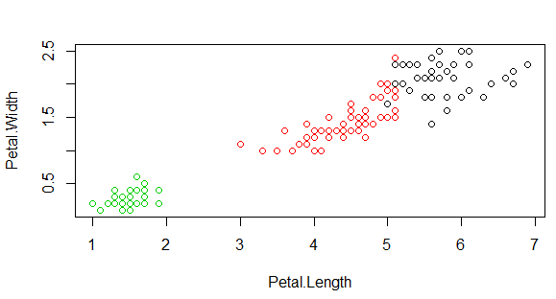

> plot(iris[c("Petal.Length","Petal.Width")],col=iris$Species)

#original dataset clusters

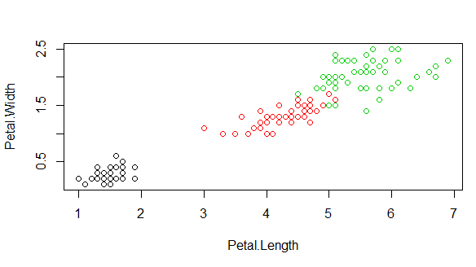

> plot(iris[c("Sepal.Length","Sepal.Width")],col=modelk1$cluster)

#Sepal length and width comparison same as petal

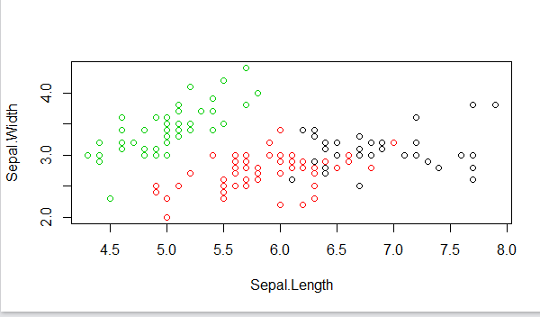

> plot(iris[c("Sepal.Length","Sepal.Width")],col=iris$Species)

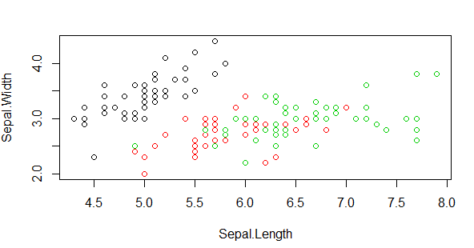

**Clustplot works only for 2 dimentional data:**

>library(cluster) #Cluster library is used to plot the clusters.

>clusplot(iris,modelk1$cluster,color=T,shade=T,labels=0, lines=0) # plots the 2 features which describes most variability

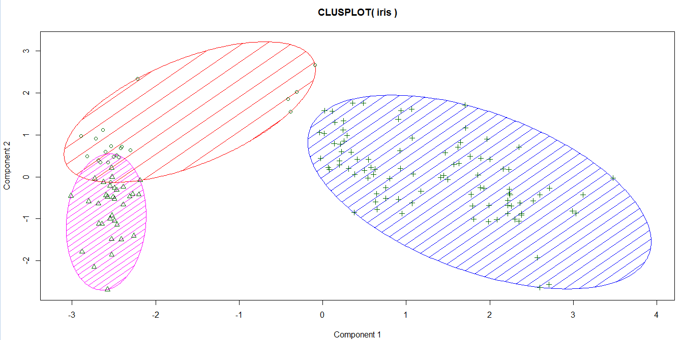



**Example 2:**

#randomly generated 60 values as matrix

> kmat <- matrix(rnorm(30*2),ncol = 2)

> head(kmat)

[,1] [,2]

[1,] 0.3295078 -1.3770596

[2,] -0.8204684 -0.4149946

[3,] 0.4874291 -0.3942900

[4,] 0.7383247 -0.0593134

[5,] 0.5757814 1.1000254

[6,] -0.3053884 0.7631757

> dim(kmat)

[1] 30 2

> kmat[1:15,1] <- kmat[1:15,1]+2 #added 2 in order to differentiate 1st 15 values of 1st column

> kmat[1:15,2] <- kmat[1:15,2]-4 #same as above

> head(kmat)

[,1] [,2]

[1,] 4.329508 -1.670492

[2,] 3.179532 -2.820468

[3,] 4.487429 -1.512571

[4,] 4.738325 -1.261675

[5,] 4.575781 -1.424219

[6,] 3.694612 -2.305388

> modelk <- kmeans(kmat,2,nstart = 20) #2 clusters and 20 times algorithm runs to find best clusters.

> modelk$cluster

[1] 1 1 1 1 1 1 1 1 1 1 1 1 1 1 1 2 2 2 2 2 2 2 2 2 2 2 2 2 2 2

> plot(kmat ,col =(modelk$cluster),main ="K-means clustering",pch=20,cex = 2)

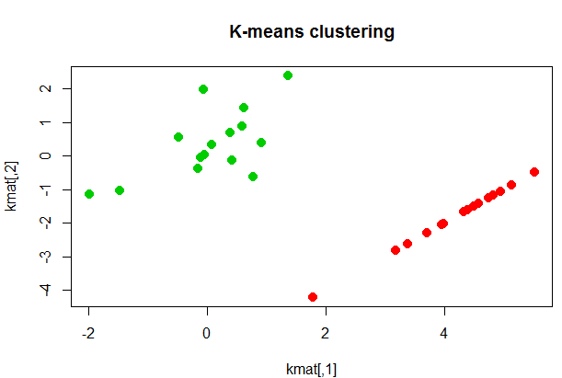

**K medoids: (PAM – Partitioning Around Medoids)**

k-means doesn’t work properly for large value objects and sensitive to outliers. k-medoids use a reference point called medoids instead of cluster center/mean as in k-means.

1. Randomly select k objects as mediods or reference points.
2. Assign remaining objects to the cluster that is most similar to medoid.
3. Randomly select a non-medoid object O(random)
4. Calculate the total cost C of swapping the medoid O(i) with non-medoid object O(random) by cost function that is used to determine the dissimilarity between O(random) and O(i).
5. Swap medoid O(i) with O(random) to make new medoid, if total cost of swapping is negative.
6. Repeat step from 2 until no swapping occurs.

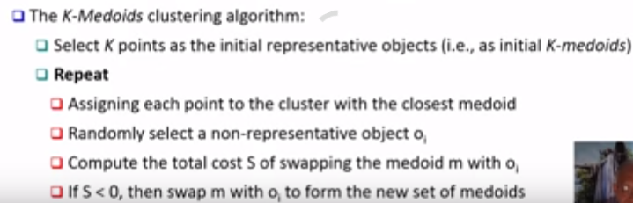

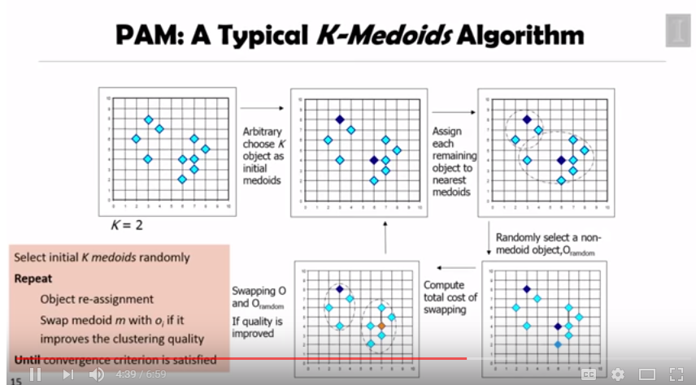

In below 4 scenarios, swapping is possible. (green single line indicates – existing connection, double green line indicates, new connection. Blue line indicates swapping medoid with non-medoid)

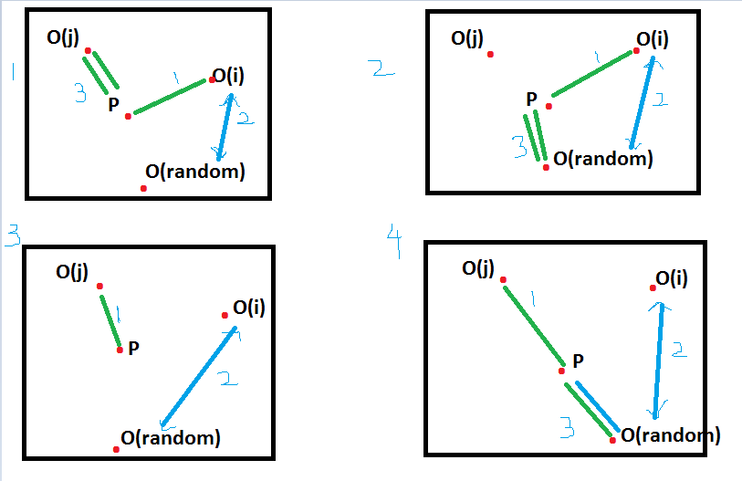

1. O(i) is the medoid, P is the sample object, O(j) is another object and O(random) is the non-medoid object. Initially P is assigned to O(i) but P is closed to O(j), when O(i) is swapped with O(random), P gets reassigned to O(j)
2. P is assigned to O(i), but P is closer to O(random), when O(i) is swapped with O(random), P gets assigned to O(random)
3. P is assigned to O(j) and that is the closed medoid. When O(i) gets swapped with O(random), P stays with O(j)
4. P is assigned to O(j) but it is closer to O(random), when O(i) swapped with O(random), P gets reassignend to O(random)

**Partitioning in Large Database: (CLARA – Clustering large Application)**

K-medoid is suitable for small size data set, on large data sets, computational complexity is high. For large data set, Clustering LARge Application(CLARA).

CLARA is PAM on samples ie: instead of using whole n points, we use only on s - sample size. But the drawback is if the initial sample selection is not good, algo efficiency will be poor.

Later, CLARANS(Clustering large application based on RANdomized Search) was founds which will do randomized re-sampling. i.e instead of having fixed s samples, we randomly resample, ensuring efficiency and quality of the cluster.

**Hierarchical method**: not used for large datasets.

o/p will be dendogram(contains the order in which the data points are merged)

Dendograms contain the memory of how the clusters were formed during hierarchical clustering.

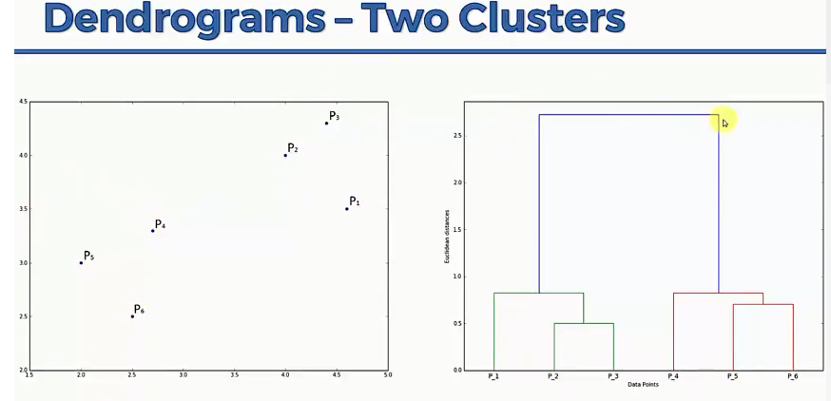

The height of the bars indicates the Euclidean distance between the datapoints.

Groups all objects into tree of clusters that are arranged in hierarchical manner.

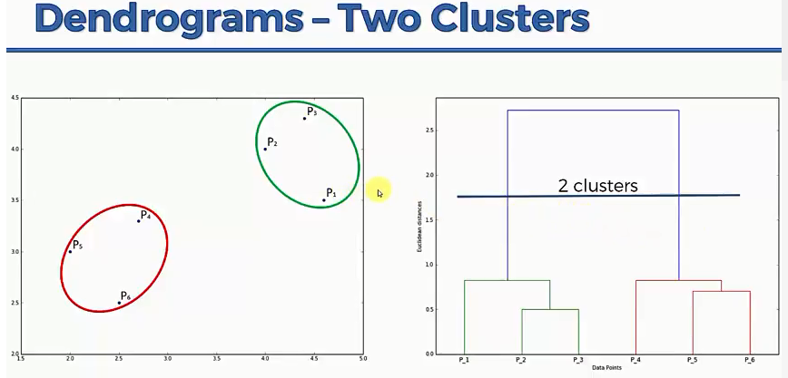

In above diagram, we have set the dissimilarity threshold to 1.7, by that we are implying that we don’t want the clusters which have dissimilarity more than 1.7 euclidean distance, So, the number of vertical lines crossing the threshold line is the number of clusters we have.

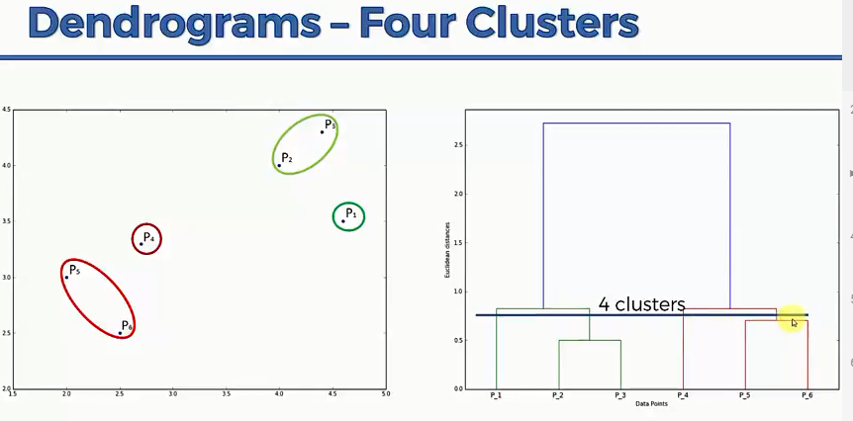

**Optimal number of clusters- as per dendogram:**

Take the longest vertical line which is not crossed by any horizontal lines and make a cut on that line horizontally, the below clusters will be the number of optimal clusters as per dendogram. This is one of the approach to identify number of clusters. Other approach is to use elbow method as in kmeans.

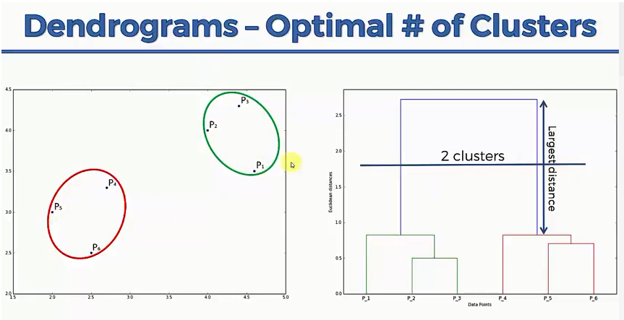

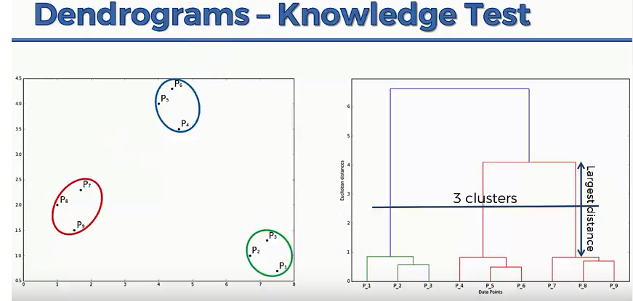

**2 types:**

1. Agglomerative (bottom-up approach) AGNES(AGglomerative NESting)

* Each object creates its own clusters
* Single clusters are merged to make large clusters
* This merging continues until all single clusters are part of one big cluster containing all objects

1. Divisive (top- down approach) DIANA (DIvisive ANAlysis)
   * 1. All objects are arranged in a big single cluster
     2. Large cluster is divided continuously into small clusters until each cluster has a single object.

**Drawback of hierarchical clustering:**

Once the clusters are merged or splitted into small clusters, you cannot change the generated clusters. No undo and you cannot perform object swapping between clusters.

Complete linkage analysis – pick up the distance between farthest point in the clusters (not isolated and cohesive). Forces spherical clusters with consistent diameters.

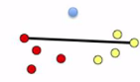

Single linkage - pick up the distance between nearest/closest point in the clusters (isolated and not cohesive). Drawback – it has chaining phenomenon. Assume Dumbell shape clusters, Instead of considering each side as separate cluster, grouping both the sides as single cluster is a drawback.

Produces long chains.

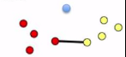

Average linkage – inbetween approach. Average of all pairwise distances. Less affected by outliers

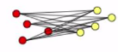

Example:

> kmat <- matrix(rnorm(30*2),ncol = 2)

> head(kmat)

[,1] [,2]

[1,] 0.6955508 -0.5806143

[2,] 1.1462284 -1.0010722

[3,] -2.4030962 -0.6681786

[4,] 0.5727396 0.9451850

[5,] 0.3747244 0.4337021

[6,] -0.4252677 1.0051592

> hcomplete <- hclust(dist(kmat),method = "complete")

> hsingle <- hclust(dist(kmat),method="single")

> plot(hcomplete,main = "hierrarchical clustering", cex = 0.8)

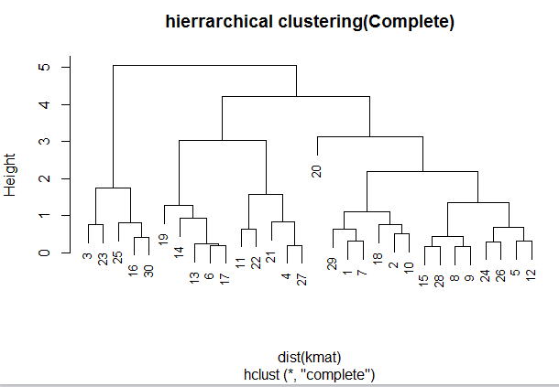

|  |
| --- |
| > plot(hsingle,main="hierrarchical clustering(Single)",cex=0.8)    > haverage <- hclust(dist(kmat),method="average")  > plot(haverage,main="hierrarchical clustering(Average)",cex=0.8)    >dendogram = hclust(dist(X, method='euclidean'), method = 'ward.D')  method =’ward.D’ indicates, we are trying to minimize the within cluster variance to find our clusters. In kmeans, we try to minimize within cluster sum of squares using withinss parameter.  **Hierrarchical clustering(agglomerative) in Eucledian space:**  **Ref link -** https://www.youtube.com/watch?v=rg2cjfMsCk4  Each data point will be a cluster initially, 2 data points are merged to the **centroid**(**average of the data points**)  dendogram represents the sequence in which the data points are merged.  In below case, 2 blue points were merged followed by 2 green points, then, left pink point with blue group and  right pink point with green group. We can merge the final 2 clusters to one but in most cases, merging as 1 cluster  doesn’t solve the purpose as we need to find the different groupings rather than bringing all under one roof.    **Hierrarchical clustering(agglomerative) in Non- Eucledian space:**  In Non-Eucledian space, there is no concept of average. The only thing we can talk about is the points themselves. Instead of centroid, here clusteroid is used.  Clusteroid –existing datapoint which is **closer** to other points in the cluster.  Nearness of cluster calculated by considering clusteroids as centroid. |
|  |
|  |

**Cohesion**: we set threshold for diameter or radius or density and stop clustering when they exceed the threshold.

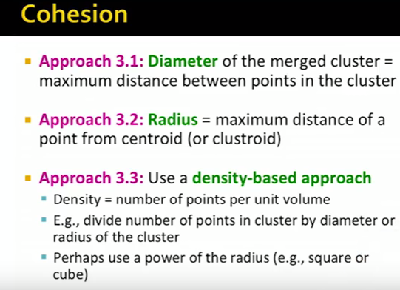

**Gaussian Mixture Model(GMM): package(Mclust)**

Generative unsupervised clustering is GMM.

Also called as Expectation Maximization (EM) clustering

* Each point is generated by Linearly combining multiple multivariate gaussians.

Gaussian (PDF- probability distribution function): - is a distribution is a listing of outcomes of an experiement and the probability associated with each outcome. It is even distribution. Half of the data lies to the left and half to the right of mean.

Gaussian Mixture Model: It’s a probability distribution that consists of multiple probability distributions. Each peak is a gaussian, If the data had multiple peaks, then we can apply GMM.

In k means, we have clear clustering that it falls under A class or B class..but in Gaussian, we will have soft clustering. ie. A given point mostly belong to A class than B class.

**Expectation Maximization algorithm:**

What is Expectation–Maximization (EM) algorithm?

An iterative method for finding maximum likelihood (MLE) or maximum a posteriori (MAP) estimates of parameters in statistical models,when the model depends on unobserved latent variables

Alternates between performing:

* Expectation (E) step: Given the current parameters of the model, estimate a probability distribution.
* Maximization (M) step: Given the current data, estimate the parameters to update the model.

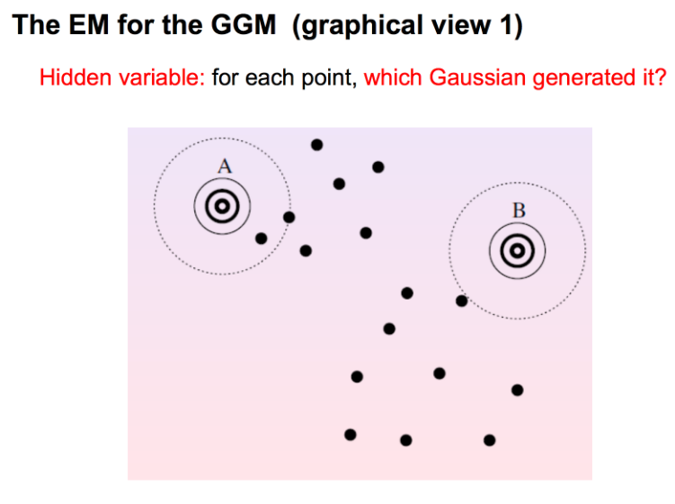

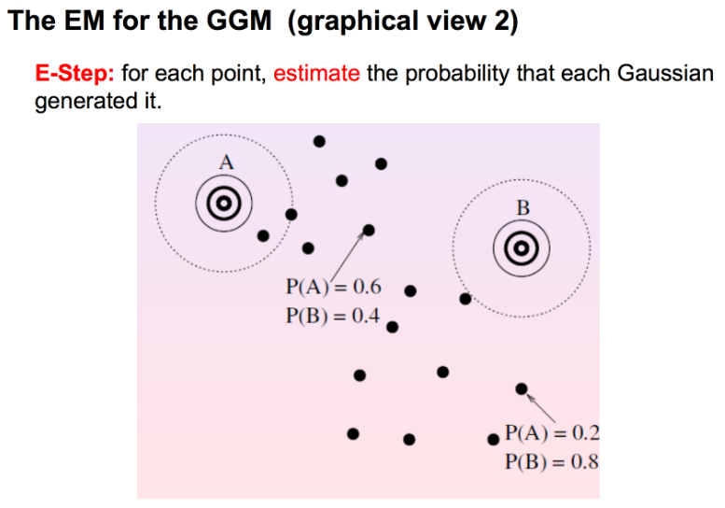

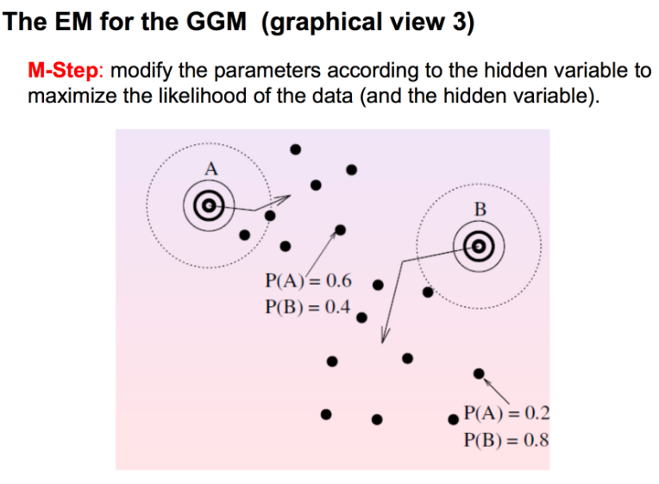

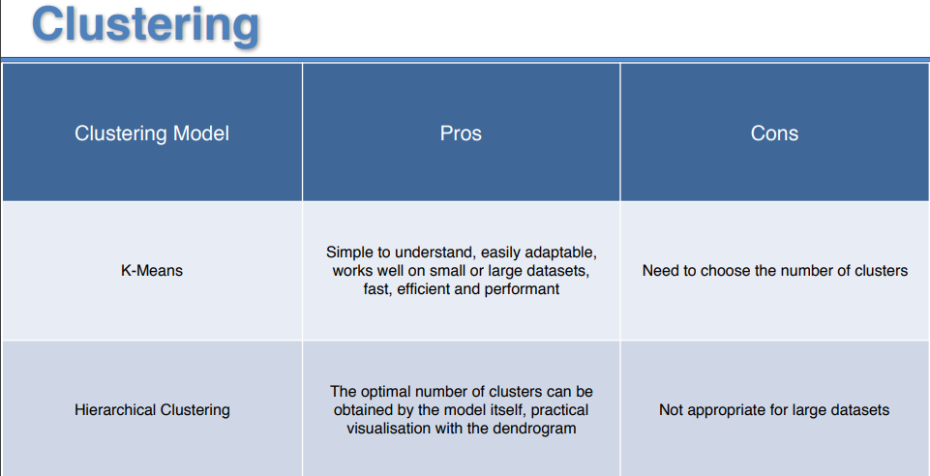

**Supervised and unsupervised learning**:

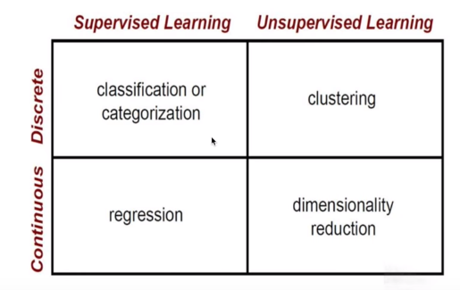

**SVM algorithm: Support Vector Machine: package : e1071,** LiblineaR(useful for very large linear problems)

**Hyperplane:**

In a p-dimensional space, a hyperplane is a flat affine subspace of dimension p – 1 which classifies or divides the points.

Eg: in 3 dimensional space, hyperplane is a 2 dimensions flat subspace. In 2 dimensional space, hyperplane is just a line.

Mathematical formula for hyper plane, β0 + β1X1 + β2X2 + . . . + βpXp = 0, for parameters β0, β1, and β2 etc, X = (X1,X2, . . . , Xp)T in p-dimensional space (i.e. a vector of length p) satisfies this equation, then X lies on the hyperplane.

If X does not satisfy the equation, it can lie on either of the sides of hyperplane.

β0 + β1X1 + β2X2 + . . . + βpXp > 0. 🡺 on one side of the hyperplane

β0 + β1X1 + β2X2 + . . . + βpXp < 0. 🡺 On other side of the hyperplane.

**Goal:**

Our goal is to develop a classifier based on the training data that will correctly classify the test observation using its feature measurements.

Blue points refer a class and purple refers other class. there can be n number of hyperplanes between the points to classify them. Let’s say, If f(x*)(the previous equation) is positive, then blue class and negative, then purple class. We can also make use of the magnitude of f(x∗). If f(x∗) is far from zero, then this means that x∗ lies far from the hyperplane, and so we can be confident about our class assignment for x∗. On the other 9.1 Maximal Margin Classifier 341 hand, if f(x∗) is close to zero, then x∗ is located near the hyperplane, and so we are less certain about the class assignment for x∗.

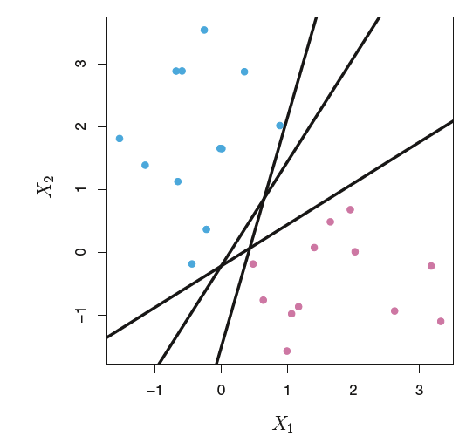

|  |  |  |
| --- | --- | --- |
| **Maximal Margin Classifier/**  **Optimal Separating Hyperplane** | **Support Vector Classifier/Soft Margin Classifier.** | **Support Vector Machines** |
| Classifying a test observation  based on which side of the maximal margin hyperplane it lies. This is known  as the maximal margin classifier. | The generalization of the maximal margin classifier to the  non-separable case is known as the support vector classifier. We develop a hyperplane that almost separates the classes using soft margin. The margin is soft because it can be violated by some of the training observations. It allows some observations to be on the incorrect side of the margin, or even the incorrect side of the hyperplane. | The support vector machine (SVM) is an extension of the support Vector machine classifier that results from enlarging the feature space in a specific way or projecting the data points in a higher dimension, using kernels.  **Enlarging feature space:**  In case of non-linear class boundaries, support vector classifiers or any other linear models don’t perform well. To over come that, we consider enlarging the feature space using functions of the predictors such as quadratic and cubic terms and even higher-order polynomial functions of the predictors, in order to address this non-linearity.  For instance, rather than fitting a  support vector classifier using *p* features  *X*1*,X*2*, . . . , Xp,*  we could instead fit a support vector classifier using 2*p* features    Binary Classification is possible. It can also be extended to more classes. |
| **Support Vectors:**  Observations that lie on the margin are support vectors.  the maximal margin hyperplane depends directly on the support vectors, but not on the other observations. | **Support Vectors:**  Observations that lie directly on the margin, or on the wrong side of the margin for their class, are known as support vectors. These observations do affect the  support vector classifier. Rest will not affect. |  |
| **Advantages:**  it is elegant and simple, we will see that this classifier unfortunately cannot be applied to most data sets, since it requires that the classes be separable by a linear boundary. | **Advantages:**  support vector classifier, an extension of the maximal margin classifier that can be applied in a broader range of cases where the classes are separable using **linear boundary.** | **Advantages:**  support vector machine, which is a further extension of the support vector classifier in order to accommodate **non-linear class boundaries.** |
| Eg: | Eg: |  |
| **Disadvantages:**  It may overfit the data. Eg.We have obtained a maximal margin and a single test observation is creating drastic shift in the margin, then there is no point. To overcome, Support vector classifier or soft margin classifier arrived. |  | Mapping to higher dimension is computational intensive. Hence, we go for Kernel approach. In kernel trick, we can map the data in the same dimension and get the complex boundaries. |
|  |  |  |

Used for both classification, regression and outliers detection.

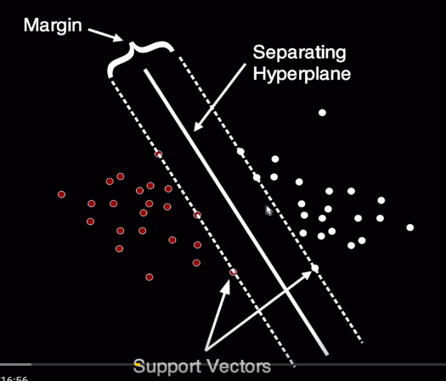

**Margins:**

compute the (perpendicular) distance from each training observation to a given separating hyperplane; the smallest such distance is the minimal distance from the observations to the hyperplane, and is known as the margin.

**Support vectors:**

“support” the maximal margin hyperplane in the sense vector that if these points were moved slightly then the maximal margin hyperplane would move as well. Interestingly, the maximal margin hyperplane depends directly on the support vectors, but not on the other observations.

**Ref link**: <https://www.svm-tutorial.com/2014/10/support-vector-regression-r/>

**Support Vector Classifier:**

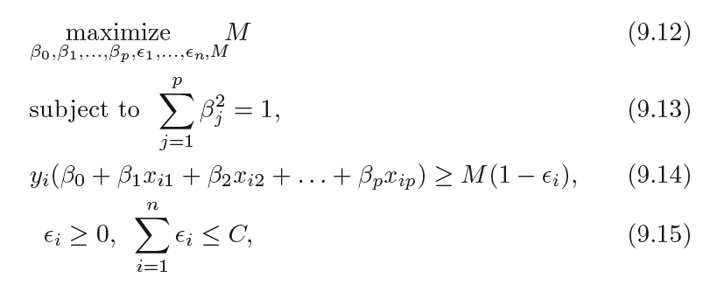

M = width of the margin.

ϵ1, . . . , ϵn are slack variables that allow individual observations to be on slack the wrong side of the margin or the hyperplane;

ϵi tells us where the ith observation is located, relative to the hyperplane and relative to the margin.

ϵi = 0, then ith observation is on right side of margin.

If ϵi > 0 then the ith observation is on the wrong side of the margin, and we say that the ith observation has violated the margin.

If ϵi > 1 then it is on the wrong side of the hyperplane.

C = non-negative tuning parameter. C bounds the sum of the ϵi’s, and so it determines the number and severity of the violations to the margin (and to the hyperplane) that we will tolerate.

IF C=0, then ϵ1, . . . , ϵn =0, nothing but maximal margin classifier.

C>0, then no observations more than C would be on wrong side of hyperplane.

If C increases, more tolerant to violations and margin widens, high bias and low variance.

If C decreases, less tolerant to violations and margin narrows, low bias and high variance

**Support Vector Machines:**

support vector classifier is equivalent to a SVM using a polynomial kernel of degree d = 1.

**Kernel:**

A kernel is a function that quantifies the similarity of two observations.

**Linear Kernel:**

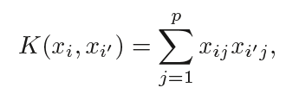

This would give us a support vector classifier. The linear kernel essentially quantifies the similarity of the pair of observations using Pearson (standard) correlation.

**Polynomial Kernel:**

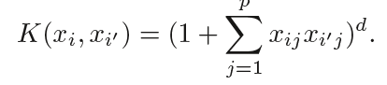 🡪 9.22

This is known as a polynomial kernel of degree d, where d is a positive integer. When the support vector classifier is combined with a non-linear kernel such as (9.22), the resulting classifier is known as a support vector machine.

**Radial Kernel / Gaussian Kernel:**   
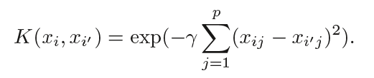

γ is a positive constant. The right-hand panel of Figure 9.9 shows an example of an SVM with a radial kernel on this non-linear data; it also does a good job in separating the two classes. Radial kernel has very local behavior, in the sense that only nearby training observations have an effect on the class label of a test observation.

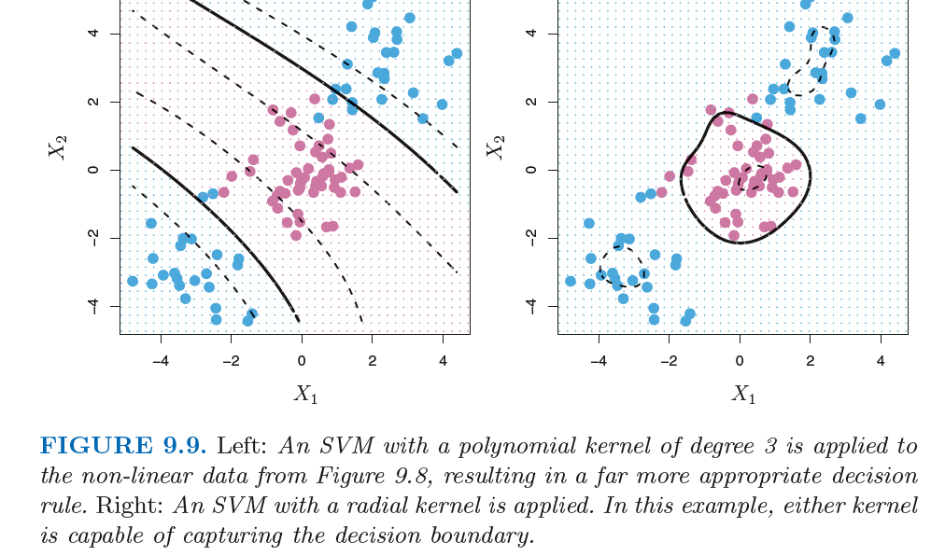

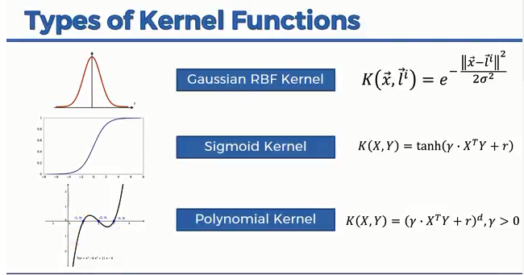

**SVMs with more than 2 classes:**

2 most popular approaches for extending SVM to classify more classes are.

1. One versus one/all pairs approach
2. One versus all

Support vector machine alogorithm performs feature scaling, hence not needed.

**Support vector classifier: (non-separable data)**

Package : e1071

Method : svm()

**Parameters:**

1. kernel= “linear”
2. cost (is for soft margin parameter) to specify the cost of violation to the margin. If cost is small, then margin is wide and many support vectors will be on margin or will violate the margin.

If cost is large, margin will be narrow, small number of support vectors

1. scale =TRUE/FALSE (scale false indicates not to convert each feature to mean 0 and sd 1.)
2. type = “C-classification” 🡪 default for classification problem, If regression problem, type =”eps-regression”.

In e1071 library, tune() is used to perform cross validation. By default, cross validation with 10 fold is performed.

**Support vector machine: (non-linear data)**

Package : e1071

Method : svm()

**Parameters:**

1. kernel= “polynomial” , degree =
2. kernel = “radial”, gamma = (is the free parameter, if small gamma means, high variance low bias, if gamma is large, low variance high bias)
3. cost
4. decision.values=TRUE to obtain the fitted values for a given SVM model fit

**KNN: (Classification)**

|  |  |
| --- | --- |
| **Parametric** | **Non-Parametric** |
| Eg: linear regression | Eg: KNN |
| It assumes linear functional form for f(X). | Do not explicitly assume a parametric  form for f(X), and thereby provide an alternative and more flexible approach for performing regression |
| **Advantages:**  easy to fit because one need estimate only a small number of coefficients.  As a general rule, parametric methods will tend to outperform non-parametric approaches  when there is a small number of observations per predictor. |  |
| **Disadvantage:**  by construction, they make strong assumptions about the form of f(X). | **Disadvantage:**  decrease in performance as the dimension increases is a common problem for KNN due to curse of dimentionality. |

**curse of dimensionality:**

If there are 100 training observations; when p = 1, this provides enough information to accurately estimate f(X). However, spreading 100 observations over p = 20 dimensions results in a phenomenon in which a given observation has no nearby neighbors—this is the so-called curse of dimensionality.

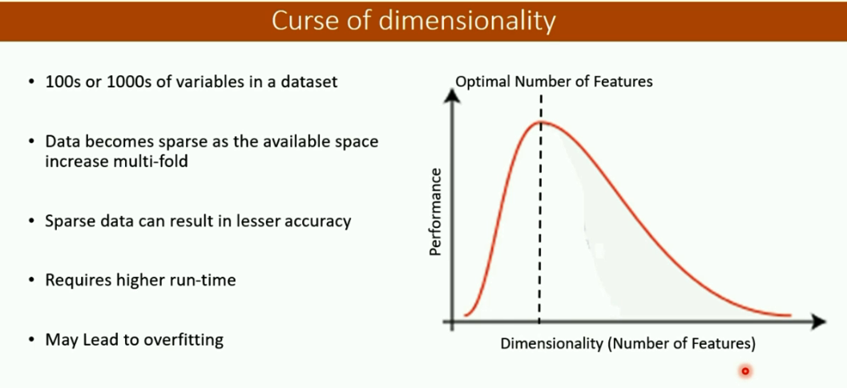

**KNN()**

* Is part of **class()** library.
* Other models have 2 steps, one for model creation and prediction.
* knn() does both in one step

The function requires four inputs.

1. A matrix containing the predictors associated with the training data, labeled **train.X** below.

2. A matrix containing the predictors associated with the data for which we wish to make predictions, labeled **test.X** below.

3. A vector containing the class labels for the training observations, labeled **train.Direction** below.

4. A value for K, the number of nearest neighbors to be used by the classifier.

We need to standardize the variables (i.e mean 0 and sd 1) in order to have all variables on a comparable scale.

**Reason to standardize:**

For instance, imagine a data set that contains two variables, salary and age (measured in dollars

and years, respectively). As far as KNN is concerned, a difference of $1,000 in salary is enormous compared to a difference of 50 years in age. Consequently, salary will drive the KNN classification results, and age will have almost no effect. This is contrary to our intuition that a salary difference of $1, 000 is quite small compared to an age difference of 50 years. Furthermore, the importance of scale to the KNN classifier leads to another issue: if we measured salary in Japanese yen, or if we measured age in minutes, then we’d get quite different classification results from what we get if these two variables are measured in dollars and years.

**Elbow method to determine k value:**

|  |
| --- |
| > #elbow method  > knn.pred <- NULL  > misclasserror <- NULL  >  > for(i in 1:20){  + set.seed(101)  + knn.pred <- knn(train.X, test.X, train.Y, k=i)  + misclasserror[i] <- mean(test.Y != knn.pred)  +  + }  >  > misclasserror  [1] 0.116 0.107 0.074 0.070 0.066 0.064 0.062 0.061 0.058 0.058 0.059 0.058 0.059 0.059 0.059  [16] 0.059 0.059 0.059 0.059 0.059  > library(ggplot2)  > k <- 1:20  > error.rate <- data.frame(misclasserror,k)  > ggplot(error.rate,aes(k,misclasserror))+geom_point()+geom_line(lty="dotted",  color="red")+theme_bw() |
|  |
| |  | | --- | | > | |

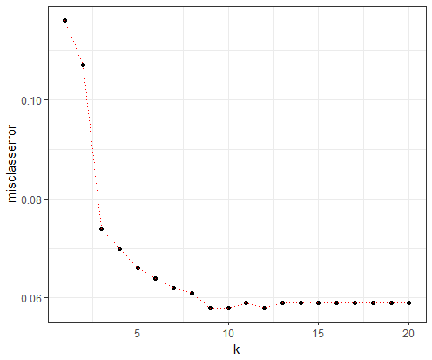

As per graph, after k=9 there is no reduction in the error rate. Hence, best k value for knn algorithm for this dataset is 9

**Steps in knn:**

1. Dataset importing to R
2. Data cleaning and EDA
3. Standardizing using scale() 🡺 very important.
4. Train and test dataset split.
5. Knn() algorithm
6. Misclassification error rate for the prediction
7. Use elbow method and plot to determine best k value
8. Reapply knn() for the final k value for best knn-fit.

**Unsupervised Learning:**

There is no need of prediction, instead identify the subgroups in the data. 2 types of unsupervised learning.

1. Principal Component Analysis -> a tool for data visualization and data pre-processing before supervised learning techniques are applied
2. Clustering -> to identify subgroups in the data.

Unsupervised learning is often performed as part of EDA(Exploratory Data Analysis).

There is no way to check our work because we don’t know the true answer (which is opposite to supervised learning).